Polly Grows Up
A Short Story
By Maryanne Peters

Maggie Dawson looked across at her husband Brian and smiled. They had been married for 26 years and he was still a good-looking man. He was also slight of build and not ruggedly handsome, and his hair was prematurely white, but his skin was remarkably unwrinkled, although thin and pale. She had far more wrinkles than him. She loved him now more than ever. There life together had been much more interesting lately.

“Is Polly coming for dinner tonight?” she asked.

“I think she is,” he replied.

“I’m just letting you know that we are eating at six”.

“I had best let her know,” he said. He stood up easily from his deep arm chair, his body still flexible and fit despite his limited exercise regime. He kissed his wife on the forehead.

Maggie lifted up a magazine she had been reading. She smiled. She was happy.

Polly appeared just after five. Maggie had poured herself a drink.

“Can I have one of those Mommy?” chirped Polly.

“You are far too young, Darling,” replied Maggie with a good-natured reprimand.

“I am not so little anymore, see.” Polly did a little spin so that Maggie to admire her new dress. It was indeed a far more mature outfit than usual. The skirt flair out as she spun, as did her blond hair, with just a few curls in the ends.

Maggie smiled at her daughter. “You are still too little to be drinking wine, Sweetheart.”

Polly poked out her bottom lip and stamped her foot.

“Please don’t be like that, Darling,” said Maggie. “It doesn’t suit you. You are so pretty when you smile. And when you smile, that makes me smile.”

Polly smiled, and Maggie’s heart leapt. “We’re just so lucky to have you,” she said, her eyes moistening just a little. “Daddy and I thought we would never have children. We are just so happy that you came along. A little late perhaps, but that makes you even more loveable.”

“I love you too Mommy,” said Polly. She seemed close to crying as well. “I love that we can talk like this. Mommy and daughter stuff. It’s neat.”

“Yes,” said Maggie. It was. Now she had the daughter that she had always wished for. A wish that had been a burden on her poor husband until he had found Polly for them. So many tears, and now they were happy. The three of them.

“I have made you lasagne for dinner, Sweetie,” said Maggie. “I know you love that.”

“Oh goody. I do love laza … laza. Whatever. With lots of cheese?”

“Lots just for you my sweet. Now sit up at the table.”

Polly bounced over to the table enthusiastically, planting her little frilly pantied bottom onto the chair and swinging her legs around.

“Mmm, it smells good.”

“Smell it by all means sweetie, but don’t let your hair dangle in it. Let me get you a clip for that.”

“Maybe I should wear my hair shorter?” said Polly.

“I thought that you liked your hair long,” said Maggie. “You like it when I braid it for you, don’t you?”

“I guess,” said Polly. “It’s just that, I think I would like a nice hairstyle that I could go to sleep with. Just wake up and pretty it up. For a while anyway. I could always grow it long again. I do like it long.”

“That settles it then,” said Maggie, with some relief. “You wouldn’t want to cut the hair on your Barbie dolls, would you?”

“I don’t play with my Barbies so much anymore,” Polly announced flatly.

“Why ever not?” Maggie was genuinely disappointed. She had loved those dolls when she was little.

“I want nice clothes on myself,” said Polly. “Why dolls get all the good clothes and I just get crap to wear?”

“Polly,” snapped Maggie. “Mind your language.”

“I’m sorry Mommy. I like this dress, but not the other stuff. Not the big skirts and the bows and stuff. That’s so old-fashioned.”

“But they are so pretty, Sweetheart,” Maggie protested.

“I have some nice Barbie clothes,” said Polly. “Like the knit dresses and the pencil skirts and deep vee-neck tops, and the little jackets, and the crop tops that show off you belly button. Stuff like that I like now. Modern stuff.”

‘Inappropriate for little girls,” said Maggie. “You are the wrong shape”.

“I should be the right shape,” said Polly, petulant again. “I should have boobies.”

“You get boobies when you get old,” scolded Maggie. “Old like your Mommy. You don’t want to be old, do you Darling?”

“Don’t be silly Mommy. Nobody wants to be old.”

“Well then, just stay the way you are.”

“But I want to wear makeup,” insisted Polly. “You say that is nice that I am so pretty. I want to be pretty. I could be even prettier if my eyebrows were shaped and I could wear some eyeliner and lipstick.”

“That’s for older girls,” said Maggie. “Not for you. Not just yet.”

“I just want to play with it,” Polly said. “It’s just for me. I know that when I get older, I will want to look pretty for boys. But that’s different.”

“Boys?” Maggie gulped. She forced herself to release a little laugh. “Oh Polly. You shouldn’t be talking about boys

“But boys are nice to girls, Mommy.”

“Not all men are nice, Darling. Men like your father are very rare.”

“I could find somebody like Daddy. Somebody who would look after me and always tell me how pretty I am. Somebody who could buy me stuff I like. Maybe even diamonds!”

Maggie smiled. How could she not. Polly was adorable.

“You’re right,” she said. “That would be nice.”

“Daddy holds you so tight,” said Polly, putting down her fork and looking at the ceiling. “It would be nice if I had somebody to hold me like that.”

“I hold you darling. I love to hold you.”

“But not like that. Not like … you know.”

“I told you, Sweetheart. That’s for older girls. Not you.”

“But I do feel a bit older Mommy. I’ve got girly juices running through me now. I can feel them. They make me feel so … soft and girly.”

Suddenly Maggie had a knot in her stomach. Her hands went to her face. “Oh my God,” she said. “My missing menopausal HRT patches. Brian? How could you?”

“It’s not Brian, Mommy, not anymore. It’s Polly now. Now and always. You have to face it. I’m growing up.”  She pulled off the blonde wig to reveal the cutest little pixie cut.  The End  © Maryanne Peters 2019 | 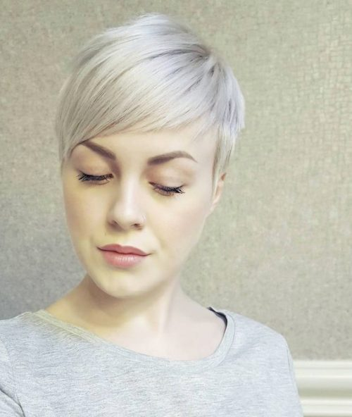  And this is how Polly looked after she got back from the salon

