Homemaker
A Short Story
By Maryanne Peters

I never thought that there was anything odd about Matt. I would not say that we were friends, but we worked alongside one another for three years and we always talked. I knew that he was married, and I had even met his wife, once, when they met on the street after work. She was plain as I recall.

His wife had some success in business. I am not sure what she did, but she must have been good at it. She made money which resulted in Matt ceasing to be the breadwinner. We can all say that this would have to be good news for any couple, but I got the impression that Matt did not welcome it. If it was pride, he would never say it. But he said that he had no reason to work.

So I do not think that anyone was surprised when Matt said that he was quitting to become a “househusband”. It seemed to me that he used the word with some bitterness, as if his wife’s new wealth had demeaned his status somehow

He promised to stay in touch, but I never heard another word from him.

His name came up from time to time, so on a whim I called him a few months after he had left. His cell-phone was cut off, which surprised me. He was always on it. I did not have a home number, but I knew where he lived as I had dropped him off a few times. I was just curious as to why he seemed to have simply dropped of the edge of Earth.

So, I went to his house to see him. I even fabricated an excuse for doing so. I had some cash of my own which I was going to explain was his share of an old lottery syndicate we had going. I had it in pocket, but I never pulled it out.

She answered the door. Tall, blonde hair styled in a roll at the back, high on top, swept across the front with a tendril hanging down – full pink sleeveless dress, pearls, makeup, big eyes with full lashes, strong jaw …

“Matt?” It seemed an outrageous suggestion. How could it be?

“Hello, Jim!” There was a beaming smile, but the voice was hardly his. It was high and feminine, but not entirely female. It was his voice, but coached. “Come in. I have something on the stove. Gabby is almost home. She likes me to dress for dinner.”

She scuttled down the hall ahead of me. She was wearing white high heels – not something you would normally expect to be won at home, even by a woman. But this was no woman, although from behind it seemed otherwise. I followed.

She set about her work in the kitchen. There was meatloaf in the oven and vegetables in the steamer. She put an apron on which had clearly been put to one side when she went to the answer the door. How old-fashioned.

“Matt. What’s going on?” My amazement must have been obvious. Sure it had been months, but what could have taken place in that time to bring about such a total change.

“This is what I do now,” she said. “I never thought I would be happy being at home like this, but the truth is, I love it. I love being a house husband.”
“But Matt,” I implored him, “This is not being a house husband, this is being a transvestite.”  “Somehow it just seems more natural like this,” he said. He seemed to adjust the front of the dress and it dawned on me that her chest jiggled and that the visible cleavage disclosed to reasonable large breasts that appeared to be very real.  There were other things too. While the face was made up it was clear that it was devoid of hair, so too the arms and legs. The hair was real too, pulled back at the sides and at the back, seemingly in a natural blonde color and shining with fresh hairspray. Putting aside the presence of Matt she was really very attractive.  In fact, the presence of Matt seemed the illusion, and one that was dissipating quickly.  “Honestly, leaving the office was the best thing that ever happened to me”s he explained. “I mean, you guys were great, but the relentless stress of it all, I’m glad its all over. All I need to worry about is what is in the oven and how tidy the house is – all things within my control. Honestly, it’s empowering.”  “But, I can’t believe that Gabby wants you to be like this,” I said.  “Don’t be silly,” he scolded. “Why else would she insist that I dress like this and take the tablets. Of course, this is how she wants me. And I just do what I am told. She’s the boss now. She makes the decisions. She worries about the mortgage. Not me. I don’t have a worry in the world. As long as I keep house and stay looking pretty, I will always have a provider. It’s a great life.” | 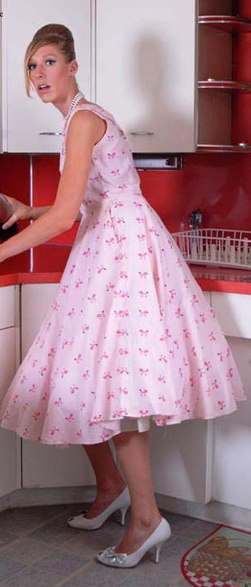

“You are taking pills? Like, hormone pills?”

“How else would I have skin this soft and hair this silky? And they make me feel so good. So peaceful and calm. Not like I used to be. Not aggressive and nasty. I am a nicer person – don’t you think?”

“I don’t think I know you, Matt,” was my honest reply.

“You should stay for dinner,” he said. “Get to know the new me a little better. And meet the new Gabby. She is so in control, sometimes it scares me. Of course, I will need to check with her first, but I want you to stay. I will call her. She must be on her way. Do you think my hair looks aright at the back?”

She turned her head and put her hand up to check her perfectly placed her in a manner so feminine it caused a momentary arousal in me. Her nails were short but painted pink.

“It looks great,” I said. It did. There is something about the nape of a woman’s neck with her hair swept up that just demands a kiss..

She rushed off the make the call, wiggling what seemed to be the perfect ass in that pink dress. I could hear her chatting in happy high tones. She got the go ahead and I agreed to stay, despite some misgivings. I just needed to understand.

Matt insisted that I take the big reclining armchair in the living room and read “Sports Illustrated”. She bought me a pair of men’s slippers that were too small for me – they might have once been his – they were still more comfortable that my shoes.

Somehow that armchair seemed just what I need, enveloping me like mother’s arms do a child. It had been a hard day – stressful. Perhaps Matt had found an escape from all of that.

“Before I fix you a drink would you like me to rub your shoulders. You look a bit tense.”

I had to smile my approval, but I am not sure why. She moved around behind me. I could smell an intoxicating perfume – all flowers and spices. Then strong but gentle hands finding the spot with skill.

“I love helping to relieve the tension I feel,” she said. “It is so rewarding. But you need to do it right.”

She did. I felt the stiffness in me escape as if a dam had been released.

“That’s better, now let me get you that drink”, she whispered in my ear, her warmth breath tickling me suggestively.

She brought me a caipirinha – something I had never tried. It was made of limes and Brazilian rum. He said that he would never make it for Gabby. “Caipirinha is a man’s cocktail. I have the ingredients and I have always wanted to make one.”

“It’s delicious,” I said, because it was.

A slam of the door announced to arrival home of my friend’s wife, Gabby. Matt immediately swung into action, rushing to collect her things and make her comfortable opposite me.

“Did you have a good day, Honey,” she said. “Here is your cosmopolitan. Would you like me to rub your feet? Would you like some snacks? Dinner won’t be long.”

Gabby showed a disinterest that I found slightly abusive. Here was a guy who had sacrificed every ounce of his pride to please this woman, and it was clear that she looked at him as if he was filth. She said nothing as she scuttled back into the kitchen.

Gabby sipped her drink coldly, and said: “E=Well Jim - what do you think of my little man-wife?”

“To be honest I am pretty upset about it,” I said. I really could not care less if I offended this woman. It seemed as if she had done these awful things to somebody who was at least a previous colleague of mine, if not a friend. “He tells me that you havie him take hormone pills. That can’t be good.”

“No, it’s not,” she said. “It has gone way too far. At the beginning I wanted him to understand what I had gone through when I was in his position. When he was in charge. He was an asshole as a husband, you see. When he got home, he was awful to me. I told him that if I was bringing in the income, he should play the supportive role. The clothes were a joke. Pretty clothes and regular trips to the salon was expected of me, so why not him.”

“I am not sure if I will stay to dinner. I think that is monstrous.”

“You blame me? I thought he was making fun of me by taking me up on it and becoming a wife. But look at him now? Could I do this? He says that he has found his place. He lacks ambition, you see. Hell, he lacks pride. Who would take it this far? The pills are too much. He can no longer perform as a man in bed. He wants me to be the dominant partner during sex. He has breasts you know. He says that their rapid growth proves that he was meant to be this way. The only thing that I like about him is that he is constant proof of my dominance in this relationship.”

“I don’t think that is healthy,” I said. “Marriage should be between equals. I think most men understand that.”

“He didn’t” she quipped. “And now he lives by the rules he set.” She laughed. Not quite the laugh of the arch villain of melodrama, but close enough to it.

“Frankly, I think that he is a better wife that you deserve,” I said.

“Well, if you think that, maybe he should go home with you,” she said. “Maybe I can find a man like the one you are talking about. An equal. Because my man-wife is certainly not that.”

We both turned towards the doorway and saw her at the same time. It was Matt, with meatloaf held in oven mitts in front of her, crying.

“You’re truly pathetic!” Gabby shouted at her. “Put it on the table and pull yourself together!”

She did as she was told, putting the casserole dish on the table and fleeing the room sniffing.

I looked at Gabby in disgust. I was not about to stay in the same room as this bitch.

I followed Matt. She was in the kitchen facing the wall, her body shaking in her grief. Surely man or woman I would have done exactly what I did. I came up behind her and put my arms around her. I could feel her fragility and her pain, smell her perfume and her hairspray, calm her shaking body.

“Oh Jim, I just want somebody to devote my life to. Somebody that I can please and support. Somebody who will look after me in return. I want to make a home for somebody.”

“That is admirable Matt,” I said. “I think I understand what this is all about. But for Gabby this is some kind of payback. And I think that she will never be comfortable with you like this. I am not sure what she wants, but I don’t think that it is a woman.

“You’re right Jim, but the man she thinks she wants does not exist.”  I want to live in a house and make it a home,” she said.  I could feel a yielding in her body. There is no other way to describe it. Even with he back turned I knew what she wanted. She turned. Her eyes were wet with tears and probably the most beautiful eyes I had ever looked in to.  “I have a house,” I said.  The End  © Maryanne Peters 2020  Author’s Note: “Trading Places” was a little short inspired by a captioned image that received a lot of comments when posted on FM in May 2019. It ended with the words: “If only I had somebody as caring as the person in there to look after my every need” and the consensus was that he should have his wish granted.  Maryanne. | 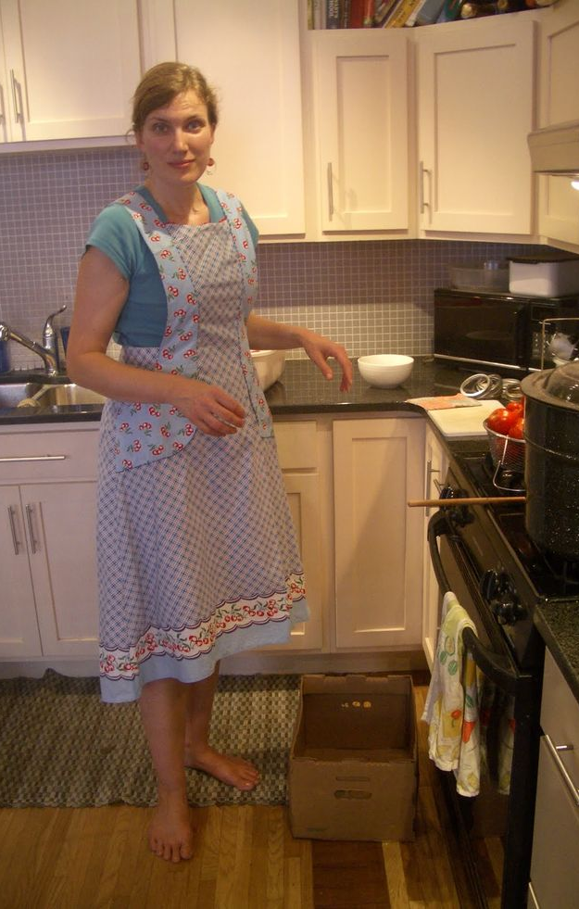  Even in bare feet and without makeup, she is still the most beautiful housewife in the world to me.

