Pre-Planned
Inspired by a Captioned Image by Kenneth to Willow (Deviant Art)
A Tale of Emancipation by Emasculation
By Maryanne Peters

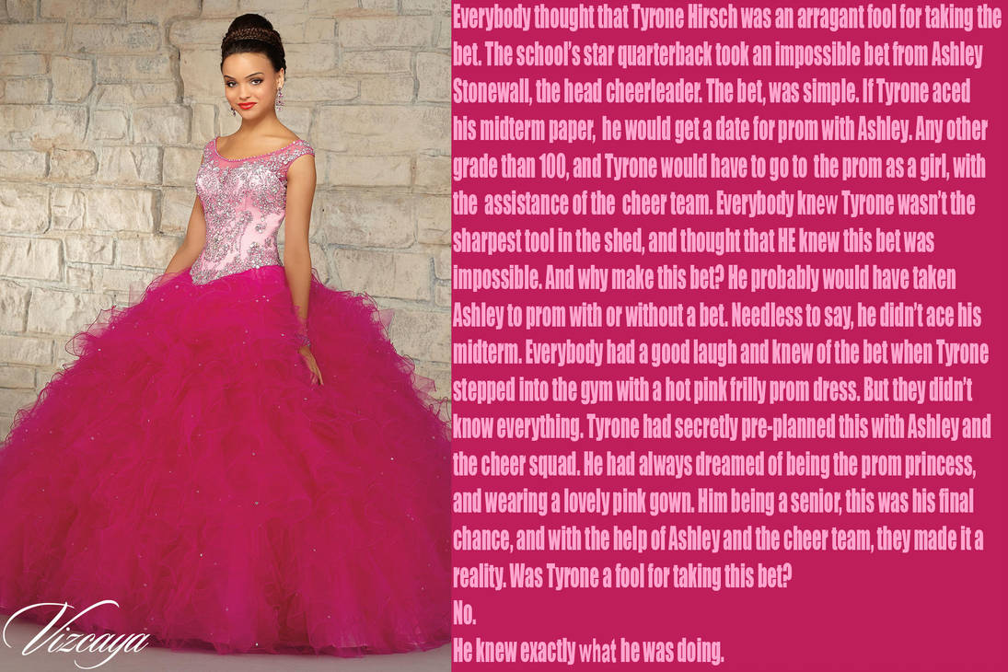

Before that night, my whole life was an act. I was pretending to be the person everybody expected me to be. Tyrone Hirsch, football jock and dumbass.

Everybody knew that I would fail the paper, and I did. But nobody asked how much I got. 98/100 is what I got. I wanted to give it my best – that’s my way - just as long as I did not get 100. I wanted to lose the bet.

Nobody wants a footballer to be smart. You have to be fit and aggressive, and be ready to suffer pain to achieve victory. There is nothing to be gained by thinking. Even at quarterback, our coach always said “stick to the plays and don’t improvise”, “Throw to the map, not the player”. I had points to hit, and that was all that was expected of me. The same goes for everybody on the team.

Likewise, your teammates. Chant in the huddle, move the ball, take the tackle, chest bumps, high fives, deep grunts. The very essence of being male. I wanted it to be true. That is what drove me to be the best player that I could be.

But for me, it was a lie. It always has been. My father expected me to be a man, and my mother too, and my younger brother, and all other family, and all my friends. And me too, I suppose.

Even when I saw Transgender people on TV and could tell myself “that is me”, I still could not imagine myself going that far. It was like, I felt that if I just tried harder to be a man, all thoughts of another kind of life would evaporate. Or perhaps I just lacked the courage. Not physical courage, maybe, but courage none the less.

It was my girlfriend Asley, Ashley Stonewall, the head cheerleader, who helped me through this.

We were watching TV at her place and something came up on a show we were watching. It was about a football star, a quarterback just like me, who went to his high school reunion, now a woman, and made a movie about it. I found myself spilling my guts to Ashley, telling her everything.

She could have laughed and me or abused me. But instead she took me up to her room, and put my hair in pigtails, and put makeup on my face. We both looked at the reflection of me in the mirror and I think that we both realized something that I would have thought before, was totally ridiculous – I could make quite a good-looking girl. I mean I had big eyes and not a big chin.

But how could we make it happen? We decided to go with her idea. Ashley said: “It’s just the kind of stupid thing that people would expect you to do.”

I thought: Now she knows my secret, but she really doesn’t know me at all. I am not as dumb as I look.

I made a huge show of being reluctant to submit to the transformation. People who could see me, thought I was terrified of being made a fool of, but instead I was shaking with excitement.

The cheerleaders and their support mothers had fashioned me a frock that screamed “Girl”. It had an embroidered bodice which needed a corset underneath, and full skirts in pink organza with ruffles and details all over. It was adapted from another dress, but I thought it was the most beautiful thing I had ever seen. They thought of it as a huge joke.

Of course I said: “No, no, it’s too much.” But I could not wait to get it on.

The week before the prom I paraded in the dress in the gym, to prove that I would honor the bet.

A guy in my team laughed and said: “At least it is long enough to cover your legs. You won’t have to shave them.”

“Too late,” I told him. “The cheerleaders have already given me the Brazilian.”

They had, and I have never had a hair on my body ever since.

For the prom itself, I went in to hiding for the whole week, so that I could make my grand entrance. I arranged for Ashley to go to the prom with the shyest guy on the football team, so I did not enter on the arm of a girl. They are still together, Ashley and my old team-mate.

I asked the captain of the basketball team to take me. Next to him, I would look positively petite. He could have said no, but he had no girlfriend at the time, and I guess he was up for some fun. He got plenty on that prom night.

I had a whole week to have the facials and skin treatments and to have my hair prepared for the big occasion. My hair was long enough to pull up onto the crown, and it was colored to match a hairpiece on top, an elaborate do with a high bun surrounded by small braids. My eyebrows were plucked, and a great makeup job was done, avoiding false eyelashes so that as much of the real me as possible, was visible. I wore the most gorgeous drop earrings.

Just before my date came to pick me up, Ashley told me that there was one final touch to be added if I was willing. She produced a syringe which she told me full of a heavy dose of female hormones including slow release capsules for long lasting effect. Would I?

You bet you I would. Quick as a flash my skirts were up, and my black lacy panties were down so that she could stab my butt cheek with what I craved. When I felt the cool liquid enter me, I knew that I was changed forever, no matter what would happen that night. The effects would come much later, but the first time I knew that in my blood, I was a woman.

My date was blown away. But at least he knew it was me. When I got to the prom most people seemed to think that I had found a stand-in. They could not believe it was me, especially when I started using the voice I had been practicing with the girls. I guess I spent the early part of the night with the girls, just talking girly stuff. But as the night wore on, my date felt he should do his duty and dance with me.

He was a perfect gentleman. He held me tenderly, as if uncertain of his own feelings about me, and the position he was in.

“There’s nothing wrong with being attracted to me,” I reassured him. “I’m not really a boy at all.”

He wanted to believe it. He held me a little closer. My team mates looked on with increasing uncertainty. It was thrilling. I am sure that if I had not made such a convincing female, they would have teased me, but in the main they just looked uncomfortable. That made it much easier for me to feel the opposite. I just breezed through it all, as only a really pretty girl can.

Largely through the way I carried myself, but also because of all my new girlfriends, and the votes I had extracted from the football team even before they had seen me, I was crowned Prom Princess. I cried a little as the placed the tiara carefully in my hairdo. Maybe the team expected me to drop the whole thing then and there. But instead I squeaked out a thank you speech in front of a slack-jawed audience, talking about my future being “best woman I can be”.

After the night was over, I rewarded my date with a blow job. The first of my life, but not the last. I took to it with surprising ease. I had already determined that I would leave all of those male inhibitions behind me. I was going to live as a woman from that day forward. I have.

Of course that meant appearing for breakfast in a nightie the following day, with my hair brushed out but looking really girly. I quietly ignored my father shouting and my mother screaming, as put on my mascara and I painted my nails at the breakfast table. But I know who I am now, and they don’t.

The End

© Maryanne Peters 2019
Eight Months Later  Inspired by a Captioned Image  (Kenneth2Willow Deviant Art)  By Maryanne Peters  What my brother Kevin failed to understand is just how fit and athletic you need to be to be an award-winning male dancer. Ballet is hard. And I think it is even harder for boys.  Am I a sissy? He had no idea what a sissy was until he became one. Mom knew that I was no sissy, because, like she said, she knew the training I did and the work that I had to do, every day, to be at the top in my chosen hobby – classical ballet. | 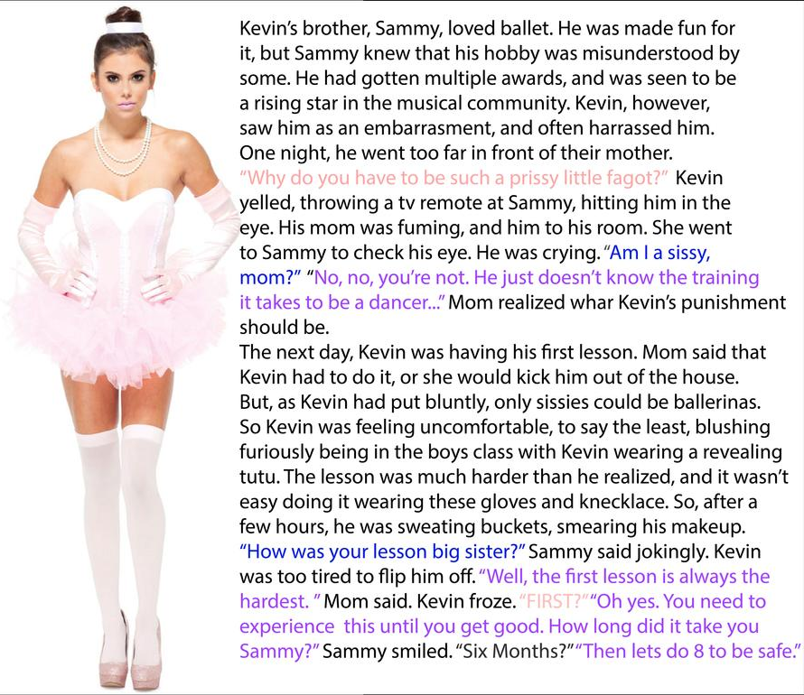

The truth is that I got into it to get to get close to girls. I guess that I was more interested in girls than my older brother. It seems to me that I now know why.

And Mom was quite specific. She showed the ballet instructor my black eye and insisted that Kevin attend training in a tutu. It turned into a full outfit.

But as it turned out, Kevin was too weak to cut it with the boys. He made a better ballerina.

He was only doing two lessons a week, but that seemed too much for him.

“If you don’t improve, we will get you an extra lesson or two,” Mom said. “And no hair cut for you. I want your hair long enough to put up in a bun like all ballerinas should have.”

Then somewhere along the line, things changed for Kevin. I cannot even tell you the moment. One day he just jumped into the car with his hair already up and a little make up on. He said it was easier to do it at home.

Then, eight months later he was Kaylee, and suddenly I am not the sissy brother anymore.

The End

© Maryanne Peters 2021

Blushing
Inspired by a Captioned Image
By Maryanne Peters

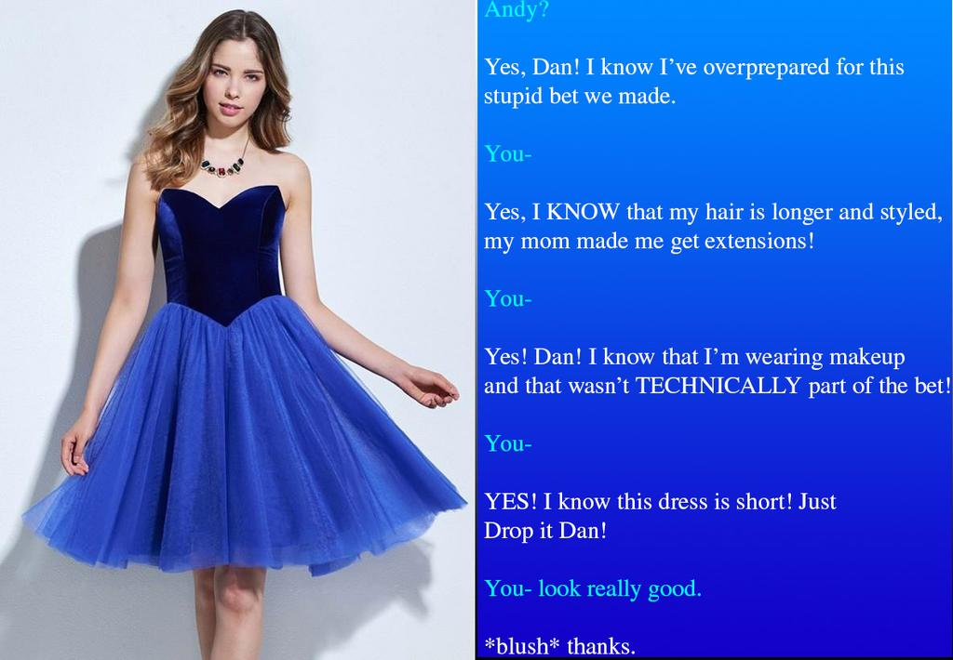

Can you see a boy? Look closely. Is that a boy under that waved hair? Is that a male body in the satin bodice? Is the pale flesh it is pushing up other than a woman’s breasts? Do those legs under those fully skirts belong on a guy? I challenge you. That is not Andy. If it was I would not be in love.

The previous year one guy took a bet that he would turn up to the dance dressed as a girl. He went hard out, but he was still a guy, and everybody knew it. He didn’t care. He was that kind of guy, I guess. Outgoing and ready to be outrageous.

Andy was not like that. He was shy. He did not want to draw attention to himself, but he taken the bet and he was going to win it.

His mother told him: “If you don’t want to look like a boy in a dress, but you still have to wear the dress, then you need to look like a girl in a dress. Nobody will stare at you then.”

But she was wrong. Everybody stared. I stared, but so did everybody else. I heard them whisper: “Who is that beauty with Dan? Have you seen her before? How could Dan swing a girl like that?”

“I had better call you Angie,” I said. “You had better take my arm, and maybe dance with me, if you don’t want people to know you are not a girl. Okay, act as my date. I will cover for you. Of course you have one the bet. Unless you want to double up. I don’t know, say I pay double if you give me a big sloppy kiss on the lips?”

I love it when Angie blushes like that.

The End

© Maryanne Peters 2021

Going All The Way
Inspired by Kenneth to Willow’s Caption
By Maryanne Peters

I just got caught up in it. Once I had decided that I was going to honor the bet but not make a fool of myself, I just threw myself into the task of being able to appear as a believable girl. Actually, the hardest part about it was appearing to be a believable boy in the weeks leading up to the prom.

I bound up my growing chest and kept my hair in a greasy rat-tail. I experimented with makeup and walking in heels in private. I went online and coached myself to acquire a feminine voice and be able to achieve those feminine movements without pretense. The big problem was not slipping into that voice or those mannerisms at school.

But as time went on, I wondered what it would be like to make the leap – to go all the way. Maybe I could even go to college as a girl. I could walk on the other side, if only for a little while

And then on the day of the prom I took that extra step. I went to the salon and had my brows plucked and the extensions put in and curled. I had already waxed and hidden it, but now I was able to live in the feminine body that I had been working towards, taking those hormones my sister had arranged.

That was when Kaylee walked in. She saw my breasts fully on display for the first time and could not believe that the flesh was my own. She started to get very worried. I think she was concerned that our parents might think that it was her fault. They had heard about the bet but had no idea that I was talking it so seriously.

“Did you take the entire pack?”

“Whoops,” I said.

It looks like I will be going to college as a girl after all. Oh well. At least I will be a pretty one, with a nice pair of boobs!

The End

In the Group
Inspired by a Captioned Image by Kenneth to Willow (Deviant Art)
By Maryanne Peters

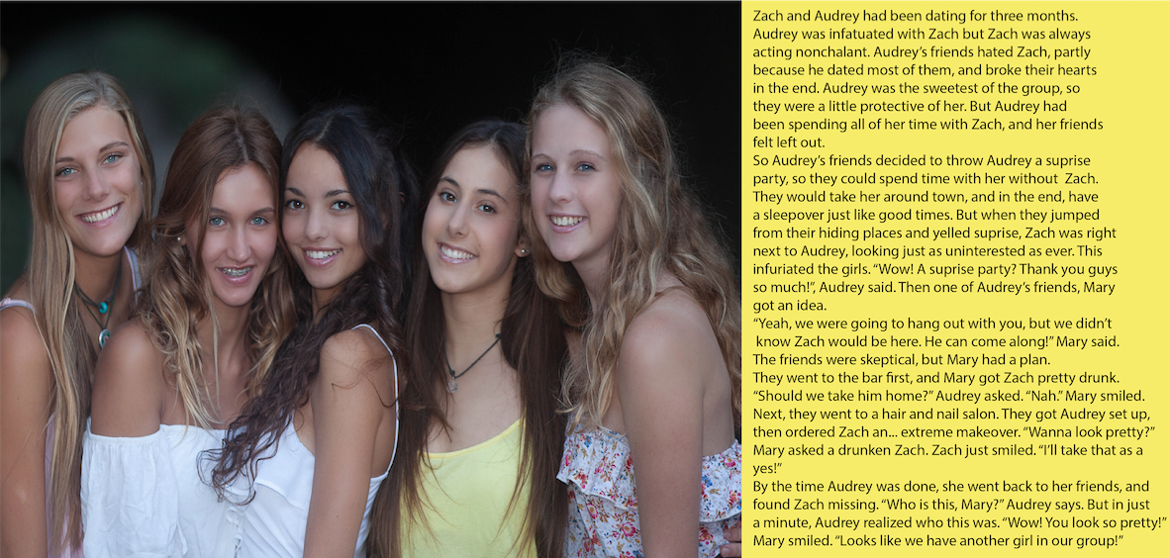
That is me on the left, Zoe. Audrey is in the middle. She is still the prettiest, but I must be running a close second. Tell me you think so.

We are a great group of girls. We have so much fun. I guess that was never really part of a group until I became a part of this group. Some boys are loners, especially ones who seek out girls as conquests. Such guys have no time for friends. All they want is one on one with some poor girl, then they dump her and move on. That was what I was like.

It now seems to me that everything I did was trying to make up for something missing in my life. I misunderstood my attraction to women. It was not sexual desire - it was envy.

Maybe being intimate with girls was somehow allowing me to enter their space, and become one of them. I always preferred sex with them on top. I would cry out and imagine that the spurt was coming into me instead of out of me.

I had slept with all of them except one. I had dumped them all, and I would have dumped Audrey too, despite her being the best of them. It was not that I was a bad guy, it was just that I was not a guy at all. I just never understood that until I became one of them.

They now trust me on the choice of boy. You know them better if you used to be one. There are boys like the one I used to be, and then there are true gentlemen, who love you for who you are and will wait for the girl to signal when it is time for sex.

The group needs to approve if it looks like it is getting serious. Five heads are better than one when it comes to making lifetime decisions.

It was only three heads that made the call that Zach was wrong for Audrey, and they were right. Audrey needs a man, and I was not that. Instead they made me into Zoe, and made me one of the Group , and I am ever grateful for that.

Now Audrey has a man we all approve of. In fact we all have a man approved by the Group – even me. He is somebody who is prepared to wait until I am ready.

But I am. I have always been ready. That is w=one thing I have carried over from living as Zach. I want sex. I want that spurt coming into me.

The End

© Maryanne Peters 2022

