-mini story-
You: *yawn*...
Our vacation ended and we returned to student life x(. The wonderful sea breeze and pleasant sunshine were exchanged for the cold Monday morning in the city..
You: Brr... today it is very cold! >_< … … … Hmm…
Although just thinking about how Rarity looked that night ...
You: Amazing and stunning… heh, thinking about that would help me fight the cold … huehuehuehue!!.. … Ah! NO! Get out impure thoughts! I'm a gentleman, and I must behave like that!... Huh?
I notice Sunset is talking with a girl ... maybe she is new around here, since I don't remember seeing her before. They are in front of that strange mirror at the school, I've never had a particular interest in that mirror, however I thought I'd use it to get away from that costume event at the school a few weeks ago xD.
Anyway, As I get closer, I can get a closer look at that girl ... Oh wait!
You: I know that girl... her name is Starlight.
Yes, I remember her now… at the Mall. She had a confrontation with Juniper on that occasion. Well, the truth is, I didn't stick around to find out. Hey, I'm a simple ordinary human, really can't you give me a power?!...
Sci-Twi: hi! ^^
You: huh?.. oh, hey Twi.
Sci-Twi: Are you okay? You've been standing there for 5 minutes O.O'
You: yes hehe, sorry.
Sci-Twi: Come on, classes are about to start!
Twi takes my arm and leads me to class.
Once classes are over, I go with my friends to play soccer in the courtyard. But right then, Sunset stops me.
Sunset: hey, can I talk to you?
You: yes, sure.
Sunset: great, come with me.
This caught me off guard, Sunset don't have the best relationship with me, and although I consider her a good friend, I'm sure she would have preferred to tell about her problems to a stone rather than me. Still, I'll be happy to help her if she needs anything… unless this is about Rarity? O_O
She leads me right to the front of the school, I can see someone else there waiting for us. It's Starlight.. she is in front of the mirror.
Sunset: hey Star, sorry to make you wait.
Starlight: no problem. *She looks at you*. Hi ^_^.
You: h-hi..
Starlight: I never thought to see you again, the legendary "gray t-shirt coward" x'D.
You: ...
WHAAAAAAAAAAAT??!!! Her first impression of me is that I'm a coward??!! I also can see Sunset is about to explode with laughter... ¬_¬''

You: Hey I don't know what you saw! But if you mean the incident at the Mall, what did you want me to do?! I don't have magic rays or lasers in my hands! I also can't make pony ears stick out of my head or a long tail stick out of my... you know! Dx
Starlight: hahahahha!!.. i know hehe, just kidding… but it was very funny to see you run there x'D.
You: Alright! Did you only bring me here to make fun of me? I have enough with Pinkie!
Sunset: ahem… Starlight is not from here, and she still needs to get used to the city. I would like you to take her for a walk to see new places and familiarize herself with the surroundings.
You: ahm, no problem... but what about you, or the rest of the girls?
I don't want to sound rude, but like I said earlier, I find it hard to believe that Sunset needs anything from me.
Sunset: We would do it ourselves, but you know that the girls and I have an important matter to finish... I need your help :/.. please.
Do they have something important to do?
You: You can count on me, Sunset.
Sunset: What a relief! thank you! ^_^!
Just then I hear Applejack's voice calling Sunset.
Applejack: Sunset, hurry up!
Sunset: oh right! Okay guys I leave you alone. Ahm, Starlight... if HE has any pervy behavior, let me know <.<.
Starlight: hehe dont worry ^^
You: *gulp*
Well, trust was short-lived x'D. I won't lie to you, I'm very curious, but I guess it's a girl things so that's none of my business.
You: I guess I'll have to cancel the soccer game ..
Starlight: That will not be necessary, I have free time so I can go with you, I will cheer you on :)
A personal cheerleader? OMG, that would be great!! *0*!!
The soccer game was fast, my team won very easily muahaha!. I don't want to show off but my defense is impenetrable, my friends call me: "Iron wall" B)...
Random guy #1: excellent defense "gray t-shirt coward" HAHASHJSASAGJHSAGHSAJDSAGJDA!!!!!
Random guy #2: HAHAHAHAHAHAHAHSAHSAGDSAAGJHS!!!
Although I think from today I will be known as the cowardly boy in the gray t-shirt >_>''
You: Starlight!!! You had to cheer me up by calling me like that?!! D<
Starlight: oops! sorry hehe :P, but hey! You did it pretty good! From today I will tell you “Iron Wall” if you want.
Random guy #1: You can be as coward as you want, but ... do you really have a cheerleader all to yourself?!!
Random guy #2: You!! She is your girlfriend, right?!
Random guy #1: oh, that makes sense! why didn't you tell us!!
You: WOOOAHH! Stop right there!! she is not my girlfriend!!
Little by little those guys start questioning me about Starlight. Sure, it may seem lucky that a cute girl cheers you on at the soccer match, although she definitely have to work on her lines!
You: excuse me!! i need to go home! Starlight, with me!!
Starlight: okay!
The boys start to crowd... argh!! At this rate we will be squashed with Starlight!
Starlight: Eek! HEY…!!
Starlight yells and clings to my side…
You: huh? are you okay?!
Starlight: Someone touched my butt! Dx
And it wasn't me!! GRR!!
You: Get your filthy hands off her!! HAAA!!
I try to use the maximum force of my arm, and I throw a punch... *POW!*
Random guy #1: Oooff!! Dx
Excellent! I hit one of them! Fortunately, they are just like me... if they had magic, it would be over for me!
Random guy #2: woah! How dare you!
Random guy #3: prepare yourself! Now this is personal!
You: bring it on, you punk!
I don't try to clean my image, if I’m a coward I don't care, but I will not allow them to touch Starlight! However, I feel like something is pulling me…
You: …?!
Starlight: Don't do it… le-let's get out of here… please.

Starlight starts to emit a faint turquoise light ... the situation made me completely forget that she can use magic! I can't let her do that!! I quickly grab Starlight by the arm and start running. It doesn't take long until I lose sight of the boys.
You: *pant* I think we are safe now. Wow, I didn't expect that!.
Starlight: Sorry
You: hahaha, It's not your fault, don’t worry ^_^… *sigh* Very well, im gonna home.
I start to walk back to my house, however, I notice Starlight following me.
You: Hey, I need to go to take a shower. Can you wait for me at your home? Give me your address and I'll pick you up in two hours.
Starlight: I'm not from here, remember?
You: Oh! right... *sigh*... *You look at her*, okay, come with me.
I have no choice but to take her to my home. I can't leave her here alone, especially with those vultures circling!
It took us only 15 minutes and we got home.
You: finally! Make yourself comfortable, there's orange juice in the kitchen if you are thirsty.
Starlight: thank you ^_^!
With that I say "see ya" and go to the bathroom to take that long-awaited shower.
My mind still thinks about that important matter of the girls ... I feel like I'm forgetting something, but I don't know what it is.
You: uff.. I feel like new!! … … .. woooooooooooOOOOOOOOOOOOOOOOOO!!
I almost had a heart attack!!! O///O.. Starlight is on my couch wearing a VERY different outfit!
You: the-HECK!!
Starlight: hmm? what happens? :O
You: No "what happens", what are you doing wearing that!!!
OMG, Starlight looks extremely sexy! She is wearing a gray t-shirt with a little short pant... also, in detail I can see that she is not wearing bras ._.
You: ...How the hell did you change your clothes so fast!!
Starlight: you told me to make myself comfortable, and these clothes are very comfortable. I borrowed them from Sunset's house. You like it? Look, it’s gray like yours
You: from Sunset-WHAT?!!
Starlight: Hey, you don't have magic, but I do :)
You: ...
I guess she has a point..
Damn! I can't stop looking at her breasts!! I need to think of something, otherwise the girls will destroy me!
Starlight: hey "Iron Wall"...
You: huh?!
Starlight: Would you let me stay with you for a couple of days?
You: ... ahh... QUEEEEEEEEEEEEEEEE???!! ah sorry, i mean, WHAAAAAAAAAAAAAAAAAAT????!! ABSOLUTELY NOT!! NEVER!! NEGATIVE! that's not gonna happen!!
Starlight: why! Dx
You: It's not correct, that's why! Go and stay with Sunset, Fluttershy, Pinkie or Sci-Twi!
Starlight: I can’t stay with them.. They will be very busy these days, you know it!!
Nope, i dont know what she talking about :S
Starlight: Come on, it's not so bad. I can help you with the chores here!... hmm, Oh I know! Would this change your mind?
You: Huh? no, you cant... stay here. Im sorry...
Then, out of nowhere, Starlight lies down on the couch, exposing the top of her two... you know! O///O... She gazes up into my eyes as her cheeks glow bashfully.
Starlight: If you let me stay here, we can do something even more fun than this!
Oooo?! I love fun!! Those magical words of her fill my mind. Wait! This is impossible!! Yeah, this is a honey trap, you dolt!
You: wh-what's gotten into you?! And who taught you how to do this!!
Starlight: who taught me? Rude!! I learned how to do this myself! Well, i read about it in a digital manual first, but you know.
You: digital manual...?
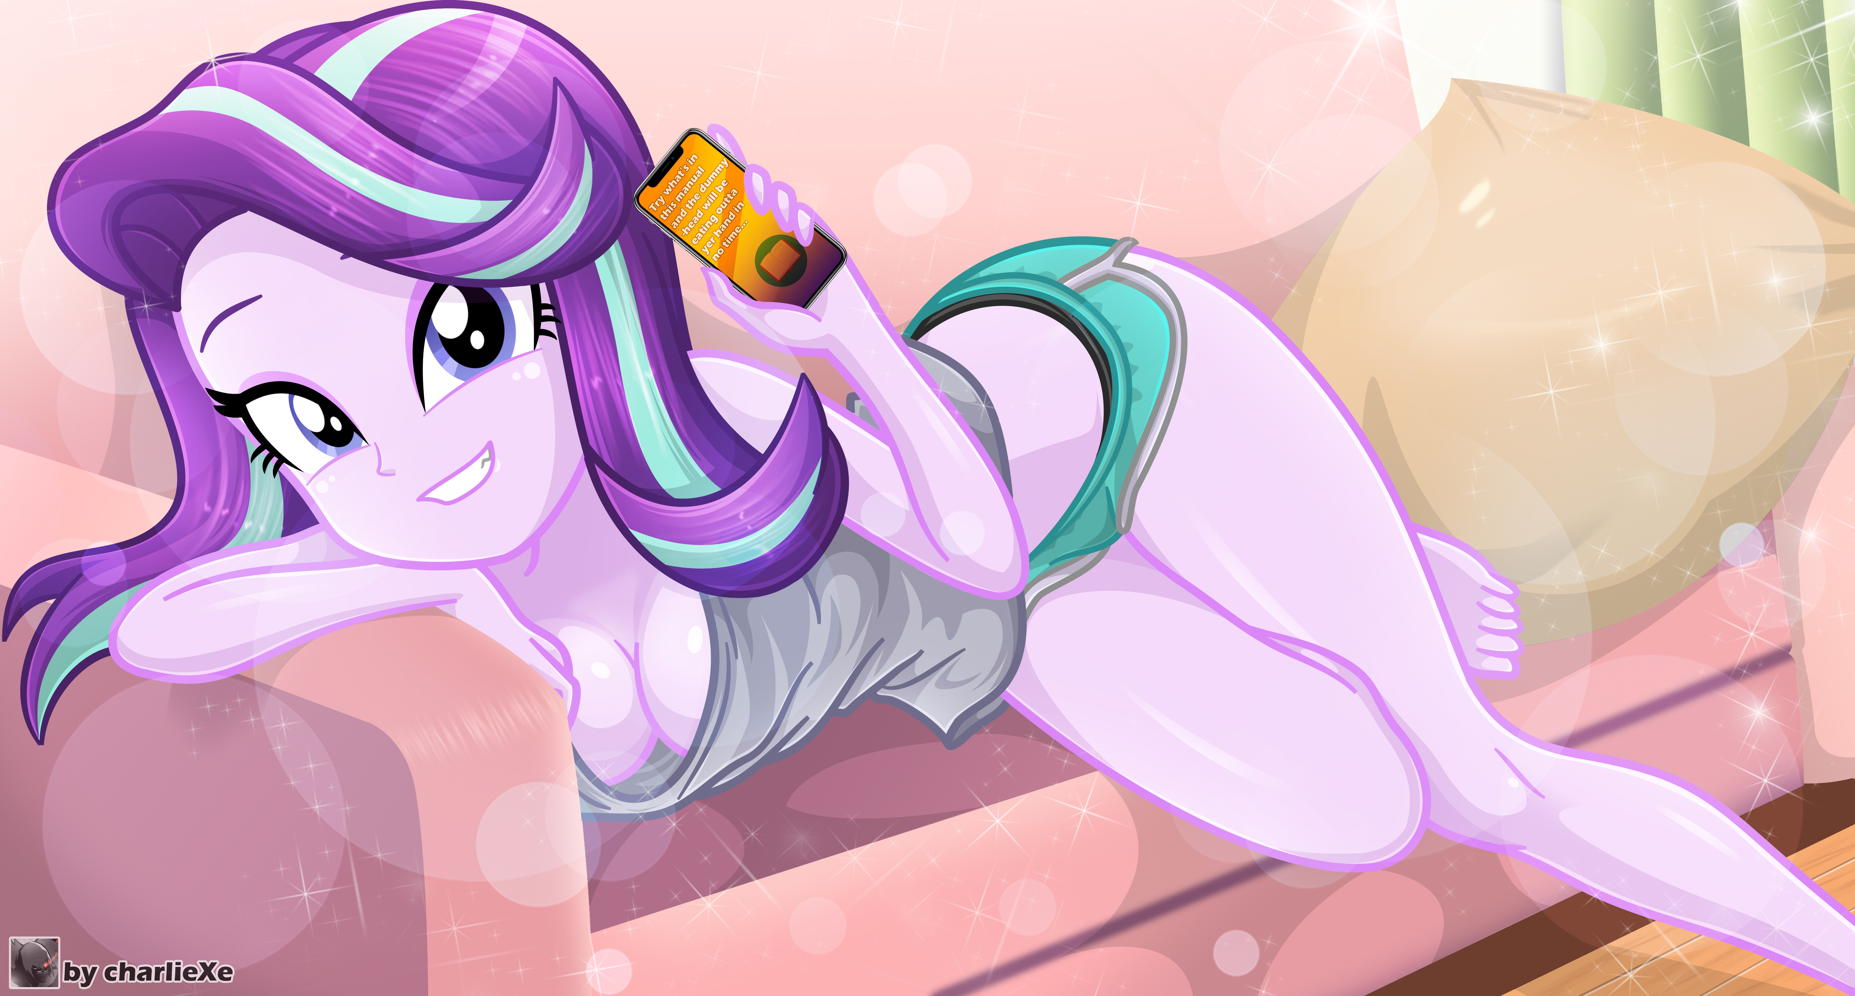
Starlight: yeah, Pinkie sent it to me. She was like, "Try what's in this manual and the dummy-head will be eating outta your hand in no time".
You: that little....!!!
The heck is she making manuals like that for?!
Starlight: so, please? pretty please?
Is this still part of the honey trap??!
You: F-FINE!! okay!!
Starlight: really? thank you soooo much!! This will make things easier for the party.
You: Party? what party...
Starlight: Pinkie's birthday party.
You: ...
Starlight: You didn't forget it, did you? That's why I'm here, and that's why Sunset and the other girls are busy, they have to plan everything to surprise her, and that take time.
You: ...
Starlight: ahmm, hello? o.o
You: ... Pinkie... birthday... PARTYY??!!!
Suddenly I start to see everything blurry and to sweat cold :S .. I knew I had forgotten something!
Starlight: woah, dont worry! I'll help you buy her a gift, since now we are housemates, it’s the least I can do hehe *giggles* ^^
Then, Starlight walks up to me and takes my arm. I feel something soft and warm that is touching me... HOLY !! Can it be…?!
You: ..?!
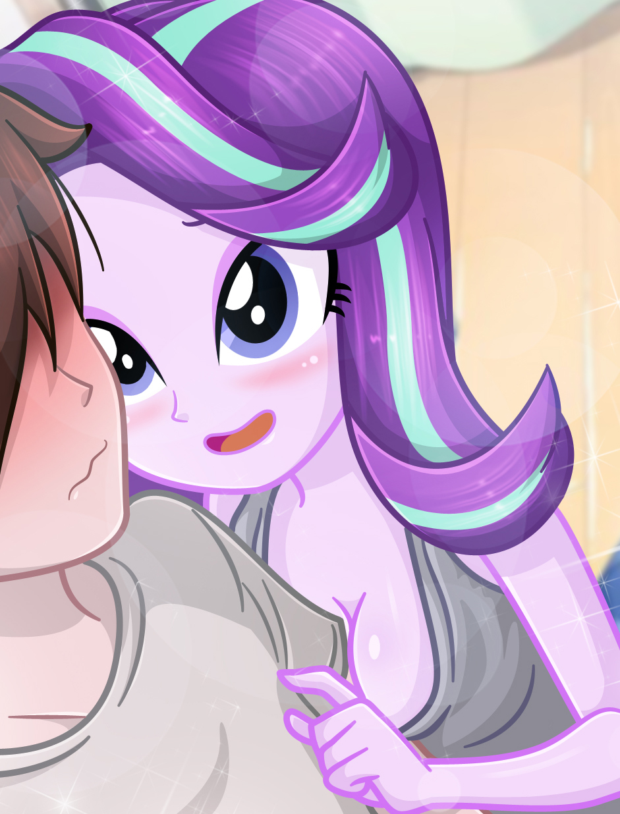
Starlight: thank you very much for letting me stay here, I promise I will not be a hindrance for you ^^
Woah! I can feel her breasts touching my arm ... and dude, again: SHE IS NOT WEARING BRAS!!
You: yeah, sure, no problem… o///o
My arm jerking hurts, but her breasts feel so good!! A painful pleasure!! Ouch... yeaaaah! Ouch!! yeaaaaahhh... Ah!! no!! Im not a pervert!!!
Starlight: Hey, I need to go to the Mall to buy some clothes, my own clothes hehe. Would you mind joining me?
You: okay… yes. Ahm, ca-can you give me some personal space? :S
Starlight: hehe sure! my bad!.. Well, I think is my turn to take a shower!
You: take your time… :S
Now I have two problems: What am I going to give Pinkie on her birthday ... and, how am I going to explain to the girls that Starlight is going to live with me!!
Starlight: oh and before I forget, I'm sorry again for the trouble I caused you with those guys.
You: I already told you, wasn't it your fault okay?
Starlight: *sigh* but we both almost made a mistake, you know?
You: what do you mean?
Starlight: You don't have to hide it from me, I've seen you from the other side. I know you are a reformed like me.
You: …!
Starlight: I did horrible things in the past, and I have no right to judge you for what you did, but… I like the boy who prefers to flee more than the ruffian who solves everything with blows ^-^
You: …
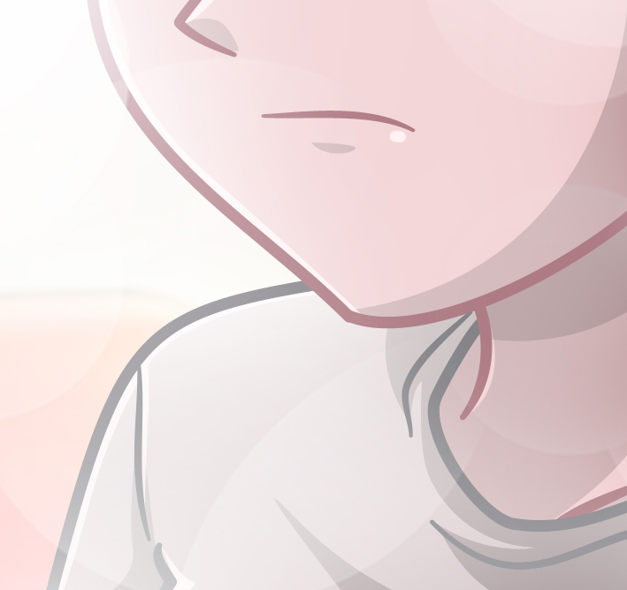
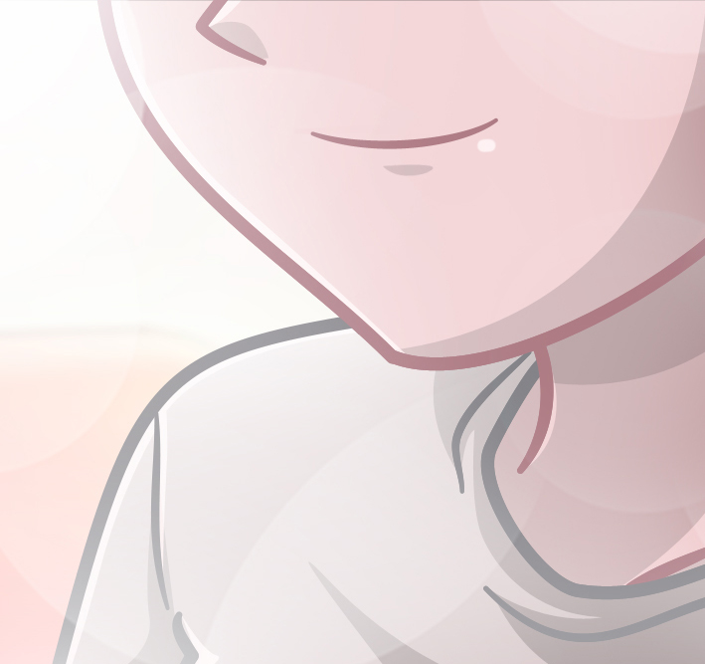

Starlight: and dont worry, your secret is safe with me, you can trust me . Anyway, I will be back soon! ^^
Starlight goes to the bathroom to take her shower… I look at the ceiling while I think about it…
You: …
Nah, this is the present, my present ... and now I must take care of Pinkie's gift and explain the situation with Starlight living here.
You: … ha-hahahaha! What a week awaits me! xD …

-END- ^-^

