The Wedding Guest  Inspired by a cap by Always Fem  By Maryanne Peters  It was a “trans-wedding”, I suppose you could say. Two gay drag queens tying the knot. They were friends of my wife. She had occasionally helped them with their costumes and accessories through her styling consulting company, so we were invited to the wedding.  “Dress code is dresses only,” she said. “But I know nothing about drag. I only know about style, and I am not about to have my husband turning up looking awful. I have a reputation to protect.”  Naturally, I was not keen on crossdressing in any form, but I was not about to ruin their wedding, or my wife’s precious reputation. So I could only shrug my shoulders and go along with it.  She said that I had the advantage of having “a slim build”. She used to say that I was “weedy” but now all of a sudden she was complimenting me on how good my legs looked. Just as well given that I had to submit to shaving them and wearing stockings. | 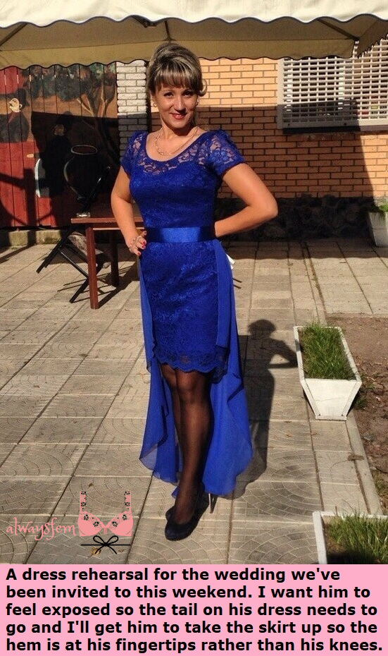

She said that I could conceal my shoulders with a wide neckline and short sleeves, and make a bust and a good waist with a forming bustier and gel inserts. “Cobalt blue is your color,” she said. She was the expert.

But the big surprise was that she decided to use my hair. I had a good amount and wore it slicked back, but she brought to forward to cut bangs, with the sides pulled back and she added a fall clipped on top and flowing down the back. It was then washed and colored to the shade of the fall and the makeup went on for the rehearsal.

“The tail on the dress really has to go,” she said. “And to be honest we should probably hike up the hem. Most of the guests will be drag artistes after all. The way you look now you don’t look like a guy in drag – you look like a woman.”

“Sure we can lose the tail,” I said. “But do you really want me to explain to other guests that my wife the celebrity stylist, chose a hem as high as Slut Mountain?”

I had come to the conclusion that I would prefer to go to this wedding looking like a woman rather than a transvestite. Is that unreasonable? After all, I was not competing with them. My wife had styled me to appear female, not shemale.

“Well, you will have to get the voice right”, she said. “And follow my lead on movement and gestures. All the guys in drag will either be striding or mincing, and you will have to learn to glide”.

I could have looked out of place. Every other guy looked either overly glamorous or just plain hilarious, but I just stood with the ladies tittering quietly, as we do.

I guess all of those guys took off their crazy outfits, their wigs and their body shapers at the end of that wedding day, and laughed at the fun they had. But for me, it was not like that. As the bride and groom left the reception in matching frocks, I shed a tear of joy with all the other women, and when I got home I just sat at the mirror wondering what had happened.

I didn’t want to take off my dress. I didn’t want to take off the fall. As for the body stocking, I just found myself wishing that it was real flesh and not just padding.

My wife called out for me to come to bed. She had been on the karaoke machine and her voice was croaky. Just for a moment I imagined it was my man calling for his woman to come and lay out for him, and that he would fondle my breasts, and kiss my mouth and plunge his cock deep inside me.

It was a day that was special to the couple who were married that day, but I also came to realize how special it was for me. I discovered who I really was that day.

The End

Shaking it Off  Inspired by a cap by Always Fem  By Maryanne Peters  But the hint of a 5 o’clock shadow was the only problem. You can see it in the photo. My own hair washed and cut in a feminine bob, legs shaved and fake tits showing off my womanly shape, make up perfect except for one thing… it is after dark and the beard is poking through.  I look at it now and laugh. It was the getaway that I had always dreamed of, that holiday. A chance to live completely as a woman, and see whether I could do it. It was to be the last time with Megan. I told her that I would either succeed or fail. We might still stay together if I had no future as a woman, but I think we both knew that it would end either way.  Megan was wonderful. She still is. She helped me to become who I really wanted to be, even if it was only for those 14 days. She coached me too, so that I could present so completely as a woman that nobody could tell I was not one.  Until that 5 o’clock shadow appeared. | 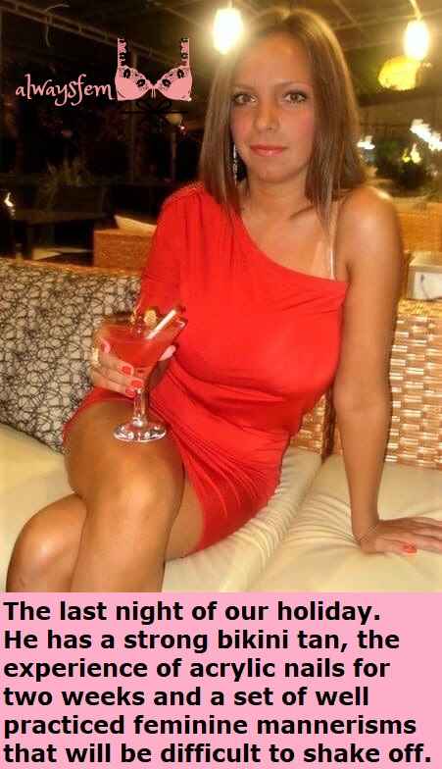

She said that I was so perfect by the end that I would not be able to shake off the real me. Even if I cut back my hair to a masculine style and somehow masked the plucked eyebrows, I would mince around and flap my hands like a fag. Maybe she was right. We will never know.

I had a decision to make. What was I going to shake off? The woman in me, or the man. I had only a day to decide before I went back to work. This is the photo that made me decide. There I am, a beautiful confident and even sexy woman, completely at home in that red dress and matching nail polish – bright eyed and happy, with whiskers.

There was really only one option. One option and to appointments. The endocrinologist and the electrolysist.

The End

Rebecca Always
Inspired by a cap by Always Fem
By Maryanne Peters

We both worked for Mega Mass Inc and wanted to climb up the ladder. Sally worked in Projects and was keen to leapfrog over her boss Joe to work directly for his Boss Tom. Her present boss was giving her stress that was bad for her, so when she suggested a radical move to get what she wanted, I was prepared to go along with it.

I was to be part of the plan, but as Tom knew me from the company, I would need to be disguised. But Sally had a plan for that too.

Okay, so I cross-dress. I always said that it did not rule my life – it was not a craving. It was just a comfort thing – another character to slip into – Rebecca, sometimes.

“You can be with me as Rebecca,” she said. “It will be perfect. If we want to lure Joe into a trap it will be so easy to pretend that you are just my friend. Even if he finds out you are not really a guy, or even recognizes you, he does not know you are my husband. With you dressed as Rebecca he will feel free to molest me like he does, but this time we will have you as a witness and your hidden camera. He will have to promote me given the strict policy on sexual harassment.

I suppose that I could have been just her dowdy friend, but she likes to do a good job with makeup, and I don’t want my alter ego to be just plain, and I can assure Rebecca feels exactly the same way. But all three of us were amazed at the look she was able to achieve. My wife Sally is very attractive, but with her sculpted body and striking facial features, Rebecca was a knock out.

Joe fell into a trap alright, but it was not trying to molest Sally. He only had eyes (and hands) for Rebecca.

As Sally explained to me later, Tom simply said: “Yes, I have a duty to protect all employees from sexal predators, but your friend Jessica does not work for the company, so I have no responsibility. And, I should probably not say this, your friend is so sexy she might be leading him on”.

But that night I just saw them talking and then Sally grabbed her coat and they were both gone, leaving me to deal with the amorous Joe.

“You friend Sally has been eying Tom up all night”, said Joe. “And I thought she was married”.

“She is”, I said. I was going to add “And I am too”, but for some reason I didn’t.

I told Sally later that I was sticking around to gather the evidence, just as we had planned. I wanted to prove that Joe was the type of monster who treated women like objects, who ignored their protests and manhandled them into the first dark spot he could find, who disregarded their protestations that it was the wrong time of the month and would simply plunge into any other orifice and have his way. That is the kind of person that my wife had to deal with. And now I know all about him.

But she ended up getting her promotion and now she is with Tom. And I am with Joe. Not that I am complaining. I think that sexually aggressive men are easily misunderstood – but not by me. How could I complain when it is Joe who allows me to be Rebecca always.

The End

© Maryanne Peters 2021

Girls Night Out
Inspired by a cap by Always Fem
By Maryanne Peters

In a word he was needy. It seemed like he always needed to be around me. He even started working entirely from home so that he could spend more time with me. It was not that I did not care about him – I did. It is just that a girl has to spend time with her friends – girl time.

“But why? Why can’t I be with you? Why can’t I come too?” Like I said – needy.

“It’s a girl’s night out. Like, it’s for girls. If you were a girl, then you could come too. Do you want to be one of the girls for a night?”

“I want to be with you.” It is a wonderful thing to hear, but sometimes it is all too much. I thought that if I set the rules for him to come out with us, he would scream “No way!” I guess I just underestimated how needy he was.

I told him that I could find him a dress to wear that would fit, and pantihose, but he would have to buy the wig and the shoes. I assumed that he would just pick up some junk, but the wig was good quality and a great color, and the shoes seemed totally impractical – heels that he would need to learn how to walk in.

He shaved his own legs and painted his own nails, but I did the rest using my cosmetics. He even let me shape his brows. He looked pretty good. “Perfect”, I told him. What do you think?

The girls were impressed. They all knew him and everyone of them told me that he was worth keeping.

“The best man is one who adores you,” one of them said. He did adore me. It is just that a man who will dress like a girl just to be near me for one night every fortnight … it just seems weird to me.

He was still a guy in a dress. At least, that was what I thought. I did warn him that he should watch the way he walked, and used his hands, and how he drank his wine – only wine as women drink. He worked hard at it. He watched us closely, and he did as we did. He worked on his voice, and some of my girlfriends helped him with that and other things. It made for a fun night.

It seems like no girls night out can ever pass with some dickhead guys coming over to chat us up, and that night was no different. I thought at close quarters my man would be found out. I almost hoped that he would. It would put an end to this pathetic charade and confirm that he was the man I wanted to have in my life – a manly man. Instead this one guy who focussed on him seemed to be totally smitten.

I heard this guy saying – “If you were my girl, I would never want to let you out of my sight”.

“If I was your girl, I would never want you anywhere else,” came the reply. It was almost as if it was for me, as if I was supposed to overhear and learn my lesson, but there was not so much as a nod in my direction. They were just looking at one another.

I didn’t mean to be unkind, but it seemed like this was not the way my girlfriends and I wanted to end the night. I gestured and whispered and we told the other guys that we were not interested, and we left that bar – the real girls (including me) did.

I had a tinge of concern a little later. I guess I thought that he would be uncovered and maybe even physically attacked. Any decent girlfriend would be appalled at what they had done and go back, but we were having a good time, so I just put it aside. It doesn’t sound good to say it.

When I got home and he wasn’t there, I did get worried. I even thought about calling the police. I picked up my phone and there was a missed text – “Must have missed you leaving. Don’t wait up”.

I didn’t. I went to bed and slept like a log. I never gave a thought about him.

I never saw him again. The image is the last photo I have of him – the pretty redhead.

He is fine, as I have learned since. I should probably say “she is fine”. One of my girlfriends ran into her.

“She looks great post surgeries,” I was told. “She still puts it all down to that girls night out.”

The End

The Final Course
Inspired by a cap by Always Fem
By Maryanne Peters

“Darling, your chignon is just perfect. Simply gorgeous”!

“Sweetie, you are so kind. Your is too. Hairstyling was such a great course, following from styling and dressmaking and color coordination. And that blue is just so good on you”!

“Thanks, Hun. Now we need to check the pretty course diary to see what comes next for us.”

“What is it? You seem a little put out?”

“Here it is – “Satisfying a Gentleman.”

“Oh my God! Do you think that means … getting dirty?”

“I have to say that I think that I am feeling the same way you are. I never thought I would feel this way when this all started, but now I just love being a woman – being dainty and pretty and always so clean and tidy, so soft and so sweet smelling.”

“Yes, even our smooth plucked buttocks and our buttholes smell like flowerbeds. Just like flower beds they need an occasional encounter with manure, but otherwise they are just another wonderful part of the beautiful creatures that we have become.”

“I like the idea of being so gorgeous that we are the envy of all women, But I know the same looks make us attractive to men too.”

“Not in these outfits, surely? High neck lines just as our little titties continue to grow, so that we have natural busts.”

“Quite right! Miss Weber’s is a Finishing School for Feminized Boys. Not a school for plastic trans-sluts! We have learned class and style.”

“It does say that we will learn to satisfy a gentleman. That sounds like the right kind of man for us?”

“Sweetie, they will still want us to suck their cocks and then bend over while they hump up the anus.”

“Don’t be so crude! That sounds awful.”

“Just think back to what you might have done, when that was your thing”.

“I never want to think about that awful ugly existence. Look at the world we live in now. Everything is beautiful. We are beautiful. We deserve the best of life – don’t we?”

“A gentleman perhaps? A true gentleman? Somebody who appreciates class. Somebody who might treat me as if I was a precious china doll. I think that I would be ready to satisfy such a person.”

“Even if that involved messing your hair and being manhandled, and shedding sweat and other oozy stuff?”

“Sweetie, it is the next course. Let’s face it, every course has been great. Every course has made it clear that being a woman is the best way to be.

“You’re right. How exciting! When does the course start?”

The End

