Turned On
A Special Request for John No. 61
By Maryanne Peters

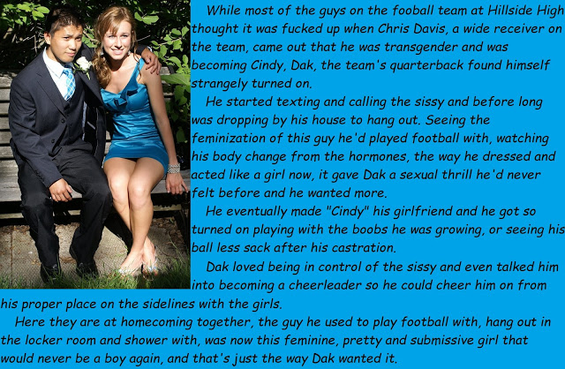

People don’t understand football. My grandfather said that a football team is like a platoon in combat, and he should know. He has been in both. He says that in football you may not be about to die, but you know it is going to hurt. If the team pulls together then you are going to win, but it will hurt. You suffer for your teammates, in order to win. It is honorable.

Just because I am a girl doesn’t mean I don’t understand. It doesn’t mean that I cannot appreciate the game and want to play it, just as my father and my grandfather did. I remember when I came out my father was like: “But Chris, you play football?”

“That’s right Dad, and I love playing football. But when I go on hormones my body will not be strong or hard enough to play the game, so I will have to give it up. I will have to find other things to do. Things more appropriate for a girl. But I will always be a fan of the game, just like you and Gramps.” And I still am. I never miss a game.

I always liked Dak, our quarterback. His family are Vietnamese and there are not many Asian guys who play American Football. But he is tough and has all the skills, so he won the position of quarterback and is the best going. Still, he was a bit of an oddity – an outsider, if you like, just like me. There are not many girls playing football either.

Some guys on the team say that – that he was turned on when he discovered I was going to transition to female, but they don’t get it. Dak was just being supportive the way I was for him. Before he won the arm punt job, I was telling him that he ought to have it and after training I was still there taking forward passes until the light faded.

His texts and calls were to let me know that there was one guy on the team who would not be calling me a sissy. When he came around to my place it was not only to back me but to assure my parents, and in particular my father and grandfather, that there was nothing wrong with me in wanting to be the person I was.

As Dak said, the sexual attraction came later. And I am glad that it did.

He said that he felt a bit guilty that he was getting these feelings for somebody who had been a guy, but I told him that that guy was gone. I told him that falling for the woman I was becoming was normal. For me it was better than that, it was an affirmation that I was becoming the girl I wanted to be. Maybe I was even a little guilty of showing off my growing breasts in a way that it not appropriate for a young lady, but I was just so excited that he be the first to see them, every time I notice growth.

My hair has grown really well too. I know he likes it and likes to watch me brush it and tie it back in a pony tail, bouncing around when I run for those passes he still likes to throw to me. He asked if he could run his fingers through it and I said yes. He looked into my eyes as he did it and then we were kissing. It was just so natural, and so good.

I don’t care what the other guys on the team say. He sees the girl in me, not a sissy boy.

But I wanted to show him my empty sack, just so that he could see that there was no going back. I wanted him to know that I was going to have all the surgery done, but for now Chris was gone forever. I don’t think he wanted to look at it, but when I showed him how it would be used to make the labia for my new pussy he started to get so excited I had to suck him off then and there.

He knows that we have a future together now. He wants me and I want him.

I never thought of being a cheerleader until he suggested it, but I guess I am a natural athlete so I won a spot without too much trouble. Now I am back on the field with all the guys I used to play with, but as cheerleader and as Dak’s girlfriend.

The End

Camp Counsellors
Inspired by a Capitioned image by Becky
For John No. 62
By Maryanne Peters

If you want to call me gay for feeling about her the way I do, then call me gay. Call me gay and proud. I don’t care. But then meet her and tell me that. See her and tell me I am gay for wanting her.

They told me that there would be a transgirl at camp – somebody to reflect the need for diversity. I did not know what to expect. In fact I did not care. I figured that if some guy wants dress up as a girl, what did that have to do with me. I am a liberal-minded guy. I could wish that person well and get on with what I did.

I met Stephanie and I fell for her almost immediately. She was just so beautiful, with that blond hair, big blue eyes and just the perfect figure. I flirted with her without ever knowing that she was the transgirl they had talked about. We ended up kissing at the campfire.

These things happen at camp. Hot summer nights and skimpy summer clothes. People close together and having funs. Smiles exchanged over laughing kids. You just warm to somebody like her. She never said anything.

I was shocked when she told me. I just could not believe that she was the transgirl that they were talking about.

It seemed to me that she was not even trying to be a girl – she was a girl. She wore jeans and a sweat top most of the time, or sometimes skimpy shorts and a tank top.

I would have loved to see her in a bikini but she told me that she did not own one.

“Next summer for certain,” she said. “But for now it would just not look right.”

I could not believe it. She still had her … I can’t even say it. It is just so wrong. My heart went out to her, in more ways than one. It seemed wrong that she had been born that way when she was so clearly female. She said that she had surgery booked. I had visions of her naked, with a cute little pussy between her legs. It seemed impossible to think of her any other way

So how can that be gay?

She is a woman. She deserves to live a complete life as a woman, and it occurs to me that I might be able to give her that life, if she will have me.

The End

Flip Up
Inspired by a cap by Becky for John Number 63
By Maryanne Peters

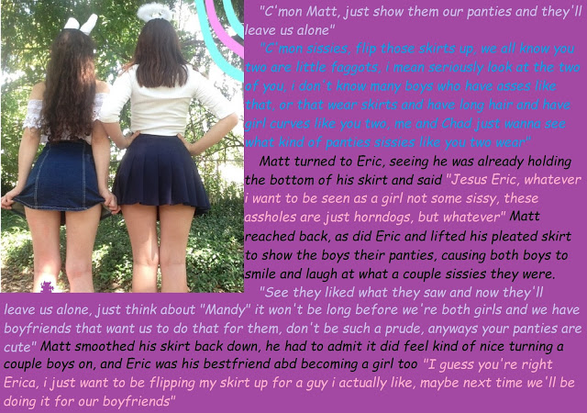

Isn’t life weird. Erica and I remember it so well, and not just because Chad took those images and posted them online. It was Halloween and we were both dressed as girls – me with the halo and Erica with the bunny ears. It was how we wanted to be all the time, and we had been working on it. We had both grown our hair out, and Erica had extensions put in for occasion, but those rear ends show the clear signs of the hormones we had been taking, even back then. We were on the yellow brick road to womanhood, and we were well down it.

But at school we were the two sissies. So strange that we found each other the way we did, but it made all the shit we received bearable. When there is two of you is seems so much easier. We would often say how thankful we were to have each other, and how awful it must be to be a transgender girl going it alone through high school.

They could call us fags and we would just walk away arm in arm, giggling at how silly boys can be.

But Chad and Gary were always on at us. It was like they could not leave us alone. Erica said: “Let’s do it”, so we did. Chad took the three images. That one you see is only the first. The second is our tightie whities. The third, well the third did the trick.

“Look at the fags,” they captioned the images. But they didn’t post the third. They kept that for themselves. I guess Erica and I knew from that day on. She said that we had turned them on, and I guess we did.

It was not long before they were back, wanting to touch the merchandise they had only viewed from a distance.

When Erica and I talked about having boyfriends I don’t suppose that we were talking about those guys, but life is weird.

I am no shrink, but maybe Chad and Gary were just fighting off their feelings. The fact is that they were more than curious. At first what they wanted we were not interested in giving them. Girls need to be selective. But after a while a boy’s persistence can wear any girl down.

Again Erica said: “Let’s do it”, so we did.

Now both those boys have put a ring on it. Life is weird.

The End

Surprise Coming Out
Inspired by a cap by Becky for John Number 64
By Maryanne Peters

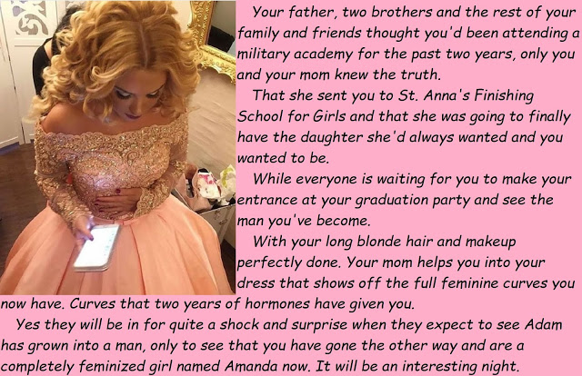

Dad had a posting in Africa and Nick and I were both on deployment, so we missed a family Christmas in 2018. It was not the first time. We were a military family. It made sense that Adam should do the summer program at the academy, jut like I had done years before. That means the best part of two years with no physical contact with the family. That can be tough, but we were expected to be tough. Just so long as the family was there for the passing out parade for 2019. It was a big occasion. The colonel (Dad) was looking forward to it even though with his late flight in he would only be there for the dinner.

So we met Amanda before he did.

But Mom told him that the dinner would not be at the Military Academy as usual, but at another venue. She had a cab pick him up. We would be waiting for him. The hall at St. Anna’s had been fitted out for a fine dinner and everybody was dressed to the nines. Mom insisted that all three of us wear US army mess uniform, so she sent the cab with Dad’s on a hanger, pressed and ready.

Who knows what he thought when he rolled up the drive at St. Anna’s? It must have seemed strange that he was the only father in an army uniform, given that there were plenty on display when Nick and I passed out at the Academy. At least he could see us at the table standing for a superior officer, with Mom seated and smiling, and beside her the beautiful Amanda.

“At ease boys,” he joked, giving Mom a kiss on the cheek. “Now where the hell is Adam?”

Amanda stood up. My God, she was beautiful. She was wearing an apricot dress with full skirts and the top part all decorated in detail – we learned later that she had made it herself. Her long blonde hair was styled in soft waves parted in the middle to frames her perfectly made-up face. We had only met her ourselves at the graduation that afternoon. When we took our seats in that same hall before it was reset for the grand dinner, we must have had the same look of confusion on our face that we could see on the Colonel’s.

Mom said: “Darling, I want you to meet Amanda, your beautiful daughter.”

We were still standing, watching. Dad always said that you never know a man until you see him under fire, and somehow this seemed like just that moment. Would he jut his jaw and fight on, or collapse and hide under the table? We were captivated by the moment. It seemed to take an age.

We saw the moment of recognition. We waited for the bellow. A son of his now dressed as a girl, standing with a look of uncertainty in her pretty eyes, and perhaps a pleading look too – something like: ‘Daddy, please accept me for who I am’. Still silence. Still we waited.

Amanda spoke. I guess she had too. She said: “I guess that the army is not my thing, Daddy. Not as a man, anyway. Because I have always been a woman. Always.”

“I’m guessing that you haven’t spent the last two years at the Academy,” Dad said. And then, with a calmness that amazed Nick and me, he just sat down.

“No,” Amanda said. “I have just graduated here art St. Anna and I am going on to college in the fall.”

Because he had looked across accusingly at Mom she had to speak too: “Darling, you have to understand that I have always known about Adam’s feelings. I think you have too, with the dressing in my slips when she was just a little thing. I just wanted to help her to have a happy life. So I enrolled her here instead.”

“I am not a fool,” said the Colonel. “Although maybe I am guilty of fooling myself on occasions. I worried that you might be gay.”

“I am not gay, Daddy,” said Amanda. “I am a woman now and I have a boyfriend. His name is John, and he is British. I am sure you will like him, Daddy. He comes from a military family too.”

“Well, I am not surprised he fell for you … Amanda,” Dad said. “Everything else is a surprise, but seeing just what a beautiful young woman you make, that is not surprising.”

The Colonel always told us that surprise is the best weapon. With surprise even a weak force can defeat the strongest enemy. We all knew that. Even Mom and Amanda.

The End

Unfair Advantage
Inspired by a cap by Becky for John Number 65
By Maryanne Peters

I am not quite sure why I asked the question. I have compered plenty of beauty contests. I am well known for it. If you had told me that I would suggest that a boy dressed as a girl might have any kind of advantage over real girls, I would have laughed out loud, before the Sweet Valley Pageant.

Even when they told me that one of the contestants was a boy, I would never have guessed that it was Amanda. Wendy maybe, or Katie? But not Amanda. I mean she was too pretty. But then when they told me it was her, she seemed to become so much more than that. She became captivating.

Was it because she was an exotic thing – a girl with a secret under her skirts? Or was it just that she seemed so much more feminine because she had not begun her life that way? As she said in her answer, she embraced being female because she wasn’t, and now it seemed to exude out of her.

The truth is that I was besotted. Why would I pose such a questions if that were not the case?

I suppose that leads to the question as to what kind of man I must be. Amanda was not the first contestant that I wanted to bed, but she was certainly the first who was not a complete woman. But somehow that seemed to make her doubly attractive. Almost like a forbidden fruit – something that draws you to abandon your principles of heterosexuality to experience a different kind of sex. Somehow with her it seemed not to be gay to want to make love to her – to get inside any part of her on offer and erupt.

Maybe I hoped that she might be receptive because it seemed to me that T-girls want sex more that regular girls. They have the male libido – don’t they? They want it as much as we do – right?

After that question and her popular answer, she just had to win. Her perfection was made complete.

Later I found a moment to talk to her privately and express my feelings. As I said, I don’t do that often, but I just had to.

All she said was: “Thank you for your interest. I am flattered of course. But I actually have a boyfriend, and he proposed to me before the pageant. I told him that if I won the answer would be yes. So that takes me off the market, I guess. Not that I ever was. We believe in marriage you see. I will be saving myself until after the wedding, you see.”

I have to say that I have never stopped thinking about her.

The End

© Maryanne Peters 2021

