Hungover
A Short Story
By Maryanne Peters

I was hungover big time. I filled the sink with cold water and plunged my whole head in. The only comfort was that I knew that the night before had been the craziest of my life. It was a night that we would be sure to talk about for the rest of our lives. Except maybe not Greg. He might want to forget all about it.

It had started out as a joke, but maybe it had gone a little too far. It was just that the ladyboys at the bar had been going on about how beautiful Greg’s hair was. Greg had long, thick, dark brown hair, and he was proud of it. It is true that you might think he was a girl if you saw him form behind, but when he turned around you would see the black beard and dark brows. That is what he had until last night.

The four of us had been planning the trip to Thailand for over a year. Three of us had never been outside the States, so we wanted to go somewhere exotic. Soapy said: “Choose a country where the women are sexy and have no self-respect.” It helped that at the time the US dollar bought almost 35 Thai Baht, so you could fuck for ten bucks.

We had all been donkey deep in pussy for a few days before we went to the ladyboy bar. We were just interested in drinking and watching the show, although Beck did say that he would be happy to ass fuck quite a few of the “girls” on display. But the “girls” were most interested in Greg.

“Your friend could be very beautiful,” they were saying to us.

Greg was well under by the time the next shift of performers came on, so with our encouragement, he staggered off with his new friends to undergo a transformation. He was away for so long that I started to get a bit worried.

“He will be having his dick sucked by all of them in succession,” said Beck. We had another round. We were seriously hammered.

Then, at what ever hour of the night it was, the girls appeared with a white chick in tow. I say this because there is no way that any of us recognized Greg. “She” was dressed in a short figure-hugging red dress and heels that took her up to six feet tall. Her hair was piled up on top put had a long curled tendril hanging on one side. He face was smooth and her brows plucked into two striking dark arcs. Her makeup showed off those dark eyes – Greg’ eyes.

“Can I join you boys?” The voice was husky and sultry. Not Greg at all. But it was him.

I looked around and all three of us had the same expression on our face – confusion and amazement.

Then Soapy started laughing. He said: “Omigod, this is incredible. You look good enough to fuck.”

“Now boys,” she said. “I am not that kind of girl.” She seemed the most sober of all of us. Had it not been for this spectacular appearance, we were about ready to fall asleep at the table. But she was just getting started.

“These ladies have taken my cash,” explained the vision. “So you boys are going to have to buy me drinks. And I am going to be drinking those colorful cocktails. Beer and shots are so unladylike.”

Greg was having fun with this. He (or she) pulled down the hem of the red dress and we could see the legs crossed before us were shaved or waxed to a smoothness that almost begged us to touch them. He (she) carried a small clutch bag with a mirror inside for putting on a display of checking hair and makeup. The lipstick was red to match the dress, and he (she) pretended to freshen it in the sexist was possible.

We ordered the cocktail for her, and another round of beer and shots (Thai SongSam liquor).

“Tell us about yourself,” slurred Beck. “What is your name?”

“Whatever you like,” she purred. I swear that, despite having emptied a lake of beer into my belly, I started to feel an erection coming on.

“Bella,” gaped Beck. “It means beautiful.”

“Oh, you’re so sweet,” she said. “So, you think I am beautiful?”

We had almost completely forgotten about them, but behind this vision of loveliness, the three ladyboys who had worked this miracle were tittering away, clearly highly satisfied with their efforts

I have to confess that I cannot even recall the answer. The shot that I downed shortly afterwards did me in. I am not even clear how I got back to the hotel, although I am told that I stayed on my feet most of the time. I was out of it.

After the third dunking of my face into the water I felt ready to allow a little light to enter my room. I dried off and put on short pants and a T-shirt.

I took the elevator down to the breakfast restaurant. Service was almost over but Soapy and Beck were there. They were both wearing dark glasses inside to ward off bright light. There must be a God because there was coffee – strong and black. There was no sign of Greg. I fell into a chair.

“Did I dream last night?” I muttered.

“Greg is going to be fucked off when he wakes up and finds that he has lost his beard and most of his eyebrows,” said Beck.

“Now maybe he will get his hair cut,” said Soapy. “Maybe leave some bangs to cover the eyebrows until they grow back.”

“We egged him on,” I noted. “We should buy him a cap to hide those brows”.

We laughed. But after we had taken our fill of coffee I went up to his room to check on Greg. Afterall, maybe he was too embarrassed to come out. He was not in his room. I went back to report to the guys.

“He can look after himself,” said Soapy. “We’ll go down to that street market by the river. We can leave a note.”

We were just composing something with a humorous reference to the night before when a woman came walking towards us. She was wearing a sleeveless pale pink floral sundress and sandals. She had her dark brown hair in a high ponytail. She wore pink lipstick and sunglasses. She walked right up to us before we had any idea what was going on.

“Greg?” I think I asked, or did we all ask at the same time?

“Bella,” she replied. This person who had been Greg sat down in the vacant 4th seat. She took her sunglasses off. She was wearing makeup. Not like last night – just some eyeliner and mascara, and some light work around the face and highlighting the eyes.

“I have been up for a while, shopping,” she said. “I let you guys sleep in. After last night, you needed to.”

“Are you crazy?” said Soapy. “Look at yourself.”

“I did, this morning. A few times in fact.” And to emphasize the point she pulled out a compact and inspected her lips, while pouting. It occurred to me that Greg / Bella was talking in the same voice as last night – husky but feminine. “I looked at myself and I realized that I didn’t look like a guy. So, I could walk around looking like a fag, or get myself some clothes to suit the look.”

“So are you going to dress like a chick until your beard grows back?” asked Beck.

“God knows how that that is going to be,” she said, with apparent calmness, as she poured out a cup of coffee. They used some smelly cream to pull my beard out completely. I woke up completely smooth. Have a feel.”

For some reason I reached out to stroke the face of my old pal. It was as smooth as he said, and soft, and warm, and beautiful. I started to feel weird, and I pulled my hand away. Was that a stirring in my pants?

“Anyway,” It’s so hot in Thailand that I have only just realized that the best clothes to wear are what I am wearing right now. With the special underwear I was given I feel almost naked in this dress. It’s silk. The feeling of silk on shaved skin is so soothing. I feel so cool, whereas you guys look about ready to explode in the heat. And we are only half way through the morning.”

She was right. At least the other two guys looked as I felt. But not from the heat. I am not sure whether we were blushing from embarrassment, or turned being turned on by her playing with the hem of her dress over those wonderful legs, or whether we were just out of breath from the whole thing.

“So you are going to hit the town like that?” Soapy asked.

“Where are we going?” she said.

“We were going to go down to the Riverside Market,” I said.

“Great,” she said. She stood up and smoothed her dress over her bottom, casting a little glance over it as she did so. I realized that I was going to have difficulty standing. I was able to readjust my erection under the table. But I am sure that Beck noticed. I had a feeling that he might be having the same problem.

And so the four of us went down to the market. But it did not seem like it was the four of us. It was three guys, and a girl who was turning everybody’s head. I mean, she looked good, but she carried herself so well. Her sandals had a little heel and Greg was shorter than me, but she looked tall, with long legs and well-toned arms. Not a masculine shape, but athletic. The inserts in her bra must have been the perfect size, as her dressers from last night would have known well.

Soapy whispered to me: “How is he doing this? He’s a natural.”

“Then you would have to say – she’s a natural,” I replied. He could only nod.

She bought some trinkets. Some silk fabric – like a scarf or a sarong – and some drop earrings. These were things Greg had no use for. Sure, the cost was minimal, so it could be just shopping for the sake of it. Or maybe gifts for a girl back home? Somehow it did not seem so.

There was lots to see, and once we got used to the brightness of the sun on our tender eyes, and we had rehydrated to settle our heads and guts, we started to enjoy the day.

We decided to have lunch in a bar beside the market. We could get food from the hawker stalls and use the tables in the bar if we bought drinks. We secured a table and left Bella to hold it and order drinks while we set off to find some interesting local street food.

When we were walking back, we could see that Bella was not alone. There was a guy with her. He was tall and looked like a frat boy, freshly shaved and with creased pants, not like every other guy in Bangkok. Bella had her hair out and was flopping it around in front of him, playing with it before banding it back up.

Soapy was first up and took the hand proffered with the introduction: “Hello, I’m Hugo Danforth. I’ve just been talking with your friend Bella. It seems you’ve all been here for a few days.”

With few words we all introduced ourselves.

It is difficult to know how we all felt about this stranger, but it seemed as if we all felt the same way. Perhaps a little protective of our friend, who seemed suddenly weaker and in need of protection. Perhaps a little threatened by another guy walking into a tight team. Perhaps a little jealous, crazy as that may seem, maybe feeling that she might be inviting his attention, and not ours.

Bella had ordered beers for us three and a cocktail for herself. Hugo had insisted on paying. It seemed that he costume served for more than just comfort on a hot day. She sipped quietly while we gave Hugo some tips on places to do and things to see.

Bella offered to share her food with him. It seemed that Bella had less than half of the appetite of Greg. But Hugo bought some other item from a passing vendor – sticky rice in bamboo tubes. We lunched together and had a few more beers. Despite last night, they went down easily.

Hugo seemed to spend a good deal of time staring at Bella. I suppose it was seeing this that prompted Beck to say some words to break the spell. It may have been cruel, but he said: “And as for Bella, well if you are interested in ladyboys, there is this club we went to last night …”.

He tailed off. Bella was smiling at Hugo and he was smiling back.

“Only in this one,” said Hugo.

Shortly after that, Bella needed to go to the toilet. We watched her as she headed off – straight to the room marked “Ladies”. Beck went to the men’s toilets and Soapy to the bar to get one more round.

“I think that it is great what you guys are doing,” Hugo said. “Only true friends would do that for one of their pals. I think it is fantastic.”

I had no idea what he was talking about, but I felt able to say: “Yea, we are very close, the four of us.”

“I mean, I think she is fantastic,” he continued. “Obviously I have only just met her and only know her as Bella, but … well, to stand beside her through the whole transition, well, and to come with her to Thailand to scope out surgery options. You guys are great.”

What was she telling this guy? I had an idea now. Should I correct him? I just said: “Hey, what are friends for – right?”

She reappeared, sashaying towards us with the most beautiful smile on her face.

“You guys aren’t talking about me, are you?” she teased. “I sure hope so.”

I was having those feeling again. It was becoming very awkward, to put it mildly. So I found myself saying: “Tonight Soapy and Beck and I might cruise some strip clubs, so Hugo, if you want to take Bella out for dinner, maybe you could do that? Maybe be meet up later.”

I suppose that I just wanted some time away from her. I mean Greg is my best friend, but the circumstances were now … unnatural. Bella was too damned attractive, it was playing with my head, and other parts as well. Here was a chance for me to get my thoughts together. Soapy and Beck had just returned to hear the last part of the exchange, and glanced at me in agreement.

“Would you?” Hugo asked her. He was as keen as could be.

“Why, of course,” she said playfully. It was as if she had been flirting all her life, rather than well less than 24 hours.

We left the bar by the market after that round and idled away the afternoon together before Hugo went off to his hotel.

“If we are going to have another big night, I might grab a little afternoon power nap,” said Soapy. It seemed like a very good idea.

“I’m going to go to the spa,” said Bella. “Maybe have a facial and manicure, and get my hair done.”

“You’re crazy, man,” said Beck.

“It won’t last forever,” she said. “I am just going to live it while I can.”

To help her, I laughed heartily, and the others joined me, but I think somehow none of us believed what she had just said.

The following morning was not as bad as the previous one, but I still needed to dunk my face in that cold water to prepare myself for the day.

I was not the first to breakfast. Bella was there. It was still Bella. No sign of Greg.

Her hair was curly. She had worn it pinned up the previous night, but now the curls bounced about her face. There was a hint of color in her otherwise dark hair that made those curls come alive when a shaft of reflected sunlight played on them. She was fingering out a text message on her phone, with long pink fingernails – clearly another residue from last night.

“Hey, Gorgeous,” I greeted her half-jokingly. The other half was pure desire. “Did our new friend Hugo look after you last night?”

She looked up. There was a look in her eyes that caught me completely off guard. I think it was fear.

“I am in trouble,” she said. “Well, sort of in trouble.”

“But he knows that you are not a real girl,” I said. “He knows that this is just pretending.”

“Not for him, it’s not,” she said. “He wants to pay for everything.”

“What are you talking about? What is he going to pay for?”

“Sex change surgery,” she said. “For me. To change me into a woman.”

I have to confess, I just burst out laughing. But I found myself stopping suddenly as my old friend Greg was not laughing with me. The face kept the same look of concern. The face of Bella, with the painted eyes and lips, and that beautiful hair.

“Well just tell him – thanks for the offer, but I am a guy, just having some fun,” I suggested. “How could he think that you would want to have surgery.”

“I guess I might have led him on a bit,” she said.

“Why? How?”

Bella looked at me straight in the face. Nobody could look at another more directly. She replied: “Because we talked about it. Because it could be an option for me.”

I was struck dumb. I guess I just sat there looking at that face. Her painted full lower lip quivering with emotion. She was upset, and I felt an urge to hold her, as a man would a woman. Not something a man would ever do for another man.

Soapy rolled in a took a seat beside me. To add to the confusion, he blurted out: “We still have Bella with us I see. I have to say I am going to miss her when you switch back, Greg. Bella’s pretty face is a welcome sight for a man in my condition. What a night!”

A tear rolled down her cheek. We could both see it. Soapy was struggling to understand what was going on.

“It’s a big step,” I said. “No it’s a massive step. Something that there is no going back from. Not something that you should decide without plenty of time to consider.”

“What? What?” Soapy protested. “What is going on?”

“It’s not like that,” she said, ignoring him. “I now realize that I am different. I think that I always have been. I just never thought it could work this way.”  “Will it work?” I asked. “You would be taking a big step into the unknown.”  “What is happening?” Soapy interjected.  “Hugo would be there,” she said, but with uncertainty.  “You are not sure about that,” I observed.  “I could make it anyway,” she said. It seemed like she meant. “I definitely could if I knew you were backing me. Will you? What should I do?”  Now there is a question no friend wants to hear, especially when he is a little hungover.  The End | 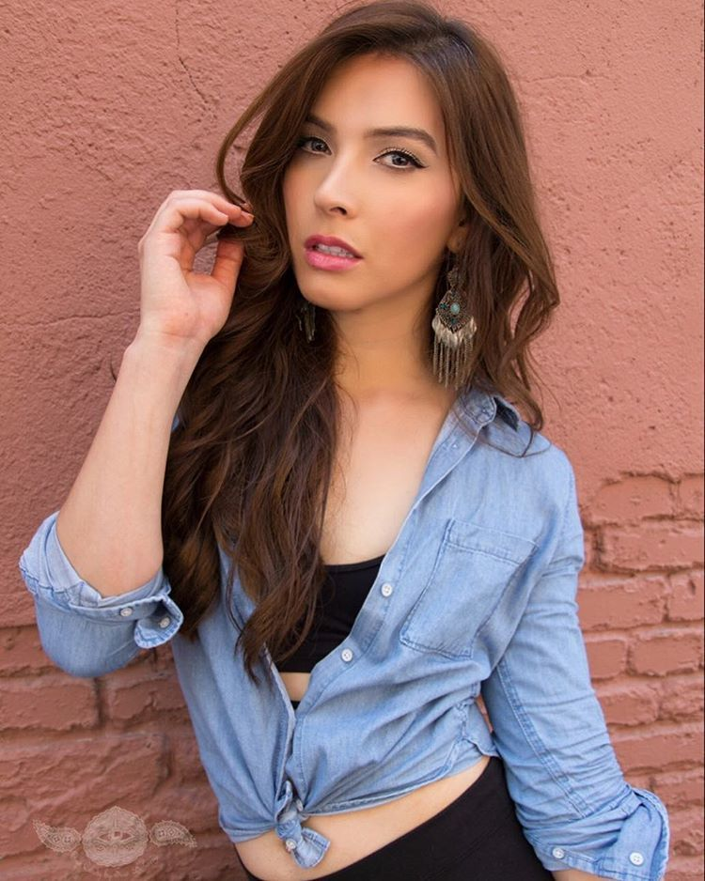  Bella
© Maryanne Peters 2019

