CICADA SPRINGS BUG TESTING SHEET

Hello everyone - first thing’s first, I appreciate you all being here! Having you guys as a ready team of players so that I can squash as many bugs as possible was such an integral part of Coven of Calahree, and I’m so happy that I won’t be going into Cicada Springs blind like I did with the last game.

With that being said, I’m still pretty new at Game Dev! I’m sure that I’ve made lots of mistakes - and that’s where you guys come in!

Below, each map is listed individually. To begin, there’s just “general” bugs (that either don’t fit into map-specific issues), The Overworld, Apartment, Cutie Pie’s, the Broken Stool, Fiction Addiction, and Bean Machine. In order to keep chatter to a minimum, if discussion of a bug is necessary, please do so in the discord server (channel #cicada-springs-🦗)

Please report things like collision errors, typos, scripting issues, or anything else that fits the criteria of a “bug” in this format, accompanied with a screenshot (where applicable/available):

[YOURHANDLE]: “Example” - v.0.x.y

My responses will be bulleted underneath the reported bugs and italicized. If a bug remains unfixed after I have made an attempt at patching it, make another bullet point under mine with your handle in brackets.

- [Bobo] Response
  - [YourHandle] Rebuttal

Please put gamebreaking bugs in red font and report them on the dedicated Discord subchannel!

I thank you all again for your help, and hope that we can all come together to make this game the best that it can possibly be.
–Bobo

GENERAL BUGS

Shihi234: “When going into a building in windowed mode, if you click off the screen, your character will move towards the entrance but not enter. Only entering when you return to the game. Music is still playing tho.[v0.4.0]
- Bobo: This may just be a processing error–something wrong with the actual engine of the game. Will look into this further.

Shihi234: Not sure if this counts as a bug, but when first introducing yourself to a girl, when asking to give a gift, the game will say ‘you’ve already given her a gift today’. Tried it with Clover on the second day and it still said the same thing.[v0.4.0]
- Bobo: Simple switch mistake. Will correct. It is on all giftable characters atm.

MightyHalberd: Seems to be a recurring thing where I choose one option and it immediately plays the Talk dialogue.[v0.4.0]
- Bobo: Hopefully this can be explained by what I used to hide the SPECIAL options.

Tones: Activating Margot’s Clover dialogue anywhere has some overlapping sprites. [v0.4.1]
- Bobo: Attempted patch on Margot’s Clover dialogue. Will watch.
- T.Maxi: Margot’s sprites have doubled after I gave her a gift.

Guy Ferrari: Two double images from Bobo Blue Burger. [v0.4.1]
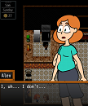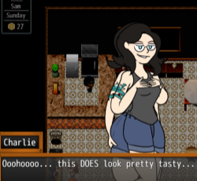tree
- Bobo: Fixed this!

Tones: This ones a bit weird, I talked to Kendra on the first day and out of curiosity tried the SPECIAL option. It gave me a box for an empty option and then she acted like I gave her a gift and then gave me 20 bucks. You can repeat the bug, but you only get 20 bucks the once.[v0.6.1]
- Bobo: I’m a dummy and assigned the Dev Version switch to be left on - which is where the SPECIAL stuff is into play. This should be fixed now. [v0.7.0.0]

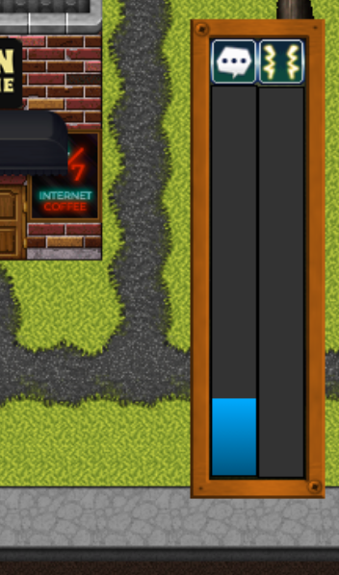
Tones:If you try using the SPECIAL option and then exit for any character, their stat bars stay up. Can be removed by talking to any character with a stat bar again after.[v0.6.1]
- Bobo: Same as the above [v0.7.0.0]

Tones: Margot doesn't have a picture for her last line of dialogue when you ask her about Kendra, just disappears.[v0.6.1]
- Bobo: Fixed this! Order of operations issue. [v0.7.0.0]

Tones: Big, weird one. When you work the calendar graphic updates to show the next day but the day doesn't actually change. You’ll still get the money bonus but all the characters and items stay the same. Only going to bed actually advances the day. If you work too many times in a row it’ll say you’ve worked enough and won’t let you work ever again, even if you actually advance the day. It also seems not to matter how you advance time, it only let’s you work so many times before it stops you permanently [v0.7.0.1]
- Bobo: This has been fixed - Computer is now one of two ways to progress to “Evening” mode, and will not let you work through the night.

Tones: Notes don’t always update properly, will list them as I notice them, anyone else feel free to add to this post if you notice any yourselves[v0.7.1.0]:
- Alex’s dislikes don’t update after Charlie tells you she hates chocolate
  - Bobo: this feature hasn’t been implemented all the way yet. But it’s on the way! [v0.8.1.0]

OVERWORLD

Shihi234: Because the MC will try to cross via the sidewalk when moving over the street, when trying to cross the street behind FIction Addiction, the MC will not be able to cross. They’ll just be stuck there. Seems to be common in any place without a sidewalk available.[v0.4.0]
- Bobo: For passability, will adjust building height. For tileset issues, layering may be needed.

MightyHalberd: The street behind the Broken Stool can be crossed without using the crosswalk.[v0.4.0]
- Bobo: Attempted retiling on multiple layers. Hopefully that helps.

MightyHalberd: Talked to Alex on Sunday and her dialogue tree indicated she was still working at the store. Also she appears to be in two places at once since I found her in the book store.[v0.4.0]
- Bobo: Removed Alex from the Park on Sundays, added “AlexWork-OFF” switch to events where she’s scheduled to be on her day off.
- Bobo: Did the same for Charlie in the Bean Machine. Hopefully redundancy will win out and catch anything that I missed here.

Guy Ferrari: The fence around Bobo’s Food Truck can be walked through at the furthest right, at the stool, and at the gap parallel to Bobo’s face.[v0.4.0]
- Bobo: Adjusting tileset accordingly.
  - Tones: Can still walk through the fence where the table and stool is.[v0.4.1]
    - Bobo: Tileset collision issue. Fixed with guardrail events.

Tones: 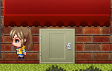 You can stand on the sides of the cutie pie’s door.
- Bobo: Fixed!

Guy Ferrari: Extra thicc Margot can be found in the park before she reaches her next stage. First seen on the first Saturday.[v0.4.0]
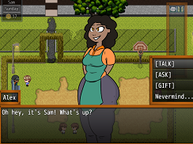
- Bobo: Fixed this!

Guy Ferrari: Clover has customer service dialogue when she’s next to Bobo’s stand.[v0.4.0]
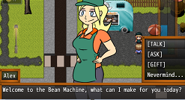
- Bobo: Got the wrong HUB event attached to this Clover. Fixed!
Bobo: Cannot access the Bobo’s Menu or interact with cart.[v0.4.0]
- Bobo: Fixed!

Tones: This bench in the park has the one sprite that’s above the player, making it appear above them. [v0.4.1]
- Bobo: Fixed!

Tones: On the first Saturday, double Downtown Man near the construction site and on the date in the Park. [v0.4.1]
- Bobo: Still getting some scheduling things right. Fixed!

Tones: Two Margots on Sunday, one in the park and one at the Bean Machine. [v0.4.1]
- Bobo: Fixed!

Guy Ferrari: The Blue Bobo Latte is brown. [v0.4.1]
- Bobo: That’s what I get for being lazy and copy/pasting the hot chocolate entry. Fixed!

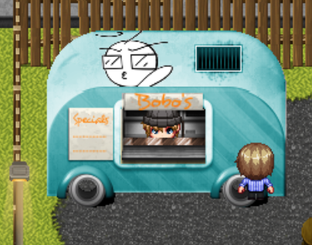
T.Max: You can stand on both tires of the Bobomobile. [v0.4.1]
- Bobo: Fixed this! [v0.5.0]

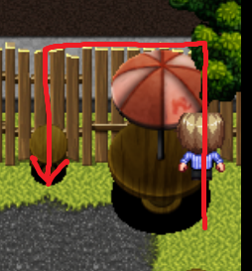
T.Max: Next to the Bobomobile, you can walk onto the right side of this table, through the fence, and also walk through the fence onto the stool. [v0.4.1]
- Bobo: Fixed this! [v0.5.0]

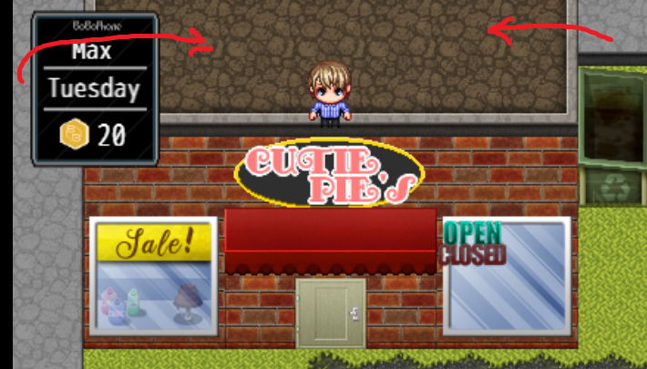
T.Max: Can walk onto the roof of Cutie Pie’s by walking behind the dumpster or from the top left corner of the screen. [v0.4.1]
- Bobo: Tileset adjustment hopefully fixes this [v0.5.0]
- Tones: Still can as of this version, it seems where the road tiles intersect with the roofs it lets you. Can walk under the roof of the other building where the road would be too.[v0.6.1]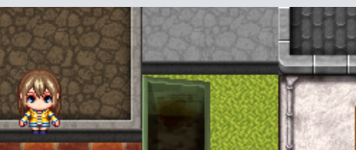
- Tones: Still a thing, sorry bud, the sidewalk that runs behind it seems to be the issue. [v0.8.0]

Firewalk: Can walk into The Broken School building from the right. [v0.4.0.2]
- Bobo: Same as above - tileset adjustment hopefully fixes [v0.5.0]

Firewalk: Not a bug, but annoying. Walking over a bench triggers an event which stops your character to sit on the bench [v.0.4.0.2]
- Bobo: this is intentional, since there’s no way to “sit” on a bench seat.

Tones:The top of the tree next to the Bean Machine is fine and you walk under it, but you can walk over the bottom two tiles of it.[v0.6.1]
- Bobo: Fixed this one, hopefully. Tileset issues are a lot more difficult to deal with in RMMZ.
- Tones; It’s back. [v8.0.0]

Tones:Nitpicky sorry, but you walk above the tiles of the broken fence.[v0.6.1]
- Bobo: Same as the above - tileset issues in RMMZ are a bitch lol [v0.7.0.0]

Tones: 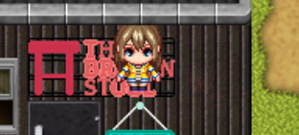 Walking in from the right side you can stand here. [v0.8.0]

Tones: I don’t know why but for some reason the close sign graphic stays up after checking out the Broken Stool on an off day. It persists no matter what. [v0.8.0]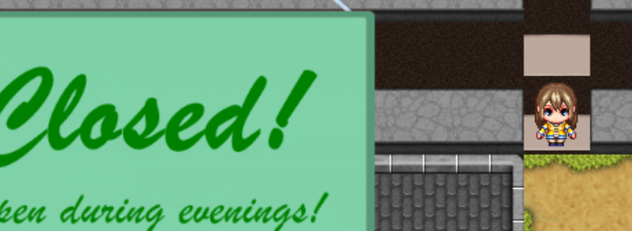
APARTMENTS

Guy Ferrari: The window in the bathroom isn’t a solid tile. You can walk up the window and around the edge of the apartment.[v0.4.0]
- Bobo: Tileset adjusted. Hopefully this helps.

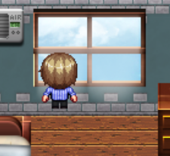

T.Max: Can walk on both sides of the window in the bedroom. [v0.4.1]
- Bobo: Tileset adjustment made [v0.5.0]

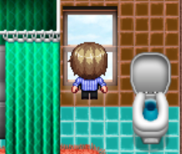

T.Max: Can walk into the window in the bathroom. [v0.4.1]
- Bobo: Tileset adjustment made [v0.5.0]

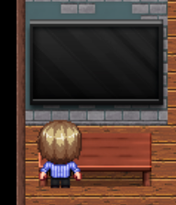
T.Max: Can stand on both halves of the table in front of the tv. [v0.4.1]
- Bobo: Tileset adjustment made [v0.5.0]

Tones: When entering Clover/Kendra’s home you get stuck at the door and can’t actually move but you can still leave at least. [v0.7.0.1]
- Bobo: Fixed this! [v0.8.0.0]

Tones: Can’t move past the couch in Charlie’s apartment despite the tile being empty, cutting you off from most of it. [v0.7.0.1]
- Bobo: As of right now, this seems to be a tileset limitation. Will look into it further. [v0.8.0.0]

BEAN MACHINE
Shihi234: Issue with initiating dialogue with Margot. When talking to her for the first time, after the initial conversation, all dialogue options disappear. Music is still playing.[v0.4.0]
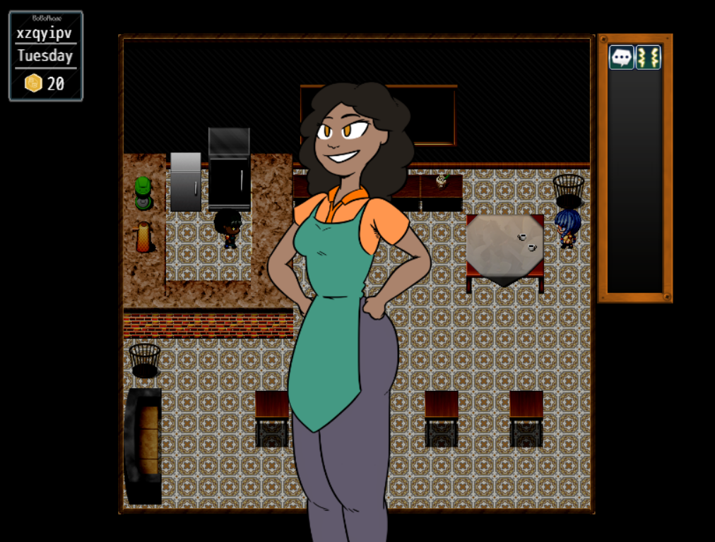
- (Bobo): A switch got crossed with Margot’s “first” common event. If possible, test other characters, as they all run on a similar template.

Shihi234: Same thing just happened with Clover. Went into SPECIAL and asked about Alex, and the game basically paused again.[v0.4.0]
- (Bobo): Got it. Will debug SPECIAL menus so that they’re either inaccessible or not broken. They won’t come into play until they all get programmed, so that’s fine for the release later this week.

MightyHalberd: Super minor, but the collision on the tables are kinda wonky[v0.4.0]
- Bobo: Adjusting collision. It’s never going to be perfect, but I can at least try and make it a little less awkward.

MightyHalberd: Meant to say goodbye to Margo and she went into gossip about another girl instead. Worked fine the second attempt.[v0.4.0]
- Bobo: cut back on looping immensely with dialogue overhaul in v0.4.0. Hopefully this helps.

MightyHalberd: Yeah lots of looping on Margot’s options then she got permanently stuck on the screen.[v0.4.0]
- This was fixed with a dialogue overhaul [v0.4.0]

Guy Ferrari: Margot’s image stays after exiting conversation. Seems to happen if you exit out of the conversation from the gift menu.[v0.4.0]
- Bobo: This will require some doing - will look into a Keymapping Plugin

Guy Ferrari: Clover’s dialogue is labeled “Alex” when she welcomes you[v0.4.0]
- Bobo: Fixed!

Guy Ferrari: Whenever Clover’s dialogue disappears, giving her cheesecake raises her green bar, but keeps the cheesecake in your inventory.[v0.4.0]
- Bobo: Cheesecake and Chocolate Cheesecake got mixed up. Swapped them on Skinny and Chubby stages.
Tones: Can stand on tables.[v0.4.0]
- Bobo: Tileset adjusted. Hopefully this fixes it.

Guy Ferrari: Clover’s ask changes her name to Charlie [v0.4.1]
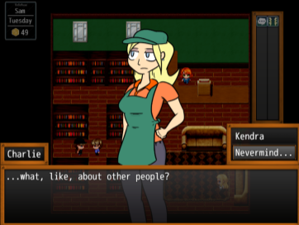
- Bobo: Fixed this!
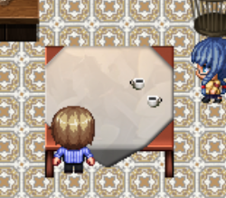
T.Max: You can stand on both sides of the bottom half of the table. [v.0.4.1]
- Bobo: This is to allow characters to sort of “get close” to the table. As of this update (v0.5.0) it is intentional.

T.Max: When you Ask Margot about Kendra, her portrait disappears. [v.0.4.1]
- Bobo: Fixed this [v0.5.0]

T.Max: Whenever you talk to Margo after being introduced, her name is displayed as ‘Alex’ before switching back to Margot. [v.0.4.1]
- Bobo: Fixed this [v0.5.0]

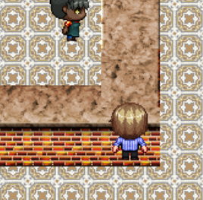
T.Max: You can stand on the bottom right corner of the counter. [v0.4.1]
- Bobo: Tileset adjustment made [v0.5.0]
- Tone: Still can.[v0.6.1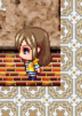]

Firewalk: Talking to Charlie on the weekend locks her portrait on screen. Stays on map change but goes away if you give/ask her something. [v0.4.2]
- Bobo: Fixed this [v0.5.1]

Tones: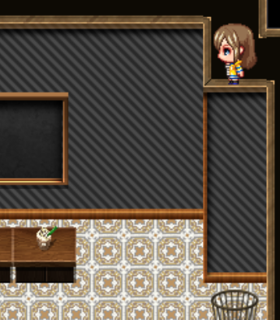The new wall lets you walk on it, can just walk all over it. [v0.7.1.]

Tones: Can’t interact with Charlie at all when she’s there in the morning. [v0.8.0]

THE BROKEN STOOL

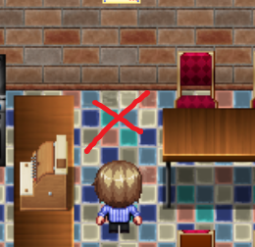
T.Max:This empty space is inaccessible.
- Bobo: tileset adjustment made, hopefully this fixes. [v0.5.0]

Tones: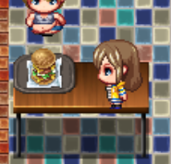Really want da burg.[v0.6.1]
- Bobo: Guardrail placed! [v0.7.0]
- Tones: Guardrail removed? Can still get on table from top of tile. [v0.8.0]

BrainLeech: Bartender sprite disappears once she gets to stage 3 on weight, and then when i talk to the spot where she was i will talk to her and then alex [v0.7.0.1]
- Bobo: Fixed! [v0.8.1.0]

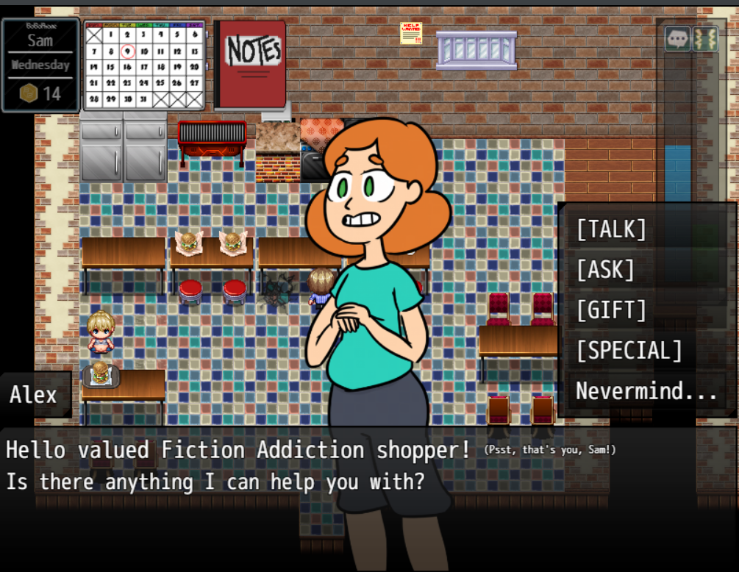

And afterwards i talked to alex in the bookstore and she is stuck to the screen
- Bobo: this should also be fixed by merit of connecting to the correct hub now [v0.8.1.0]

CUTIE PIE’S
MightyHalberd: Talked to Charlie and chose [Gift], and when I hit escape to leave the box, Charlie’s last sprite stayed on screen until I looked at a cake again.[v0.4.0]
- Bobo: Sometimes switching out of RMMZ causes bugs. Will look into it, but I think this may be another “engine” error.

MightyHalberd: Overlapped sprite when I gave Charlie a drink and she declined.[v0.4.0]
MightyHalberd: Definitely some crossed wires, I keep hitting nevermind and it plays the talk option.[v0.4.0]
- Bobo: This may be due to what I used to hide the SPECIAL options from selection. Disallowing auto-cancel - “nevermind…” will have to be a manual selection for now.

MightyHalberd: Charlie seems to be getting fatter despite not taking my gifts.[v0.4.0]
- Bobo: This was fixed with a dialogue overhaul [v0.4.0]

Guy Ferrari: Sprite overlap when asking Charlie about Margot and Alex[v0.4.0]
- Bobo: Misordered erase picture commands - should be fixed now.

Guy Ferrari: Blonde girl on Wednesday started walking backwards.[v0.4.0]
- Bobo: That’s spooky as hell. Fixed.

Firewalk: Invisible sprite at weight stage 2. Possibly connected to other bug I put in Bean Machine as talking locks her portrait similar to the issue I added to Bean Machine [v0.4.0.2]
- Bobo: Fixed this! (v0.5.1)

FICTION ADDICTION

MightyHalberd: The sprite that comes up when Alex says “Oh geez I don’t know” overlaps the old one instead of replacing it.[v0.4.0]
- Bobo: Fixed!

Guy Ferrari: Alex’s counter can be walked through at her right.[v0.4.0]
- Bobo: Collision issue; fixed!

Tones: Clover is here now but talks like she’s at the bean machine.[v0.4.1]
- Bobo: Not seeing a reason why this would be happening. Ignoring for now, will look at later.

Tones: Can’t talk to blue haired girl at all when she’s running the Fiction Addiction. [v0.4.1]
- Bobo: Event was set to “below characters” - this is fixed now!

Tones: Giving Alex a gift makes her sprite disappear, but you can still interact with her. [v0.4.1]
- Bobo: Remnant of old weight progression system. Fixed now!

Guy Ferrari: Alex dialogue has bracketed numbers. [v.0.4.1]
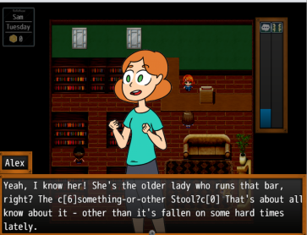
- Bobo: That’s part of the code I use to color certain words. I just typed the slashes out of order. Fixed now!

Tones: Talking to Clover here, she has no sprites.[v0.6.1]

Tones: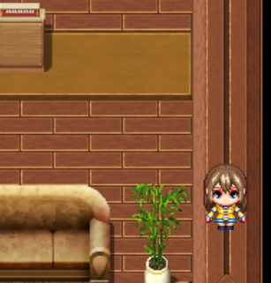Can walk on the railing of the wall, letting you walk all around the place freely of the normal walls. [v0.8.0]

PROOFREADING

- Kendra, Overworld, First Day, Ask, Clover: ‘Niece’ is misspelled as ‘Neice”
  - Bobo: Fixed!

