The Bisley Boy
A Short Story based on Alleged Fact
By Maryanne Peters

My husband, the late Sir Thomas Parry, was a man of great importance in the household of the late Queen Elizabeth for the two years before his death. Some said that he was poorly qualified to serve as the Controller of the Royal Household. That may be the case. Some said that he must have some hold over Her Majesty, but I doubt that anybody could fully appreciate how momentous was the secret.

The only others who shared the secret we me, Anne Parry, as my husband’s closest confidant, and Mistress Ashby – Katherine Ashby nee Champernowne, known as “Kat”, Governess to Queen Elizabeth from the age of 4 until she (Kat) died in 1565. She died in the service of the Queen as did my husband, but in gratitude for my loyalty (and perhaps my silence) having never been in Royal Service I received and still receive, a very a large annuity as I have done for close to 50 years.

I knew, but I have remained silent out of loyalty to our Queen. I never told a soul, not even my daughter now widowed, who was the wife of Thomas Knyvett, 4th Baron Berners as the Queen so kindly arranged.

It seemed to me that Robert Dudley, the Earl of Lester may have known, but he died well before his queen, so we will never know what he knew.

Now the Queen too is long dead and King James sits on the united throne. With her death the secret is no longer valuable, as the line of succession could never pass through her, but there could be shame, and Her Majesty does not deserve that. She was the finest of monarchs and earned the respect of everybody by force of her personality. Out of duty and in honour of our Queen, my secret remains a secret.

So what is it? It was hinted at but never confirmed, by such as the spies sent by the Doge of Venice in the early years of her reign had learned: “For a certain reason which they have recently given me I understand that Elizabeth will not bear children”. I know the reason.

My husband told me that it all took place in the Manor House at Bisley in Surrey, where Princess Elizabeth once lived during the period after the execution of her mother, Anne Boleyn. Her father, King Henry VIII had little interest in the child as he pursued his objective of fathering a male heir using a series of wives.

However, the king saw some political advantage in offering his 9 year old daughter as a bride to a claimant for the Scottish throne upon the ascension of James V of Scotland, the father of our present king. He arranged to visit the child and sent my father to make the arrangements. When King Henry arrived, he did not noticed the differences from the daughter he barely knew. He did not realize that the princess was not a princess at all.

The story my father told me, for I had not yet been born, was that the real princess had died, and that the household feared for their own lives given the King’s well-known temper. The idea was to find a substitute. It was seen as a temporary measure only. In the fullness of time the fate of the princess would become immaterial as many heirs would follow, given the Kings renowned vigour.

But as it turns out the youthful strength and vitality of King Henry VIII would never pass down to his children. They all of weak disposition and died, although the papist Mary was executed.

Finding a substitute would be a challenge. My father and Lady Ashby would need to find someone who at least resembled the king with the same distinctive red hair, but even at 9 years of age Elizabeth was a proven scholar. In England in our times girls are simply not educated, the aristocracy being the exception. Finding a flame haired girl of that age from the scrupulously recorded peerage was impossible.

And then by chance a red-headed child was located, from a humble family but taken in by a local clergyman (a protestant from Flanders) on account of a considerable natural talent with languages which drew attention. Rarely a child of low origins can be selected for an advanced education, but such a child must inevitably be a boy.

The way my husband described it there was no option but to have this boy fill the role. As mentioned, it was always anticipated that once the successor had been born, and probably others to meet the needs for strategic marriages, the death of the princess could be revealed and boy could return to a normal life, forever silent that he had served a brief period as a princess.

But the child had a king to meet if the household at Bisley were all to keep their heads upon their shoulders. And that meant that it fell to me and to Kat, with a little help from my Tom, to teach this young Bisley boy how to act as a young lady.

As said, the King went back to London well convinced and the boy was more than pleased with his own performance. He took to tell all that they should call him Bess and treat him like royalty. I have to say that it would have been galling had the child have not had such a winning way about him, or more properly we should say “Her”.

The King was now married to Catherine Parr, who would be his last wife and would bear him no children. It was she who arranged for Her to return to Court in London in the year 1543. By Her insistence those who knew her secret accompanied her – Tom and I, and Kat.

In London there was a new tutor appointed for Her. William Grindal was amazed that the child could speak French, Italian and Spanish, and also Flemish (from the clergyman). Grindal added Latin and Greek, which were quickly master by Her. She was later to study all of the languages of the British Isles and be able to converse in all of them, including the outlandish language of Wales.  Still my husband could not imagine that this child would figure in the succession, When Henry VIII died in 1547 Princess Elizabeth’s half-brother Edward VI became king at the age of 9. She became even less important, and with the past king’s widow remarrying the colorful Thomas Seymour, our young imposter (with us) became part of that household. It seemed possible that Seymour might discover the secret as, even though in middle age, he was prone to being overly playful with young girls, including our charge. Ultimately his conduct would see him beheaded. | 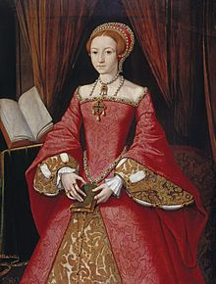  Elizabeth 1546 (age 13)

To be honest, it seemed that Bess enjoyed the attentions of the older man. Even before she acquired real power, she learned that a woman can exercise a sort of power over a man. She was not as pretty as she might be, but in just a few years her hair had grown long and was strikingly beautiful. But unfortunately, the signs were beginning to appear on her face that presaged the early signs of manhood.

To some extent my husband and Kat believed that these changes could be delayed by binding the groin and drinking a concoction of angelica and red clover but as events began to take shape it was decided between the two of them that more drastic action was required to prevent a man blooming out of our little princess.

Even in youth there was no denying the intelligence of our deceiver. If you ask any person from modest means to choose between wealth and power for as long as you can live, or wife and progeny (should they survive in our dark times) while living close to poverty in some country village – what will they say? This clever child chose to surrender manhood for a chance at power.

Because by now it seemed a possibility that Edward would not live to father a child, and the protestant Parliament did not think well of the catholic Mary Tudor, the daughter of King Henry by the even more catholic Catherine of Aragon. To add to the problem in Edward’s will (doubtless written by plotters within the Privy Council) he named the distant Lady Jane Grey as successor.

Before long, Mary Tudor came courting support from her half-sister in person. This was perhaps the biggest test for our Bess as even half-sisters raised in different households ought to recognize one another. But if she suspected anything, Mary kept silent. This was the only Elizabeth she had, and she felt one was needed to bolster her claim to the throne. She asked Bess to join her on her parade into London, which Bess did. But all the time our girl knew that a catholic would not hold the throne.

Some have said that the daughter of King Henry was firmly protestant in honor of her father who created the new church of England, but in reality our Bess was well taught by her childhood protector and despised the corrupt practices of the Church of Rome. Good Englishmen shared this view.

Mary Tudor reigned for less than a year before there was open rebellion, and she summoned Bess before her to question whether she was behind it, which she was not. Still my father and Kat feared for their charge. Mary would gain nothing by claiming that the princess was an imposter. In the time of the Plantagenet kings all manner of such claims had been made, and never resolved. The solution would be to publicly execute Elizabeth, but there was simply no evidence of treason.

Instead Mary sent Bess and her household (including Tom and me and Kat) to house arrest in Hatfield House where we lived for 4 years until Mary Tudor died.

Over those years Bess was preparing for the possibility that she may be queen, which would mean living as a woman for the rest of her life. She was no longer a man, but not yet a woman. Kat had experience in the herbal arts and added more concoctions to assist in a transformation including daily consumption of chasteberry and other exotic formulations not available to her in earlier times. These substances and the use corseting gave Bess a feminine shape.

So when Bess ascended to the throne in November the Year of our Lord 1558, she was in all respects except one, a woman.

I know nothing of politics and will give no opinion upon it, other than to say that Bess was naturally skilled in that area. But among kings in turbulent times, marriages and heirs are better tools than war, and in this our new young ruler was at a disadvantage. A husband would certainly discover that she was not female, and of course, no heirs were possible.

Some years into her reign it was reported to the Queen that the Pope had been advised that she could not bear children because she lacked the private parts of a woman. Our Queen acted affronted, but referred immediately to Kat and to others of us, and was assured nothing had come from us.

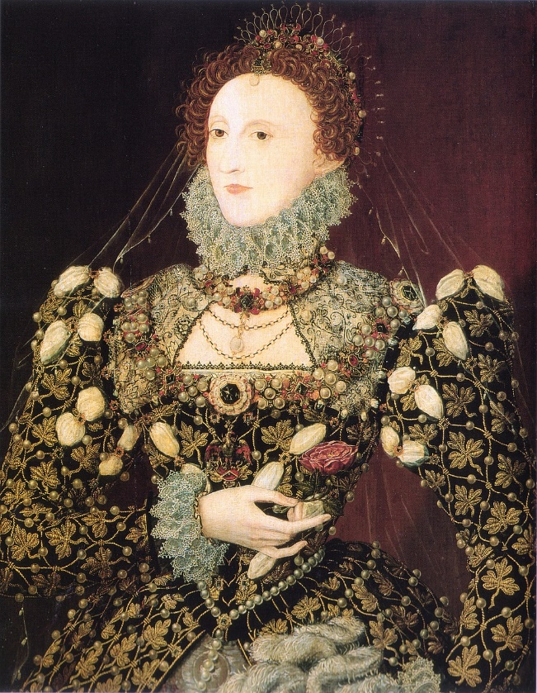 | One of the only other people who may have known was her favorite - Robert Dudley, Earl of Lester. If it is true and she had taken him into her bed, then he must certainly have known. But he had every reason to stay silent to keep her favor, and that favor he enjoyed until he died in September 1588, the month after the Spanish Armada was defeated.  For our Queen had found that our island nation could master the seas. The battle and the earlier success of the privateers who played key roles in courage and seamanship, established the beginnings of the nations command of the world’s oceans.  The other person who would have known was the Queen’s doctor, the Portuguese Jew Roderigo Lopez. His tale is a story in itself, but he was silenced by imprisonment and later execution.

And so, She reigned, until all of her advisers had died and the son of Lord Cecil had become her last leader of Her government. And it was he who arranged for James VI of Scotland to visit her and humor her in her final months, and thus secure the succession that nature could never provide.

And the Bisley boy lies buried beside Mary Tudor in Westminster Abbey – “Sisters, in hope of resurrection”. Because the real Princess Elizabeth, who would have been queen, lies in a village cemetery in Bisley, in the Borough or Surrey.

The End

© Maryanne Peters 2020

