Calling Rick  Number 11 for John  By Maryanne Peters  Hi Rick, it’s Chrissy  Chrissy? Hey Baby. How are you?  I have been thinking. Well, not really thinking … I just haven’t been able to get you out of my mind. Not since yesterday afternoon.  Did you like it, Baby? Did you like what I did to you?  Hmm hmm.  Tell me how much you liked it. Tell me. | 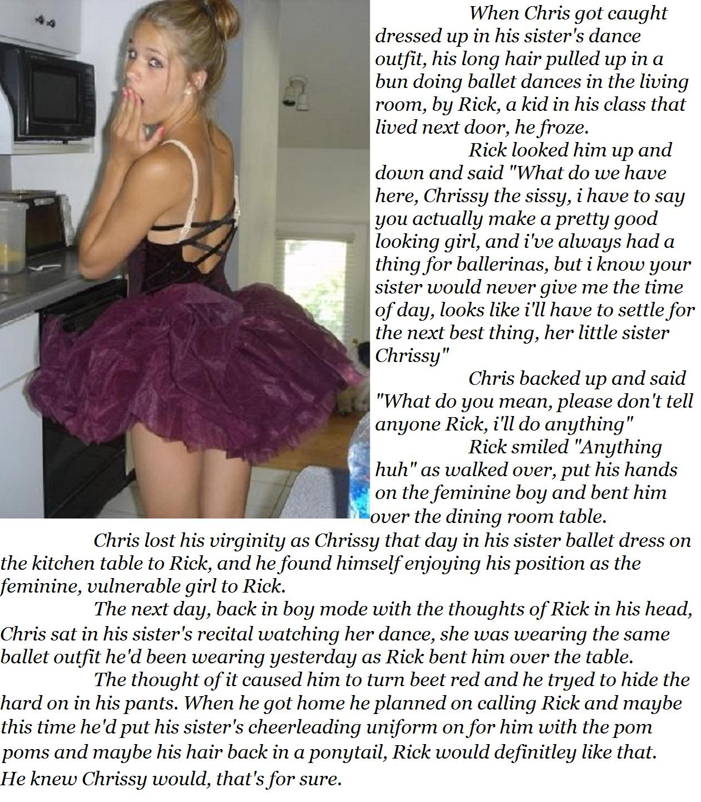

Well, not so much at the start. You see, I have only ever poked a candle up there before. A few times. Just to see what it would be like, to be a girl. Never anything as big as you. You’re so big, Rick.

I think you make me big, Baby.

Really. Oh Rick!

You are so much prettier than your sister.

Do you think so?

I loved your hair in that ballet bun. You know I have a thing about ballerinas. They have those supple bodies. They can do any position. What positions can you do, Chrissy?

I don’t know. I guess we’ll have to find out.

Tonight?

Maybe … well … sure. Tonight. But not here.

You come over here then. Will you be wearing the tutu?

It’s in the wash. My sister had a recital tonight. But I think I can find something tonight. Do you like cheerleaders?

Oh Baby. Could you do that?

I have a blond fall that I could put in my hair, and my sister’s cheer outfit. Maybe I could do a little cheer for you. Ra Ra Rick. Ra Ra Rick. Would you like that?
Fuck Baby, you spoil me.  I promise I will. That’s the kind of girl I am.  You are everything I want.  So, you don’t mind my … my little thingy?  I never even noticed it.  Tonight then. I will be clean as a whistle for you. I am expecting you to fill me up.  I can’t wait to my cute little cheerleader.  The End  © Maryanne Peters 2019  Note: I have used the telephone exchange story telling as I did in the ongoing “Rear Window” series. | 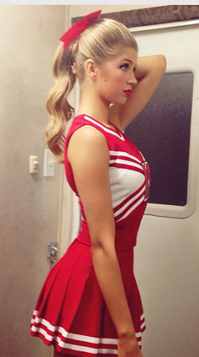

Brothers Friend  For John (Number 12)  By Maryanne Peters  When I started all of this, I was not sure if I would be attracted to men. That is not what it was about for me. It was just the feeling that it was all wrong. Not just the penis, but everything about my body. I had to change it. I did not even think about sex after my transition. It was less important than living as a woman.  But now I know for sure.  My brother Steve’s best friend Jake, is what I want. | 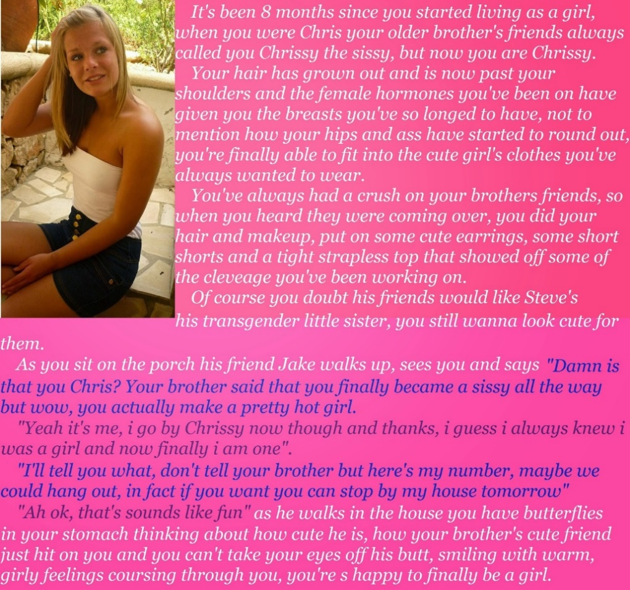

I was still going to school in “gender-neutral” clothes. I suppose everybody knew that I was a not a real guy. Gay? Sissy? If anybody ever asked, I would tell them flatly: “I’m transgender. I have a girl’s brain in a guy’s body, and when I am older, I am going to fix that”. But I never announced it or anything like that. I guess I just lacked the confidence.

But at home I could dress as the girl I wanted to be. Even my father was happy with that. If I did not dress in public, I guess he thought that any crazy things I did were better kept within the four walls of our home.

So, I had a few dresses and outfits including the tight blue skirt and the white tube top with the special strapless uplift bra to go underneath.

When Steve said that he was going to have his friends over, I decided to go all out. Steve’s friends are jocks like him, so I figured that if they could see me as female, any guy could.

I washed my hair and used straighteners and special conditioners to give it a sheen. I applied some makeup – not too much. I tucked away my junk as tightly as I could, so that even a bend over would show nothing. Then I squeezed into the outfit.

Then I sat on the porch and painted my nails.

“Damn is that you Chris? Your brother said that you finally became a sissy all the way, but wow, you actually make a pretty hot girl.”

“yeah, it’s me. I go by Chrissy now thought and thanks, I guess It always knew I was a girl and now finally I am one.”

“I’ll tell you what, don’t tell you brother, but here’s my number. Maybe we could hang out. In fact, if you want to, stop you can stop by my house tomorrow.”

“Ah, OK,” I said: “That sounds like fun.”

Fun? Oh my God. I just watched him walking into the house. His big shoulders and a great butt, and the confident swagger in his walk. So manly I almost wet my panties. Honestly, I wanted to crash tackle him right there. I wanted to strip him bare and pull him onto me. Have fuck me any way he wanted.

To think that I said that I was not sure if I would be attracted to men!

And he was attracted to me. He had just hit on me. I had his number, clutched in my sweaty quivering hand. I had butterflies in my stomach and an ache in my loins. Only a twitch left in my little clittie after all those hormones, but what a twitch!

That was yesterday. I went to bed with those warm girly feelings coursing through me, and in the night those dreams a Jake had me ooze a little something into my panties. What a night!

And today I am headed around to Jake’s house. What will we do? I need to get myself ready. I already put some work in last night. I practised a blow job on a banana, and the I put baby oil on it and shoved it up my ass. It hurt a bit, but after I worked it a little, I figured that I am dilated a bit. I don’t want it to hurt when Jake sticks me. I just want to giggle and cry for joy. I want to tell him it is wonderful, I am sure it will be.

Now I am going to give myself an enema. I have read all about it and I have put everything together. I have some scented oils that I am going to use. Maybe he might nuzzle my butt. If he does I want him to be able to say that I smell like a peach. I want it to be better than any pussy he has ever pushed into, so that from now on, he will only want mine.

And I want us to kiss. I want us the kiss like crazy. Not just on the mouth – all over. But mainly on the mouth, so that we can tickle tongues. I will use strawberry flavored lipstick and wash my mouth out three times with the strongest mouthwash. I am going to taste like a strawberry cocktail.

I am going to use musk perfume. The one with extracts from a lady goat or whatever. It is designed to drive men wild. I want Jake to be wild about me. I am going to put it behind my eyes and splash it on my boobies. I want his face buried between those. I might put a little of that strawberry flavored lipstick on my nipples – brighten them up and make them lickable. Yum yum.

I am just so happy that I am finally a girl.

I’m coming Jake. I’m coming.

The End
© Maryanne Peters 2109
Mother’s Help  For John (Number 13)  By Maryanne Peters  It was all a misunderstanding.  I mean, of course I asked Mom for help. I knew nothing about acting like a girl.  We were doing Shakespeare as a school play and the teacher said that the principal role needed to be played by a boy, pretending to be a girl, pretending to be a boy. Or something like that. Three guys wanted the part. I got it, maybe because I had the long hair.  The hormones were hers. For her “change of life” thing. She just put them on my dresser. She called them: “Essence of womanhood”. I don’t know why I swallowed them. | 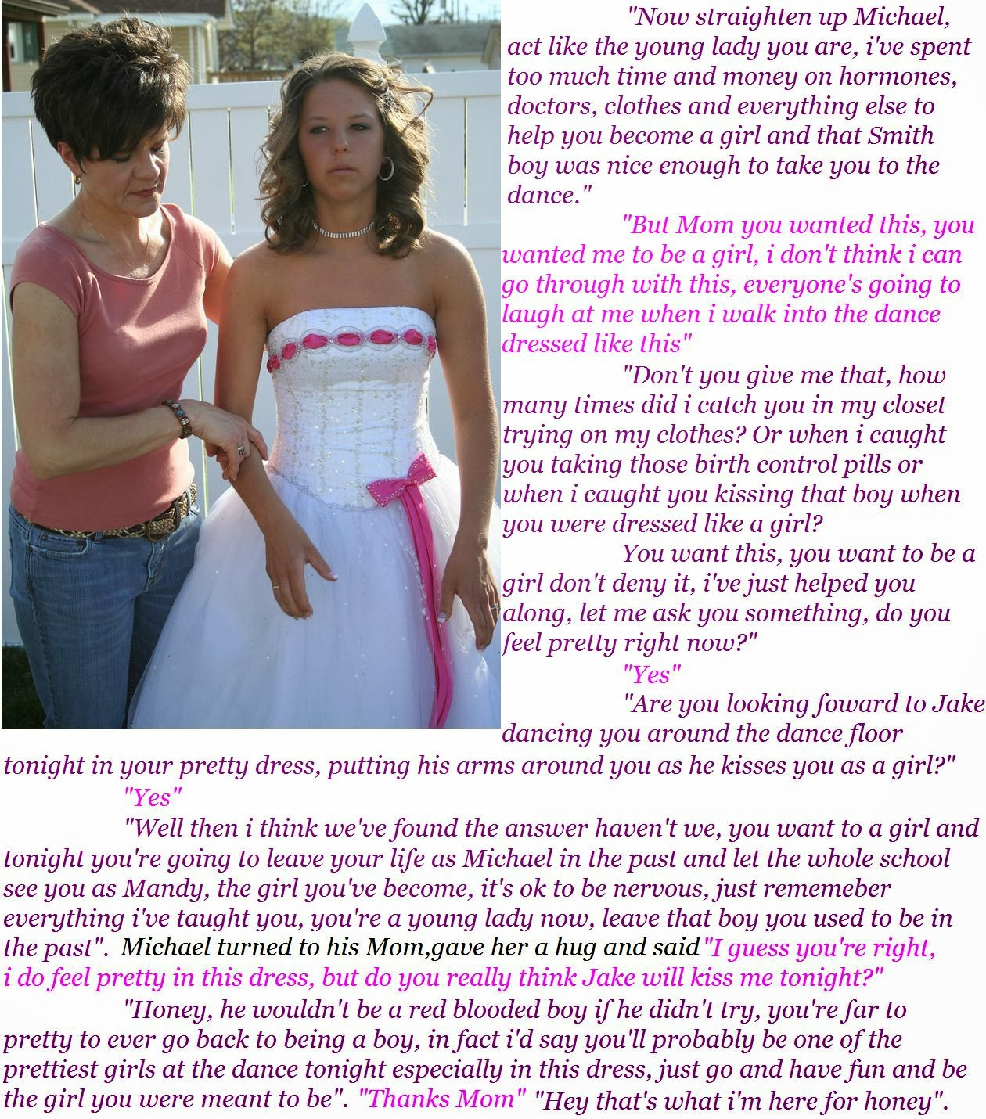

As for the kiss. That was just rehearsal. I don’t even like Xavier.

Mom just got completely the wrong idea. I mean, she was so excited that I was going to be pretending to be a girl in a play that it was like she suddenly forgot I was a boy.

She kept on going on about me trying on some of her clothes. What guy doesn’t do that? Just playing around pretending to be a grow up. All of my Dad’s clothes are way too big. But Mom, well you can see that we are the same size.

She wanted me to a be a girl. It’s not what I wanted.

She took me to the doctor and told him what she wanted, not what I wanted. Of course, I wasn’t going to say: “Mom is crazy” right in front of the doctor. No way.

Ok, so I did feel pretty in that white dress with the pink ribbons. Who wouldn’t? Just look at it. It’s adorable. But look at my face. I’m fighting this. I’m fighting to stay a boy.

So, am I looking forward to going to the dance? Of course, I am. Hanging around with Jake? Sure. He’s like, the coolest guy in school.

Him putting his arms around me and kissing me as a girl? Ok. So that is a bit weird. I guess that in a dress like that, your mind can wander. A dress like that is designed to make you feel different – feel special, like a princess. Isn’t it funny how girl’s clothes can make you feel stuff, where boys clothes are just … clothes.

And those hormones that I am taking. They can fuck with the mind, those things. God knows they have fucked with my body. I mean look at these tits. How am I supposed to hide these? I can’t. Now everybody knows that I’ve got a pair. The guys stare at them, and not because they look weird on a guy. No, because they look good on me.

Ok. So, I am still getting used to the hair. Mom has put some curls in it. She wanted to put it up in a “do”, but I drew the line at that. Besides, Jake likes it down. He said so.

With all of the shit that I am going through with my crazy mother, Jake is with me. He is a special kind of friend. Agreeing to take me to the dance dressed like this? I said that I owed him, bigtime.

He told me that he might ask me for a little favor after the dance.

I don’t know what that might be, but when he asks for it, I’ll be ready to give it.

The End

© Maryanne Peters 2019

Summer Camp  A Story for John (Number 14)  By Maryanne Peters  When I said “I think I could get used to the new you” I was just trying to say that our friendship did not have to end just because he now looked like a chick. That’s what I meant. I mean we had been friends since we were toddlers. You don’t throw away that kind of connection just because his Mom had sent him away to some kind of reform camp. Is that really what happened?  When I asked whether he was interested in guys I expected him to say “no”. You can’t change those things, can you? | 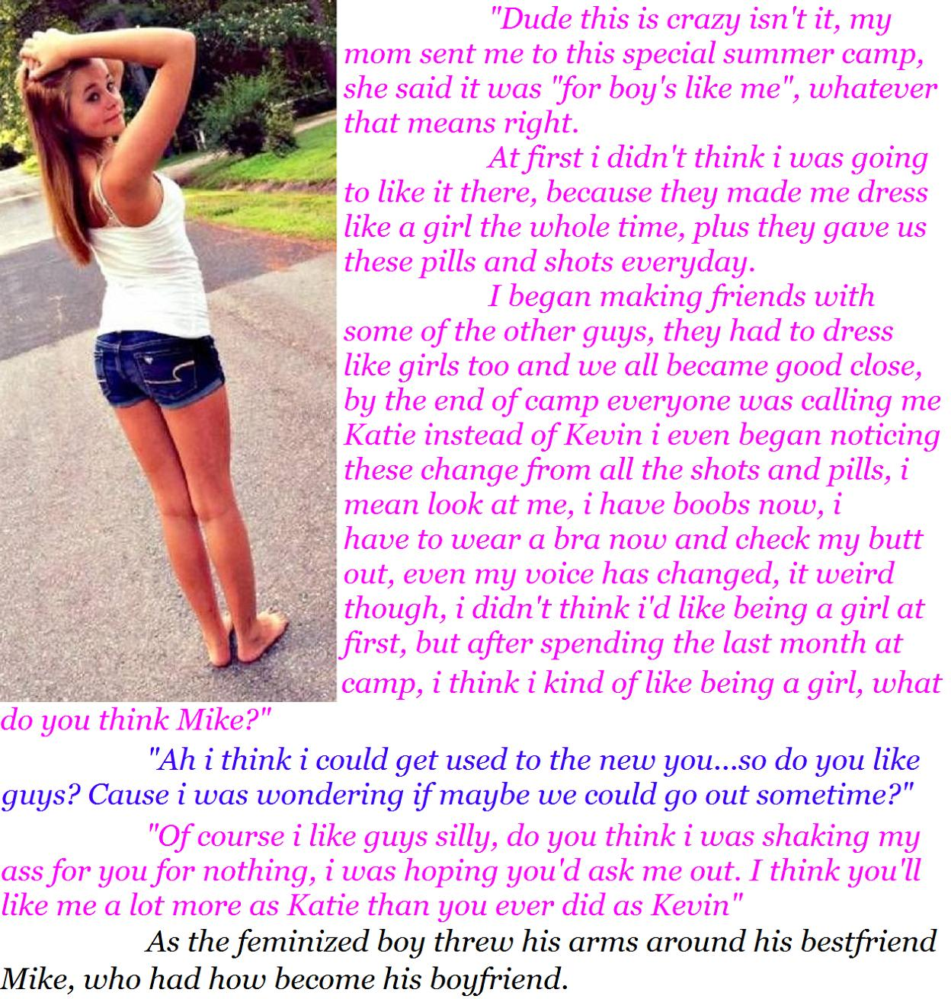

I still wanted to be able to go around together, like we used to. Surely that did not have to change, just because they had done a number on his body, and maybe his mind too?

I mean Kevin was a regular guy just like me, before he went away. Sure, he was a trouble maker, but isn’t every kid at our age?

Do such camps really exist? If it’s true, then how many guys out there are parading around dressed as girls like Kevin?

A what about the body changes? I’m no expert, but nobody grows a pair of tits over summer. And look at that butt? How the hell? Kevin has been wearing track pants a lot. Could this have been going on before? I mean his hair was way too long, and that was his choice. Not this long though. And not looking as it good as this.

Are you supposed to turn up to this camp and then just climb into girl’s clothes? What guy would do that? You would say “no way”, or just run off – wouldn’t you. Who would say: “Sure, hand over the dress and panties and I will slip them on”? Not me. Not any normal guy.

And what about the pills and the shots? Do you just take those?

What the hell are “boys like me”? Did his Mom send Kevin to this crazy conversion camp because he was a bad ass, or because this is who he wants to be? A sweet ass?

But here is my old friend Kevin with his arms around me, telling me that he is Katie now. I am in shock. What is happening?

I can small that long soft silky hair – flowers and sweet fruit. I can feel those neat little tits, cupped in her soft bra, pressing up against me.

Oh no. I feel an erection coming on. Right here in the street!

Now she is looking up at me and my hands are in that hair.

Not Kevin – Katie. So pretty. The look in her face says to me that if I want her, she is mine.

Those lips. Those eyes.

There is only one thing I can do.

The End

© Maryanne Peters

He’s My Girl
The Fifteenth Story for John
By Maryanne Peters

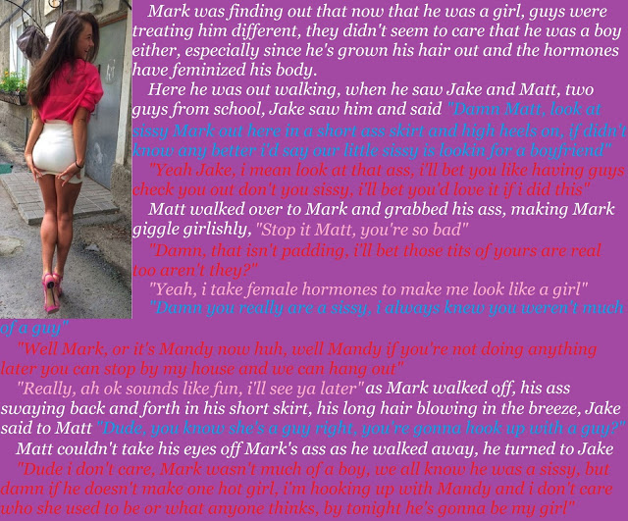

“So how did it go Bro? asked Jake. “I mean between you and the sissy last night.”

“She’s not a sissy” said Matt. “She’s a girl now. She’s Mandy. And from now on I am going to be proud to call her my girlfriend.”

But Bud, she’s as pretty as a picture, but she has a dick, right?”

“That’s not a dick any more, Jake, that’s a dangly clit, that’s what it is. It just flops about when I fuck her. I think its kind of cute. I’ll never look at a cock on a guy, but I tell you, Mandy is no guy.”

“So you giving it to him, I mean her, up the asshole, right.”

That’s not an asshole, Man. An asshole is what shit comes out of. What she has there is a back pussy. Only it smells better than any pussy I’ve ever fucked. It’s sweet, Man, sweet.”

“Bro, I’ve gotta say it: You sound bowled over – cunt struck. But without the cunt.”

“I tell you Jake, sure I know what she was, but what she is now is better than anything I have ever known. She just wants to please me, anytime I want it. I mean, she wants it like a guy. Like as much as she can get. No week off a month. No mood swings. She knows what fucks a guy, and she’s not into that. She’s into me.”

“Wow. Does she … would she do it for others?”

“Fuck off man. She’s my girl. Find your own little sweet thing.”

“Maybe just a blow job? Do she do that?”

Does she ever. Man, she treats a cock like she knows what one is, because she does. She licks and slurps and makes it sound like it’s the sloppiest fuck ever. And she swallows. And she licks off her own goo too.

“She cums? Like ejaculates?”

Like a fire hose, Man, but just a cute little teeny weeny one.”

“You have to let me have a try. Brothers and all?”

“I said no way, and I mean no way. He’s my girl.”

The End

© Maryanne Peters 2019

