Raising the Stakes  Inspired by a Captioned Image by Tiffany  By Maryanne Peters  I suppose it started when I insisted that my father-in-law honor the bet and walk down the main street in his jockeys. It was demeaning, especially for a man of his stature as a local big wig. He had to fix the next bet for me with equivalent embarrassment.  He knew that I valued my masculinity above most things. I told him that his daughter had married me because I was a man’s man, even though my butch behavior was often a problem for her. He was sensitive about it because his wife, my mother-in-law, had run off with the virile pool boy.  “I need feminine company for the annual retreat,” he said. “So if Boston win the Stanley Cup you will become my female escort.” | 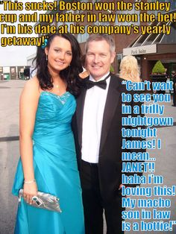

Do you remember the final game? We were 3 games each going into the decider against the Vancouver Canucks, playing in Vancouver. Who would have believed it? What happened to hometown advantage? When Boston won, I was not looking forward to keeping that bargain, the way he had kept his. I offered another bet. But there was no way he was not going to get his own back.

“You can raise the stakes for the next bet, but I’m collecting,” he said. “And don’t think that you can just step into a frock and slather on some lipstick. You know some of the guys I work with. If you don’t want them to know it’s you, you had better make a very convincing woman.”

My wife agreed. “The best chance of keeping that precious male pride of yours is to be invisible, and that means not looking like you. We will need to dress you up and give you lessons so that nobody that you are a guy. Luckily you are skinny. I am sure that my friends at the salon can make you look convincing as a woman.”

At the time I wished that I would been able to say that they never would have succeeded, but that was not true. Maybe one of the reasons why I acted so butch was that I was concerned about my lack of a rugged male body. The fact was that when my beard was pulled out (shaving would not have last for the retreat) what was underneath looked decidedly feminine. A little coaching from my wife and some online lessons on voice, and the man in me took a back seat with surprising ease.

I became his escort as I promised I would, and I played the part so well that I surprised myself. I suppose it was like “method Acting” – you know, where you get so into character that you become her. I ceased to be James. I became Janet.

Some actors find it hard to shed their new persona having lived it for their performance. I was only supposed to be Janet for the 3 days and nights. But it seemed like that was enough to get me a little bit stuck.

I lost that bet in 2011. As any Bostonian will tell you, that was the year the Bruins won, almost decade ago. The photo is of us at a hockey dinner last year.

It is a not an act anymore. I became real on that second night sharing the double room at the retreat lodge. The first night had been cold, but that second night was freezing despite the heating. We just got closer than we should have, I guess. He said that I was a hit. All the women admired me and all the men desired me – including him.

Who would have thought?

My wife was horrified. She has come to terms with it since. I needed to be with him, so I cut her off, and some other things besides.

My man challenges me sometimes, just in fun, but I have never made a bet with him since. I think that it is not ladylike, and that is what I try to be. And it can be dangerous too.

The End

I love White Boys
Inspired by a Captioned Image
By Maryanne Peters

I am one of those dudes you have heard all about. Somebody that has white boys shakin’ in their boots. The kind of black man who thinks of anything white as being fuckable. It don’t matter if you are male and female, if your ass is white, I am gona want to fuck it, and fuck it hard.

Now, there are black faggots, but I ain’t one of them. My brother, for example – “a drag artiste” so he says. He likes to dress up as a bitch, and sassy around, turning men on.

I like black women. I don’t like black men dressed as women. But white guys? Well, to me they look like women, all pale and scrawny, You just gotta rip off that body hair. Hair like that belongs on an animal. You gotta rip it or shave it off. Get right down to the pale soft skin. Something to curl up with, and fuck.

When I saw that white boy Jerry move in next door I told my brother: “Now there’s a project for you. Those white folks are as poor as dirt, and that little Jerry with that snow blonde hair and those skinny arms, he needs to be in dresses so a rich black man like your brother can care for him and keep him satisfied.”

Well, my brother ain’t stupid. He says: “Are you paying Bro’?” so I tossed him a bankroll.

I dunno what he said and how he spent the money, but the next thing I came home from work and there is Jessica waiting for me, looking as pretty as a picture in a tight dress and black stockings with just a feather boa around her shoulder and a pair of rubber tits on her chest … at least I think they are rubber.

The little she-boy is looking slightly scared as I poke them to find out. She has reason to be. When I get off my suit and tie, she is going to see just how big a healthy black man can be, and she will know just how much I love white boys.

The End

© Maryanne Peters 2021

Young Expert
Inspired by a Captioned Image
By Maryanne Peters

I admit to being a little old-fashioned. Is it really such a bad thing? I think that I am a good employer. I am considerate and generous. I just felt that the standard of dress and presentation in the accounting support section had deteriorated, and this was a way of lifting standards. They did not have to take up the offer. If they did, I would pay. It was that simple. I never even knew that there was a male on the staff down there. They all looked like women to me.

I was told later that he took up the offer of a makeover to embarrass me.

“The old man thinks that there are only women working for him down here. Well, if he is offering a free makeover and a new outfit from the corporate fashion boutique, I am not about to turn down a gift.”

He just chose the shortest skirt and the highest heels at the store.

As I say, I cannot ever remember seeing “Julien” at the support section, but I must have hired the young man. I only recall meeting “Julie” for the first time. I was told that here was an example of improved presentation that I had paid for. I remember thinking that the skirt was a little suggestive and the shoes impractical, but that hardly matters when you look at the smile. “Flirtatious” they call it. Apparently in the modern age employees can flirt with their bosses but not the other way around. How is that fair.

Anyway, as I learned later, the makeover had included hair extensions and a body wax, all paid for by me. All I can say is that it was money well spent. Most of the women had taken up the offer and the benefits seemed palpable to me. Employees looked good and felt good. I felt good looking at them. Positivity rose; productivity rose; standards rose – all off the back of a new feeling of self-confidence.

Julie asked to see me, no doubt to bring the boom down and disclose that her stupid old boss had paid to have a male member of his staff transformed into a beautiful woman, but I have to say that I really did not allow her the opportunity to do that.

While at the outset ensuring that I used the modern language required to eliminate any suggestion of sexual harassment, I commended Julie on her appearance and hoped that she and I could work more closely in the future.

Julie is no fool. An expert, so it is said. She knew enough to stay silent and not make a fool out of me. In fact it was weeks before I discovered her secret, and only then when we had become so close that it could no longer be hidden.

If I was a younger man, I may have been more upset that I was. But in truth when you get older the best place for a beautiful woman is on your arm rather than in your bed. But as it happened, that was to follow much later.

It turns out that Julie is not just an expert in the accounting field. I think that she has even surprised herself on just how good she is in other areas.

The End

Runaway Groom  Inspired by a Captioned Image  By Maryanne Peters  I found out later that her brother Frank had always wanted me. He was gay, I suppose. At least he was then. Now I am not so sure.  He said to me: “It is a woman’s privilege to be able to change her mind, but not a man’s. A man makes a promise and he has to keep it. So, I guess that makes you a woman.”  I did break a promise. I promised to marry her, and I abandoned her in that church. I shamed her in front of her entire family. She and her brother should be entitled to punish me – to do what they wanted to me.  “It’s not a punishment,” Frank said. “It’s what I want, and what you want too.” | 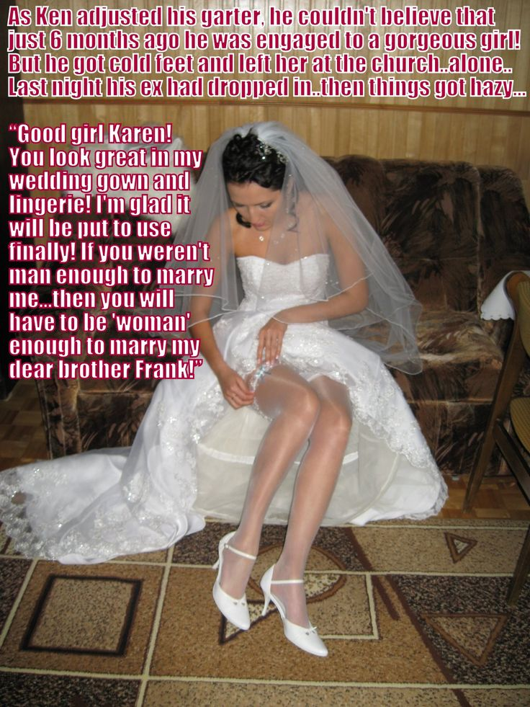

And he was right. I left her at the altar because I knew the moment that I saw her in that bridal gown, that was what I wanted. Not her, but to be her. It was as if pursuing her was chasing my dream of a feminine life, that I hope to live through her. But when I saw her in that gown I knew in that moment that it was all a lie. I am a woman inside, and the more I deny that fact, the more people I hurt. It was a case of a little short sharp jolt of pain, or a lifetime in agony.

So I ran. The runaway groom.

Frank sought me out and found me, shivering in a corner. I just told him everything. I thought that he would beat me, but instead he just pulled me to my feet and held me, and I sobbed like the woman I am.

He asked me what my female name would be, and when I told him, he said: “Don’t cry Karen. Everything will be alright. Trust me to put it right.”

That is the kind of man he is. He is organized and used to getting what he wants. He put me on the fast track to transition, like the rocket engine test track. The whole thing was a blur. And then the surgery was booked and proposal and everything, with a wedding date when I was back on my feet.

Of course I was hazy. I was still on pain medication.

“But I have nothing to wear to a wedding,” I told him. “Of course I want to marry you, but the way it should be done.”

And there she was, the woman I had abandoned and should hate me forever, standing with the gown in her arms and a smile on her face, saying: “I’m glad it will be put to use finally”.

She was my bridesmaid and ended up marrying Frank’s best man and best friend who had wanted her from the first day he had met her as a child.

My wedding was perfect, as all weddings should be, and as my wedding as a man could never have been. A Frank is the perfect husband. He was considerate in delaying lovemaking until I was fully healed, but since then we have been at it like crazy, now that I am woman enough for him.

The End

Under or Over
Inspired by a Captioned Image
By Maryanne Peters

So, this was the deal: I would get immunity only if I gathered the evidence. I had already been outed as a snitch, so I could not go back in except in disguise. I knew where the bodies were buried, as they say, but I had to dig them up and hand them to the District Attorney.

“They’ll know it’s me. What kind of disguise would allow me to be in an office with guys I have worked with for years and not be recognized!” It seemed to me that it could never work. But if I did not do something I would be locked up, and a guy like me … to put it simply, I am not built for prison.

“I have an idea but you are not going to like it,” said FBI Special Agent Shaylah Griffin. “A disguise that will make you totally unknown to all the guys on the floor. We’ll disguise you as a woman.”

“You’re crazy!” I said. There is no way I would pull that off even if I agreed to do it. Besides, the guys know all about my trading methods.”

“No. We are not talking about inserting you in selling. We can put you in as a secretary. They have a high turnover in secretarial staff at your previous employers. And as a secretary you can move freely in the deal room and collect the paper evidence that we need.”

“There is a high turnover in secretaries because they only hire good looking ones and then they get molested and abused until they quit.”

“You ought to know it,” she accused. It was not unfair. I had been a part of it. Boiler room share trading is a macho activity. When we weren’t making millions doing secretly informed trades and stealing from our clients, were taking advantage of female employees. The firm had the money to pay the settlement of grievance claims and were happy to do it so long as the boys stayed on their game.

“Modern pharmacology and cosmetology can work miracles,” she said. “Or there is jailtime”.

It seemed to me that Shaylah had another axe to grind. But what choice did I have? I shrugged my shoulders. I submitted. I wanted the deal. A suspended sentence. No jail time. Barred from the industry. No future, but free.

“What about my wife?” I had to ask.

“Tell her that you will not be in touch with her for a year other than by mail,” said Shaylah. “It will just be like you are in jail to her. But you won’t be. You’ll be working for us; and working for your freedom.”

But the truth is I only thought about her when there were times like that. When I was getting dressed or putting on makeup or styling my hair and I would be wondering how my wife would do it. I did that for quite a while. Right up until I found my own style, I guess. From what I can remember my wife was not a very stylish person. Come to think of it, I can’t even remember her name.

Anyhoo! Got to go! Drinks after work and I love to flirt with all those high rolling share sellers. There was something I had to do about that, but I can’t remember what it was.

The End

© Maryanne Peters 2020

