Messing with Me
A Story for John
Number 36
By Maryanne Peters

I don’t really believe that Adam was forced by his mother to dress like a girl. That is the story he told around school as he grew out his hair and as his body changed. There was some complicated story about a deranged uncle or a maiden aunt who hated boys, or something. It was all about saying that it was not his choice; that it was out of his control. But to me anyway, it seemed that he loved being Amanda. And I loved it too.

Her hair grew down her back and her tits grew out in front, and she just got prettier every day. Even without makeup, tell me if she is not just the prettiest thing that you have ever seen.

And why would she wear that. If she was a guy just pretending, why would she wear that pink knit dress that would creep up her legs, and fall off her shoulders. Not that the stretch fabric could hide her shape in any way. You could see every inch of her: The tits, the butt, and even the lump where a normal girl would not have one. She is not wearing any underwear, you see.

Little wonder my cock was strained to bursting, which is just the way she wants it.

I tell you how else she wants it: Right up the ass. Over the back of that sofa, with a bit of lube and there is a passage no red-blooded male would not want to go down. Tight and snug and nestled between two of the smoothest and prettiest buttocks you could ever see.

An she knows it. She was never forced to be this. The girl is messing with me.

The End

© Maryanne Peters 2019
His Kind of Girl
A Story for John
Number 37
By Maryanne Peters

As the song goes: “I was working as a waitress in a cocktail bar”, but it was a themed bar and I was in drag. I may have done a little cross-dressing, but it was not serious. I really wanted to work in the production side of movies or television, and you wait for that by waiting tables. I was good, but the best tips in town came from that bar – “The Drag Net”.

I never expected to get my big break by being picked up by a customer because of how good I looked in drag, but that is what happened. I had been working one high tipping customer to the best of my abilities and he told me in passing that he was in production.

“I could get you a job, Tiffany,” he told me. “But only as Tiffany.”

“This is just a job,” I explained.

He gave me his card to call him if I changed my mind. I got plenty of cards and plenty of bullshit, so I should have put it with the others, in the round open top file. But instead I called, just to check. It turned out that “Jack” was a major player in independent files and TV.

It seemed like I had to face my destiny.

“I don’t have suitable clothes,” I told him over the phone.

“Don’t worry,” he said. “I will provide you with a wardrobe.”

“Do you want to know my size?” It was a sensible question. I was serious about the work.

I know the measurements I want, so we will adjust the body to the clothes rather than the clothes to the body,” he said. “But give me your shoe size.”

I could have chosen suitable clothes, but he was paying. Every top he had bought for me was made to display breasts that I did not have. That is what he meant about modifying the shape of my body. Breast implants, paid for by him were a requirment of the job.

The thing about breasts is that you cannot take them off and throw them on the bed when you get home. If you go out, you have to go out as a girl, with breasts like that. There is no hiding them, except maybe in the middle of winter.

And then the was the hair extensions and the all over skin treatment. You cannot hide that either. While I held down this job and built experience in the firled I wanted to make my carreer, I needed to be prepared to dress and act like a woman 24/7.

“You’re actually very good at this,” said Jack. “You could have a future in the line of work. And you have the added asset that you look good, and you are not carrying the baggage that those born-as-a-girl girls have. Of the people I worked with, only he knew for sure that I was not one of those. But I was the kind of girls he liked: Pretty and with a bright personality, and not given to monthly episodes of bad temper.

And I got used to the breasts and the long hair that I also could not take off.

At the start Olivia thought I was a girl, I am sure. She should have guessed I was not one, because she was not one originally. She was kind to me when she thought I was a genetic girl, helping me through things as the senior production assistant. But when she found out that I was a boy underneath it all, her attitude changed. Suddenly I became a threat.

She said as much to me. She said that she and Jack were in a realtionship, and that she had endured painful bottom surgery “Because Jack prefers to fuck warm fleshy pussy – prerable man-made pussy.”

“I am not having any surgery,” I explained to her. “When I leave this job I intend going back to being a man.”

That seemed to satisfy her, but then it was clear that she just could not leave it alone. She wanted to drive me out I think. She started to suggest that if Jack wanted me he might get his way. She said I should not be surprised if I woke up one day having been drugged and operated on, so that I could be another plaything for Jack. It was designed to make me feel uncomfortable, and it did.

But maybe she wanted to get rid of me because she did not believe me? Maybe she thought that I was lying about goig back? About having my breasts cut out and my hair cut off. And the truth is that as time went on the prospect of that horrified me. When I got up in the morning and nestled my breasts in the cup of my bra, brushed my hair into my tidy ponytail, plucked out a stray hair from my top lip or chin, and applied my mascara and lipstick, I felt great. What looked back at me pleased me, almost as if I had married the perfeect women who greeted me with a smile and blown kiss every morning, and every night.

And the hormones were working on me too. Did I forget to mention those? Great for your skin and hair, and they make sure that your male bits are kept in check.

I was not the only person who was pleased to get a smile from tiffany every morning. Jack did notice me. I like to think that it was the quality of my work. I was better than Olivia and I think that she knew it. I mean, she knows how to do her job, and how to look good, but she is just missing that fizz of energy that comes with youth. That is the fizz that I have got.

I mean, they are not married or anything, so I can accept his offer of a meal – just the two of us at a classy restaurant. Olivia should not feel threatened. She is the transgirl, not me.

Except Jack does seem very keen on me. I am not flirting or anything. In fact, I playing hard-to-get because he cannot have me. I have something that he doesn’t like hanging between my legs. He would never touch me unless that is gone, and something installed tailor made for him. And that is not going to happen.

Well … I wonder?

The End

Call from Daddy  For John Number 38  By Maryanne Peters  I reminded Ashley of that call at her own hen party, where I made a speech as first Bridesmaid.  “Will your father give you away,” I whispered to her afterwards. “Will he even be at the wedding?”  “John has spoken to him,” she said. “As you know, John can be persuasive. He persuaded me to marry him after all. My guess is that he will bring him around, with Mom’s help. | 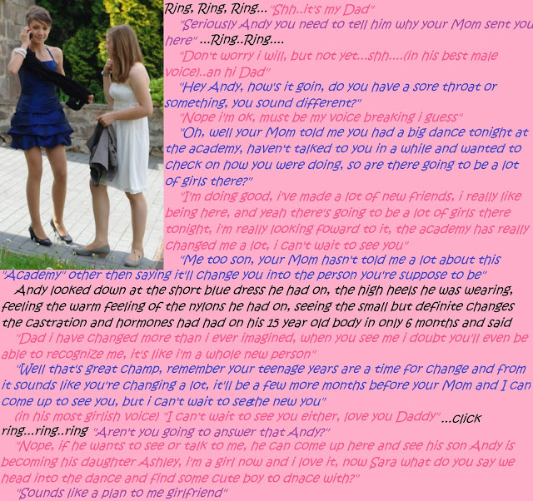

It could not have been lost on Ashley’s father, that It was he mother who had sent Ashley to the academy where we first met. I had already been there for several months before “Andy” arrived. I was there by choice. I had always felt out of place as a boy, but Andy was trying so hard to be “his father’s son” that he was uncertain at first. He was only prepared to accept that trying something different at a private school where he knew nobody, and nobody knew him, was something that he would consider.

I don’t know the details, but there were mood swings and anxiety attacks, and some antisocial behavior. It all convinced both of Andy’s parents that he needed special attention. The choice of establishment was left to Andy’s mother, and she had her own ideas about where Andy’s problems stemmed from.

She must have known something about her own child. Once he was in a dress it was as if a light had come on. Once the hormones kicked in Andy was gone forever.

Normally it takes ages to get to the level Ashley achieved, but she was a natural. There is no better was to put it. Even by the time of that call from her father, before her hair had grown and her breasts had filled out her bra, she was more woman than many of us.

She had already disposed of her balls. A surgical castration requires parental consent, but some of the girls at school had discovered a way for doing the job with an injection into each testicle. We could do it to each other, but at only 15 or 16 it takes a determined transgirl to whisper to her friends: “Do it”.

We expected her to show pain, but she just grinned. She said: “Now my future is sure”. You were call that ballsy, if it were not the complete opposite.
But she was the one who had to walk up to her father in that outfit she chose when her parents came to collect her. That outfit where she spilled out of the polka-dot top, that stretch skirt showed her butt to perfection and the patterned tights and heels revealed the longest legs anywhere.

“It’s Ashley now, Daddy.”

At least everybody else’s father knew they were going to be picking up a boy who was now a girl, but to Ashley’s dad this was earth-shattering.

Ashley’s mother was crying tears of joy. She had made the right call, and this beautiful new daughter confirmed that. But Ashley was waiting, and all of us in the background who had greeted our own parents were looking at Ashley and her family too.

Her father was just moving his mouth like the fish gasping for water. While Ashley struck her pose. Wonderfully feminine, because she was – an example to all of us.

“What happened?” her father said. Not ‘Is this a joke’, or ‘take that off and put some clothes on’. What happened is a good question.

“This is who I am now,” said Ashley. “It is who I have always been, but we could never see it. I mean you and me, Daddy. We did not know that I was a girl inside.”

“This is how you want to live?” her father asked.

“This is how I have to live,” said Ashley. “I don’t want to disappoint you Daddy, because I love you so much, but this is who I am.”  Her father had already drunk in the view of her new body, a body that any man would desire, one beaming with health and vitality as well as exuding sex. What he saw now was that face. The eyes of his child above those trembling painted lips. And in those eyes, the love for a father.  “Come and give your Daddy a hug,” he said.  The End  © Maryanne Peters 2019 | 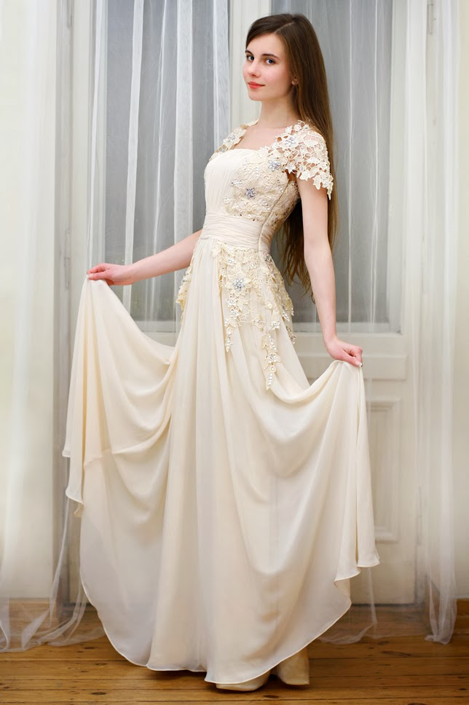
Risking it All
A Story for John Number 39
By Maryanne Peters

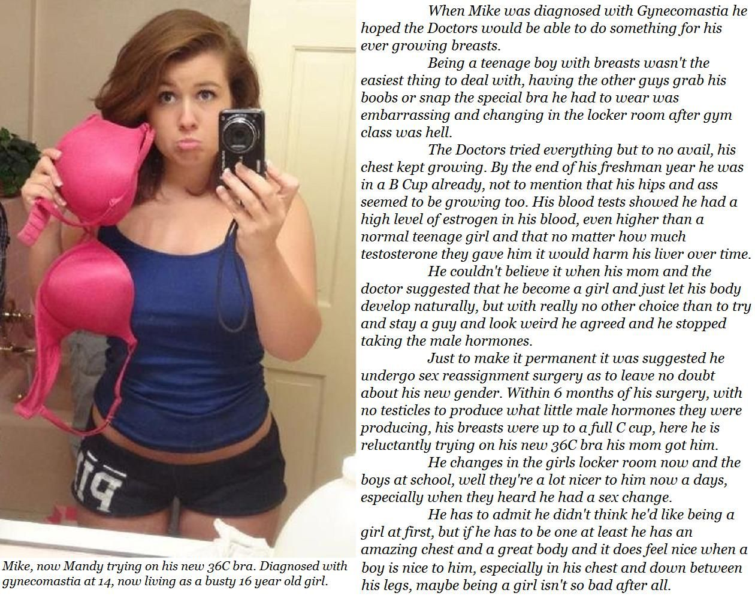
It is grounds for revocation of my license to practice medicine, I know it. No physician can expect to retain their license after doing something like that. But love will drag you into the very worst of crimes, even though this hardly seems like a crime to me. What would be a crime would be for Mandy to grow to adulthood as a man. That would be a crime against beauty.

I fell in love with her the moment that she walked into my consulting room, as a teenage boy called Mike. He had the most wonderful brown hair, fairly long and very thick, which he flicked out of his eyes in a playful way. He has warm brown come-to-bed eyes, and a mouth that begged to be kissed. I knew immediately that this was not a boy. Medically perhaps, but science cannot understand the soul of a person. Here was a feminine soul.

The gynecomastia was minor. It was just late puberty. It happens that before the male hormones can kick in the small traces of female hormones in a young man’s body can have the effect of producing incipient female secondary sexual characteristics. I knew that needed to be allowed to continue to enable the woman to come forward.

I used an androgen locker injected in slow release form. I told the mother and child that this would solve the problem, which of course it would for me, but perhaps not for them. The second shot was female hormones which I told them was testosterone. I instructed them both to return for a booster in a month’s time. I took blood samples, but I did not bother with analysis.

When they returned, the boy was distraught. I was thrilled. I had bought a plain training bra which I produced and described as a “special medical bra” to hold the growths in place. I instructed the child not to cut her hair, as I would be measuring the effect of hormones on that. I took more blood and gave more shots. After they had gone, I took a break and jacked off in my sink.

On subsequent visits I showed them the test results and I told them that I had consulted widely. I said that nobody understood why the testosterone was having no effect, but that continuing with it would cause serious liver damage. I said that we would need to consider a new strategy. It was a strategy that I discussed with her mother in private.

“He has an older brother,” she said. “The truth is that I have always wanted a daughter.”

I could not stop myself from saying to the woman: “I think that Mike will make a great girl. We just have to persuade her to accept it.” I even used the feminine pronoun, almost giving my feelings away. But I cannot think of her in any other way.

It took a while for Mandy to be persuaded, but with me advising the (false) medical imperatives and her mother gushing over all the advantages of being a girl, she came around. The fact is that no young person wants to be seen as a freak, and with transition prior to puberty and modern surgical techniques Mandy could be a complete woman short of the ability to become pregnant. And I already have children by my ex-wife.

The gender problem has been overcome, but there is still the age gap. I suppose that I felt that I could just call her into my arms because she would be uncertain about her sexuality. Afterall, the physical changes do not affect orientation, so I somehow expected that I would be the one who would lead her into understanding the love of a man, in every sense.

So imagine my appointment when I discovered at her six month post-surgery examination that her new vagina, that I had intended would be for my use only, showed signs of regular use.

“I just love being a girl, Doc”, was her chirpy reply. Given all the risks I had taken, all my dreams seemed to drain away in that moment.

The End

© Maryanne Peters 2019

Old Friend  For John Number 40  By Maryanne Peters  I meant what I said, I am open-minded. It was just that I was not expecting this. I had an idea in my head that Josh would not be able to present as female given that he always seemed to be as manly as the next guy all the way through high school. | 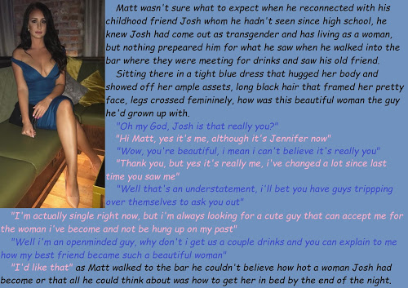

When I saw the woman in the blue dress I was blown away. I could not help but picture her naked, with a woman’s muff where Jason’s cock had once hung. I hurried back with the drinks – a beer for myself and a glass of chardonnay for “her”.

“I know it must be hard for you to accept that I am a woman now, with all we have been through,” she said. But strangely I seemed to have completely forgotten about Jason. Her presence seemed to have blacked out the memory of him. Those breasts and perfect legs, on full display in that blue dress that seemed ready to fall off the moment she stood up. That perfectly made up face, and the masses of soft dark curls that I longed to run my fingers through.

“It was a long time ago.” It was better than the suggestion that I barely knew Jason. He lived two doors down. We did everything together, when we were boys. We were both boys then. And it was not that long ago.

“Do you remember when we stole that sexy nightie off the music teachers washing line?” she said.

“That was a great trophy.” I remembered. “She must have known it was some of her students.”

“A trophy for you maybe. That was the first item of female clothing I ever wore. I wore it to bed until it was worn through. You thought that I threw it in the trash. I still have a thing for nighties.”

God, I wanted to see her in a nightie. But suddenly the image of us running back to my family’s garden shed with that nightie in my hand flashed through my mind, with Josh beside me, staring at it.

“So how did we lose touch?” I said.

“Because I needed to leave everything behind, including my family and my friends. I was not confident to reveal myself to those I cared for. How sick is that? I had to transition in front of strangers. Well, strangers in the same position as me. Forgive me, Matt.”

She held out a hand, palm down. What do you do? You can’t shake it. You can’t high-five it. I took it as it was tendered, in both of my hands, to give comfort. Her hands were so soft, with only the hardness of the long painted nails.

“Hey, Jennifer,” it was the first time I had called her by her name. “No forgiveness needed. You did what you had to do. It must have been hard. But it is clear to me that you had to do it. Look at yourself. You could never be Josh again.”

“Are you sad about that?” she asked. “We were close friends. Old friends.”

“We are still friends, right?” I was just looking into those beautiful feminine eyes and noticing that they were now a little moist with emotion.
“Maybe even more than that,” she said.

God, yes, I thought. I felt my cock jump into life. Everything about her exuded sexy, and now in her eyes was a fragility and a need for affection that is stronger than any aphrodisiac.

“Sure,” I said. “Let’s start over, now that you are a woman, and I am … a man.” I still had her hand in mine. We were still looking at one another.

“Would it be weird if we found a room somewhere?” she said.

“No,” I said, at once both thrilled and relieved that a wall had collapsed between us. “I think that we both want that.”

“Old friends, but not just old friends.” Was it a suggestion?

We were both smiling, but the smell of sex was already in the air.

The End

© Maryanne Peters 2020

