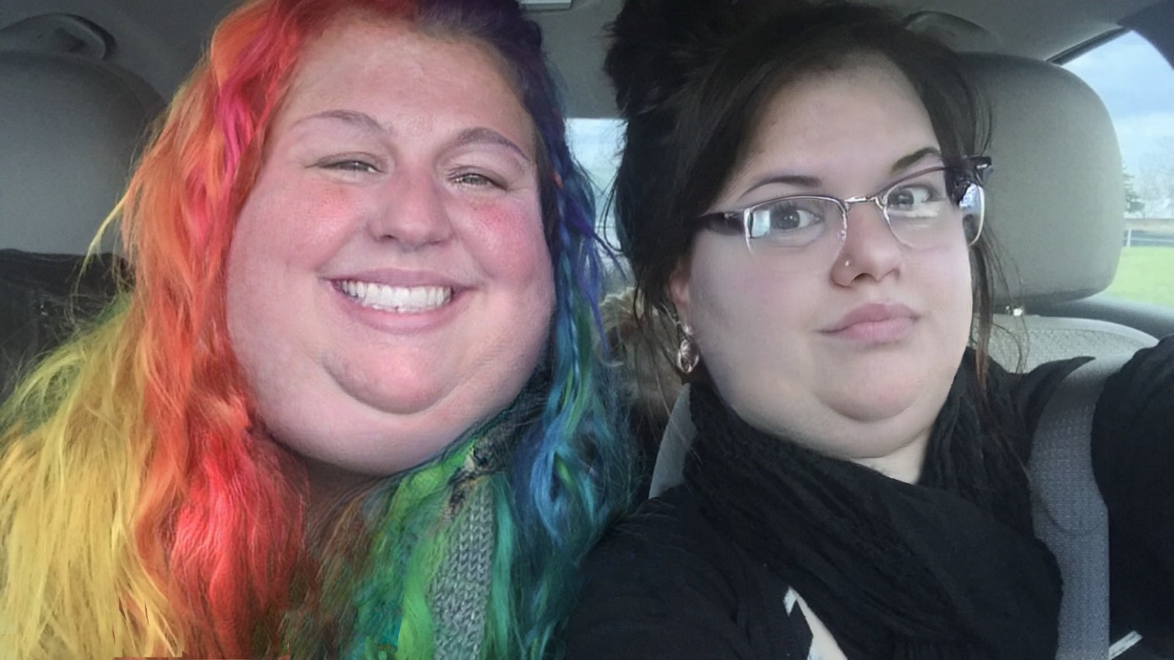

The two of them could not have been more different if they had been of a different species to each other.
They might as well have been, to be honest. Bright, sunshiney Sam with rainbow-colored hair and drab, black-garbed Leigh trapped in a car together. What fun, right? Without knowing that they were roommates, friends since college, and that they worked at the same coffee house, you would have wondered what on Earth could have gotten these two fatties wedged into the same car.
Honestly, even knowing all of that, Leigh had been wondering the same thing.
But Sam had felt that they were drifting apart lately, and wanted to repair that with a good old-fashioned road trip. They used to do this kind of thing all the time back in undergrad! Back in the days of wearing spanx and not making heavy “oof” sounds every time they got out of the car.
Truth be told, she couldn’t have cared less about the pop-up shop that they were making this great pilgrimage to see (although, a Kwik-E-Mart themed donut shop seemed pretty neat!). All of this was a ploy at getting Leigh out of the house and getting in some quality time with her bestie!
“Okay, which one do you want first?” Sam’s chunky fingers wrapped around the edges of Leigh’s options for highway wolfing, “Ho-ho’s or Pringles?”
“Gimme the Pringles.” Leigh’s double chin squished as she raised one plump arm to grab the tube, “You like that sweet crap more anyway.”
On the other end, the bespectacled goth should have been watching her weight. For, like, a few years now. Being Sam’s roommate was fattening as hell, and she’d gone from a skinny little mall goth to a dignified, but double-wide, Elder Goth thanks in part to Sam’s insistence that eating was some kind of communal activity.
Whatever.
Honestly, if Sam hadn’t offered to pay for all of the snacks that they wound up consuming along the way to this donut shop, Leigh probably would have dipped. But she supposed that she could put off her diet a little longer—after all, it wasn’t every day that a Kwik-E-Mart Pop-Up came within a reasonable driving distance away…
Besides, it was kind of nice to get to hang out with Sam outside of work.
She plunged her thick arm into the tube wrist-deep and emerged with a stack of salty snacks.
“Eat up, Leigh—we’ve got a long drive ahead of us.”
“But we’re going to a donut shop.” The paler woman said with a scoff, “Why do we need to eat up if we’re gonna get food at the end anyway?”
“Because that’s what road trips are for, dummy!” The suspension creaked a little as Sam leaned forward to nudge her roommate in the fleshy gut, “Road snacks!”
“Whatever.” Leigh laughed a little, popping a few more chips into her mouth, “You’re just saying that because you’re horny for donuts.”
“Are you not horny for donuts?” the round rainbow-haired roommate scoffed playfully, “Because I thought I knew you, Leigh.”
“Okay, fine, I’m horny for donuts too.” The hippo-hipped goth chuckled under her breath, her hand coming to rest on her doming gut as it swelled just slightly against the steering wheel, “But you’re driving back.”
That suited Sam fine, just fine. It was all that she could do to contain her excitement anyway—she probably would have agreed to take over the wheel then and there if she thought that it would help Leigh get in the Road Trip mood. She’d made sure to get plenty of her favorites to help keep her frowny friend in a good mood the whole way up. They had about two hours of driving to do, and she (personally) knew how much of an appetite that that kind of road time could work up in anybody—not just these two seriously chunky chicks.
The top-heavy passenger shotgunned both of her Hohos before moving onto the next round of snacks that she had procured for herself. Like the passengers on this calorie-crusted road trip, the contents of her plastic bag from QT couldn’t have been more different. Sweet and salty, gooey and crunchy… okay, they both had picked out sandwiches, but that was pretty much all that they had gotten in common!
“You want some cookies?” Sam piqued helpfully, “My hands are on the cookies…”
“Christ, Sammy, I’m still working my way through the Pringles.” The grumpy goth sniffed, “I can’t drive with my knees.”
Anymore. Leigh couldn’t drive with her knees anymore. Because her fat gut got in the way now.
“Ugh, you’re so grumpy ever since you started that diet.” The fat-tittied (former) blonde chuckled in chin-rippling appreciation for her roommate’s tsundere tendencies, “I'm just going to leave these cookies here and look away..."
Sam balanced a stack of Oreos on Leigh’s acre of thigh, squeezed into black leggings. They bounced uneasily a bit as Leigh took her eyes off of the road, onto the stack of cookies, and then back to her roommate. She was always doing shit like this. Was it any wonder that she had gotten so fat with literally the worst influence ever around?
"You'd better hope they give me a heart attack, because if not, I'm going to murder you." Leigh laughed huskily as she ventured out to grab two off of the top of the stack, “Seriously, I’m going to murder you.”
“No you’re nooooot~” Sam’s voice was deceptively high-pitched as she appealed to the soft spot that her roommate had carved out for her, “Because you love me, and I’m your best friend!”
“Ugh, fine, I won’t kill you.” Leigh stuffed down her cookies whole like someone who had certainly done this before, “Today. But one day, when you’re asleep, I’ll smother you with one of your own giant titties.”
“I’ll make sure to listen out for you loud-ass footsteps then.”
“Hey!” Leigh winced, “Mean!”
“Oh, what, you can be mean but I can’t?” Sam giggled as she stole an Oreo off the top of Sam’s thigh-stack, “How is that fair?”
The two of them couldn’t have been more different than night and day. But Leigh and Sam were good friends. Perhaps not exactly good influences on one another, but they were certainly good friends.
And even though Sam wouldn’t live up to her promise to drive home (far, far too many donuts had gotten her punch-drunk on carbs) Leigh certainly hadn’t minded this long trip upstate.
She’d make a note to do it more often; for equally silly reasons.

