Roommate Wanted  A Vignette  By Maryanne Peters  Much to the disgust of my parents I decided to move into the apartment that my wealthy grandfather had left me in my will and lead a debauched life in the city.  I remember that my father said to me – “We cannot change the fact that you are gay. We can only say that we love you and that we ask you to be careful in choosing the people that you associate with.”  I have to say that I was touched. I had always expected stronger disapproval. I decided to respect his words. I think that he is happy with the decisions I made. I may have doubted myself, but now I am happy too.  It was a big place with 3 bedrooms, and I decided that I would let at least one of them out. So, I put an advertisement in the paper saying something to the effect of – “Young man seeks male roommate to share classy inner city luxury apartment. Applicants must be well endowed and ready for fun” – or something like that. It was designed to receive enquiries from oversexed gay men like me. | 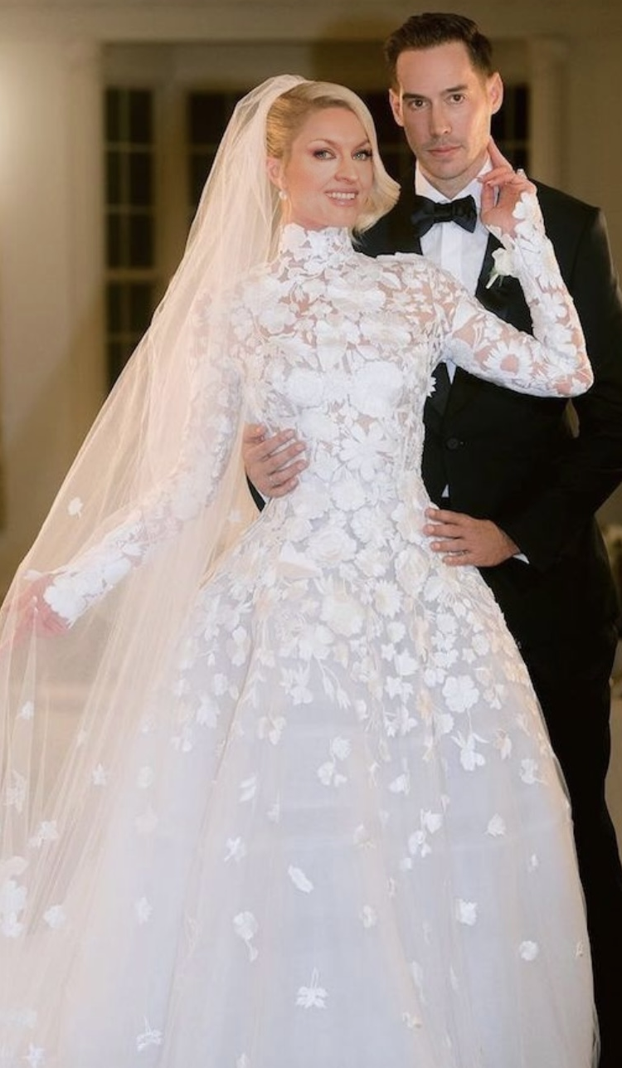

Some such people did apply, but I was mindful of my father’s words. I was not sure what I really wanted, but I knew that none of those me were right. And then Miles Mantell walked in, and somehow he seemed to be the fit. He was handsome, but it was like he was the kind of man that my father might approve of. He even looked a bit like him, but I don’t want that to sound weird. He didn’t look gay.

“I’m not gay,” he said. “Your advertisement didn’t say that I had to be. I am well endowed. I can show you if you like. And I do enjoy fun, as I am sure that I can prove to you. It is just that when it comes to sex I prefer my partners to be female. Or at least appear to be.”

“I can do that,” I said. The words just came out of my mouth, probably because I didn’t want him to go. There was something that drew him to me. Gay men – especially promiscuous gay me like I was – don’t like to use the word love, but that is what it proved to be.

“I really need a place and the apartment is just great,” he said. “I earn good money so I can pay you whatever you like. I am sorry that I might not be able to provide you with the fun you like, but it is a big city so I am sure you can find what you are looking for outside, but I think that you will find me a great roommate.

“I do cross dress,” I told him, although it was a lie. I did a little drag on nights set aside for that at a local gay bar, but I never regarded myself as in any way trans – not then anyway.

“I would love to see you as a woman,” he said. “I think that you would be quite beautiful, in a strong and powerful way.”

He was the one that looked strong and powerful. And he was tall too. Even if I was wearing drag queen heels he would be taller than me. Suddenly I was obsessed by wanting to see him naked and to feel his throbbing cock in my hand.

“When can you move in,” I asked him.

The problem with falling in love with a heterosexual man is that you have to become a woman. It was not something that I had ever considered doing, but love can motivate you to do anything. Once I discovered how we could be together it was just a case of following a well-worn path. It was the path so many transwoman had travelled and I never for a moment thought it would apply to me – I loved my cock too much. But surprisingly perhaps, not as much as I loved his. Even before any surgery, from the moment his cock was inside me, I knew that mine would have to go eventually.

I put it off for as long as I could but when he talked marriage that was his only condition. Now I find that I really don’t miss it at all.

He is everything I want. I am his wife now. We are still in the apartment, and only using one room. But we won’t be looking for anybody else in our home.

The End
763

© Maryanne Peters 2024

