Transatlantic
A Short Story
By Maryanne Peters

“Women and children only! Women and children!”

I am a coward. I know that now, and I knew it then. The fear of the moment gripped me. People talk of panic, but it was not like that. It was the stillest of nights. I had been on deck earlier and looked up at the stars. They seemed close enough to touch. I had heard the impact. Felt it too. Then silence. Even those giant engines could not be heard from the promenade deck. Silence before confusion, the night the great “Titanic” sunk.

No panic because until I was in the lifeboat, things appeared to be organized. Everybody was doing what they were instructed. I think that panic requires more than one. If it does not, then I alone was in that state. I knew, you see. I am a counter. 2,200 people. 16 lifeboats with capacity for 68 people each, is a total of 1,088. I knew half would die then, although three quarters were lost that night.

My terror must have been visible. My wealth also. Jack McKay saw it. He was the senior deckhand and in charge of Lifeboat 6. He was very senior being almost 40 years of age at the time. He had intended that it would be his last voyage, the maiden voyage of the world’s largest ocean liner. His wife was aboard, travelling in steerage class. He was carrying a small suitcase of hers – some surplus baggage of hers in his care, with limited and insecure storage in the lower classes of accommodation.

Then the officer called out: “Women and children only. Women and children!” And to Jack he said: “Get aboard Jock. We must get this boat away. I’ll look out for Rose.”

Jack nodded. He turned to me and whispered: “What is the value of your life? There is a dress in here and covering for your head. Save yourself and I will decide the value.”

I am a coward. So many lost their lives that night. But not me.

He was boatswain, the senior deckhand aboard “Titanic”. He had charge of the lifeboat but also all boats. Some women aboard cried out that we should be lowered as the boat was full. But it was not. Jack insisted that all the women and children that could be taken, were taken. He saved lives that night.

He looked at me as the boat was lowered, huddled in that dress, with the heavy shawl around my shoulders and over my head. His look was one of disgust. I knew that from that moment on that if people were to die that night then that is the look that I would endure for the rest of my life. 1,500 people died that night. With only a few men put aboard before the call, and crew in charge of the boats, it was women and children that survived. Women and children and me.

It was only in the boat that the noise started. First the steam vents howling. Then the rockets firing. Then, at first a single voice, then another … shouts, screams, wailing. Sounds that cut into the soul.

“Row,” Jack shouted from his position at the tillers. Some women and even children, took to the oars. But not me. I was huddled in fear. Perhaps not fear of death now, but the fear of discovery. That I would be found out and subjected to a shame worse than death.

But can any shame be worse than death? I was about to find out.

When we were pulled aboard the vessel “Carpathia” the risk increased. A man with a booklet was going among the survivors on deck asking: “What is your name?”

“That is my wife Rose.” It was Jack, coming to my rescue again. But he whispered in my ear: “I stick to you like glue until we are square. I decide the price, remember?”

He knew even then that his wife would not have survived. Some say that steerage class were locked below decks the whole time, and all went down with the hull. Jack lost his wife and ended up with me.

He stayed beside me through the voyage to New York. Three days under a tarpaulin on the deck of the “Carpathia”, some of it through thunderstorms and rough seas, so unlike the night of the sinking.

He helped me pull out my beard in order to allow me to uncover my face. He held me tight as we disembarked. For me it was a comfort, but I suspected that for him he was just holding on to his investment. It never occurred to me that he might be holding the memory of his wife.

We had nothing when we arrived. All I had was my billfold, which had some cash, and my Swiss pocket watch and chain that was soon to become cash. I had access to other money, there in New York City, but I did not tell Jack. For him what I had, were riches beyond his imagination. Perhaps I thought if he knew there was more his price would be even higher. I did not know that his price would not be in cash.

My own name was on the list of the missing presumed drowned. But better to be on that list than on the list entitled “Survivors – male”. It became clear very soon that any man who survived was condemned to a life of shame. I did not want that. I watched it play out in the press. My name was on a list of heroes. Men of honor who surrendered their seats so that the children and their mothers could live. And yet here I stood. My shame was private, and therefore bearable.

And then Jack and the other crew received the advice that all crew were unemployed. Not only that, but all wages stopped the moment that Titanic sank. Even in command of that lifeboat he was not entitled to be paid. It seemed so wrong, with all that he had done. On the “Carpathia” as well.

One of the crew members who did not survive had a small house on the coast on Long Island. It was a very different place in those days. Small beach cottages that were popular with seafarers like Jack have now gone, replaced by grand homes. But the cottage we took was more valuable to us than a mansion. It was a home.

Jack needed to go back to sea. He needed to find work, and he said that he needed to collect some things of value from back in Scotland. Thankfully he was a seaman of great skill, and his reputation had been enhanced by what he had done in the loss of “Titanic”. He would find that work.

He asked me to stay and make the home that he and Rose would have had. That was the price that I would pay. He asked me. He did not demand it. But that was the price.

He asked me too, if I would submit to him in an intimate way. I agreed to that too. He had held me from the moment I first set foot on the deck of “Carpathia”. It was so cold that night, and Jack’s body was always so warm. I vowed that night that I would never suffer cold like that again, and Jack made sure that I never did.

It was May when he left and the weather was getting warmer. The beaches of Long Island can be wonderful in the summer.

I could have left. Cowards do. I suppose that I felt that I should live a life of honor to make up for the great shame I held within me. And the first part of that (I felt) was to honor my husband. Honor my husband Jack. My rescuer. My warmth. My lover.

I wore only dresses. I had a Sears Roebuck Catalogue. I ordered dresses and also corsets to make my body more womanly. I was always flabby in the abdomen, but I discovered that with proper corseting (not always easy to do on your own) I could lift the fat of my flesh into an acceptable bosom, even with a visible cleavage. I also bought skin creams and products for my growing hair.

I thought that Sears Roebuck & Co. had a good business, and I decided to invest. Jack still knew nothing of the wealth that I once had, and of course, that person was dead, but I filed a claim on the estate in relation to a bond that I was able to identify and some years later I received a settlement allowing a modest investment.

As for everything else in that estate, it passed on to the relatives of that person. I was no longer concerned. I was now a wife and a mother.

When Jack returned he brought with him from Scotland his “things of value” – our children. The children of Jack and Rose: Angus, James and Flora. Our children.

Of course, I was shocked at first. I had prepared the cottage for the two of us, but with a small extra bedroom. Now Jack needed to add a room for the boys, later split into two rooms. But all of the children were happy to have a mother. They had been in the care of an aunt while their parents set about establishing a home in America, but she had been somewhat cold towards them. I showered them with love.
And I still had plenty left for Jack. He loved the body that I had made of myself, but he disliked the male parts of me that remained. They prevented us from making love face to face, and that is what I wanted to do. So, when he returned from his next series of voyages, I gave him the gift of my testicles in a jar of alcohol. It was a sign of my commitment to our marriage.  It was the end of the summer of 1913, 18 months after the “Titanic” sank that we had a small ceremony on the dunes in front of the cottage, just us and the children. I wore a dress which showed just what a woman I had become. I wore my hair up, in a style that I had copied out of “The Delineator” magazine with a hairpiece for added volume. It was a perfect day | 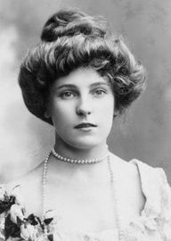

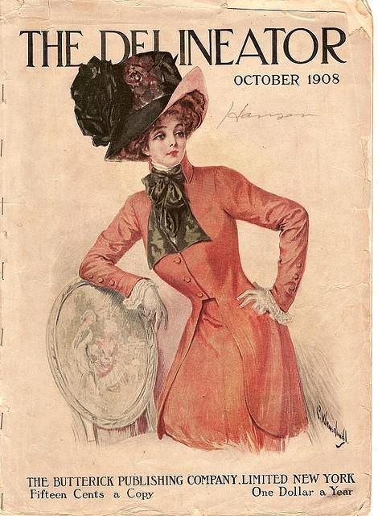 | Jack thought it an extravagance, at 15 cents a copy, but I bought “The Delineator” every month. It was my guide to becoming a mother, a wife and a woman. It taught me not just how to style my hair and present my face, but how to cook and to sew and embroider. These are all things that I never knew, but are now my joy, as well aas being useful. I am a homemaker, you see. Whatever I was before, I do not miss it. I have found my place in life.  My beloved Jack died in 1945, shortly after the end of the war. My boys were blessed with having been born at a perfect time – too young for the First World War, and too old for the Second. Their children too, my grandchildren, were spared war by the chance of generations, and thank God, none of them has suffered any other accident or disaster. So, I find myself the matriarch of a large clan.

Some of the old cottage still remains, in front of the main house on Long Island. The final work was paid for with the shares in Sears Roebuck that I sold in 1960, for a good price.

I look out at the sea from my rocking chair. The Atlantic Ocean. I sometimes think about that ship, now a mausoleum on the cold bottom of a deep ocean. The person I was is down there. I am sure that more stories will be told of that fateful day. Perhaps even the story on two survivors – Jack and Rose.

The End

© Maryanne Peters 2019

