The Joy of Serving
Inspired by a Captioned Image
By Maryanne Peters

My wife was in the catering business. Quite how that turned into a “full service” business is a little hard to explain, but bear with me …

It started like similar businesses in the central city – some sandwiches for meetings, canapes for after work functions, then business lunches with waiting staff, then corporate dinners. The business got so big that I quit my job as a financial analyst to work full time for the business – buying, food prep and occasional waiting tables.

Then things took a weird turn when my wife catered a kinky sex-themed dinner for a major client. I was in charge of waiting staff, but by request they were all scantily dressed girls.

I should say right now that I do not approve of such things. But we were in business. It is not just about not turning down the money, you need to be responsive to the market. You need to give the market what it wants. And the market wants to be served.

My wife understood long before I did. The ideal business has one customer, and no staff. Just us. We serve. We do what they want, and we get paid well to do it. And that is how it ended up. The business, that is.

It was a progression so gradual, with every step making such complete sense, that by the time I realized how bizarre it had become, it was too late.

The scantily dressed girls came to include boys dressed as scantily dressed girls, then (because men are not meant to serve) I had to become a boy dressed as scantily dressed girl. I was good at it. They say that if you want a job done right, do it yourself, and I knew by then, the standard of service that our client expected. My wife did too.

Our business became “The Mistresses of Food”, my wife and I being the mistresses. I just ended up spending more and more time dressed for my role, including preparing and travelling. I ended up shaving my legs and having my chin and eyebrows plucked, and even growing my hair out.

Then our biggest client asked for our price to be exclusive to them. We calculated a fair sum, and then we doubled it. They did not even haggle, but they said that they would set the terms. We both had to sign a “Contract of Indenture” with a penalty bond. I suppose that I could have rea it more closely, but wife and I had the money banked before we earned it. Even when we learned that most of what we earned in the first year would go to build the bond, that did not seem to matter given that we were given board and lodging in the sub-penthouse to the corporate offices. We quit our apartment and moved in.
It turns out that they were less interested in our food than in our bodies, and mine required some adjustment to meet the customer’s exacting requirements.  Of course, nobody would agree to such things unless there was some significant reward. I had always thought that would be the money. It accrued in our joint account. We watched the funds build with some satisfaction.  But that was not in my mind or in my wife’s mid either, as she pulled down my sheer pantyhose and plunged the syringe into my perfectly rounded buttock, while I draped my long brown hair over my shoulder so that it spilled onto my full breasts. No the reward that we now knew that we enjoyed above all things, was the joy of serving.  The End  © Maryanne Peters 2019 | I am ready to serve

The Experiment  Inspired by a Captioned Image  By Maryanne Peters  Barry looked right over Tom’s shoulder at me. I recognized the look. It was a what-do-I-do-now look. I felt as if I should mouth back at him: “Kiss her you fool”, but that would not be the right thing to do. This was an experiment in human behavior, and as such I could not interfere or influence either of them in any way. I just looked at him blankly.  It was the ultimate experiment. Two guys, one pheromone. Could two regular guys fall for one another? | 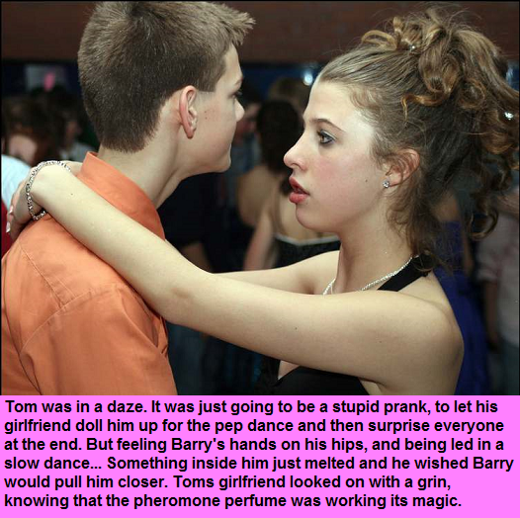

The starting point was to break the barriers in order to get them close enough, and Tom was besotted with me to an extent that would allow that. If he wasn’t then why would he let me dress him as a girl for the school dance?

It was so easy. That shaggy hair of his pulled back with a few well-placed clips and pins, lipstick on those juju lips of his, maybe a little too many hairs plucked from his brows, and a little eye makeup, blusher, fake breasts, Brazilian wax … easy. In fact, he looked way better than I thought he would. Still, he was a guy and Barry knew it.

How close would they get? That is what I wanted to know. Would the pheromone draw Barry so close that Tom would react? I thought that when Barry’s lips got too close to his, my boyfriend Tom would push him away. He would say something like: “Whoa Buddy. I’m a guy remember!”

I just watched. Test your hypothesis. It was an experiment to do that. Set it up and wait. Observe without influencing the result.

But they were getting closer. Barry gave me that look of desperation, and then never looked at me again. His hands were positioned awkwardly on my boyfriend’s back in the beginning, and now they were resting on my boyfriend’s butt. I he was not pushing them away.

Maybe I underestimated the effect that the pheromone perfume would have on Tom himself. He would be affected. He is a guy. The smell of a woman in heat is in the air.

I checked my watch. In the heat of the dance floor the alcohol-based pheromone perfume would diffuse in time. It would lose its effectiveness.

Then when I looked up, I could not believe my eyes – they were kissing!

I rose to my feet. I was going over there. I was going to put a stop to this. Tom, what the hell are you doing. I could not blame Barry. He was alone and biochemistry had deceived him. But Tom was my boyfriend.

Then I stopped myself. This was my doing. By my deeds my boyfriend will be shamed – Barry too. There they were kissing on the dancefloor, and everybody could see them. But it seemed like I was the only one looking.

I had to terminate this. My point was proven. I had a neutralizer for the scent, but it was not in my bag. It was in the car. I needed to get that.

But when I got back to the dancefloor they were gone. Tom was not answering his phone. Barry was not answering his. What had I done?

I hardly slept that night. I tried Tom in the morning several times before I tried Barry, and he answered.

“Tammy is with me,” he said.

“Tammy?”

“We are going to the mall and then we are going to Alexanders for brunch,” said Barry. “You are not invited.”

To hell with that. I went to Alexanders and waited, drinking pots of green tea.

In walked Barry, and with him Tammy. I should say Tom, but with a new patterned sundress on and her hair in a scarf with curls hanging out, and bright makeup on, she was Tammy. And she was gorgeous. She was hanging on Barry’s arm.

They saw me, and sat on the other side of the restaurant. I stood up and went over to them.

“I guess I owe you an apology,” I began. “I was testing the perfume.”

“She smells better without it,” said Barry. “She smells like what she is. A woman. And she’s not a lesbian. So you can fuck off.”

I looked at Tom. The girl he now was smiled at me, and said: “Sorry Sweetie, but Barry is right. I am not a lesbian. He is my guy now. So what he says, goes. That means that you had better fuck off.”

That is a lesson in shame, right there.

The End.

Defeated  Inspired by a Captioned Image  By Maryanne Peters  That is me alright. Look at that shot of me looking about as low as I could get. It was my low point. Look at my arms – no trace of the muscle I once had. Can you see those soft tits on my chest? Can you see those tight “concealing” panties I am wearing? What was left when was tucked away so that I could get into the bikinis that were being packed for me. Look at my face – smooth and blushing.  I used to be everything that my father expected me to be, but when he left my mother and my sister wanted me to be the complete opposite of that. | 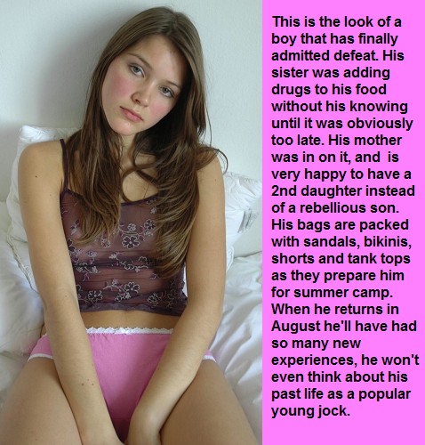

That was me then. Defeated. But the crowning humiliation was supposed to be that camp. That would be when I had to be the girl that I looked like, hiding from everybody the truth between my legs. On the assumption that I would not be able to my embarrassment would be complete. I would be forever that guy – the track and football star now an emasculated sissy.

But sometimes life has a way of working things out. Sometimes the guy you once played against tells you that you look familiar, and like the way you throw a ball, for a girl that is. Sometimes the guy who thinks that you are special turns out to be rich.

So what is a guy to do when that happens. Not be a guy, that’s what. And it turns out that when he is holding you and kissing your neck, it is suddenly very easy to not be a guy.

The other thing that I learned, is that when a guy falls for a girl, I mean falls really hard, a little deformity, provided that it is really little, will not be the end of things. He thought it might be for a while, but an hour or two and then he was back, telling me that there was nothing that could not be fixed if you have money like his family does.

Look at me now. Defeated? No way.

The End

Subliminal  Inspired by a Captioned Image  By Maryanne Peters  I loved my wife once, I think … in the way that a man loves a pet. She was cute and adoring of me, but she was as dumb as a wax oyster.  This whole subliminal suggestion thing is a classic example. What person could believe that a series of flashing lights on your laptop screen, even if operating over a year, could turn a normal heterosexual guy into a man-loving transwoman?  It was obvious to me that she wanted to be with that tech guy, that pathetic scrawny big-eared what’s-his-name. I was past caring for her at that point anyway. I had discovered my true destiny, and that was that I needed to become the woman that I always was inside.  No subliminal messages could make a man take hormones, wax his body and grow out his hair. That was me – my choice. | 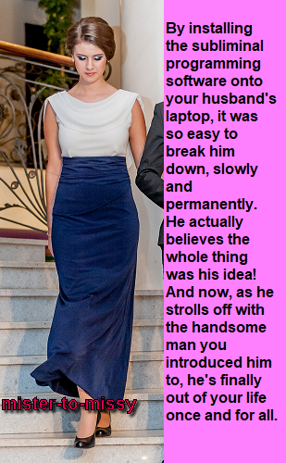

The fact is that some transgendered people repress their feelings of dysphoria so completely that they are almost unaware of their own psyche. And then, having come to terms with it, they need to make themselves complete. They need to modify their bodies and their behavior and present themselves to the world in their true gender, regardless of what others might think.

It was easier for me for the reason that will be obvious to anybody who sees me. I am pretty. So pretty in fact, that what’s-his-name’s friend fell for me big-time. That guy cannot keep his hands off me, and what girl doesn’t like that kind of attention.

It turned out that he is not fussed that I carry a little leftover of my past life down there, just above the stitches. He has to be just the perfect guy.

My wife thinks that I think, that it was all my idea, because it was. It was, wasn’t it?

The End

That is Me
Inspired by a Captioned Image
By Maryanne Peters

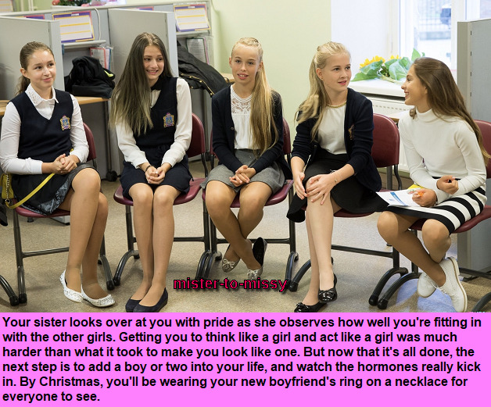

That is me, second from the left with my hair out. Extensions although you would hardly notice. But I could not grow it that long in only 3 months. That is me with my sister in the striped skirt, and all my girlfriends.

My sister is 18 months older than me, but I am taller. She is the smart one though. She left school last year and she is studying psychology. She has always wanted to do that. Something about influences on behavior. She says that she has been experimenting on me my whole life.

She diagnosed my gender dysphoria years ago. She explained it to me first and then we both explained it to our parents. They were shocked of course, but more people understand it now. There is plenty of support for families of transgirls like me, and of course my sister has been a big help.

She also helped build the support group that you see. My three best girlfriends. They have been fully supportive of me, ever since my sister pulled them together. All of them have helped me to become the girl I am today.

My sister helped me with my consultations so that I could get on the hormones as quickly as possible. I did not want to spend another second under the influence of male hormones. I told the gender specialist that I wanted castration immediately, but I was put on blockers. But it was agreed that I go on hormones and I just love them. They have made my hair so shiny and my skin so soft, and my boobies are growing nicely.

My other friends have helped me with my look, and also to correct some of my actions when I find myself doing something boyish by mistake. It hardly ever happened these days – thank God!

So here we are with my sister talking about phase 3: Boys! I am giggling a little, but I can’t wait. I can’t wait to have a big strong boy holding me close and sticking his tongue in my pretty mouth. If he wants to stick other bits somewhere then he might have to wait until I have had the surgery. But my sister says that if he can’t wait (and sometimes boys just can’t) I may be able to use my mouth or my butthole, or both – but definitely in that order.

It sounds a bit yucky, but if I am going to get a commitment before Christmas as my sister says I must, then a girl has got to use all the assets that she has.

Of course I am short of one key asset for the time being. But for now, that is me.

The End

©Maryanne Peters 2019

