The She Mask Beach Party

25. June 2021 Fringe City Beach

“Ahh what a nice Day have fun on the Beach today. Hopefully the Other Girls are bringing their Masks with them.” said Akira as she was on her way to the Fringe City Beach to host a huge Beach Party for all of her friends. Akira invited all of her friends like Kasumiko with her Mother Sanako, Mia Deltoriis, Midori, Ray, Sheila and Isserlyn but that were not all because Akira’s little Sister Nanami is invited too. Akira have seen her not for over a year because of all of the COVID-19 mess and she is really happy to see her little Sister again soon. Akira also knows that Nanami is now a famous Model too and that makes Akira even happier.
Finally, Akira arrived at the Fringe City Beach where she sets anything up really quick to have some Fun at the Beach with the other Girls. Then the first guests arrived at the Beach it was Kasumiko with her Mother Sanako. Sanako looked exactly like Kasumiko but her hairstyle was different and she had green hair and other than Kasumiko Sanako was a Full grown up nine tail Kitsune Girl. Sanako wears a sexy red bikini which fitted her sexy Curves pretty well. Next to her was her daughter Kasumiko.
Kasumiko is wearing her favorite Purple Bikini with the Leaf sign on the Bikini top and of Course Kasumiko knows that she has an awesome Beach Body and so she is posing Sexy for the Guys that where at the Beach and then she said “Hey there! Your sexy Kitsune girls have arrived! <3”
Shortly after Sanako and Kasumiko, Sheila arrived at the Party and Sheila is wearing a Sexy Yellow Bikini which hugged her Body quite nicely and she said: “Hi Akira! I’m ready for the Party!”
After Sheila, Isserlyn arrived at the Beach and Oh Boy! She really is looking hot in her Black Bikini. “Hi there, Girls! I hope you’re ready to have much Fun! Hi Kasu you’re looking hot in this Sexy Bikini.” she said. Then she hugged Kasumiko and they give each other a really passionate Kiss and then Kasumiko said: “Wow! Iss you’re looking hot as well in this Red Bikini. <3”
The last ones that arrived are Ray who is wearing a sexy heart shaped Bikini, Figuchan the Cat Kemonomimi wears a sexy yellow Bikini and of course Akira’s little Sister Nanami. Nanami is wearing a sexy Pink bikini similar to that from Kasumi from Dead or Alive Xtreme 2. Nanami is Akira’s little Sister but her Body is really hot too and the Bikini presents all her Sexy curves amazingly.
“Hi girls nice that you have arrived welcome to my Beach Party I hope you have all brought your Mask with you we will have so much together! I have organized a Photoshoot where we all pose for a Sexy Calendar and of course we will play some Beach Volleyball too but first we need to get ready for all this hot fun!” announced Akira.
Then Akira goes to her little sister and hugged her and said: “Finally we see again Nanami-chan ^^ How are you doing so far?”
“As you can see, I’m Fine and damn Akira you’re looking hot in this Bikini. I also have brought my own mask with me but it’s a bit different.” said Nanami.
“Huh? Can I see it?” asked Akira.
“Sure, why not.” replied Nanami and handed Akira the Mask over.
“It almost looks like Ray’s foxy Mask but this here seems more traditional to the Japanese culture but it looks really old too.” said Akira as she inspected the Mask.
“This is the Mask of the Japanese Goddess Izanami and is called The Mask of Izanami I have found it a while ago on my way back home from work and when I putted it closer to my Face it jumped in my Face and transformed me into an really Sexy Catsune and from then I’m Nanami the Catsune maybe you have seen me in one of the Japanese Model Magazines.” said Nanami.
“Ah yes! You’re that Sexy Catsune girl with the Red Face on the last Bikini issue of Japanese Models Illustrated. You’re looked really hot but I haven’t you recognized but now all makes sense Sister.” said Akira.
After some more chatting with the other Girls on the Party Akira then decided it is time to put the Masks on but Figuchan has no mask and she would be the only one Girl to have no Mask and Akira needed to fix it. Then an idea comes to Akira’s mind, she goes to Kasumiko and asked her if she can make a working Copy of her Mask for Figuchan. Kasumiko said: “Sure, no problem.” And a few seconds later Kasumiko has make an exact Copy of Akira’s Mask of Loki.
“Thanks for helping me out Kasu.” said Akira.
Then she headed to Figuchan and said: “Here take this mask. You will need it for this Party.”
“Oh, thank you Akira. B-but what will this mask do?” asked Figuchan a bit confused.
“It will make you much sexier! Don’t worry I’m sure you will love it.” answered Akira.
Then Akira announced that all girls should put on their Masks and so the girls did it starting with Figuchan who was the first to put her Mask close to her Face.
The Mask jumped out of Figuchan’s Hands directly into her beautiful Face then quickly after that Figuchan feels a massive pain and she tries to remove the Mask from her Face but without any success. Quickly after that initial phase Figuchan then feels that the Pain is fading away and instead she starts to feel more and more pleasure. Then her Body starts to change too. First Figuchan’s legs become more longer and more feminine, her hips get a little bit wider and her Ass firmed up and gets bigger and sexier. Figuchan’s waist gets slimmer and her belly gets flat and sexy and shortly after that her abs gets more toned giving her a sexy Six-pack of course her breasts gets bigger too and they’re growing from Figuchan’s initial C-Cup to a huge Double D-Cup. But that was not all Figuchan’s Cat tail grows a bit longer and a bit fluffier also her Cat ears becoming more ears of that of a Lynx. Her yellow Bikini also changed into a sexier Bikini which hugged her expanded Body nicely.
In the meantime, Sheila has put her Mask on too and of course she already enjoys the feeling of the Transformation. First Sheila’s legs get a little bit longer and sexier, then her hips are getting a little bit wider and her waist shrinks and her Butt grows a little bit bigger giving Sheila a sexier look at all. Of course, her Breasts are getting an upgrade too. Sheila’s breasts growing from her original B-Cup to a huge D-Cup. Sheila now wears an even sexier yellow Bikini.
After Sheila it was Kasumiko’s turn. Kasumiko was already in the Middle of her transformation and she moaned lustfully as her legs grows longer and sexier. Of course, the rest of her Body is getting a huge upgrade too giving Kasumiko an real Beach Goddess Body with huge Breasts, a firm and Sexy Ass, a slimmer waist with a sexy Flat and well-trained belly with sexy Six-pack Abs.
Then it was Ray’s turn and instead of the Mask of Loki she uses of course the Creatius Mask also like Kasumiko she is already in the middle of the Transformation. Ray’s Body starts to get sexier by every second. First her legs get longer shortly after that her hips are getting a wider and her Ass grows. Then her B-cup breasts starts to get bigger until they stopped at a Double D-Cup. Ray moans in pure pleasure as the transformation goes on and finally nine tails are growing behind of her back and her hair are getting longer and changed the Color from Black with purple to Gold blonde in color on her head. She also gets two Fox ears. After the Transformation was finished instead of Ray, Massa stands there in the middle of the Beach wearing her sexy Blue Bikini.
After Ray it was Sanako’s turn the already sexy Mother of Kasumiko has already gone though the most of the Transformation and of course she has got a huge Upgrade. Sanako’s breasts are now a Huge E-Cup and ger Ass is extremely big and firm. Her abs got more toned and like Kasumiko she has a Sexy six-pack. Her nine Fox Tails are now longer and much fluffier. Sanako wears now an even sexier red Bikini. She was also one of the First to be finished.
A short while after Sanako Akira was finished with her Transformation too. Akira’s legs are now much longer and sexier and her hips are a bit wider, her waist has shrunk a few centimeters and she got a really Sexy six-pack. Akira’s breasts are now a full Double D-Cup which was close to an E-cup and her already firm Ass is now even more firm and bigger. Akira wears now a sexier Version of her purple Bikini which showed of her awesome curves nicely.
Then Isserlyn’s Transformation was close to finish. Isserlyn feels much pleasure as her legs grow longer, her hips wider and her waist slimmer. Of course, her breasts grow several Cup sizes from her D-Cup to a full and sexy E-Cup which was close to an F-Cup now. Also, her Ass firmed up quite a lot making it super firm and of course bigger and sexier. As Isserlyn can’t hold back anymore because of the pleasure all of her nine tails burst out and she moans in pure pleasure as the feeling was orgasmic for her. After the Transformation Isserlyn stands on the beach right beside of her love Kasumiko in an even sexier Bikini and she said: “Oh that feels Awesome! Come on girls let us have some fun! But first I need to have some Fun with my Kasu-chan. <3”
Finally, it was Nanami’s turn to put her Mask on. Nanami put the Mask of Izanami close to her face and then it jumped out of her Hands right on her cute Face. Then the Transformation begins. Other as the others using the Mask of Loki Nanami instantly feels a pure wave of pleasure cursing through her Body and she can’t hold back and starts to moan in pure pleasure. With every second Nanami gets more and more sexier. First her already long legs got even longer and sexier then her hips are getting wider and her waist shrinks a few centimeters. Shortly after that her flat belly gets perfectly firm and she gets a Sexy six-pack like Akira but a bit more defined. Then her C-Cup breasts starts to expand until her breasts reached the size of E-Cup breasts.
With every second Nanami starts to moan louder and louder. After that her hair gets a little bit longer and her hair color starts to change from brown into a Blue with Red Tips and then she gets two cute Cat ears on the head and her teeth reshaped a little to give her cute cat like Fangs. Then Nanami got two sexy Cat tails and shortly she gets two fox tails too. The tails where also Blue with Red tips making her more of a Catsune girl.
After the transformation stopped there stand a completely new Catsune Nanami on the Beach. Nanami wears now an even sexier Version of her Bikini but instead of the Other Girls her Face is not Purple or Green. Nanami’s Face is instead light Red and she wears a sexy blue eyeshadow and her lips are fuller and dark purple in color.
Nanami makes a sexy Pose and said: “Good to be here with you sexy girls! Let’s have some Fun! Nya~!”
After all girls where Transformed the Party could now begin and Akira announced: “Wow! Girls you’re looking awesome! Time to have some Fun! First let us play some Beach volleyball and then were heading to the Photoset to make some Sexy pictures together.”
After several rounds of really hot Beach volleyball all Girls then headed to the Photoset and they are doing one of the sexiest Photoshoots of all time. First Isserlyn and Kasumiko are doing some hot poses together and then Massa have her fun with Akira. After that Sheila and Sanako are posing together and then Figuchan with Nanami. The two Cat girls doing one sexy Pose after another. Then each girl poses for her Own and so there are enough Pictures to fill an entirely sexy Album of hot she Mask Pictures.
After the Photoshoot all Girls have some more Fun on the Beach giving the Guys a good show and all of the Girls are enjoying their time together.
The end.

Thanks to all Patrons who made this Possible and for the following people:
RayDark for Ray Dark and Massa
MegaLinx for Sheila and for Creating my OC Sanako
Figuya.com for creating Figuchan
Isserlyn for letting me use her OC Isserlyn
My Girlfriend for creating Kasumiko and Nanami for me
Myself for creating Akira

A little Bonus below:
A Picture of Figuchan in her Bikini:
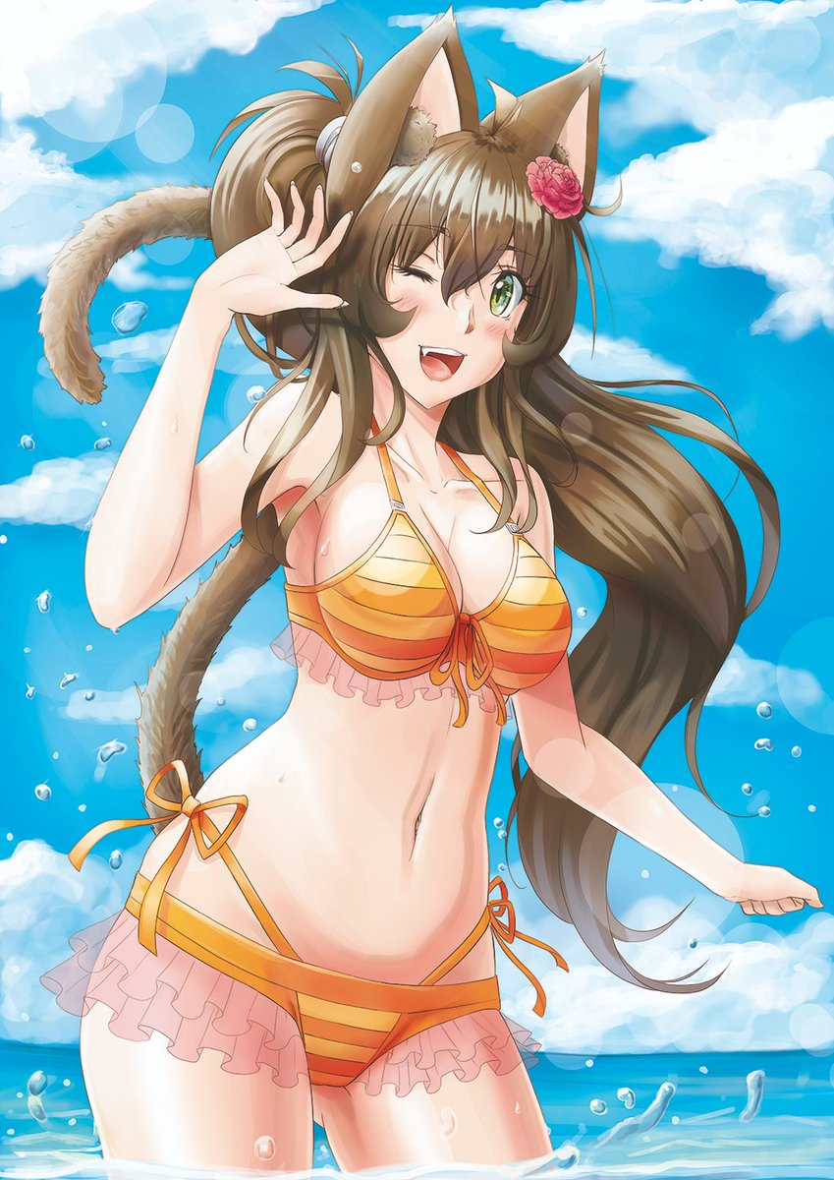

Kasumiko wearing her Bikini:
