Trader Girl
Inspired by a Tiffany Captioned Image
By Maryanne Peters

Stock and commodity trading is a tough business. People say the best traders are the macho types. It is true that we were an efficient and effective team. We worked hard and handled some big trades and when the bell went, we could drink hard too. It was in one of those sessions, maybe after a few too many, that our head of trading told us the bad news.

“In the old days this was a boy’s club, but now we live in different times – affirmative action – we need to have women in the deal room. I am sorry guys, but we are going to have to make room for women in here … unless one of you is prepared to wear a dress to work.”

Everybody laughed, including me. But it was a serious issue. There were only so many seats on the trading floor, only so many terminals.

The mood changed as we started to consider who would have to go. All too young for early retirement, and all too hungry to quit. So LIFO? – that is, last in first out. That meant me.

To that I said: “I might be prepared to wear a dress rather than be tossed off.”

I said that I might be prepared, so I had conditions. No more cutting the junior out of the big deals going. And a girl has to dress right, and have her hair done at least once a week, and be treated right. That was my bottom line. Successful traders build their own fund and then work it. Pretending to be female was not a long-term thing, or that it what I thought. Somebody mentioned a year. That was what I told my girlfriend.

“I just need to pass,” I told her. “It’s your business. You know all the tricks.”

Out of nothing she got really pissed. She said: “Tricks! There are no tricks! Beauty comes from within. If you want my help with this crazy idea then I will make a woman out of you, starting by scrubbing out the man in you. So lose that attitude. You have to start from the bottom and work your way up. You are right, beauty is my business and I am good at it. I will not do this by halves.”

She was not lying. The ground up meant starting below the skin – right at the root of every hair on my body. Except my scalp of course. She said it had to be my hair. That meant a little surgery to pull my scalp forward, and some drugs to stop further hair loss, and extensions that I would need to care for as my own hair.

“For a year it is worth investing in breast implants,” she said.

“But how will I be able to take a day off with a pair of tits on my chest?”

“There will be no days off. You are taking a woman’s job. Only a woman can do that. This is not a costume – this is a way of life. Your employer needs a woman on the staff – if that is you, then you are a woman.”

I thought that she might have some fun with it, but she was serious. She said that all the guys at my office were the worst kind of males, and – “Perhaps you might find that out when you are the only woman.” She said that she did not like doing it, but she would and she would do it properly.

I remember that first morning when I went into the office for the first time in women’s clothes with my hair extensions freshly straightened and shiny, my legs freshly shaved, wearing my purple dress and my adorable black bolero jacket and the heels I had been practising in all weekend.

I gave her a little smile and she wished me well – told me to go out there and give ‘em hell. But I think that I saw a trace of a tear in her eye even then. It was like she could see into the future and see that this meant that we would never be together in the future. It was like she could see that I was just too pretty to ever go back, even on that first day. She told me that I was good at my job – “one of the top up and coming traders”. It was like she could predict that being a woman would take me to the very top, which is actually what happened.

The End

© Maryanne Peters 2021

Spotted  Inspired by a Captioned Image by Tiffany  By Maryanne Peters  Anybody who has trawled through the job postings the way I had would understand. I was ready to anything to get a job. Anything!  It was not as if I was qualified or strong enough for a manual labor. I was neither.  My father would tease me: “There is no work for long haired pretty boys, unless you are ready to wear a dress to work!”  That stung, but it put a seed of an idea in my mind.  Down at the mall they were advertising for “Presentable young women required to attend mall kiosks – no qualifications or experience necessary.  I just thought that I would try for the job. All I needed was to raid my girlfriend’s wardrobe. | 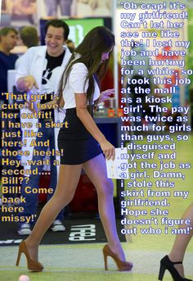

I just needed one of her skirts and blouses, and some tights and shoes. She had so much stuff! It was not hard to find something. And I needed some of her shampoo to wash my hair, and some conditioner and a good brush to make it look like girl’s hair, with a center parting. I went to Sephora to get my makeup done just before the appointment. I just wanted to see if there was any chance to get the job.

I did the whole thing in a voice that I thought might work. The lady asked me whether I was a smoker and I said that I wasn’t. She said that my voice was “mature sounding, and that is a good thing”. And then she asked – “Can you start tomorrow”.

The problem is that they pay good money to man the kiosk and a commission on sales, and It turns out that I can sell. I really want this job now.

Then she spotted me. My girlfriend whom I had avoided for weeks. I told her that I had a job and she was happy for me, but then she caught me out at the mall and I was wearing her stuff. I just tried to put my head down and walk away.

“Come back here, Missy,” she snapped at me. I turned and she was smiling. “So this is your job. Well, at last you have a reason to get out of bed. A job will be good for you, but I am not sure this look will be good for our relationship. But never mind, the first thing we need to do is collect your pay and then get you some clothes of your own. Then perhaps we can find a couple of guys and double date Girlfriend!”

The End
A Cure for Back Pain
Inspired by a Captioned Image by Tiffany
By Maryanne Peters

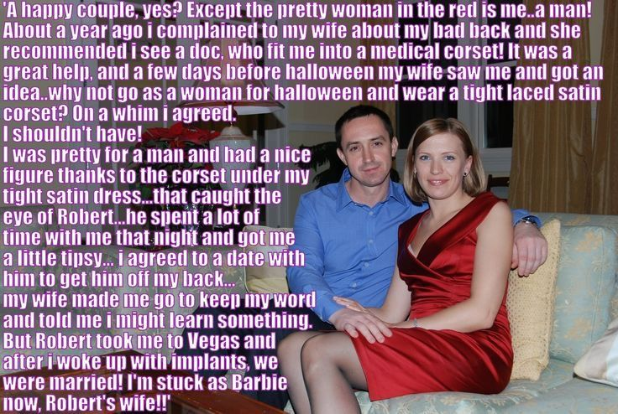

To look at us now you would think that I have always been what I appear to be – a woman. You might think that I had labored for years under the oppressive pain of gender dysphoria. I know what that is now, but I never gave it much thought. Back pain was my burden.

If I had any feminine thoughts they might have arrived around puberty, but as my bones grew at the same time I first felt the spinal agony that was to plague my life until recently.

All the doctors that I saw had no answers. All the tests, and the scans and the x-rays revealed nothing. The word “Psycho-somatic” was even mentioned, as if my brain was inventing this torment. Why? Why would the brain, even the subconscious one, inflict this distress on me?

It was a wonder my wife married me. All our milestones seemed to have been marked by men collapse ng in pain – our first few dates, my proposal of marriage, even our wedding day. I was double up. I went through it all with gritted teeth. Psycho-somatic? Are you kidding me?

The alternative doctor was her idea. I mean he was a doctor of something. He talked about curing the whole person. He talked about looking into his patients right to the core of their being. He talked about the spine as being the structure upon which the body is built – the foundation of personality such that extreme pain in the spine indicates something completely misplaced.

To be honest I took it in but did not really understand it. I can be a bit impatient, at least when it comes to discomfort. I wanted to know what the cure was – and fast.

“You need a cleansing and you need a corset,” he said. “The corset will help to reshape you, and the removal of all your body hair except for the scalp, will give you the chance to start afresh – a clean slate, we like to say.”

Honestly, I would have done a lot more than that. It seemed a small thing, to at least try.

My wife came up with the Halloween idea, but she said that she had discussed it with him – I suppose to check that the black women’s corset could do the same job as his white medical grade one. But I was ready to go out in any costume at all. This was the first few weeks in which I had been 100% pain free. I felt like celebrating.

My wife dressed me up and coached me on a few actions and lines to deliver in a feminine voice. You know what women are like – “Don’t dress as a woman and then embarrass me by doing it badly. At least try to get this right.”

Like I said, it was her idea. It was even her who introduced me to Robert. Then I looked around for her and she was gone.

I should not have been attracted to him, but I won’t lie – I was. Maybe there is something inside everybody that can trigger that kind of attraction, even if is not across the sexes like it should be. His attraction to me was more understandable. I mean – I looked like a woman. He insisted on asking me out for a date. What was I supposed to say – “Sorry, I have a wife. No, I am not lesbian I am a guy”?

I said yes, but when I got hope and sobered up I said when he called I would tell him the whole story.

My wife said – “Oh no, you will not do that to him over the phone. You said yes in person so if you are changing your mind you need to explain in person too. Do it. You might learn something about yourself.”

The idea was that I would go out to a movie with him and after the show I would just blurt it out – “I am sorry for leading you on but you seem like a nice guy so you need to know …”. Whatever.

But it was a sad romantic movie. I ended up in tears and he held me and kissed me. Suddenly everything changed. It was like a whirlwind just picked me up and set me down, not in Kansas but in Nevada – Las Vegas to be exact.

The back pain has gone, which is just as well – since we got divorced and married to Robert, he has me spending al lot of time on my back.

The End

I Love Dresses  Inspired by a Captioned Image by Tiffany  By Maryanne Peters  I don’t know where people get these crazy ideas from. Probably from those TG fiction sites, where it seems a daily occurrence that a regular guy gets turned in a gorgeous man-loving woman. I just don’t believe it. Do you?  The truth is that I always wanted him. To see him with her drove me crazy, but that is the man he is – he loves women, not men, the way I used to be.  Of course I stole her away, just prove how shallow and flaky she was. He was pissed … of course he was, but we were pals – he was not going to kill me. He just wanted me out of the game.  I put the idea into his head. I sneaked the link onto his tablet - “Don’t get mad at your rival, feminize him”. A website explaining how it can be done. | 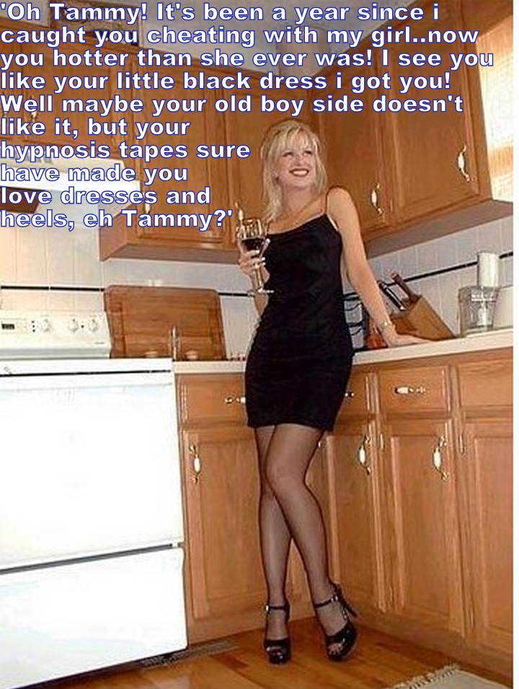

But it was a complete fabrication. I do website design and coding for a living. The whole thing was a set up. The pitch, the testimonials, the box to order the “hypnosis tapes” – the whole thing dreamt up by me, and swallowed up by him.

You love who you love, and it doesn’t matter how dumb they are. All I expected from him was his essential goodness. I started with all that “Buddy, I feel weird, I feel I need to wear dresses”.

He said: “Just stop listening to those relaxation tapes I gave you, and you’ll be okay”.

After that I went back and told him: “I destroyed those tapes like you suggested a few days ago, and I do feel better, but yesterday I had electrolysis and had my whole beard pulled out, and I feel even better.”

Of course he buys me dresses. Initially it was because he felt guilty, but now I am sure that it is simply that when we are out together he wants me to look as beautiful and feminine as I now feel!

I love dresses. The fact is, I always have.

The End

Old-Fashioned Girl  Inspired by a Captioned Image by Tiffany  By Maryanne Peters  He wants me to dress the way I did when I first met him. It is a style that I have grown used to. I can wear modern fashion, but I have learned that this is what he really wants is an old fashioned girl.  “It is just that every modern woman is not interested in being a woman,” he has been known to say, which is why he chose as his wife somebody who was not a woman … at least not when he met me.  He never knew. We talked at the party, and he never guessed that I was a guy. In part that was due to the excellent work of my wife Nancy. She used my real hair and did a great makeup job, and with corsetry she gave me shape and just enough of a cleavage. | 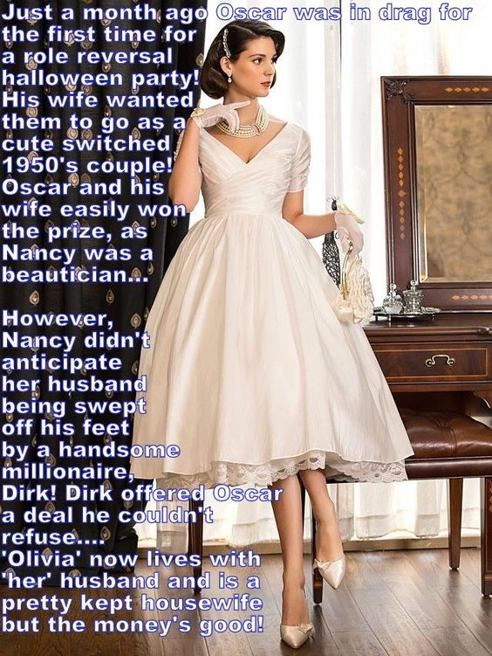

“My name is Dirk,” he said. “You may have heard of me.” The penny dropped. I knew who he was. And he was eating out of the palm of my hand. So I offered it to him.

“Olivia,” I said. “I apologize but I don’t know who you are. It is something to do with business? I really don’t know much about that. I think business is for men, don’t you? Politics too. I am interested in fashion. Fashion and beauty. I do like wearing full skirts like this one. Don’t you think they look so feminine? Shall I give you a twirl? I have to say that I favor the fashions and values of another age. I just think that women today tend to wear too much black and grey. And you can see it in the way that they behave too – black moods and grey personalities. So sad.”

“I know what you mean, Olivia,” he said. “You are like a breath of fresh air. And on that note shall we step onto the terrace.”

Why not. Even if you consider yourself solely heterosexual there is something about being admired, and being admired by a millionaire, that acts like an aphrodisiac. And the truth was that I was not solely heterosexual. I had dabbled in anal sex with a guy in college.

Of course it was cheating on my wife. It just seemed that because it was a dalliance with a guy that it could never really amount to anything. It was just that we both shared ideas about what was the ideal man and what was the ideal woman. The man should be rich enough to give his girl anything she wants, including kisses and romance, and a woman should be a woman and nothing else.

When he called me the following day I told him that I could be that kind of woman, but that it would take a major effort, because I was not a woman at all for the moment.

Of course he was shocked, not the least because he had put his tongue in my mouth at the party, but a couple of days later he called me back and said that he could not stop thinking about me.

“I sort of like the idea of building the perfect woman from the ground up,” he said. “I have been looking for an old-fashioned girl, and at the party I found her. The bad news that followed was that the body needs work, but I can afford that. The woman that I want is inside you. We just need to remould the surface.”

I know what you are thinking – but you are a married man – what about Nancy? I would not like to be though greedy for choosing wealth, because for me it soon became love, but Nancy was happy to take the money and leave me to Dirk.

As for the remodelling, well you might say – “How could you agree to that?” The answer is simple. If that is what my man wants, then I will do it, without question. It is just the way I am. I am an old-fashioned girl.

The End

© Maryanne Peters 2022

