Extended  A Vignette  By Maryanne Peters  If I don’t look happy about it, it’s because I wasn’t. I had tampered with my sister’s shampoo so she ended up with purple hair the day before the big dance, so my mother agreed upon the punishment.  “You need to understand what hair means to a girl, Mason, so you will spend a month with girl hair.”  That is Nesta putting in the extensions while I am sitting there in a print dress and with makeup on my face. It was more than just having the long hair half way down my back, it was not being noticed. . | 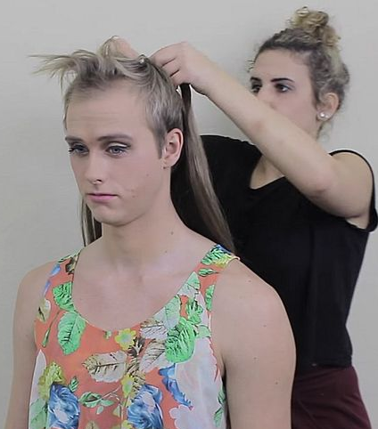

And they were right, the only way to do that was to dress like a girl and spend the whole summer that way
She said that I could work at the salon as well, sweeping up and keeping stock, and washing customers’ hair and learning all about caring for hair.

What is hair anyway? It is just stuff that grow out of holes in our skin. Why is it so fascinating? I guess that I had always liked long hair on girls, but I never realized how much I would like it on myself.

After the extensions went in I hated it at first – hair in my eyes and my mouth, dragging in my food – how do women put up with this? Because it is wonderful – that is the answer. Once you understand just how beautiful long hair is when it is properly looked after, you realize how attractive it can make you look. Women look at you with envy, and I guess men look at you with lust. You just can’t help help flicking your soft tresses over your shoulder and smiling.

I can even feel it when make back is turned. I like to put my fingers behind my neck and flick it out, sometimes more than once so it ripples and shimmers like a fall of silk. I can feel his eyes on me. It is unbelievably sexy.

It was not as if I was gay – or not to begin with, anyway. It is just that being desired like that makes you respond, and want more. It was like I had discovered that the person I was, was somehow boring and inadequate. What I needed was to be extended – to become a version of me that was wanted, and wanted fervently.  The extensions I was forced into that summer extended me that way.  Oh no, these are not those extensions. That was years ago. This is my own hair now. Do you like it?  The End  © Maryanne Peters 2023  439 | 