My Sexy Trans Wife
Inspired by a cap by Becky for John Number 76
By Maryanne Peters

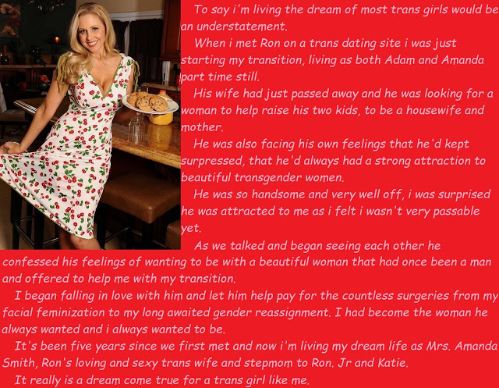

I am not sure where these feelings come from. I still consider myself 100% heterosexual because Amanda is 100% female … or very close to 100%.

She was still working days as Adam when I met her, but I had no reason to see her in that role. After work she became Amanda, so I can honestly say that I never met Adam. I have seen some images of him, but I prefer not to think about him at all.

Amanda was clearly not complete when I met her, and she was still “a little rough around the edges” as you might say. Somehow that just added to her charm. It is like “My Fair Lady” or “Pretty Woman” – you find an uncut diamond and you have a hand in polishing it into a priceless sparkling gem. There is something special in that.

I suppose that the best thing about her was that she wanted to make herself into the image of the woman I wanted. In my experience all women, including my late wife, wanted instead to make the man. I have heard it said that marriage is all about learning about the man your wife would have preferred to marry. I do not mean to speak ill of her, but it was like that. To Amanda I am what she wants and she just wants to be what I want.

And then there is that feeling of power when you are deep inside the body of somebody who may once have been your physical match. The loss of maleness and the muscles rendered flabby by hormones make her so weak that you feel immensely strong, especially when she cries out as your seed fills her.

Is that it? Is that why I went looking for a woman on a transdating site? Maybe it was just curiosity? Maybe it was just the fact that I knew that with a transwoman I would have none of her children to deal with, or any children of ours together. I was happy with my two children who were of my blood.

Perhaps I thought that if I found the right “woman” she could just move in and becomes a nanny and fuck-buddy. I have heard it said that transwomen are good in both roles.

But Amanda was a revelation. Even in her ‘rough state’ she was so completely feminine and just desperate to be rid of the last traces of manhood in her body and her presentation, that she just drew me in. If I was not in love with her on that first date, then I soon was once she had quit her job and any life as Adam and moved in with me.

I paid for all of the surgeries and I was happy to do it. I have polished her to the cut and color of a perfect jewel. I love her to bits and so too do my son and daughter.

She is perfect. She is my sexy trans wife.

The End

Newly Minted Woman
Is this a Becky Captioned Image? Number 77
By Maryanne Peters

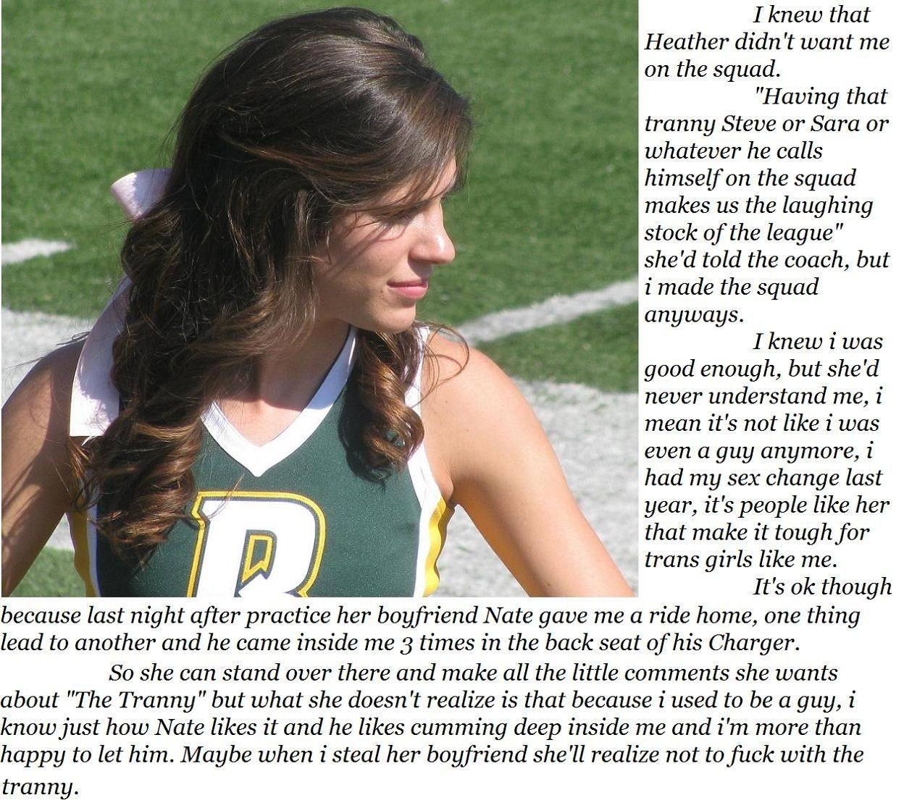

This is me. I don’t mind being called a manhunter. I know who I am and what I am. I am a woman. Sure I have not always been one, but that is what I am now. Call me “tranny” if you like. You can even call me “Steve”. But it’s “Sara”. That is who I am. I am a woman and I love men.

I have not changed my face. I am happy not to. Take me or leave me, this is who I am. I want to be pretty of course. I have been through the electrolysis. I use make up, and I use it well. And my hair? I know that it is great. I have grown it long and I keep it in top condition – better than most. I like curls or waves for volume as well as length, and bounce when I toss it is boys’ faces. That is what I do.

I keep in good shape physically, the way I always used to as a guy. The hormones have robbed me of muscles but made up for that by giving a tidy pair of breasts, a shapely butt and great legs. Why not be a cheerleader? Why not show the guys what I have, and with all those high kicks I show them what I don’t have as well. They can all see and guess what my vagina might be like. Well, it is deep and warm and made for just one thing – men. I like the lube with a bit of heat in it. It’s an improvement on nature, I assure you.

But most of all what I have that other girls don’t have is knowing how the male body works, and how the female needs to work it. You only get that knowledge from working the other side, and I did my fair share there. You can call it my hunt for gratification, which really only ended when I gave in an accepted that my fate was female.

So this is me.

Nate is great, and he has a great car, and three times is pretty damn good. But the thing about women is that we don’t have to get it up. We don’t have to wait for the system to recover, for the blood to flow back or whatever. We can just say: “Hey, when are you going to fuck me again? I’m hot and ready!”

So look out, Heather. Watch you back. Keep a hand on your man. Call me “Steve” one more time and I am treating him as fair game. And once he has been inside me, he is going to understand that the best kind of woman in the newly minted woman.

The End

© Maryanne Peters 2021

Grandpa’s Girl
Inspired by a cap by Becky for John Number 78
By Maryanne Peters

When you get to my age you look back on your life with a mixture of pride and regret. I suppose that I can be happy that I am proud of much of what I have achieved. I have not changed the world, but I have done it no harm.

I am proud of my choice in a wife and she has stood by me all these years, so perhaps I can be proud of being a good husband.

On the whole I was a good father too, but I had some regrets about how I raised my boys. When my son told me that they were expecting a child, a boy, I hoped that I would be a truly great grandfather. It seemed to me that I could give this young fellow some of the advice, attentions and exposure to experiences that I was just too busy to give to his father.

Young Chris appeared to be everything that I hoped for in a grandson. He was fit and healthy, and attentive and respectful. We bonded in a special way.

I liked to take him fishing. We would just dangle our lines in the water and talk – softly, so as not to disturb the fish or nature itself.

It seemed to me that young Chris was a sensitive boy. He was able to appreciate beauty in things, and that is good. Too many young people rush by the wonders that make up life.

It was only because my wife and I had taken our “trip of a lifetime” to Europe the previous summer that I had not seen young Chris for that long. But we stayed in touch. We looked forward to our time together when we would stay over for the holidays.

Then I got a call from my daughter in law. I came out of the blue like a sniper’s bullet.

“I just feel that I need to tell you that Chris has changed a great deal since you last saw him,” she said. “I know that he has not said anything to you about this. He is close to you as you know, and he is so afraid of upsetting you. He does not want anything to drive a wedge between you.”

“That would not be possible, my Dear,” I said to her. “We are the tightest of pals. Nothing could change that. And he is a fine young man.”

“But that’s just the point,” she said. “He is not a young man anymore. Over a year ago we learned that Chris was transgendered. All this time he has been slowly but surely transitioning from male to female. He is Chrissy now. She is a beautiful young woman, looking forward to the surgery to confirm that as soon as possible.”

It was hard to comprehend. I mean, I have heard of this transgender thing. It is in the news. Men dressed as women have been around for a long time. I may have even been to a drag revue once or twice, but surely not my grandson!

I decided that it was my duty to read up about it. I have access to the library and more recently I have been using the internet. I read all about the tragedy of those who failed to transition, or those abused when they did, but also about the happiness of the success stories. Most of all I learned that it was an innate thing. It was not down to Chris parents or anybody else. It was just the way he was born – and I needed to say “the way she was born”.

If learning about this was a shock I was barely ready to meet Chrissy for the first time. Frankly she took my breath away. Such a pretty girl with so much hair, long and dark and in soft curls. She wore a pretty dress and makeup just to show me that she was really a girl, and maybe to make sure that she looked nothing like the boy Chris.

But yet I could see that she was the grandchild I loved so much. There was that attention and respect, and the true bond of love in her eyes. I could not wait to put my arms around her. My granddaughter. Grandpa’s girl.

The End

© Maryanne Peters 2021

Frat Bro
Inspired by a cap by Becky for John Number 79
By Maryanne Peters

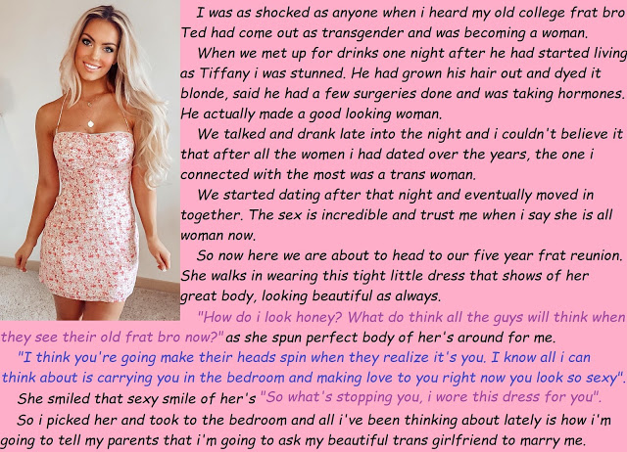

A few of the guys turned up with wives and girlfriends, so we thought nothing of it when Mike turned up with “Tiffany” – nothing except that Tiffany was clearly the best looking of any of the women attending the reunion. Some of the guys were thinking – ‘How the fuck could pull a girl like Tiffany?’ I mean she looked like a swimwear model with the body and that blonde hair halfway down her back.

“You might remember my girlfriend,” he said. “She was at college with us.”

“I am sorry Tiffany,” I had to say. “Which sorority were you at?”

“No sorority,” Luke answered for her, but she just smiled. “Looking at her while straining my memory was just an excuse for staring. We were all doing it. She had to tell us. Too many eyes were burning her.

I was down the hall from you, Silly,” she said to me. “Only I was Ted in those days. Ted Fowlds – the skinny guy.”

Everybody standing in our group fell silent, some with mouths open as if tongues had been plucked out.

“Wow’. Somebody said it. It could have been me. We were all thinking it, if that is even a thought.

“Obviously I have made a few changes,” she said, playfully swinging her hips.

Silence.

“We have been together for a while,” said Luke. “I can’t imagine being with anyone else. Honey, I am sorry for springing this on your. I was planning on telling my parents when we head to them after this reunion weekend, but here surrounded by people who know your past, I really can’t wait to ask you … Tiffany Fowlds, will you do me the honor of becoming my wife.”

“Wow.” Somebody else said it. It was not me. It was not Tiffany.

“Yes, yes, a thousand times yes!” she said. “I will be your bride.”

These are not the words that you expect to come out of the mother of a frat bro at a reunion weekend.

The end

© Maryanne Peters 2021

Stress Free Life
Inspired by a cap by Becky for John Number 80
By Maryanne Peters

I worked in public relations. It is stressful work. Your clients’ problems become your problems. Sometimes that it seems that everything is your fault, or the people talking to you make you feel as though it is.

I took on more work than I could handle too. It seemed easier to do that, so that I did not need to have a life outside of work. It was fear of that life, I guess. The fear that I might destroy myself somehow.

I suppose the various people who are like me always deal with their issues differently. For me it was work. As long as I was working, I had no time for regret – no time to think about what I should have done when I was younger, and how transition might have been easier if I had. I was too busy – I made sure of it.

I know there are transpeople out there who find other ways. They get married and have a family and tell themselves that a rewarding private life will correct them.

My problem with that is that you suck others into your nightmare. I figured that at least with work I had no commitments that I could not leave behind one day.

I had no time for dating, so certainly no time to chat to potential partners. If I had then I would have faced the question whether I wanted to date a woman pretending that I was a man, or date a man pretending that I was a woman.

No, I met John professionally. He was passing on a client as there was a conflict of interest. He had heard that I “give everything to my clients”, and I guess that was true. All I had then, was who I was then, and that was not so much.

We were talking about nothing in particular, but it was work without calling for concentration, so it was a welcome relief. Somehow that subject got on the subject of transgender women – don’t ask me how.

“I hope that you don’t think that I am weird, but I think some of those transwomen are very attractive,” said John. “Even the mature ones who leave it until later in life. I am not sure what it is but it seems to me that they have found a state of grace, like living one life and moving on to a higher state.”

What a thing to say? But it touched me. Somehow it seemed as if fate was sending me a message through this total stranger. For the first time in my life I actually told somebody the truth about myself. The words just spilled out.

“Actually, I am a transwoman. I am a frustrated transwoman living as a man.”

I felt like bursting into tears but at the same time I felt such relief that I really understood what the words “getting a weight off your chest” really mean. That was exactly how it felt. It was as if I had been gasping for air with a pile of bricks on me, and then suddenly it was gone.

“We haven’t met, but now I feel as if we should,” said John. “But Wouldn’t want to meet Dave, I would want to meet her.”

“Denise,” I said. “Her name is Denise.”

It seemed crazy, but it also seemed that the track had shifted, and I was now on the express line to womanhood. Of course that was not true – I could have got off anytime, but I was determined that when John met Denise he was not going to meet a drag queen. I booked a “Transformation” and for the first time in years I took sick leave and went about training my voice and my gestures using all the online resources available.

The boutique called me up and suggestion a full body wax in advance, plus facial waxing. My skin would need time to relax after enduring that. All the pain was a joy to me. It felt as if I was tearing away clothes that on fire, and ugly clothes at that.

When I sat down for the final work on the day of the date they said would I be happy to have my eyebrows plucked or should they just mask them.

“Make me a woman,” I said. “I don’t want to go back. She suggested extensions to my hair rather than a wig, shoulder length and caramel brown.

I had brought a dress on line, and something to go under it to give me the shape I wanted. I wanted a full figure. I wanted to be womanly.

I suppose that there may have been a nagging doubt that John would see me and be repelled, or worse still that he would laugh at me. But he was waiting for me, with an orchid in a tube in his hand, just as he said I would know him.

“You cannot be Denise,” he said. “You are absolutely gorgeous.”

I am not sure if I fell in love with him then and there, but if I didn’t then I should have.

This is me now. The hair is all mine and blond now that the extensions have been cut. It is little further forward since the facial surgery removed my heavy brow. And the breasts are implants. They are an EE cup which is a little larger than I might have asked for, but as John paid for it all he should have the right to choose. Now I would not have them any smaller. He loves them and I love the way he looks at them and fondles them in bed.

I paid for the bottom surgery. It seemed only fair. I collected a severance package when I left the firm, which including a covenant that Dave would not compete, so I spent that money burying Dave. I am out of PR now. I only want to be John’s

Now there is no obstruction to that and I am keeping busy at the home that we share making plans for the wedding. Here’ a message from him now.

He wants to come straight home and have sex with me. God, he knows I want to, but I want to be fully healed for our wedding night. But he has nothing to worry about. I have all of the experience and know exactly how to please a man.

All he wants is what I have, and what my mouth and my tongue can give him – a stress free life!

The End

© Maryanne Peters 2021

