House of Women
A Short Story
By Maryanne Peters

I was one of three boys growing up on an isolated farm, so my original experience of women was my mother. I knew that she was different because my father always told me so – he told all of us.

“Your mother is a woman, and women are different,” he said. “They need to be looked after by men - like you will grow up to be. They need to be admired and respected. If you are lucky like me, you will end up with a woman who will be the greatest thing you ever possess.”

My father was a man of few words, but that made the words he said special. I never forgot anything he told me.

Then I went to school and I met girls. I admired and respected them, and as my mother had told me, I was polite and complimentary. She always said that you should treat people the way you would like to be treated, and always look at things from their point of view to understand them better.

I never got to possess a woman, but I had plenty of sex. Girls like a big farm boy who is polite, respectful and understanding.

Then I got work that took me away from town and into the city and I started working alongside Seth on a drafting board designing machinery. Seth was older than me, but we got on well. He had drawing experience and I had practical experience. At work we helped on another.

I ended up meeting his family and having dinner at his house. He was married to Holly who seemed nice, and he had a son named Jared who was around 15 years old when I first met him. He seemed quiet but he sat and ate dinner with us but would rush to his room the first chance he could. There didn’t seem much unusual about that.

But one day Seth asked whether we could go for a drink after work as there was something he needed to get off his chest. Of course I agreed. He was a friend after all.

Seth had a couple of drinks before he could talk freely, but then he just blurted it out – “My son Jared is transgender. He wants to become a girl. He wants us to call him Jade. He wants to wear dresses.”

Now, I was raised in the country, but I know what transgender means. The way I figure it, is that if these folks truly believe that they are not what they appear to be, then they need our support. It makes for some confusion I bet, but it must be worse for them.

“Well, it is his life to lead,” I said. “But it’s a big thing to make such a drastic change in your life, so I don’t suppose that Jared feels that he has any choice.” I guess they sounded like wise words, but to me it was just being polite and understanding.

Anyway, sure enough the next time I went around to have a meal at Seth’s home, there was Jade.

I addressed her by her name and treated her as a young woman because that was what she was, or what she was trying to be.

She told me that she was growing her hair as long as she could, but that she was on female hormones and gaining far too much weight. I told he that I that thought that women should be softer and that she was going to be very attractive and fighting the boys off with a stick, if it was boys she was in to.

“Not boys, men,” she corrected me. She gave me a look, which I recognized. But Jade was only just of the legal age in our state, and besides that, as the daughter of my best friend she was off-limits as far as I was concerned.

I asked Holly how she was doing with all the changes, and she told me that she was glad enough to have a daughter.

“Happiness is the most important thing, don’t you think?” I said. “It seems to me that Jade could never be truly happy as a boy.”

I seemed like everybody agreed with what I said, but yet there was a sadness in Seth’s eyes that I could not quite understand. I suppose that I just thought that he was carrying some grief for the loss of a son to face the world as he had done. It seemed understandable.

It seemed that Jade was successfully changing, or as she called it “transitioning” into being female. According to Seth she was excited about the future, and she was also asking about me.

“She is a mighty attractive young lady,” I said to him. “But I would describe myself as a friend of the family, if you will allow that. I would never make any overtures towards her out of respect for you.”

“The fact is that she needs a little confidence, said Seth. “Non of the boys at school want to take her out, but all of the girls she hangs around with have boyfriends. It is hard for her. Now you are an older man, but not by much. Perhaps you might help her out for me by going out with her and her friends once or twice, like a younger friend of the family.”

Seth had been good to me – at work he was a mentor and partner in projects, and after work he had opened his home to me. If a man like that asks you for a favor, you don’t mumble – you say yes.

So I went out with Jade as her date, with a couple of other girls who were friends of hers, and their boyfriends. I did not embarrass her by telling anybody that I was a friend of the family. I did not tell them my age and I tried as best as I could to be like a teenager, for Jade.

I guess her friends were impressed and so were the boyfriends.

“But can you and Jade have sex?” one of them asked when all the women had needed our back to powder each other’s noses.

“You need to get educated,” I said. “A vagina is just one way in, and we will have to wait for that, but the right woman knows a hundred ways to pleasure a man. Maybe you should open you eyes? Maybe get yourself a girl who knows the male body better than any woman … just not my girl, that’s all.”

It was going to work, and Jade was going to get a flood of interest in the weeks and months that followed, but we still had to get through that night.

As I was taking her home, she instructed me to pull over as she has something that she wanted to show me. I was brought up not to refuse a lady, so I didn’t. She wanted to show me her little breasts that were sprouting around her nipples, and she wanted to give me my reward for a perfect evening.

“I don’t really know how to suck cock, but I think that I know how a cock might like to be sucked,” she said.

“First of all, you don’t have to give me anything. Tonight has been my pleasure,” I said. “Second of all, I have to say it that other girls are not a patch on you Jade. You are a sexy lady, and I am feeling you power and feeling it bad, so if you really want to then …”.

Well, in our state if she consents I can give her what she wants. I gave her some that night, and other nights. But as I say, after that night, there were others that were interested. But she likes to say “You were the first.” I am glad of it.

It seemed that maybe I had a hand in helping that child to become a very happy and well adjusted young lady. I like to think so. And I think that happiness had a role to play I what happened next.

Seth remained a little off for a while. I suppose that you might use the word “unsettled”. Anyway, it was almost a year after he got that last thing off his chest that I suggested we go back to that bar and he do it again – he needed to tell me what else it was that was ailing him.

“This is more complicated, but it is exactly the same thing,” he said. “The fact is that I am the same as my daughter Jade – I am also a woman born into a man’s body.”

Your could pushed me over. All surprises are unexpected, but this seemed unbelievable.

“You mean you have been carrying this around all your life, even after your own child transitioned from male to female?” That seemed the most obvious question, but it was difficult to ask considering the stress my friend was under.

“When Jade first told me I started to wonder if it might have been passed down. For me it was a curse that I fought hard and then buried as deep as I could. But as I see her relishing being a young woman and full of such joy, I have realized that maybe it could be possible. The problem now is Holly. She doesn’t know anything about it. How can I tell her?”

“Well, I suppose that I might be able to help.” Did that sound like I was volunteering? I guess I was. These people had become like family to me. I felt that I had to do something. I desperately want to say something like – “Man up. Grow some balls. Tell her yourself”. But those words could never seem less appropriate.

“Politeness and understanding costs you nothing and will bring you plenty,” my mother used to say, but when I went over to talk to Holly it seemed like the price was too hard to pay.

I started by apologizing for Seth. He was a friend, but so was she. It was difficult but I just blurted it out.

“I thought that you might be telling me that he was having an affair and that he was leaving me,” she said. “The fact is that we have not had sex since Jade came out. Perhaps I can understand why that is now.”

“I am sure he does not want to leave,” I explained. “But he is worried about you throwing him out, or rather throwing her out.”

“I am not a lesbian,” she said. “It seems like you are the only man here. I consider you to be a real man – you are – aren’t you?”

Holly is an attractive woman. I mean she is older than me but she has a buxom body and a great smile, and I could see in her eyes what she needed. I suppose I figured that if Seth was no longer having sex with her, maybe I could. I actually asked his permission later, but the truth is that I had already been there.

“She is a sexual person,” Seth told me. “She made the calls for sex in our relationship, and she liked to be on top, which somehow made I easier for me. Bu since Jade showed me the path, I should be on … well, I’m not a lesbian either, and when I start taking hormones I won’t be able to perform. Holly needs sex. You go for it. I want it for her and you are the right person … you are the nicest guy I know.”

I sort of moved in. Sabrina, as Seth now called herself, took the spare room and started to transition. I told the boss about it as well. I sort of smoothed the path all round.

I was still engaged in sexual activity with Jade, but I knew that she and I would not be a long term thing. It was important for her to develop an understanding of how she could use her body to pleasure a man even before her surgery.

“When I do have my GCS I want you to be the one to pop my cherry,” she said. “I know that you will be gentle with me. I know that I can trust you.”

“I told her that she should consider holding that treat for the man she wanted to be with, but I have to say that the thought of taking a T-virgin was pretty exciting. I got my chance.

Then Sabrina made me the same offer. I have to say it, I was amazed at how Sabrina turned out. She became a very attractive woman, but maybe the opposite of Holly. Sabrina is tall and lean, and her body has been wonderfully softened by the hormone treatment, yet remains athletic, and she is hungry for sex.

Holly approves. She wants only happiness for the person who was her partner all those years, and is now her housemate and closet (female) friend. Jade she does not know about, and that is the way we will keep it. Sabrina knows about Jade and she can’t begrudge her daughter the pleasures she takes for herself, although Jade seems a little annoyed when Sabrina takes too much of my time.

I love sex with Holly, but there is no denying the pleasure that can be experienced by a new woman, in the hands of the right man, of course. The fact is that they have been dreaming for this all their lives. I consider it my pleasure but also my duty, to make that dream be a great one.

It is the way I was brought up, you see. Women need to be looked after by men like me. They need to be admired and respected.

The End

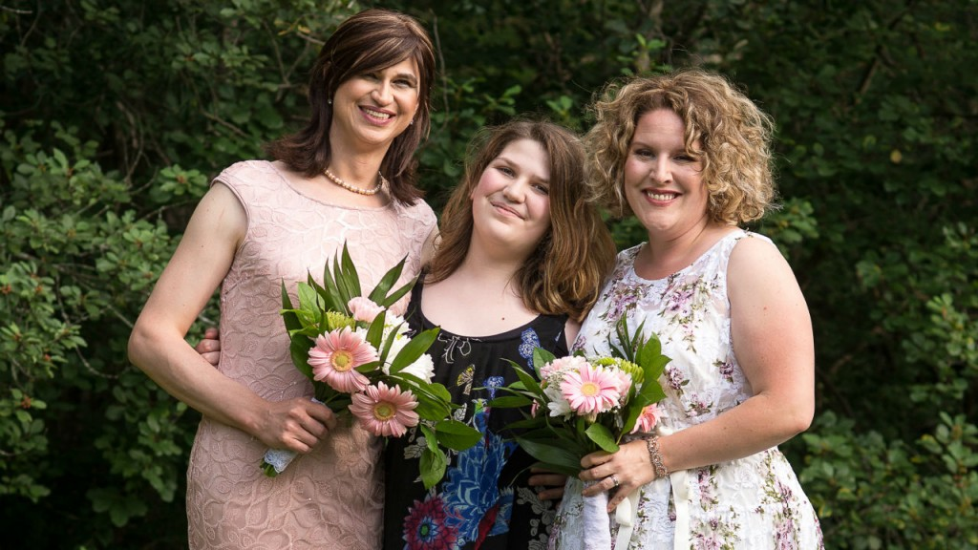
The women in my life – Sabrina, Jade and Holly

