Bolting For Love - Part II
By Soul-Controller
While running through the cramped hallway of the stadium with the rest of the Chargers players, Martin found himself becoming increasingly nervous as the sound of a roaring crowd was growing louder by the second. Although he was sure that most players would almost always feel nervous heading out to a crowded football stadium, it was especially traumatizing for Martin given the fact that he wasn’t even a football player! The man was still completely clueless as to why he had ended up in Joey Bosa’s body, with Martin not even getting an opportunity to properly comprehend his new situation or check out his muscular body before being ushered out to the field.

As such with the loud cheering reaching a crescendo, Martin’s eyes widened in disbelief as the dark hallway gave way to the bright stadium lighting with his cleats going from clacking on the concrete stadium flooring to crunching under the artificial grass of the field. Given his identity as a Mexican man, Martin had no knowledge of the American sport whatsoever; which left the man’s legs shaking as he could hear a loud crowd of people to his left cheering out the name Bosa with an alarming amount of intensity. Although he already was quite the self-conscious fellow and thus didn’t want to embarrass himself on the field, he definitely didn’t want to ruin Joey’s reputation and get his fans to turn on him as well!

While Martin wanted nothing more than to just sit on the sidelines and mentally prepare for the concept of playing professional football, the Chargers coach immediately called for Joey’s name along with a few others and sent them to the middle of the field. Trailing behind the other people that the coach indicated were team captains just like Joey, the man was relieved to find that he had nothing to do besides sitting there and watching as the visiting team picked the coin toss and opted to kick the ball rather than receive it. Although Martin hadn’t known what was really going on or what any of the other players were saying, he found himself relieved to find that he had temporarily delayed his future embarrassment as the Chargers offense team went out to play first.

As such, Martin instantly took a seat on the bench and awkwardly directed his eyes to take in the fully packed stadium. It was quite bizarre to think that so many people were there just to watch the game in person, but even more so to think about the countless people who were devoted fans of Joey’s who had come just to see the hunk in action. Just as Martin began to think about this fact, a conveniently timed cheer from the crowd behind him immediately caught his attention.

“BOSA BOSA BOSA!”

Turning to see what was going on, Martin’s cheeks began to redden while his legs began to nervously shake as he saw several fans decked out in jerseys that displayed the same number that he was wearing while also lifting up signs that had Joey’s face plastered all over them. Although he knew that the cheering was meant to be supportive, the strange phrasing and references to Joey being a “big bear” left the clueless man feeling like even more of an imposter. As such, Martin opted to just awkwardly give a slight wave towards the fans before directing his attention back to the game itself.

In hopes of getting a crash course to play defense for football, Martin tried his best to focus in closely on the players of the opposing team and watch how they performed. Upon observing as they rushed and used every inch of their body as a battering ram against the Chargers offense in hopes of sacking their quarterback Justin Herbert, the body-swapped man was quite intimidated by such a concept.

As a pacifist, the man hadn’t been in so much as a fight in his entire life, yet with this new body and life, he was expected to just naturally throw himself into a reckless and dangerous position that would leave him crashing on top of other people or even plowed over if he dared to not pull his weight for the Chargers defense. As such, watching the Chargers successfully score a touchdown was quite anxiety-inducing because that meant it was almost time for him to go out on the field and try his best to be the star defensive end that Joey was infamously known for.

After watching the Chargers score a field goal and the opposing team kick the ball so the Chargers could receive it, it was finally time for Martin to get out there and try his best to perform just like Joey. As he awkwardly lined up on the line of scrimmage and replicated the same stance as the players on either side of him, Martin found himself taking a deep breath as his eyes looked towards the opposing team’s quarterback. Unfortunately for him though, his anxiety led the man to jump the gun too quickly and rush towards the quarterback, which resulted in an offside foul. While the man was already mentally scolding himself for his overeagerness, several of his fellow players were groaning and telling him to calm down as his eagerness caused the opposing team to get five yards closer towards a touchdown.

After he profusely apologized and mentally forced himself to calm down to avoid breaking down into tears, Martin purposely waited until the quarterback already had the ball before finally rushing towards them. Unfortunately though, this also backfired through the next several plays as either Martin was completely knocked to the ground from the offense’s rush or too delayed to stop the player from rushing past him and catching the ball and making a break for the endzone. Regardless of how great the Chargers defense was in terms of remedying “Joey’s” mistakes, they could only delay the inevitable for so long before the opposing team was able to successfully score a touchdown.

This process continued for several more rounds, which caused the Chargers to go into halftime with a tied game against a team that they had absolutely demolished the previous year. As a result, Martin found himself tilting his head down in shame as he was the victim of countless booing and angered Chargers fans telling the new defensive end to “get his head out of his ass” so they could win. Making his way back into the locker room where he had suddenly found himself inside Joey’s body, Martin thought that the fan outrage would be the extent of his ridicule. Unfortunately for him though, the coach was even more furious by the star player’s piss-poor performance, throwing his clipboard across the room and telling the hunky defensive end that he needed to get his act together or he’d be sitting on the bench for the rest of the game.

Given his terrible performance thus far, Martin found that most players were giving him the cold shoulder and turned away from him just simply making eye contact with them. As such, the body-swapped man opted to just separate himself from the rest of the team and hide in the back corner to sulk in his sadness and pray to somehow end up back in his normal body.

This pity party only lasted a short while though before Martin found himself accompanied by that #49 player who he had met prior to heading out to the field. While Martin originally expected the man to give the same snarky remarks about his terrible performance, the man was relieved to instead receive some helpful words of encouragement. As the man opted to take his helmet off and sit next to Martin, the fellow player told Martin that all players have an off day but that he had confidence that they could still win this game with “Joey’s” help. Upon putting one hand on Joey’s broad shoulder and giving it a light pat, Martin turned to face the man and was immediately struck by just how attractive the man was. Not only was he buff given the thick biceps and the hint of abs that Martin snuck a peek at upon watching the player lift his arms up to the point where his jersey rode up several inches, but #49 also had a quite attractive face with a nice amount of facial scruff that worked well with the hunk’s plump lips. Upon giving the pep talk though, the player quickly said his goodbyes so he could get one last sip of water before they headed back to the field.

After receiving the encouraging pep talk from Joey’s teammate, Martin found himself regaining a desire to perform well and live up to Joey’s sky high expectations. As such, the man closed his eyes and mentally began to give himself more of a pep talk. Focusing in on the sport he now found himself a part of, the man began thinking about his new teammates and thus trying to replicate what he had witnessed them doing. Thinking about it further, his mind began to focus more intensely on the player who had treated him with kindness. Although he didn’t know the man’s name, Martin’s memories recalled every inch of the man’s gorgeous face, especially those plump and highly-kissable lips of his. To his surprise though, as his mind began to think about the last name displayed on the back of his jersey (Tranquill), there was a small intruding thought that seemed to naturally fill in the blank of the hunk’s first name - Drue.

Given the fact that Martin had no real knowledge of football besides a few hunky players that he had seen on Tumblr before, this new memory was a bizarre realization as it certainly didn’t come from him. Was it possible that he was somehow tapping into Joey’s own memories to gain that information? With this thought in mind, the man couldn’t help but think further about playing on the field and was shocked to find countless buzzwords and phrases beginning to populate in his head. Concepts such as a first down, starting at the line of scrimmage, scoring a field goal, and sacking a quarterback suddenly filled his head and gave the man a much needed boost of confidence. Maybe it was actually possible for him to know what he was doing as Joey Bosa!

Stuck on that thought, the coach finally blew his whistle and told the team that it was finally time to get back onto the field. With renewed confidence, Martin quickly pulled back on his helmet and rushed back out to the field to hopefully use these new unlocked memories to his advantage.

Luckily for Martin, this was able to happen faster than expected as the Chargers were the ones to defend immediately after halftime. After having the ball kicked and received by the opposing team, Martin joined Drue and his other defensive teammates out on the field and prepared to try and test out his theory. Narrowing his eyes and focusing on the quarterback once more, the man waited for a moment and thought deeply about how Joey would perform on the field.

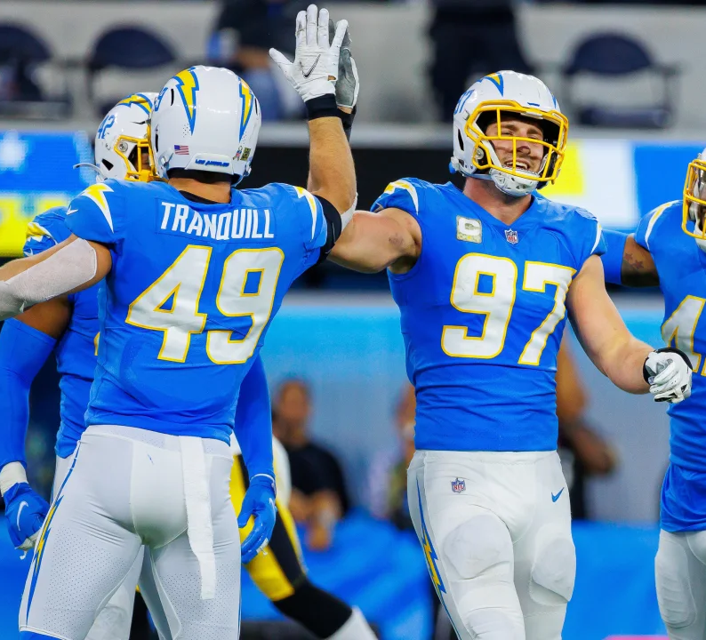
Upon doing that, memories and skills flooded into the man’s brain just as the ball was snapped. Immediately, Joey’s muscle memory came out in full force and brought Martin along for the ride as he rushed towards the quarterback and was able to successfully prevent the person in front of him from breaking away to catch the ball and gain a first down once again. To his relief, Martin received much enthusiasm from both the crowd and his teammates as they congratulated him and told him that it was great that the real Joey Bosa finally came back to play. After getting a celebratory high-five from Drue, the body-swapped man continued to tap into that muscle memory to keep the momentum going.

Within no time, it seemed as though the real Joey Bosa was back playing football as if the first half was just simply a series of bizarre mistakes. Before long, the Chargers had suddenly found themselves in the lead by six points heading into the final minute of the game. As such, Martin found himself quickly getting drunk off of the enthusiastic crowd and opting to deliver more impressive defensive talent to who he was now viewing as his devoted fans. With the opposing team opting to try and gain one final drive to hopefully score a touchdown and give them a fighting chance via overtime, Martin was eager to finish up the game with a nice flourish that would not only redeem himself in the fan’s eyes but also help him fully embrace his new life.

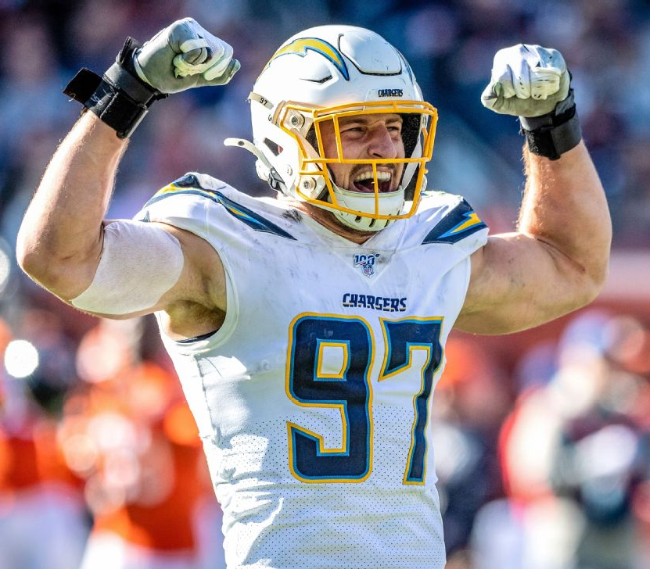
So when the final play of the game began, Martin used every inch of his bulky body to sprint past the opposing team’s offensive guard and directly towards the quarterback. Before the man even had an opportunity to throw the ball, the whistle of the end of the game went off just as Martin rushed towards the man and sacked him down to the ground. Sitting up after the sack, Martin was so overcome with excitement and pride within himself that he couldn’t resist running around the field and flexing his biceps to the crowd while cheering himself on for saving the game after his pitiful performance earlier. It was the ultimate comeback, which the fans were quite excited about based on the loud cheering that was ringing out through the stadium as the rest of the defensive team rushed to Martin and began to cheer him and lift him into the air to celebrate.

Upon making it back to the locker room, the entire team was buzzing with excitement as the coach congratulated the team and thanked “Joey” while joking about how happy he was that Bosa had “finally relearned how to play football”. While the celebration after the game opted to head out to a local bar that the team apparently frequented, Martin told them that he’d show up later and thus hung back in the locker room.

With it now deserted, the man finally got the opportunity to strip out of his clothes and check out his hunky new body in-depth for the first time. While he felt up his thick biceps and took a moment to squeeze his pecs, Martin quickly became obsessed by the alluring scent of Joey’s sweaty armpits. As such, the man couldn’t help but push Joey’s thick nose deep within the moist area and savor the erotic scent that immediately caused his new and lenghty cock to harden in response.

Just as he began to move one hand down to stroke his cock in hopes of cumming for the first time as Joey Bosa though, the sudden sound of the locker room door opening up caused the man to tense up in shock. Stuck in place as footsteps rounded the corner and walked down the last aisle where Martin was, the body-swapped man was immediately caught off-guard by seeing Drue standing there with a slack-jawed look.

“What the fuck,” Drue began, slowly making his way closer towards the nude Martin.

“I- um, it’s not what you think,” Martin tried to explain, immediately filling the room with Joey’s deep and monotone voice.

“Yeah, it better not be,” Drue continued, making his way closer towards Martin before stopping and looking Martin longingly in the eyes. “I can’t believe you’d get started without me…”

Immediately, the revelations of the fact that both Drue was into Joey and also that Drue had seemingly been intimate with Joey in the past shook Martin through his core. He had thought for a long time that Joey was this straight hunk yet in reality he was secretly hooking up with Drue on the side? Although it was quite a shocking reveal to come to terms with, Martin’s own attraction towards Drue made him quickly accept this revelation. As such, his own desire to get Drue’s affection overpowered his mind and he opted to continue his flexing and admiration session.

“Well what are you waiting for,” Martin inquisitively asked, chuckling slightly as Drue looked up at him with puppy dog eyes. “Get to work admiring this godly body!” he continued, punctuating the sentence as he pulled his arms up and flexed so each bicep intensely bulged out. To Martin’s amusement, Drue was more than willing to be bossed around as he immediately followed Martin’s orders and got to work admiring every inch of the man’s hunky body. Although he hadn’t expected it, it seemed as though Martin did actually end up finding love due to football just as he had hoped for… just not with the person (or with the body) that he had expected!

