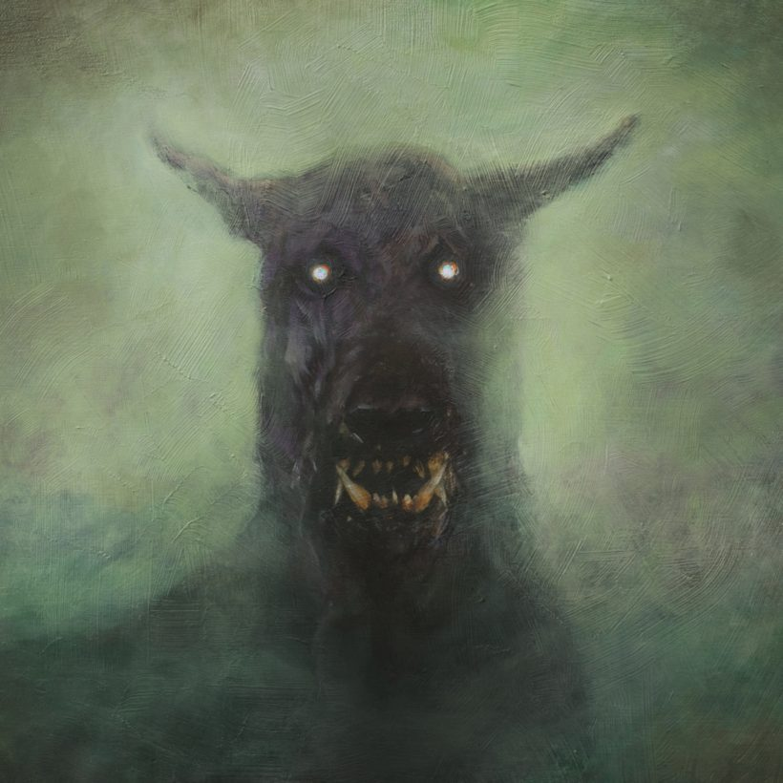
The Hound
A Short Horror Story for Halloween
By Maryanne Peters

When he stepped out of the cab, his resolve was strong. He had the papers in his hand; he had been through all of the emotions and his mind was clear. His life would be worthless anyway, unless he did this. Life is about taking chances, after all. Every time your car enters the freeway, death is a possibility. We gamble with our lives for the sake of mere convenience, and this was so much more than that.

But as he looked down the street each way, he found himself unsettled. The gate in front of him was marked “Alteron House” and the large house itself was visible at the end of the drive. It looked as if it might once have been the home of a wealthy family, perhaps perched in isolation on a hill close to the city. But long ago the city had reached it and prospered for a mere moment before it had died, at least in this direction. Localized economic failure. Surrounding houses all looked empty and dilapidated.

Still, he quickened his pace up the drive. He wanted this – more than anything in his young life. But it was much more than a want, and even more than a need.

The door loomed in front of him. It was far too big and old for the house, as if it had been salvaged from some ancient castle in Europe. It was not lit, and as the last light of dusk faded it looked threatening. To reassure himself he smiled. He was behaving like a girl. The girl he wanted to be.

There was a doorknocker in heavy blackened steel that looked as if it had been forged by hand for giants who might wish to call. He pulled it back and let it fall like the crack of thunder.

He stepped back and waited. The wind had come up and with the rustling of the leaves came the creak of the larger trees surrounding the house, heavy with wood rather than leaves. Clouds sped across the sky like rabbits running from a fox.

The door opened, with more of a groan than a creak. A man stood in the doorway. It looked at if he was dressed in black, but in fact it was dark blue – surgical scrubs complete with shoe covers. The face and bare arms were thin and pale, and in the shadows from the light behind looked heavily veined. He eyes took time to make out the features on the face, and they were not pleasant.

But beauty is not everybody’s gift. So he smiled and said – “Hello. I am Francis Hampton. You are expecting me?”

He reached out his hand, the way his father had taught him, but the gaunt figure declined to take it. He just said – “Come inside before the wind blows you away.”

The inside was somehow what he expected. A large room with a stairway that went up more than one floor. At the far end was an alcove with stairs going down. It was unfurnished except for a large table. Nowhere to sit; just a place to pass through.

“Do you have the papers?” The gaunt man was now in the light – bald except for just thin hairs over a scalp that appeared wet; eyes sunk, nose long and bulbous at the bottom above a mouth like a small surgical incision. Ugly. Francis offered another small smile.

“Everything is here,” he said. “My next of kin have signed as you require. If I die there will be no body, as I understand it.”

“As will have been explained to you, people react differently. But any deadly strain must be contained. If death results the body must be destroyed immediately. You do understand, don’t you?”

Francis took a deep breath, but it was very easy to say it – “Yes, I am ready. The disclaimer is signed. The declaration is signed and witnessed. The medical opinion as to my capacity is signed. The release from my parents is signed.” And now they were all on the table for this man to examine.

He took a moment to do that, although it seemed longer. There was nothing to look at. He could not sit down. Francis just stood and waited.

“Yes. This is all in order,” the man said. “It will have been explained to you before, but our practice is to give you a last opportunity to refuse. So let me repeat it for you. You are about to be exposed to an animal carrying a deadly disease. The animal is crazed, so anything can happen. Even if you pull away beyond the length of the chain, after you have been bitten there is a significant likelihood of death. We believe that it is much less but we say around 50% survival rate. But if you do survive … well, you are here so you know.”

“I have met somebody who went through the change,” said Francis, with excitement now building. “She is now a fully functioning woman. That is just what I have to be.”

“I understand,” said the man, but with the air of somebody who really does not care.

“Do I have to go through any preliminary tests?” he asked.

“No,” said the man. “If your mind is made up, we can go down to the cellar immediately. Delay can only distress you.”

‘How thoughtful’, Francis thought He followed the man to the stairs that descended. They led to a corridor that seemed to head off in both directions further than the foundations of the house. The basement was large and he was to learn that there was yet another level below.

“You will need to remove your clothes and leave them here. You will need to wear this robe.”

The robe was like a white sleeveless night shirt rather than a surgical gown. It was clean and smelled of disinfectant. He stood for a moment expecting privacy, but it was not offered. Nor did Francis demand it. That was not his way. He removed all but his boxers before slipping on the gown, then he took off his boxers. All items were placed in a box.

“We will go straight down then,” said the man. A door was opened to another staircase.

It all seemed to be happening so fast that Francis found himself disconcerted. He decided to run the mantra through his head to reassure himself – ‘Tonight you will become the woman you have always dreamed of being. Tonight you will become the woman you have always dreamed of being.’

The man stood by a heavy steel door. He said – “The line of restraint is marked on the floor. I suggest that you just go in there and cross it immediately. I will close the door behind you so that the beast thinks that you are alone, but I will be here. When I open the door, show me the wound and I will bring you out. If there is no wound, you will stay in there until there is. Do you understand?”

Francis gulped. Why was it like this? Why not science? Extract the disease somehow and administer it in a controlled environment? Everyone who had heard about it said that it had to be done this way, but why?

“Yes,” he said. Tonight you will become the woman you have always dreamed of being.

The dook opened. This time there was a creak. There was weight on these hinges. The room was brightly lit, but there was a shadow in one corner, and from the shadow Francis could hear a slow growl. It dissuaded him from running across the arc painted in yellow across the floor. The door slammed closed behind him.

Before he saw anything else in the shadow he could see that a pair of animal eyes had caught whatever light there was and glowed red. It was like a horror movie unfolding in real life.

Francis turned around. It was the sound of a bolt on the other side of the door. He was here now. If he threw himself at that door sobbing and begging, would that ghoul of a man even answer?

He turned back to the creature in the corner, wondering if his eyes might see better if he squinted.

But the animal moved. He could hear the chain. It sounded heavy. Thank God that it was.

The head came into view. Francis may have nursed the idea that the dog might be a rabid Pekinese, but he was not that lucky. The head itself was twice the size of any small dog. It was square and black, except for the yellow teeth visible from lips pulled back and the white frothy drool falling onto the floor in puddles of disease.

Francis gasped the girly gasp that all the boys at school had laughed at.

“Tonight you will become the woman you have always dreamed of being.” He said it aloud, but it was not enough to make his feet move.

The growl seemed not to come from the beast but from the walls. It was the kind of low bass that could make even those concrete walls hum. And combined with that was the guttural croak that told of the existence of a throat into which bits of his slight body might pass in chunks torn away by those teeth.

Then the hound pounced. It lunged forward on all fours but as the chain took hold it was pulled up to its full height – perhaps over six feet tall? Certainly taller than Francis, and maybe twice the body mass. The collar choked the animal, but somehow even that noise served to threaten.

The claws on the animals feet scuffed the concrete as it tested the length of the chain. Francis thought that he could hear the sound of concrete being ground behind that animal. He craned his head for a view of how the chain might be fastened. Could anything be strong enough?

The beast shuffled back, still snarling.

Tonight you will become the woman you have always dreamed of being.

“What’s your name?” Francis could hardly believe that he had just said it. Why do people talk to animals as if they could answer? He was just trying to remind himself that this was just an animal, and one restrained against its will.

He knew that he had to cross that line. Would the animal accept a pat on the head? He knew that he needed a bite, but could it not be an angry one?

Francis closed his eyes for a minute. He was racked with fear, and now he was being irrational. But there was adrenalin. He just needed to channel it.

He had a sudden thought that perhaps this was why it had to be done like this? Perhaps for the disease to run its course and work its miracle on the body it needs to be a body in a state of terror? That would certainly describe him now.

Tonight you will become the woman you have always dreamed of being.

Francis lunged forward. So do the animal. He tried to swat the head away, but the animals jaws crashed top and bottom onto his delicate hand.

Francis screamed. It was not the pain. The animal was dragging him into the shadow. This would not be death by the disease – Francis was going to be eaten alive.

But the door swung open and the animal's emaciated keeper entered carrying a long cattle prod.

Francis could remember the flash of the arc of electricity and the shock of it passing through the jaws into his own body, knocking him to the floor.

His next memory was of lying on a gurney being wheeled down the corridor. He raised his arm to see whether he still had a hand. He could see all five fingers but the hand was wrapped in a bandage stained with blood. It was something he could never quite bear. He passed out.

Francis’ eyes opened to a large room. It was equipped like a hospital ward. There were six beds in the room, but only his was occupied. However there were some chairs at the end and there were three young women sitting playing cards.

Francis could see that they were dressed like he had been – the white hospital pullover gown – and each had a bandage on the hand.

“I am alive!” Francis spoke. Was that voice his?

The women got up from their game and came over.

“How are you feeling?” one of them said. She was slim with long blonde hair. Francis could see that there were breasts under the fabric – real breasts. But then again some would have come here already in partial transition.

“Am I changing?” said Francis. “Have I got breasts?”

“Let’s see,” said another girl. “You are not dead, so let’s have a look. Let me help you take off that robe. Bring over the mirror Amber.”

Francis sat up and swung his legs off the bed while the robe was pulled off. There was the third girl holding the mirror.

In the mirror was a young woman. Francis could barely recognize her. It seemed as if somebody was holding in front of him a giant tablet set to selfie with the gender change filter on. A trick. But then his left unbandaged hand went to the left breast. It was small but perfect. As he sat on the bed, he could see that there was still an appendage in his groin. But not one that could be called a penis. He reached a hand down. The scrotum was empty, and a slight opening seemed to have appeared.

“Can you feel it happening inside?’ the blonde girl asked. “Your testes are on the way up, about to part company and become ovaries. You are well on the way.”

“I didn’t die,” gasped Francis in happy disbelief. “I was one of the 50% who lived.”

“Almost 100% live,” said the blonde girl. “The only ones who don’t are those that have an arm or leg torn off by the hound. You are one of the 50% alright, but one of the 50% who have officially died. We all are. The 50% that get to go home are the lucky ones, but that is not us. We are the 50% who will be bought and sold as playthings. What we wanted to be, but no longer free.”

“I am sorry sweetheart,” said another girl. “I hope your family won’t miss you too much because they will never be seeing you again.

The End

© Maryanne Peters 2021

