Inspired by Tiffany/Mandy/Jennifer/Lisa
By Maryanne Peters
Here is a small collection of extensions on the captioned images of Jennifer / Tiffany / Mandy of her various sites, the latest of which is: http://suitstoskirts.blogspot.com/, but there will soon be another: http://tiffanysachivedcaptions.blogspot.com/. Her cap “From Russia” sparked one story plus a sequel.
It Worked!
Inspired by a Captioned Image
By Maryanne Peters

I doesn’t matter that I have a master’s degree in psychology and an IQ above 150, being a natural blonde with big green eyes and a full figure, makes me a bimbo. Sure, I like to wear my hair long. I always have. I like it that way. And I wear makeup – what’s wrong with that? But unlike men, a girl always gets judged by her cover.

Finn should know better. Except for our parents, nobody has known me longer than my own brother. He just went on and on about the bimbo thing to piss me. Well congratulations, Bro, it worked.

I wanted him to try it for a bit. I wanted to dump him in my shoes for a while. Be a woman. And it so happens that I must be one of the few people on the planet to have the capacity to do just that.

You see, hypnosis does have limits. People need to be open to the suggestion but then are easily brought back to reality. A trance does not last. Not unless the physical change that is made to the subject is so great that it appears to be the reality, and what they thought was real seems so unlikely that it must be denied.

Drastic physical changes in support of the suggested reality must be effected under anesthesia before breaking out of the trance. Undetectable hair extensions. Complete and permanent hair removal. Tattooed eyeliner. Breast implants made with microsurgery. Tightening of the vocal cords through oral endoscopy.

When he is offered the two alternative explanations for his current state, which does he choose? If he is Finn then why is he is his bedroom now pasted with feminine things standing in front of a full-length mirror, breasts spilling out of his LBD, pearls and patterned tights and heels, and long blond hair. Is he Finn? Or when feels what is in his panties and looks in the mirror, surely the suggestion that he is Fay, my tranny bimbo sister, seems the easier reality. Welcome to my world, Fay.

The End
Anything to Avoid the Draft  A Short Story  By Maryanne Peters  People these days do not understand.  It was not cowardice, it was principle.  Not lack of patriotism, it was protest.  Nobody who was young and politically aware in the 1960s and 70s wanted anything of the war in Vietnam. It was wrong and people were dying. Our youth was dying, and the “enemy” was dying at our hands because of a belief system entrenched by a military industrial complex with a love of war.  I was one who protested and so was my friend Tom. We burned our draft cards and initially went into exile in Canada. | 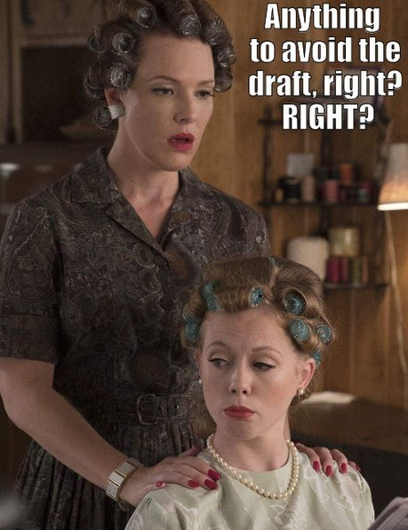

When my mother died we decided that we needed to return home, but it was clear that we needed a disguise. It was not just the authorities we had to fear. In our town, there were people that were hostile to draft dodgers. Even arriving there as strangers we would be closely inspected by the locals. The disguise would need to be a good one.

At the time, we were living above a hair salon, paying rent to the owner Mrs. Bligh. It was her suggestion that I consider dressing as a woman. I thought it was a crazy idea, but she offered to give me a free makeover. I was a bit sorry to lose my beard and some of my eyebrows, but I agreed to do it – just to consider any possibility. My father and aunt were begging for me to come back. If we could pass as women, we might get away with it.

All she did was prepare my face, pluck my brows and put a wig on my head. I was amazed and so was Tom. We realised this could work.

She suggested that Tom could do it too, although his features were a little heavier than mine. And she added: “Neither of you will need wigs, with that long hair you both have. We can give you a set. Real feminine hairdos.”

So the next thing was to condition our hair and then she put us both in curlers. While we were waiting for our hair to dry, she did Toms nails, painting them a deep red to match his lipstick. We both looked like regular ladies, even before the curlers came out.

“Now comes the hard part,” she said. “You need to learn to behave like women. Your walk looks manly, and the way you hold your arms, and move your hands. That all needs to change.” And we had time to learn. We just wanted to be home for Thanksgiving
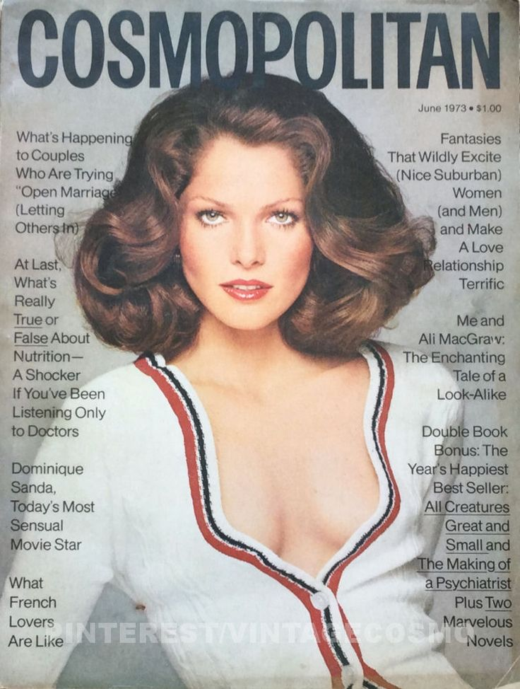
Styles of the 70’s

It was the early 1970s and big hair was the look. We both had enough to make it work. I suppose we could have gone for a more restrained look, but when you are pretending to look female, you need to push it a little. We helped out at Mrs. Bligh’s salon and we learned how to do one another’s hair, and ended up on the payroll doing roller sets, brushing out and setting.

We crossed at an uncontrolled border point and headed home. Nixon had only just been re-elected and the Vietnam war would be over in just a few years. But draft dodgers were still to be hunted down, and there were even people in our community who would have happily given Tom and me up to the authorities. For some of my father’s generation we were almost traitors by refusing to serve.

So we found ourselves stuck as women. Even in our own home.

Tom and I decided that we would move to New York City. We figured that we could just disappear in one of the world’s largest cities. It is just that without social security numbers and any kind of qualification, it was hard to get a job. We both ended up doing the only thing we knew – working in a hair salon. We were still stuck in drag.

But as it happened, the late 70’s and 80’s were great times for hair styling professionals. Even guys were coming in for perms. Hair was not only big, it was big and curly. Or the bouffant styles needed the kind of work put in that we had learned, and continued to refine by doing one another’s hair.

It was only a matter of time before we set up our own salons in Brooklyn Heights. We called it Tammy and Ginny after the names we had chosen for ourselves, but by the time we had opened three salons in Manhattan, we were just TamJin.

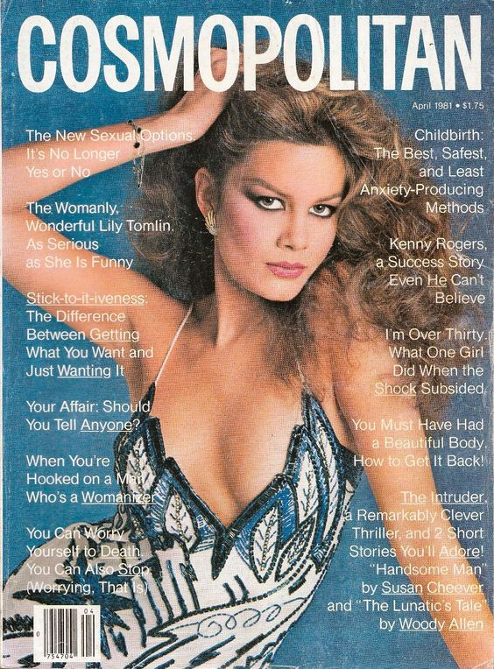 | 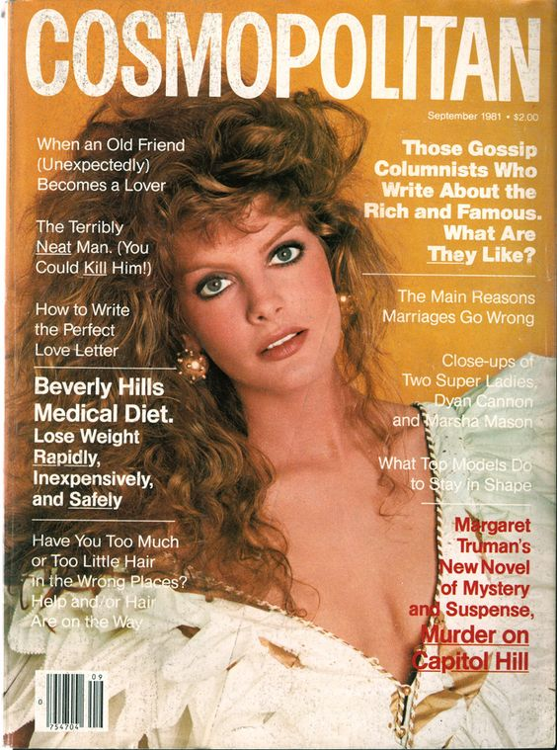
Styles of the 80’s

We worked hard. It seemed as if work was everything. We were taking hormones which killed off any sex drive, and even if we had the drive and found women who could accept us, we had long lost the capacity to become fathers, so families were not a possibility. So, it seemed that our only heritage would be our business. That would be our lot for saving our skins.

But, as you can see, it being essential for the promotion of our businesses, we were attractive women. In particular, we were attractive to men, even as we both turned 40. At that age there are plenty of men who do not expect of us what we cannot provide.

We had both decided that it was way too late to go back to any other way of living, and rich husbands can pay for any minor adjustments needed.

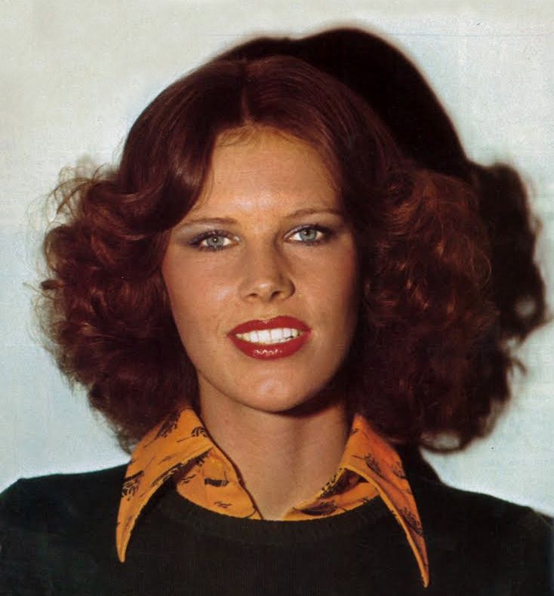
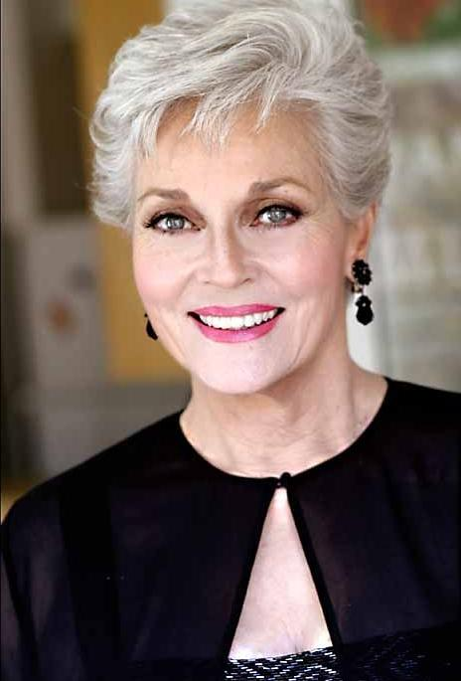

We are both widows now. Our late husband’s families have become our families. Both of us now have grandsons in the military, of who we are immensely proud. It is their call, and perhaps we both feel just a little shame for not having the courage to be willing to serve.

The End

© Maryanne Peters 2018

Voila
Inspired by a Caption Image by Tiffany / Jennifer
By Maryanne Peters

It is not easy being bought up by two gay dads. At first, I could not see any difference between my parents and other parents. I even felt that I was lucky to have two dads. The three of us would play or shoot baskets together.

I did not even know what gay meant when I was little. Kids that young don’t know about sex. They don’t think about what their parents do in bed. They just know that they are loved and, if you are lucky enough to have parents who stay together, that they love each other.

The first time sex was mentioned, my dads told me that there are some folk who don’t approve of two men living together as a couple, and some who do not believe that two men together can raise children. That seemed so stupid to me.

But it was true. Some folks don’t approve, even these days of inclusion and understanding.

I guess Victor got his ideas from his parents. Most guys do. I learned from my parents that people can be different, but they need to be treated the same as everybody else. Victor learned from his parents (actually his father because his mother died a couple of years ago) that gay people should be hated.

Victor started on at me about it. I said nothing about it to my dads, but it was getting me down. I guess they were worried enough about me to look into why I was sad, and they found all the abusive social media post and emails that Victor had sent. Still they did not want to embarrass me so they paid a call on Victor’s dad hoping that he would put a stop to it. Instead, well, something happened, I don’t know what, but Victor’s dad got into serious trouble. Apparently, he might even had gone to jail, without my dads accepting a “reparation deal”. Victor was in trouble too, so he had to go along with the same deal.

Anyway, about this time I was looking around for a date to go to the prom with me. Both of my dads said that they were so happy that I was interested in girls, although it would not matter to them if I preferred something else. My dad who is in the beauty business said that women are the most wonderful creatures on earth, it was just that he was not attracted to them in the way I was.

He said that it was his mission to refine feminine beauty, and that he even had some male clients who wanted that too. Maybe that is what was behind the reparation deal that was proposed for Victor and his father. If I approved, Victor would become Vicki and be my date to the prom, and Victor’s father would accept his son as a daughter for the whole prom season.

I have to say that I wanted to take a real girl to the prom, but when Vicki emerged, Voila! - I had to change my mind. It was not just that Vicki was pretty, she was. I mean, with the hair and makeup, and those fantastic legs, she was gorgeous. No it was the fact that Vicki seemed to really love being a girl. It was like you could not get the smile off of her face. Even the way she walked showed how happy she was. She sort of skipped around all over the place. She loved wearing heels, and even around the our house she would trot around, while my dad gave her pointers.

Vicki’s dad was shocked. I mean, he started to get really nasty towards Vicki. Anyway, my dads said something to him about having the same treatment for him if he wasn’t more understanding. What exactly was this reparation deal anyway?

So, I went to the prom with Vicki. I had a good time and Vicki was great. And all the girls loved her. She was like the new girl that nobody has learned to dislike. That’s how I figure she got to be Prom Queen. From that point there was no going back for Vicki. She was so happy that she wanted to kiss everybody, but mainly me.

She came to stay at my house after prom. She was a common house guest during her transformation, and she didn’t like to spend too much time with her father given his attitude. So she stayed over and slept in my room. In fact, in my bed.

It turns out that my dads had coached her on some other things too – how a person can sex with a guy if they don’t have a vagina. Well, I was pretty damned pleased I can tell you.

As we lay in bed together, Vicki said to me: “I love your dads. I think they’re great, but I don’t want to be gay,”.

“Neither do I,” I told her. “I want to be with a girl, not another guy. So, I guess we both want the same thing?”

“What is that?”

“Surgery, Honeybunny. Your surgery. A little snip and poke … and Voila! Man and woman. Maybe husband and wife.”

The End

© Maryanne Peters 2019

P.S.: Will Victor’s dad get over his homophobia, or …?

The Consequences of Bullying
Inspired by a Captioned Image
By Maryanne Peters

Why can’t he love me? He wanted me to be like this, and now I am. And now he does not want me. How can he be so cruel to me?

I know that it was him who told his mother what my other needed to do to keep me at school. I know that it was him who wanted me to dress this way – to be a girl for him. But now that I am he does not want me.

Maybe my mother tried too hard? She never does things by halves, my mother.

“If you are going to go out on a date as some boy’s girlfriend then you need to go out as a girl,” she said. “No son of mine is going to embarrass me by looking like a tranny. If you have to do this, then we are going to male damn sure that you do it right.”

That meant not just a padded bra and a wig. That mean proper stick on breasts and hair extensions. That meant depilation head to toe. That meant hormones and treatments to soften my skin. That meant talk training, and walk training, and all over girl training so that I hardly even know how to act like a boy anymore.

All because of a few words I said about him, and maybe be a push or too, and a dildo left in his locker. A dildo that I now have to use every day.

It was not just me. All the guys who used to be my friends hated fags. Now since I have been with him they treat me as if I was one. I am not a fag. I am a girl. I know that now. I am one now, or I am getting there. But the more girly I become the less he likes me.

So, I was guilty of a little bullying. It was harmless. Why do I have to suffer so much? I learned to love him. He should love me, but he only has eyes for other boys. Do I really deserve this?

The End

© Maryanne Peters 2019
For Her  A Story Inspired by a Captioned Image  By Maryanne Peters  I may be only thirteen, but I am smart. I mean, I am really good at school, but I think that I know people. I think that is what being really clever is all about.  I know my father because I have known him longer than anyone alive. That is because my mom died last year.  My Dad suffered badly. People were expecting me to be the one that suffered most, but it was made Dad. And I knew it would be that way.  My Dad depended on my Mom for everything. It was not just the she earned the money – my Dad kept house because he could not get a good job – she did everything. My Dad’s job was to do what Mom told him to do. So long as she was directing he was happy. But now she was gone. | 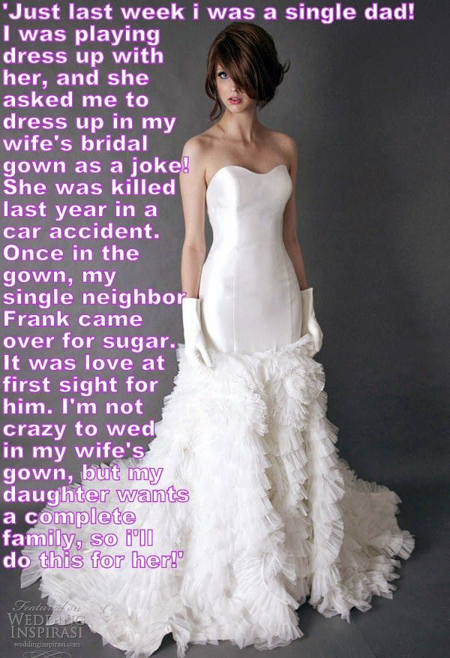

Daddy really let himself go after Mom died. He did not cut his hair and he grew a straggly beard. He even did not wash himself properly, so he was a bit stinky. The dress up idea was about getting him cleaned up.

I told him that I had always wanted to Mom’s bridesmaid, but of course they had married before I was born. I wanted play bride and bridesmaid and Daddy had to be the bride. The wedding dress was too big for me, but fitted my Dad perfectly once the girdle was on. But before he dressed he needed to take a long bath. He needed to get rid of the beard and the hair on his arms as well, and wash out that long hair. Daddy might have protested a bit, but he always wants me to be happy, so a few tears and he will do anything. And I really do think that he prefers to take instructions.

So Daddy took the bath and I added some wonderful perfumed salts. Daddy actually shaved his legs as well as his arms, and I told him to use Mom’s special moisturizer. I suggested that he use the special smelly stuff on his beard before the bath, because Mom always said that for getting rid of facial hair it was better than a razor.

When Daddy got out of the bath all rubbed down and in a soft towel robe, I sat him down on Mom’s dressing table and put some curlers in his hair to give volume. I guess that I was so happy and excited that he started to smile and laugh. It seemed like the first time for a year he did that.

“Let’s go for it,” he said. “I will be the perfect bride and you will be my perfect bridesmaid.”

He just laughed when I showed him the underwear. He put that on in private but I helped him stuff the bra and tighten up the girdle to give him a good shape. I put some make up on his face and took the curlers out brushed out his hair. Then Daddy stepped into the bridal gown and pulled it up. I zipped up the back.

He just stood and stared at himself in the mirror, first with his mouth open. I was very pleased with myself. I want to be an engineer when I grow up, but I could also do a sideline I hair and makeup. Then Daddy put a hand on one hip and gave a little wiggle. I clapped my hands. I knew I had done the right thing.

Then the doorbell rang. I rushed straight to the door and opened it. It was Frank, our neighbor. I heard Daddy call out to wait, but it was too late. I already ushered him in. And there was Daddy looking so beautiful, and Frank looking … well … amazed.

I think Daddy said: “I can explain, Frank …”, but Frank just held up his hand. This is the time when a young person like me should make themselves scarce, but I had to stay.

“Don’t say anything,” said Frank. “Unless it is to agree to come to dinner with me tonight.”

“I don’t want you to get the wrong idea. We are just playing a game.”

“I don’t care what you are doing,” said Frank, forcefully. He is a big strong guy. I suppose he is used to getting his way. He said: “You look fantastic. And you need to get back out into the world, looking just as good as you do right now. Perhaps you can change into something a little less formal?”

“It’s just a game…”. Even through the makeup I could see Daddy blushing.

“Go and change into something suitable for dinner, but keep the hair exactly the way it is.”

I told you that Daddy tends to follow directions, so he went off to the bedroom to open Mommy’s closet which he had left untouched. I went to help him. He really had not much of an idea, but I already had an outfit in mind. It was a dress that hugged the figure that we had formed with the girdle and stuff and was capped off with some classy shoes and a matching bag.

Daddy tried to excuse himself by saying that I could not be left alone. But I told Frank and Daddy that I would be able to arrange a sleepover at a friends house, and they could drop me off. That was easy to arrange. And that way Daddy and Frank would have the whole evening together, and the night as well, if they wanted.

Well, I am far too young to know what happened that night, but I can tell you that I needed to arrange another sleepover the following night, and the night after that. And now Daddy is saying that we will not be putting the wedding dress back in the box anytime soon. He will be needing it before too long.

I suppose I should confess one small thing in finishing this story. Frank didn’t need any sugar, at least not the sugar that you can buy for baking cakes and cookies. Daddy just needed Frank, or somebody like him. I know my Dad. He likes to be looked after and told what to do. And I think that I know Frank to. He likes being in control and he like beautiful things too. That’s why I called him. I knew he would be right for my Dad. I know about people, remember?

The End

© Maryanne Peters 2019

