The Date
Inspired by Captioned Image
By Maryanne Peters

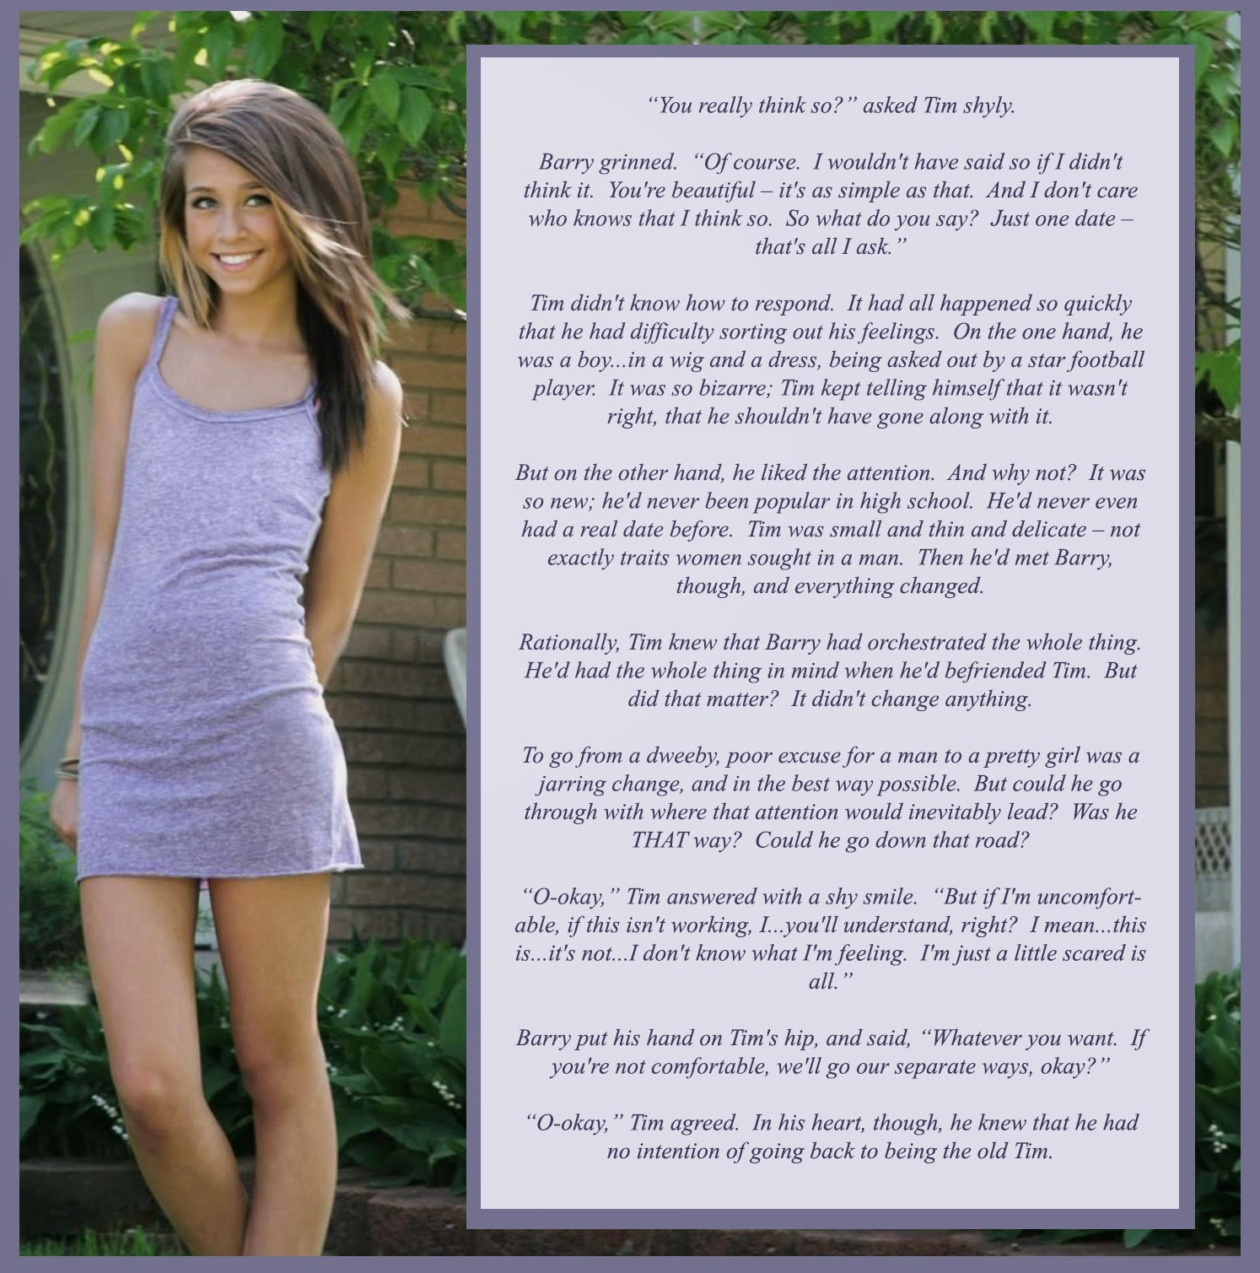

Just look at that face. Even with only the hint of makeup, that is clearly a girl’s face. Try telling me that you don’t see it. Don’t call me a queer. That is a girl. That Timmy is no boy. She is a girl. She is Tammy – my girl.

Even that body in the tank top dress. Sure, there are no breasts, but they will grow. So will her hair, which is even lighter than the wig. But look at those legs, and the hips. No boy is that shape. This is a girl, I tell you. Any fool can see it.

Nobody calls me a fag. I am the toughest guy on the team.
All I did was make the suggestion. I just wanted to see if I was right. It was like I could see it, and nobody else can. What am I saying? Nobody even noticed Tim – he was invisible. He was a nothing – a nobody. But from the moment that Tammy stepped out looking like that, I was smitten. This was somebody now. A girl.

He agreed to go on a date with me as Tammy. I took her somewhere quiet just in case somebody should see us. But it is a small town, and I did run into one of the guys. He never even recognized who she was.

I would like to think that even if he had I would have been able to handle it. I would have said that Tammy is a girl, because I say she is. Is anybody going to argue with me? Not in this town. Not even Tim.

But I was never out to threaten. I wanted Tammy to want to be with me. I did not want her to feel uncomfortable and pull out of the date. She was entitled to feel uncertain about it.

So I played it cool. I was the complete gentleman. I was watching her and imagining have her on the end of my cock, wriggling and squealing. But I bit my tongue and nodded my head as she chatted away.

It seemed like she was becoming more girly with every minute that passed. She had never appeared in public dressed as a girl before – at least not to my knowledge. She became confident, and then playful. It was great. Better than I could have imagined.

When I took her home, I asked her whether we could do it again and she said yes.

But then she said: “In fact, I don’t think I want to go to school next week as Tim. Tonight is the first time I have ever felt truly comfortable. Don’t be surprised if I tur up to school next week as Tammy”.

What am I going to do now? If she goes public as trans and I continue to date her, that makes me a tranny-lover. Am I ready for that? I am not gay, remember?

But she sure is pretty, and that little body keeps me dreaming.

The End

Leaving the Nest
Inspired by a Captioned Image by an unknown author but suggested by Annabelle Raven
By Maryanne Peters

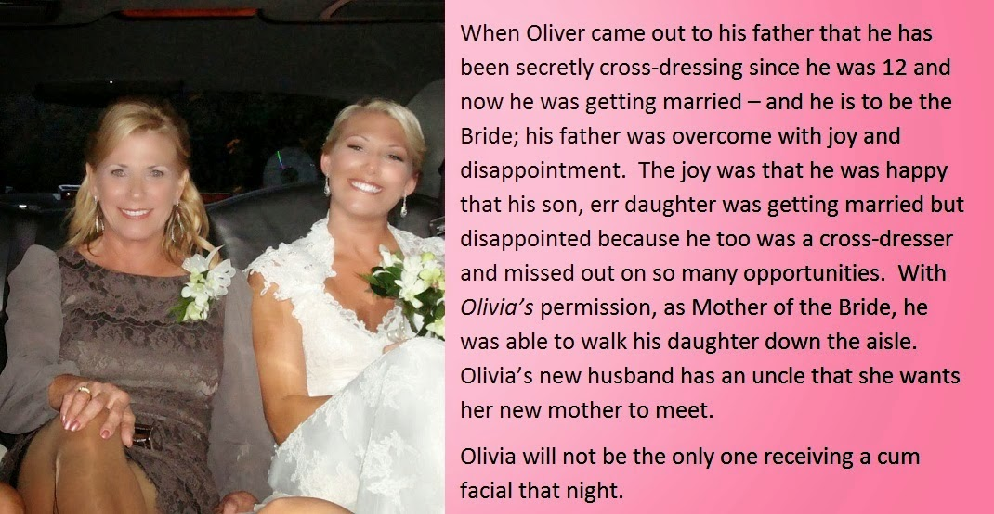

Please understand, I loved my wife. I loved her so much that I became the man she wanted me to be, although I was never that man.

She was religious, and while I was never a believer, I went to church with her and hung my head when they all prayed. She prayed that I would never go relapse into the perversion I had told her about before we married. She could never understand my desire to dress as a woman. I never could either.

When Oliver came back home from college in a dress, she hit the roof. She blamed me, although I never knew about him, and he never knew about me. She cut him off. She said that she could never accept that her son could become a woman.

But I have always loved my son Oliver, and I will always love my daughter Olivia. It was the difference between us that ended our marriage.

Olivia could not understand it at first. It would have been impossible to explain to Oliver, but to Olivia it was easy. “I’m just like you,” I said. We held one another and wept – two women born in male bodies.

She was already well advanced with her hormone treatment and feminine appearance, but I worked hard to catch up. I had some surgery on my face and chest, and hair extensions. Wen she told me that she was getting married I wanted to be there as mother of the bride. Her real mother had cut us both off by then.

I had always thought that loving that woman the way that I did meant that by becoming a woman I would be forever alone, or perhaps find a lesbian willing to take an ex-man as a lover. I never dreamed that I would ever meet a man like Marcus, the uncle of my daughter’s husband.

Marcus knew all about who I was, just as he knew that the bride had not always been a woman. He had met Olivia many times, but he did not meet me until the wedding.

He was a little older than me, but his children were younger. He still had two of the four at school and living at home with him, his wife having died many years before. He struck me as being a person very much like me – a man who believed in love and family before everything.

Olivia seated us together at the reception, and we talked and we talked. Then after dinner we danced, up close. It is one thing to know that you are a woman, but when a man holds you like that, nothing is more certain. It is often said that a transwoman does not need a man to be a woman, but I think it helps.

We were both staying in the hotel above the reception venue. He asked me whether I would consider coming up to his room for a nightcap.

He had his arm around my waist as the guests bid good night to the happy couple. Olivia winked at me. I think that I might have blushed.

He took me by the hand and led me to the elevator. We were alone inside it so Marcus took me in his arms and kissed me. Nothing has ever seemed so right. I could never have imagined myself in this position, but now that I was here, I knew that I belonged there. There in his arms.

I wanted to have sex with him the moment that we got into his room. But I told him that I was incomplete. He could see that it upset me to tell him so. He said that it did not matter.

“It’s only temporary,” I said. Whatever I might have thought before that night, I knew that my days as a man would soon be over forever.

But until then we needed to use what we had. His fondling my breasts was enough to send me through the stratosphere, so the least I could do was to give him the blow job of his life.

The End

Dad Came to Stay  Inspired by A Captioned Image  By Maryanne Peters  Ours had always been a very religious household. I guess Mom was really the key to that. Dad always said the strength of faith always comes from the women. But he was the elder in our church, and he seemed fully committed.  Me, not so much. I just never felt right. It seemed to me that faith in God and following a Christian path is supposed to settle all your internal problems, but it never seemed to do it for me.  It was not until I left home for my rumspringa that everything changed.  Maybe you don’t know what that is? Rumspringa is a period of time given to young people of the Amish faith to experience life outside our religious community; to sample the vices of the world outside, and hopefully return to the faith with a better understanding, and acceptance that the Godly path is the right path. | 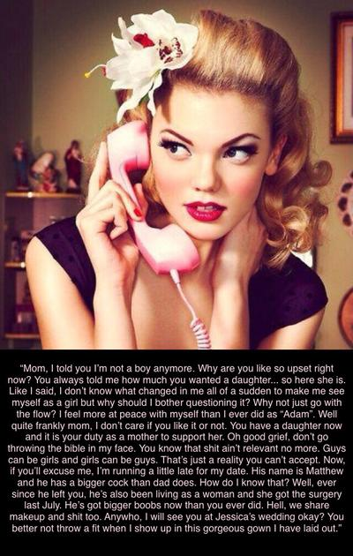

I really did not want to go. I would have been happy to stay. I thought that the problem that I was having, whatever it was, was about me, and therefore the answer was prayer, not a month of sin. But my older brother and some of the other guys my age pressured me into venturing out.

I never thought I was gay. I like the girls in our community, and I enjoyed being among them. I thought those feelings were normal. I was not sexually attracted to them, but I thought that this was because I prayed against temptation. I was not attracted to boys either, perhaps because of prayer, but more likely because then I was one of them.

When I say that I don’t know what suddenly changed me, it is because I cannot think of a single moment when I realized what I was. We never learned anything about what the word transgender meant – I had never even heard of it until rumspringa. Then I just gradually came to understand that it was the word that described me.

It is hard for people who have been brought up in a closed community to find their way in the world, but It hooked up with a transgender group in the city and they took me into my care. I remember that they were so kind to me I said that they must be Christian, but they just laughed. “We’re not religious, we’re your sisters,” they said.

Some people’s faith is shaken by death, disaster or injustice. Mine was shaken by kindness.

I was lucky that I had a talent. I was an artist. I got some work with a design group, but I also started to paint on my own, mainly my naïve and colorful interpretations of urban life form the eyes of somebody who had never seen the like of it before. Perhaps because of that, my paintings became sought after and I sold a few for some very respectable prices.

When I had money coming in, I suppose that I went all out to be as much of a girl as I could be. I mean everything pink, lots of dresses and flowers, and hair styles. But for me it was not unlike the girls on rumspringa who had never worn mascara or lipstick, or how to use hair straighteners or a curling wand. I was just Anna, the Amish girl learning how to live as a normal girl in the city.

Most families in our community just wait for their children to return from rumspringa. They wait and they pray, and usually everybody comes back. Some for good, and some to say: “Sorry, Mom and Pa, but I am going to live on the outside”. For some of those that means losing contact with their family, but nowadays the Amish are a bit more relaxed. That is why my friend Jessica, was able to invite people who had left that place, to her wedding.

But I did not return, even to explain. My brother went back, and I told him to do his best to tell them what my choice had been, but I knew that my change meant that I could never even set foot in that place. I thought it better to never show my face – my new face – to my parents. They could say one last prayer for me and move on. That is what those Amish parents did.

But my father came to the city. I was not sure why he was coming. Was he just wanting to confirm the truth? Did he intend to drag me back? Or was he just wanting to gear my story from my own mouth? He must have given my mother one of those explanations or all of them, but that is not why he came to the city, and he came to stay with me.

It turned out that my father was just like me. I say that, but of course, the difference was that he had lived a life as a man and he was now over forty, but when we sat down to talk it was not me who was trying to explain why I needed to be a woman, it was him.

If there is one thing that life in a closed community teaches you it is that when somebody needs help you are duty bound to give it, especially if they are family. Of course, I allowed him to stay, and share some of my wardrobe, and everything else that a new woman needs.

And I promised not to tell Mom. That was hard. She had already lost a son, and now her husband. But Dad said that he was no longer a true husband to her. She had been spending more time with the man who was the leader of the community. He did not blame her because he was not performing sexually. He said it was because, unlike me, he had always known his problem. It was just that until my brother returned home and told my story, my father did not believe that there was anything that he could do about it. Now he wanted to know everything.

The transgender group got him a cleaning job – we Amish have few skills that are applicable to modern life. But soon, through my connections in the art world, I was able to get him a job in a craft studio doing fine carving and cutting work, where he had the skills that I suppose were behind my talents. “Naomi” was able to generate some of her own money and buy her own clothes.

But all that Naomi wanted was to grow her hair and her breasts, and get her vagina installed. It could not happen soon enough. I was still experimenting with a sex life where I had everything, or so it seemed. I saw a future for myself having bottom surgery, but I was not in such a hurry as Naomi. Still, she led the way and showed me the path, and for that I am grateful.

But still, Naomi never contacted Mom to tell her what was going on. In the end I had to do it.

The occasion was the wedding I mentioned. My best girlfriend in the community was Jessica, who had returned from rumspringa no longer a virgin and keen to find a man to experience regularly what she had sampled. She had found Brad, a man in the local town who was Christian and whose land shared a boundary with community land so that he could be accepted as a “quasi-member”. I was invited to the wedding as Anna. So I would be going back.

Our community does not use telephones, so Mom used Brad’s phone to call me. It just spilled out. All of it. All about Dad, now Naomi. All about her breasts and sharing makeup. I knew I had gone too far. At least she would be spared the sight of Naomi at the wedding.

But Naomi said that she had been unfair to Mom, and she suggested that she travel back to the town outside the community so that Mom could come and meet her if she wanted.  So we went together, and Mom came in to meet us in the park. Her son and then her husband had left her, and this is the sight that greeted her.  Who can blame her for bursting into tears? Luckily women like the three of us know how to share our tears.  The End | 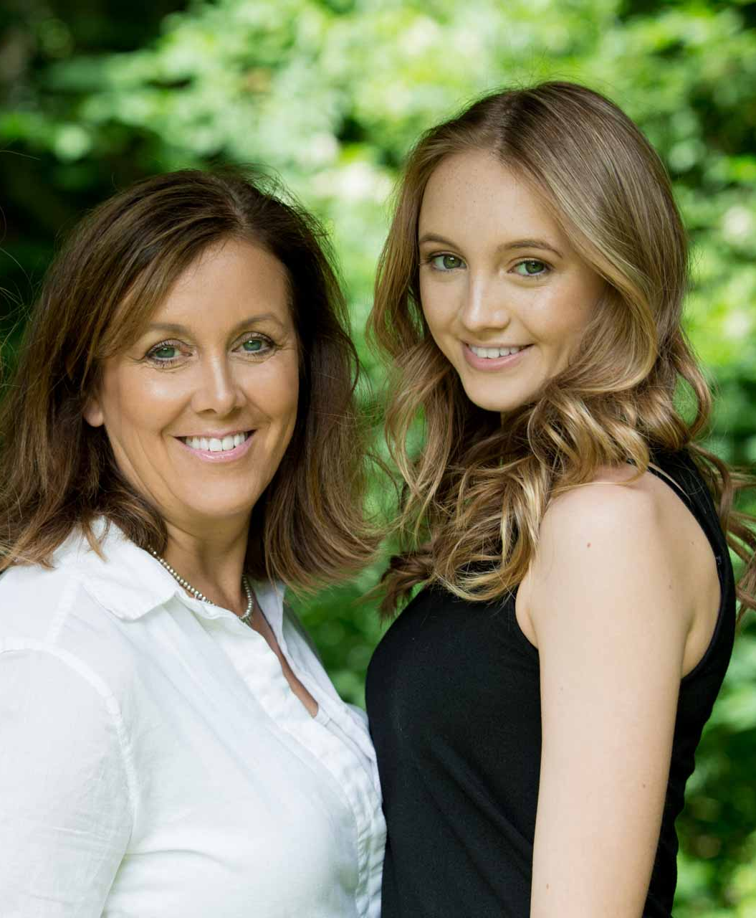

Secretary
From a Captioned Image
By Maryanne Peters

The truth is that I did stare at my secretary’s legs and her boobs, but out of jealousy rather than lust. She can have the business. It was failing anyway. The stress of it was killing me. I confess I was not up to it. God knows she is driven enough, so maybe she may succeed where I was bound to fail.
You see, what I wanted was a simple life. A girl’s life.

Back then the only release I found a guest spot in the drag act at the local gay bar 3 nights a week. By “guest spot” I mean that I was not paid, but I could dress in the body suit and a femmy costume and play up to the crowd. It was a momentary release, but it was all I had.

When she confronted me with the pictures, I was genuinely shocked, but when she told me the fate she had lined up for me I could barely hold my joy in check. Could it be true? Was she going to forcibly feminize me? It was everything that I dreamed of, but I needed to pretend to be horrified.

The truth is that the very thing that got my business into trouble had been destroying my personal life too. I was so driven by my own ego that I could not face my feminine reality, or the shame of telling everybody that I was not a man. What I needed was to be driven to make the changes. It was everything that I wanted, but I still felt the need to plead: No, no – don’t do this to me!”

Each new demand that she made of me I put on my best act of reluctance and occasional defiance, but in fact I doubled up on the hormones and the hair and skin treatments. I could not become a woman fast enough.

She would laugh and I would whimper like a sissy, but I was happy at last. She insisted that I wear short skirts, but as the hormones took effect and my skinny legs lost the ugly muscle and gained a woman’s soft flesh, I realized that my legs were much better than hers had ever been. She could keep them in the pants she now favoured.

My hair, with glossy extensions but my own growing out to good length, was nicer than hers. My face was prettier, and my fresh breasts as perky as a teenager as hers were starting to sag.

I was the new, and she was a has been.

She could have the business. I had a plan. I could start again. Not up front, but with everything that I knew I would not make the same mistakes again. The first mistake that I made was to not recognize my own shortcomings and to find and use the talent of others. As a secretary I found that the brightest guy in the business was young Marc, toiling in the mail room and working towards a business degree at night school.

Marc and I had been developing a business plan. All executives and ex-executives like me, have a non-solicitation clause in our employment contracts, but they never get that for the mail guy. But he is the guy who has the names and addresses of all the business’s suppliers and all the business’s customers. It is the list that our new business would be built on.

I thought that my life was complete. I am living as a woman which is what I wanted. I turned out to be a much prettier woman than I ever could have imagined. My business that was a leaden yoke on my shoulders has gone and is in the hands of somebody that I will happily watch destroy it, if it does not destroy her first. Instead I am starting again, as number two to a young man whom I respect.

And then, it got even better. She told me that Marc desired me – he wanted me as a woman.

He is younger than me, and he knows who and what I am. Could it be true. I went straight down to the mail room. I stood in the doorway. I was wearing my polka dot top and high waisted mini skirt with black tights and heels.
“The time has come,” I said. “But I want to be more than just your business partner. I want to be your sexy-tary!”
He took me in his arms and smothered me with kisses and then he pounded my ass over the Xerox machine. I screamed with joy. Everybody could hear.

“You’re fired!” she shouted. “Both of you!”

“We’re going!” I shouted back. “But right now, I’m coming.”

The End

Grandmother Passes
Inspired by a Captioned Image
By Maryanne Peters

My mother lied to me. It took me ages to find out. Rory explained it to me that the will could have been corrected. But he said that it was probably my mother’s doing anyway. She would have had the will prepared. She would have told my grandmother where to sign. All of this so that she could persuade me that I needed to pretend to be a girl.

When I knew, I realized just how stupid I had been. It must have been the hormones, or they certainly didn’t help. I mean they made my muscles turn to mush, so what effect did they have on my brain?

Rory says that hormones don’t have that effect – that they can change mood but will not affect intelligence. I don’t know, but he probably does. Rory is smart. He says I don’t have to be.

He says that we can talk forever about what made my mother want to change me into a girl. We will never know, because now she is dead. But if she wanted to have any part of my grandmother’s money then she missed out there. From the moment I met Rory her plan (whatever that might be) was in ruins. Rory has my best interests at heart. He loves me, and I love him.

I suppose that as a sixteen-year-old guy, I thought that I would marry a girl and live a normal life as a man. But before I turned seventeen that had all changed – I had changed. By the time I was twenty my grandmother was still not dead, and the changes were irreversible. And I had met Rory.

My mother hated Rory. I guess that she realized that he was so much smarter than she was. She said that he was a bad influence on me. All I knew was that until Rory, I thought that I could never have a sexual relationship with anybody. He showed me what was possible, even as I was then. But now … now, it is so much better.

Rory says that he cannot prove it, but he thinks that my mother got impatient. He thinks that she thought that she needed to make sure that my grandmother died which is why the car with them both in it went off the bridge. He says that she probably got sick of waiting for her own mother to die of natural causes, so she decided to get it over and done with. Rory says that as a plan, it would not have been a bad one, but she thought she could get out of the car and leave her own mother to drown. But she didn’t know to have the window down, or something. She was not smart – not as smart as Rory. Anyway, my mother drowned too.

Rory just happened to be there when it happened. Right on the same lonely bridge in the middle of nowhere. Unbelievable coincidence – right?

Anyway, now that we are married my grandmother’s money is our money. We have everything we need. I am so lucky to have Rory. He is a man I can trust.

The End

© Maryanne Peters 2020

