Matching Maids  A Short Story  By Maryanne Peters  She went way too far, and I let her. The fact is that I wanted to be her boyfriend so much, I would have (as the man said) caught a grenade for her.  When she insisted on the all body waxing, I should have refused. It was just that the chance to lay beside her and go through the same pain, seemed like something special to share.  I should have refused the hair extensions. A wig would have done the job. But going to the salon together was just more time that I could spend with her. She said it was “Girl-on-girl-time”. It was with her.  Our hair done together, our makeovers done side by side, the matching maid costumes, it would be the best Halloween ever. | 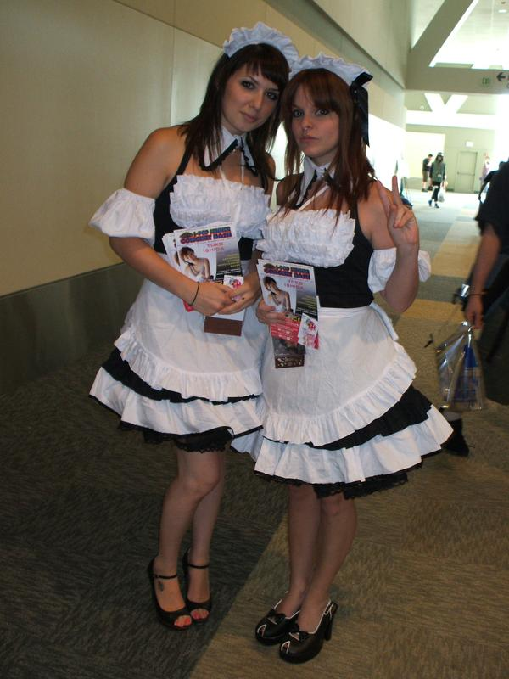

And it was for charity. I was wholly committed to raising money for research into the treatment of myeloma, a disease that killed my dear mother. There would be a charity auction at the end of the night.

So, I wore the costume, including the high heels, and I followed her direction on how to behave, including how to curtsey, as a maid should. I learned little rote phrases to be delivered in a high simmering voice: “Oui, oui Monsieur / Madame”; “comme vous le souhaitez” – “as you wish”. We rehearsed all the way to the party, so that when we arrived, I was being a maid as I if I was born to be one.

There were other costumes, but it was our “characterization” that won us the prize. We were Clarice and Yvette, matching maids. When Clarice (her real name) explained that we were a couple, the head judge seemed a little disturbed that a same sex couple had been awarded the prize, but when she said: “No, no, Yvette is Ivan, my date,” he was staggered.

I was only annoyed that she called me her “date” rather than her “boyfriend”. It seemed like all my effort had been for nothing.

Anyway, the prize was awarded to “Clarice and Yvette”, and then we were asked to make ourselves available as a prize in the charity auction. People would be asked to bid for our services. The “services of both maids (nothing indecent) for two hours”. Clarice seemed happy to do it. As I said, I was fully supportive of the charity, but I hardly thought our services were worth much.

Well, I was wrong. Bidding started at $100 and quickly went over $1,000. In the end a lady bought two hours of our time for $1,150. We looked at one another with some satisfaction. I blew a kiss to the successful bidder. She waved.

Then a man stood and shouted: “$2,000 extra for 2 hours of maid services by the taller one of two!”

I was committed to the charity so I nodded to the auctioneer. He called out for another bid, saying: “Who will pay $2,500?”

“The same guy shouted out: “I will. $2,500.”

Clarice stepped up. She was not going to be outdone by me.

“Who will bid for the other maid as a single?” he asked. Nobody raised a hand. Despite some more effort she did not get a bid. She walked off the stage with a smile, but when she looked at me, she was fuming.

I felt great. It is hard to explain why. I had tried so hard to please Clarice, and now that she was genuinely pissed that she had been passed over buy a guy, obviously a rich guy, for me, I was happy about it. But there was a simple way to put it right.

“He is going to get a shock when I tell him that I am a guy,” I said. “Or do you want to tell him?”

“No. You do it,” she said, as I saw him coming over. He was big and powerful, and quite handsome, I guess. And I may not be the best judge, but the suit and the tie looked very expensive.

I gave him a little curtsey and once he handed over his check, I said: “I am looking forward to serving you, but you should no that I am not really a maid at all. I am not even a woman.”

So the bomb goes off and I wait. I am wearing a smile in case he takes it badly. It is all for a good cause – right? Clarice is watching too. He looks a little puzzled, but then his chin rises, and he looks me up and down. No laugh. No anger.

“How interesting,” he says. Just that. Then: “When can you come around?”

“I am free tomorrow,” I said. Sunday. Then checking with Clarice: “Am I free tomorrow?” She nodded. That was disappointing.

“I’ll write another check for the same amount if you give me a full working day,” he said. “Say midday to 8:00pm?” He handed me a card. It was not a business card, it was a calling card. It just had his name – Dalton Hardwick, and his address – a 27th floor penthouse in a building right on the park.

“How could I refuse?” I simpered. I probably should have.

He wrote a check. He bought me. That was what he said. He paid for me. I was his.

The worst of it was that Clarice never even noticed that I was gone. I had done everything to build a relationship with that woman, and when she never heard from me again, did she do anything? Did she even think to call the police? I was not her boyfriend. I was just a date for that Halloween charity party.

My father never tried to find me either. But that was my fault. After my mother died, we drifted apart.

My work? I did not matter there either. One day I was not there. Maybe a week later they would have cleared my desk and put another guy in my spot. He is welcome to it.

But it is demoralizing when you realize that nobody is interested in you. Nobody wants you. Except just one person. My master: Dalton Hardwick.

He was a guy with everything. He could have had any woman in the world. But he wanted me. It took me a while to realize it, but that is something that a person can live for. You only really need one person to want you, and that should be enough. I have that one person. It is enough. It just took me a while to realize it.

He used drugs to subdue me at the beginning. So many drugs. Not just to rob me of my will, but to change my body. Drugs to destroy my maleness. Female hormones to soften my muscles and my skin, and to grow my breasts. And uppers to make me feel happy when he had sex with me. They were so good those drugs, that I found myself almost begging for him to impale me, just so I could have that fix.

Then the dieting, the corseting, the endless exercises in feminine behavior. Why? He could have had a real woman. So much effort because I was not that. For what?

I sometimes think that it was the challenge. He never told me what he did for a living, but I understood that it was challenging, and that he was stimulated but difficulty. After a while I felt that if I made it easy for him, he might tire of me.

He told me that it was nothing to do with that. He told me that he saw me on the stage in that maid outfit and he fell in love with me. He would say things like that to me in quiet moments when we were cuddled up together. I am not sure whether I believed him or not, but I loved to hear those words.

He said that we were a match, he and I. The only thing in the way was what was in my panties.

As long as I was not a real woman, I was a maid. I dressed as a maid – various outfits depending on the season and his mood – and I served him. He told me that if I was a woman, he would marry me. But because I was not, I was his servant.

I think that he sort of imagined himself as being in the sitcom – the one where the gentleman hires a quirky nanny but ends up falling for her and marrying her. We were keeping our distance from one another because we both saw ourselves as heterosexual men, but underneath there was a romance.

It would have been a nice idea if it was not for the fact that he fucked me up the ass twice a week.

He told me that when I was ready to become a woman I should just say. But that was never going to happen. I was always looking for a chance to escape.

When that chance came, it changed my life, but not how you might think.

I was locked in every day when he went out to work. I was never sure the hours he would be away. The front door had a deadbolt and we were 27 floors up. When he was out, he locked away all communications and he disabled the fire alarms. I even tried writing signs to go in the windows, but we had a great view – nobody could see it. had the run of the apartment but no way out. But then it seemed to me that he had made a mistake.

He was teasing me about being forever a man-maid. He said that I could be the lady of the house instead. He would hire a maid to do my job if I agreed to be his wife. He showed me an outfit that he had bought for me. It was beautiful figure hugging knit dress, with a fashionable jacket and a very smart designer handbag for my purse that would be fat with cash and credit cards.

“This could be yours if you agree to get rid of that last little thing,” he said with a grin.

I just turned and walked away. And he left, with the outfit lying on the spare bed.

I did the dusting, and cleaned the bathroom, and I just decided to look in the new handbag. He had gone to the trouble of preparing it for the lady of the house. It had some makeup and tissues, and even a box of tampons; it had a purse full of money – no cards without a name, but heaps of cash; and a set of keys!

How could he have been so stupid? I had come to know him as a very intelligent man. He was very learned, strong willed and thoughtful. How stupid.

I decided that I needed to act quickly. I would wear the outfit – stepping out dressed as a maid was not appropriate. I would go to the police and report the abduction and torture.

The key opened the front door just as I knew it would. But when I saw myself in the mirror in the hallway, I felt that I needed to freshen myself up. I could not possibly step outside looking messy. Just a little extra mascara and lipstick.

I took the lift to the ground floor. There was a burly doorman standing there. Would he stop me?

He just smiled at me and said: “You must be Mrs. Hardwick. I am Tom, the Concierge. Can I get you a cab? Can I call you Yvette? I am on first name terms with all the ladies in the building. Mr. Hardwick is such a great guy.”

I just wanted to get out the door and this man could not stop talking.

I smiled and thanked him: “I am so sorry, Tom, I am in a bit of a rush this morning. So nice to meet you.”

“Nice to meet you Yvette. I have to say it, I expected that you would be beautiful, but you are so much more than that.”

I have to say that I stopped for a moment and I blushed. I am not sure that I have ever blushed before, but I knew what it was. It felt as if the skin on my face had turned red.

The cool air outside restored me. I had no idea where I was. If I could just find a policeman. I just walked along the sidewalk.

People say you can never find a policeman when you need one, but this was ridiculous. The simple thing was to borrow a phone. I went into the first shop after I decided that. It was a beauty salon.

Somehow, I had the idea that when I was in the police station, I would have to hand over everything as evidence, including the cash. Maybe spend a little, then borrow the phone.

I had never been in a beauty shop before. If you buy the whole treatment including a nice hairdo, it takes some time. It’s a very relaxing environment. It is all about feminine things. It’s about chatting about beautiful things and being beautiful. It gives you new perspectives, and time to think as your hair dries. And you can pick up good ideas for making your home better; maybe giving an apartment that is overly masculine a bit of a feminine touch; maybe making your man a meal that reaches into his soul; maybe finding that perfect underwear that will blow his socks off.

Well, the front door was open when Dalton got home, and I was not in a maid’s uniform. I had bought something sexy, with something even sexier underneath. There was a creation in the oven and a new centerpiece on the dining table, set for two with candles. My hair was up with curly tendrils hanging down, and my make up had been done by a pro. I was the lady of the house.

But I think I realized when he smiled, that he had left those keys for me, deliberately.

The End

© Maryanne Peters 2019

Authors Note: Thanks to Lisa for this idea: “A man is persuaded by his girlfriend to go as matching french maids for halloween to win the costume prize. His girlfriend does TOO good a job. Not only do they win the prize but one of the judges is amazed to find one of the maids is a male! Into forced feminization,
and very rich, he 'buys' the male maid from his gf and takes him home. 6 months later, after boob surgery, and hormones, Master has his force femmed live in maid he had always wanted! Maid's male name was Ivan...female maid name will be Yvette.” Lisa likes her new girls to keep their junk, so sorry …

