Sorority Sister to Supersized Stud
By Soul-Controller

When Britney Peterson woke up one morning to discover a text from her fellow sorority sister Natalie, the blonde had to do a double-take to make sure she wasn’t hallucinating. If there was anyone she didn’t expect nor want a text from, it was Natalie Sanderson.

Ever since their freshman year of college, the duo had established themselves as formidable adversaries due to their similar skills and popularity. Yet while Britney treated others with kindness and respect, Natalie was the polar opposite. Instead of being a giver, the woman just took with no care in regards to how her actions affect others. By their senior year, their different philosophies had caused a clear rivalry to form between them as Britney was happily elected to become not only sorority president but also the head cheerleader (two positions that Natalie also desperately tried to get her hands on).

In the past few months, Britney’s brunette foe seemed eager to go scorched Earth upon losing the final elections for both head cheerleader and sorority president. Out of nowhere, the woman posted her own equivalent of a Burn Book which revealed every single secret that any of the girls had ever told her about themselves, their boyfriends, or their families. Understandably, this led to Natalie becoming the pariah of the sorority to the point where she barely left her room besides heading to class and back. Of course, Britney was empathetic to the girl who had seemingly lost everything, but it was hard to stay in that mindset for too long due to the actions she took towards not only Britney but her other sorority sisters as well.

Returning to the text though, Britney couldn’t help but be confused by the bizarre message that Natalie had sent her. On top of a long rambly apology, the message included a link to a “present” that Natalie said that she had made specifically for her. Despite knowing that it was probably some stupid prank or another attempt at revenge, Britney couldn’t help but ponder if the woman had genuine regret and thus opted to click on the link. Upon doing so though, the link pulled open the woman’s phone browser and turned it into an all-black screen. Wondering what was going on, Britney simply stared at the device waiting for something to happen… until a sudden tingle coursed through her hands and caused her to exit the window.

Upon firing a text saying that the link didn’t work, the woman headed into her bathroom and set her phone on the countertop as she undressed and began to shower. As she did this though and remained utterly focused on cleaning herself off, Britney was unable to notice the tingle that had transferred into her fingers spreading throughout her entire body and causing a series of changes to occur. In an instant, the woman’s toned physique began to suddenly inflate with muscle. While her biceps and thighs grew incredibly thick, the woman’s plump breasts and ass were like balloons as they suddenly popped and were sapped of any supple adipose tissue. Despite finding herself struggling to fit into the now-tight quarters of the shower due to her newfound bodybuilder physique, Britney remained completely oblivious as she continued to wash along her plump pecs and firm muscle ass.

As the woman’s shower continued, Britney began to focus on washing her genitalia. But as she rubbed along her vagina, a sudden tightness began to emerge as she washed the area. Despite this sensation, the woman was in an entirely different world as a ballsack complete with golf-ball sized testicles birthed themselves from her feminine folds. From there, the water flowing down her body continued to change course as inch-by-inch, a girthy 8” appendage manifested to complete the woman’s physical shift into a man.

From the neck up though, the delicate features of a female visage complete with long blonde hair seemed ill-fitting on such an imposing physique. Luckily this wouldn’t be the case much longer as Britney’s focus now shifted toward washing her hair and face. With each run of her shampoo-covered thick callused fingers through her long blonde mane of hair, the strands were quickly receding into her scalp until she eventually gained a tight short blond hairstyle. As she grabbed some facial scrub and began to rub it into her visage, the features began to shift from soft and dainty to hardened and angled. In addition to the light sensation of trimmed stubble now brushing against his fingers, the new man gained a prominent brow and jawline as his nose straightened and also widened to give him the face of an imposing male model.

As the man lifted his head up and allowed the water to wash out the shampoo and face scrub, the memories and personality of Britney were undergoing a significant shift to fit his new form. Rather than being the head cheerleader, the new man was a linebacker on the college’s football team. In addition, the intelligence and well-mannered personality of Britney devolved severely to turn this new hunk of a man into a crude and cocky young man who would rather spend the entire day in the gym or being athletic than in a stuffy classroom.

With the final bit of shampoo and soap being washed down the drain, Brian Peterson went ahead and turned the shower off before wrapping a towel around his waist and stepping out. As he made his way to the sink, a swell of pride couldn’t help but fill his wide chest as he took in his tremendously imposing physique. He looked like an absolute god, which was a great thing since he WAS a god on campus!

Eager to revel in his own vanity, the man went ahead and grabbed his phone to pull open his camera. As he lifted the phone up to the level of his prominent Adam’s apple, the man hit record as he posed for the camera and showcased the hardened angles of his jawline.

In the midst of inflating his ego even further, the immense hunk was suddenly interrupted via a text by Natalie. Instantly, memories implanted themselves into the man’s mind in terms of his new relationship with the woman. Rather than being adversaries, the two were closer than ever – as a couple! In Brian’s eyes though, it only made sense that the head cheerleader would be dating the captain of the football team. Plus, they were both hot as fuck so every other couple on campus could only aspire to be like them.
As he opened up the text and saw a photo of the woman’s breasts with a seductive text talking about how badly she wanted him, it wasn’t a surprise that the man’s cock began to harden up at an exponential rate. Eager to return the favor and give her something to lust over, the man wasted no time pressing record as he pulled off his towel and mentioned how “chubbed up” Natalie made him.

Back in her room, Natalie couldn’t help but smirk as she got her ultimate revenge against Britney. With her out of the way, Natalie’s life was utterly perfect now. She was head cheerleader and sorority president (which was the only reason why Brian could get away with sleeping and showering in one of the spare sorority bedrooms whenever he partied too hard), with a ripped and hunky boyfriend to boot. The woman was on top of the world and if any adversary ever came up against her, she now knew the power of the Chronivac!

Chris Gets Collared
By Soul-Controller

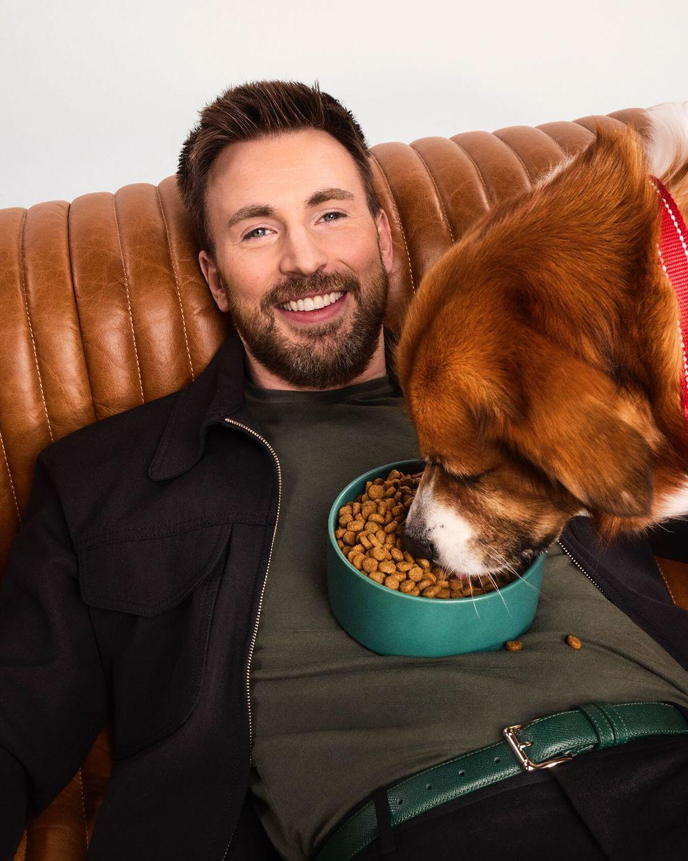
Beyond his wife, there was no one that Chris Evans loved more than his dog Dodger. Ever since he got the mixed-breed Boxer back in 2017, his furry friend had been with the actor through the several ups and downs of his post-Marvel career – which was something that Chris was eternally thankful for.

So when Dodger began to behave strangely and avoid eating his food entirely, the actor spared no expense going to any vet or specialist that could get him better. Yet no matter where he went, no one could give Chris answers as to what was going on with his dog. With himself running out of options and fearing the worst for his dog, the 42-year-old actor was left with no other choice but to enlist the help of a self-proclaimed “animal whisperer” named Sean Cunningham.

After only five minutes alone with the dog, Chris was surprised to watch Sean exit a nearby room and reveal that he had already discovered what was wrong with his dog. Upon being asked if he would be willing to do whatever it took to make his dog feel better, Chris wasted no time nodding his head and saying that he would without a doubt. In response, Sean simply turned on his heels and exited out of Chris’ mansion to grab something out of his car. Upon returning, Chris’ eyebrows raised in confusion at the sight of two red dog collars in Sean’s hands. As Chris asked what was going on, the dog whisperer simply told the man to trust him and put the collar around his neck. Believing that simply the embarrassment of wearing a dog collar was the only concern, the actor complied and quickly placed the collar around his neck.

Instantly, Chris’ eyes rolled back as the entire world went black. The man returned to consciousness with a jolt, gasping as he opened his mouth and took in a deep breath. But as he did so, the return of his senses revealed several bizarre things – firstly he felt as though he was head-to-toe wrapped in a cozy blanket. In addition, the man couldn’t help but feel as though his tongue wasn’t fitting in his mouth correctly as he could feel the now-long body part hanging down past his lips and teeth. Most importantly though was the sight of his new perspective – beyond his apparent low height he could also see straight across from him that Sean was standing there with his own body!

As the man attempted to scream and demand answers though, only a series of growls and barks escaped from his throats which only emphasized his new fate – he had swapped bodies with his dog! With his eyes and now floppy ears, the man-turned-dog could only watch in disbelief as Sean explained that he realized that Dodger was tired of being a dog and wanted something more. As a result, the only solution was to give Dodger the chance to be a human owner.

The dog-turned-man initially had a struggle navigating his new gift of English, with his words slurring for a while as he eagerly thanked Sean for the opportunity to become human. Yet as Sean began to discuss the concept of the duo swapping back to their original species, Dodger wasn’t too eager to go back. Luckily for him, he was aware of the immense wealth and success that his new life possessed so he couldn’t help but smirk as he turned towards Sean.

Across the room, Chris’ heart began to frantically beat and a whine escaped from his lips as he heard his former dog ask how much Sean wanted to keep them like this. As he stood up and realized his new status as a four-legged creature, Chris Evans was left with no other choice but to begin walking around as it seemed like he’d be having to get used to being a four-legged creature…

Father-Son Bonding
By Soul-Controller
When Scott Matthews first found out that his girlfriend was pregnant, the 20-year-old college student was ecstatic. Despite the newfound stress he now felt in terms of finding a career that could sustain a wife and kid, there was nothing else that he wanted more than to be a father.

In his youth, the man found great solace in his close relationship with his father, so when Scott and his wife went in for an ultrasound and discovered that they would be parents to a boy, the man was eager to replicate it with his first-born. Just like his father, Scott was an incredibly athletic and handsome guy, which allowed his father to help mold him into a standup guy who was both instantly charismatic to others and appealing to the eyes. His father helped coach him in sports and do fitness training with him on the weekends, so the concept of doing the same for his own kid was extremely exciting for the expecting father.

But as his son Jacob was born and began to grow up, Scott was disappointed to learn just how different his life was in comparison to how he envisioned it. Firstly, the man had never considered the concept of being a single father, but he was forced to accept it after losing his wife to cancer a few weeks after Jacob’s sixth birthday. Even prior to the death of his wife, being the main breadwinner was a lot of stress and hard work so the fact that he now had to handle his roles on top of his wife’s after her death made him feel incredibly overwhelmed.

Additionally, the warm tight-knit relationship that Scott aimed to form with his son never really materialized. Attempts to play catch or be active outside were instantly rejected by the young boy, who would have much rather stayed inside to read books and watch television. Despite his own disappointment in not having a sporty son, the man still viewed his son’s behavior adorable as it just reminded Scott of how much Jacob resembled his mother. But in the aftermath of his wife’s death, it soon became a painful reminder of what he lost and thus only caused the duo to become more disconnected as they both grew up.

By the time sixteen years since his birth had occurred, Jacob had also come to realize a similar case of disappointment and resentment towards his relationship with his father. Unlike his popular and athletic father, Jacob was more of a reserved academic – who found flexing his intellect more interesting than his muscles. In school his father was a straight C student, so the 16-year-old wasn’t too shocked to realize that the mid-30s man didn’t have much understanding or interest in most of his hobbies or coursework (including the AP courses he took at school).

Yet even if his dad didn’t understand anything, Jacob still would have loved it if his dad ever attempted to show up to his various events and provide some encouragement. But unfortunately, the young man was forced to attend mathlete competitions and Science Olympiad events utterly alone with no one to cheer him on. Of course, his dad said that he couldn’t get off of his factory job to go, but Jacob knew deep down that his dad just simply didn’t want to go. He always knew that he resembled his mother more than his father, so sometimes when he’d sit and think about why his dad wouldn’t come, he’d feel guilty believing that he was a constant reminder of his father’s loss and suffering.

Eventually, their tensions reached an all-time peak after his father didn’t come to the final mathlete competition of the semester. As they drove home, Jacob was the one to break the tension, asking why his dad hated him so much. From there, their conversation bounced between annoyance to tear-filled responses as the duo finally purged themselves of all of their innermost thoughts. Once his dad’s truck pulled into the driveway, Jacob exited and headed into the house with haste before slamming shut his bedroom door and falling into his bed.

Despite wanting to patch things up with his son, Scott’s own tear-filled eyes caused him to choose to give the duo some alone time so they could properly comprehend their emotions. As a result, the duo simply fell asleep crying into their pillows, wishing that somehow someday their bond would be unbreakable and the duo would equally understand each other.

Upon waking up that next morning, both men were shocked to find that their bodies had been swapped. Of course, such a shock caused both men to decide that they needed the day off to fully focus on figuring out what happened and how to swap back. So now forced into the fatherly role, Jacob called into his father’s job before then calling his high school to state that his “son” was sick and thus staying home for the day.

For both men, it was equally uncomfortable and unnerving to find themselves in each other’s bodies, especially due to Scott’s new teenage morning wood refusing to dissipate and thus forcing him to deal with his son’s boner. The same could be said for Jacob upon waking up in his dad’s body, especially as his father slept nearly nude besides his underwear so the teenager was forced to look at a rather scandalous amount of his father’s muscular mid-30s dadbod.

Despite their best attempt at finding some sort of online solution or consulting with supposed “magical consultants”, no solution to their body swap problem ever presented itself to the duo. As a result, the worries of both income and teenage truancy meant that they were left with no other choice but to live the lives that they had been magically forced into.

Understandably, the adaptation period was quite rough for both men as they adapted to the new roles that they were either 20 years too early or too old for. For Jacob, it was an instant struggle adapting to being the hardworking breadwinner of the family. Additionally, the teenager wasn’t the type to get his hands dirty or be physically active, so the concept of going to work in a factory was incredibly daunting and terrifying quite frankly. In fact, there had been several instances in his first week as his dad that the young man had nearly gotten himself severely injured by a machine.

As for Scott, the popular and athletic man had quite a rough time adapting to his son’s life. Rather than the countless friends that he had growing up, Jacob only had three best friends who were a part of the same programs and clubs as Scott’s son. As a result, his social life was relatively limited and thus meant that he had a lot of free time to just wander around town or find somewhere to hang out to avoid going home and interacting with his son-turned-father. Additionally, it was an absolute mindfuck for the straight C student to suddenly find himself tasked with living up to his son’s potential. He could barely pass biology and chemistry yet now he was expected to ace AP variations of these courses!

Over time though, the initial distance between the duo faded as they found themselves needing each other to best adapt to their new scenarios. With the several near-injuries that his son experienced at his job, Scott worked hard to help teach Jacob what to do in addition to teaching him about his co-workers and how to stay safe 24/7. In response, Jacob returned the favor by helping tutor his father in those tricky AP subjects that he did in addition to showing up to Scott’s various Science Olympiad and mathlete competitions due to his intense nerves.

As six months passed, both men had ultimately begun to accept that they would most likely never be going back to their old lives. Yet despite how most would mourn such a loss, neither the new Scott or Jacob felt that way. As time passed and they got into the routine of their new lives, the duo had truly felt as though they had been given a new lease on life. While “Scott” was able to be more mature, it also meant that he had the ability to help improve the family’s situation by beginning night school courses at a nearby college for engineering. In time, the 36-year-old hoped that one day he’d be able to leave the mechanic position at the factory entirely and instead get himself promoted to one of the engineering positions which provided a much more appealing salary.

With “Jordan”, getting the ability to redo high school meant that he was able to actually get a second chance to enjoy his youth. Although he loved his time as a father despite the several heartaches that occurred throughout, the man had never been given the ability to savor his twenties as he needed to become the strong family man that his wife and future son needed.

So as Jordan lifted up his phone to take a selfie with his father at the county fair, both men’s smiles couldn’t have been more genuine as the son’s finger pressed on the camera button. Through some magical interference, the father and son had grown closer than ever and after being able to say they’ve lived both of their lives, each man could confidently say that these were the bodies and lives that they were meant to have.

Reforming The Police
By Soul-Controller

“Alright officers, I think it’s about time you get back to your car. I’m sure your chief will be wondering why you’ve been gone for so long…”

Immediately, each of the middle-aged cops looked at the elderly woman and nodded with a grin as they savored their new title. Never in their lives did they think that they would ever be addressed as cops, but it was something they were willing to accept for the greater good.

In reality, the two LAPD officers now walking back to their squad car were actually members of a poor, under-served minority-ran area of Los Angeles. Despite the troublemakers in the area who did things from looting to the rampant drug-dealing in the area, officers had been turning a blind eye to all of that. Instead, the department would send squad cars out and the officers would instead target the homeless community or any minority they set their sights on. Anyone who attempted to record the officers would find themselves forcefully beaten up and even be planted with drugs as they were hauled off to the nearest station for booking. Rather than protecting and serving the community, the police force instead mercilessly terrorized them.

After enough of these instances, the community was desperate for retribution and thus conversed with a local self-proclaimed witch who stated that she had a solution to fixing this rampant issue – creating a trap where the cops would respond to a call and end up swarmed by members of the community. But rather than returning the favor with intense violence, the community members held the cops down as the witch plucked out the souls of two poor yet upstanding citizens in the community and placed them in the bodies of the officers.

With the two cops now back at their patrol car, the witch smiled as her trial run had worked flawlessly. Now, the community could continue with their plan of secretly reforming the police in their image. No longer would the average citizens of the community be terrorized by those meant to protect them, instead a real difference would be made!

