Irony  Inspired by a Captioned Image  By Maryanne Peters  When Bill told me that he cross-dressed occasionally, I laughed, but not as loud until I saw him dressed for the first time. He looked ridiculous.  I know that it was a horrible thing to do, he looked hurt, although he laughed with me once he was over the shock of it.  “Maybe you should try to look better than I do?” he said.  I cruelly responded: “Buddy, I am sorry, but I could look better than that without even trying. I could convince my own mother that I was female.”  “Your mother is dead,” he said.  “Your mother isn’t,” I said. “I could convince her.”  “You do that, and I’ll never cross-dress again,” he said. | 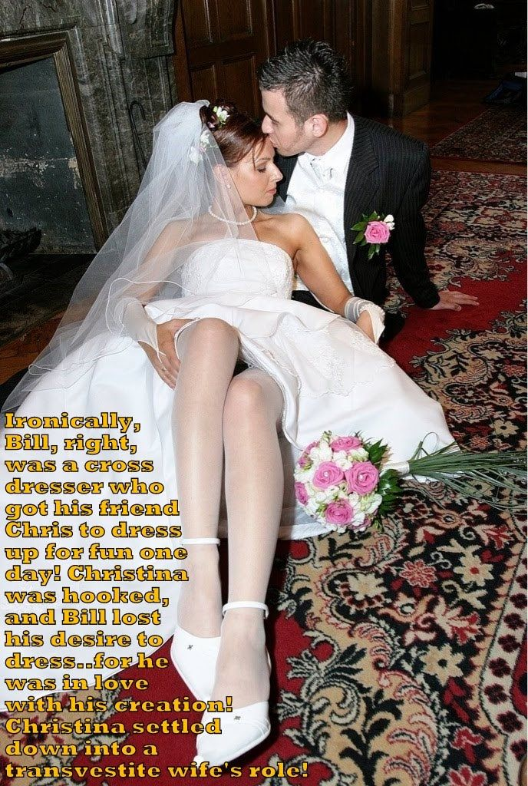

As I said to him, I owed the world a favor in ensuring that he never did, he looked that bad as a woman. I, on the other hand, looked damn good.

I had to spend the whole day as Christina, Bill’s new girlfriend. After I had finished my makeover, we needed to drive three hours north to Lake George where she lived, have lunch and then drive three hours back home.

I needed those first three hours. The salon had done a great job with the hair extensions, maybe a little too aggressive with the eyebrows and the body wax, but fantastic with the makeup and the manicure. But I needed to master the voice with Bill’s help, and develop with him a plausible back story.

“Just don’t give her any stupid hints that I am Chris,” I squeaked in my girly voice. You have to give me a chance to convince her that I am a girl. Then I am going to hold you to you promise.”

“I have to say that my future in skirts is not looking good,” he said. I had no idea that you would turn out looking this good.

We stopped for coffee at a tiny village in the valley on our way up, and it gave me a chance to work on my feminine table manners. Bill was a complete gentleman. I was a complete lady.

When we got to his mother’s cottage on the lake she heard us pull up and she came out to greet us.

“What a pretty girl you are Christina,” she said. “My Bill is a very lucky boy.”

I smiled at my new boyfriend. He looked resigned to his fate. Unless I let something drop badly, I was going to win this. The truth is that I didn’t know where it came from, but it came easily. I think that I know now, but I didn’t know then. It was always there. It must have been.

It was a wonderful day. Bill’s mother is a wonderful woman. What I didn’t know about women before I met her, I learnt from her that day, just by being with her and talking about the kinds of things women talk about. We had time. She had small manly chores for Bill to do. The kind of thing that he was good at, and neither his mother nor me had any clue on what to do.

When we drove back to the city it was late. After getting almost halfway Bill said that he was too tired to drive further. I was tired too. There was a motel, so we did what people ought to do, we decided to get some sleep and head back at first light. Room options were limited, but we could handle it - just two old friends sharing a double room.

“You’re still talking in that girly voice,” said Bill.

“Am I?”

“And you are moving like a woman. Something I could never do. You’re a natural.”

“Do you think so,” I purred, for some reason coming close to him, and fingering the collar of his shirt. Something no guy would ever do to another guy. But it was as if I was somebody else, and I had been ever since I stepped into his car that morning.

He took me by the shoulders and kissed me on the mouth. I tore myself free and stared at him angrily. I just stared at him, not saying a word. And then we just fell together, like two magnets, attracted by forces beyond the understanding of ordinary people.

I am not sure when Bill’s mother learned that I was not really a woman, but it was not that day – it came later. She said that she knew of Bill’s attraction to women’s clothes, and she was glad that he was now cured of it.

“He just needed somebody like you to show him that he could never be female. That’s what you are. And I am so pleased that you will be my daughter in law.”

The End

Sold Off
Inspired by a Captioned Image
By Maryanne Peters

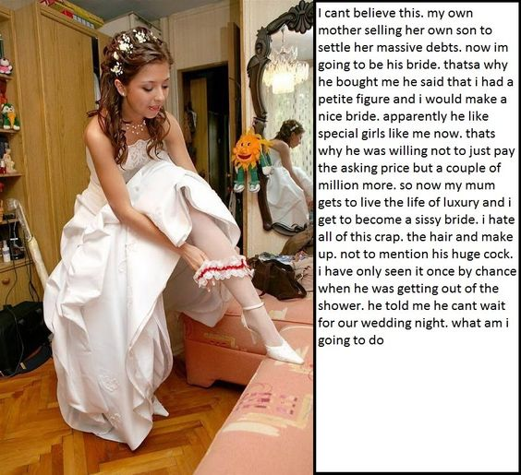

I never thought that this kind of thing happened for real, but there are strange people out there.

I suppose my mother was strange too. She always had a hankering to see me dressed as a girl. She told me that she did it when I was a baby, dressing me in pink just because she liked to hear people say: “What a pretty little girl”. Any chance to put me in a dress for Halloween or fancy dress she always said: “Go as a princess. Let me get you the outfit.”

She always encouraged me to wear my hair long, and she would like to brush it when I was doing my homework. Sometimes she would lift it up at the back and twist it around – just playing with it as if it was girl’s hair.

You might think that being treated like this would turn me into some kind of sissy, but I never was like that. I wasn’t a jock either, but I found my place with a good bunch of guys, and we did fun things together. Everybody understood that my Mom was a bit wacky, especially when I turned up to a Halloween thing in the princess get-up.

“Don’t tell me. This was your Mom’s idea”. Same thing every time. I just shrug my shoulders and check my lipstick.

My mother loved to take photos of me dressed as a girl. She would say: “Strike a pose. Look like a princess longing for her prince”. Embarrassing stuff like that. It was her thing. How could I refuse?

I knew that my Mom was a failure in business. I guess she was a failure in relationships too. She only had me, and as it turns out, she was happy to trade me to get out of debt.

I didn’t know it, but she had been posting pictures of me dressed as a girl on the internet, or some of those dark places on the internet where people are interested in such stuff. She ended up in deep correspondence with a guy called Victor.

I didn’t learn details of the deal until much later, but Victor was looking to marry a sissy boy. It must have been that he couldn’t find one, because Mom volunteered me, for a price. For money she would prepare me to be his, and in return he would buy up her debts and forgive them over time.

To give her some credit, she was not just selling me. Victor lived in another state, where marriage to a minor was legal, and so was marriage between a man and a transwoman, but my mother would be moving to live with us too. I suppose that I can see why it worked for Mom, but she never consulted me.

All I knew was that she started me on “vitamins” and “flu shots” and had me washing my hair with some miracle growth promoting stuff. You know how this ends, so you know what was happening, but I didn’t. At least I didn’t until one day I looked at myself in the mirror and I saw tits, and my hair hanging down almost to the nipples.

Facing Reality
Inspired by a Captioned Image
By Maryanne Peters  I watched the video and I was supposed to laugh. I was supposed to be smug and satisfied that Garret had paid the ultimate price for dipping his dick where it did not belong, so now he does not have one.  But that is not what happened. I realized that I wanted her. I am not talking about the post-wedding video. That never happened. It was our wedding, you see.  I must have seen it in him. It was my call that he not be killed. Even then he was a pretty boy. Too pretty to die so young. | 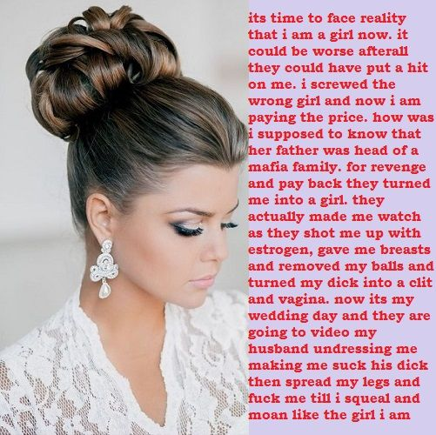

The video I watched was the work of the surgeons, much of it carried out with only local anaesthetic – an epidural which extended high up his body. He watched in horror but without agony as they took away his manhood, but I had them fashion something wonderful in its place. The tears rolled down his smooth face, stripped forever of a beard, denying him the chance of return.

The agony for him came later for him. The camera rolled again after the anaesthetic wore off and he had recovered from fainting as surgery was completed. I wished that I had been there to direct he be sedated, but it was all in the past. I only had the video.

“When it is healed enough not to leave too much blood on our cocks, we can all fuck the new girl,” said my knuckled headed “assistant” Joe. “We can video that too. Video “her” sucking and squealing as we ream her …”.

“No,” I said to him. “She is mine.”

She thought I was a monster, and with good reason. But I will not take her by force. I will not inflict more pain on her. I will worship her new body as a husband should. That is why I proposed marriage. I suppose that she felt she had no option but to say yes, when she looked at Joe and his friends leering at her, but I take marriage seriously. I will honor and protect my wife, and I hope to win her love.

There will be no video of our wedding night, my darling. That is for us alone.

The End

Thee, Bride
Inspired by a Captioned Image
By Maryanne Peters

Sometimes, when working as a professor of literature and a drama coach, you come upon what you consider to be a real talent. But it seems that some such talents are prepared to turn their back on their potential for a mundane life.

Matthew was a real talent. Most of all, despite his diminutive size, he had a real presence on stage. It was just trying to find him the right role.

The playwright behind the show “Thee, Bride” had been a student of the college and for that reason the time had come to mount a performance of the play. Matthew was unsuited to the leading man (the groom) and the supporting roles of the best man and the two fathers, because of his size. And that left only the female roles – the mothers and the bridal party. That was when I came up with the idea of Matthew playing the bride.

As I said, he had presence, and the idea of a man playing the title role added some real spice to this production, of a play mounted on many prior occasions. The cast was then evenly divided.

The only question was whether Matthew could pull off the most challenging role of his life – so far. I had confidence that he could do it, but it would require a new level of commitment.

It was a commitment that he was prepared to make. As a method actor re resolved to become his character, and live in the role from the first dress rehearsal. That meant becoming the bride, Kathy. On the surface that meant a complete body waxing and having latex breasts stuck to his chest so that he could “live in a female body”. It meant hair extensions rather than a wig, so that he could not simply shed the role after each performance.

I learned about the hormones later. Matthew had been scratchy in the week leading up to dress rehearsal, as if he was in a pre-menstrual mood, and somehow he was able to procure an injection of powerful female hormones which he told me: “Left me at ease and comfort in my femininity”.

I have always been a strong believer in the Stanislavski system at the heart of method acting, but it would be foolish not to acknowledge that it can affect actors in unintended ways. Many great actors have been affected by their immersion in their roles, and often in trying to find their way out of their roles into the “self” when that self has been lost. The most recent examples might be Philip Seymour Hoffman, and perhaps Shia La Boeuf. If somebody does not have a self to go back, or does not like that self, they may find themselves adrift.

Who knows? But Matthew never came back. He immersed himself so deeply in the role of Kathy that he became Kathy and never came back.

He played opposite Donny, the leading man. Donny was a talented actor, but it was just something that a young man with his overall abilities could do for mild amusement. He would go on to become a leading attorney and litigator. He often told me that the stagecraft that he learned from me stood him in good stead in court. He has stayed in touch, which gives me the chance to catch up with his wife Kathy.

There is no sign of Matthew in her anymore. She has had all the surgeries now, so that they could get married a few years back. They now have two children by surrogates and Kathy lives only to be the perfect wife and mother, just as she was the perfect bride.

The End

Author’s Note: I assume “Thee” was a typo, but I worked with it by adding a comma.

Pumpkin  Inspired by a Captioned Image  By Maryanne Peters  I felt that I was entitled to an easy life. The way I saw it was that my Dad had worked his whole life to make money to support his family – I was his family – I was to be supported by him. I didn’t need to go to Harvard, and all that work and pressure. I could live off his work and the pressure he was under. I was his son. Well, I was his son. I am not his son anymore. Now I am his daughter, and he likes it that way. | 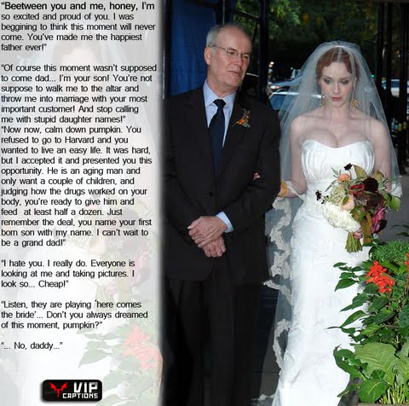

Oscar Gidley was my father’s most important customer. By that I mean that if my father did not have Oscar’s business, his own business would collapse. Oscar was a little younger than my father, but he still seemed very old to me. I was aware of the way that he stared at me whenever I was around. He told me later that he saw something in me. It was something that he wanted.

Oscar told me that his father was complaining about me one night when they were sharing a bottle of scotch, and that was when he made his proposal. He told my father that they needed an alliance to cement the business relationship, and I could be the key to that alliance. My two older brothers contributed to my father’s business and I did not.

But he saw something in me. Something I didn’t see. He saw a woman.

No father should have agreed to what was proposed, and I like to think that he wrestled with his conscience just a little. But all I was aware of was that my father started looking at me differently, and how he started constantly referring to how I looked like my late mother.

No so should ever agree to what was proposed either. But Daddy made it clear that if I wanted to be supported, I would need to accept the changes that Oscar required. He pointed out that if I married Oscar I would inherit his entire (and considerable) wealth upon his death. I would be set for life. And my father had extracted from Oscar a pre-nuptial agreement to ensure that he could not terminate our marriage, given the sacrifices that I was required to make.

So many red-blooded men out there will be asking: “How could you ever agree”, but you have no idea of my position. I had an education but no skills, and a disinclination to work. My father said that all that I had going for me was what my mother left for me: Copious red hair, big green eyes and a pale skin. Those were the very things that Oscar saw in me.

I now have a pair of D cup breasts to add to that.

The wedding dress was cut to show them off. Is Daddy looking at them as I took his arm? What man wouldn’t? Daddy is a man after all. I’m not.

I have to say that despite myself, I found my wedding day to be a wonderfully happy day. I know that all brides feel the day is special, but for girls who have imagined this day all their lives, and the romance of it all, that makes sense. What sense can there be in it when the bride had always been a boy, and had never contemplated marriage to anybody, let alone a man.

I guess that it was being the centre of attention. That and hearing Daddy say for the first time that he was proud of me. More than that, I am doing what my brothers cannot do: I am cementing the future of the family business. I am more than relevant to it – I am vital.

That, and everybody loves the bride. It was the day I realized that men don’t have real friends, but women do. All the women in my wider family and the girls who really never liked me as a man, are now my true friends since I am become woman.

And the biggest surprise was yet to come. When he lifted my veil and I looked at Oscar’s face, I saw love. It was the first time that I had seen it. Well maybe the second time, but on the same day. First Daddy and now Oscar. I was loved.

But that was still not the biggest surprise. When the celebrant said that he could and Oscar kissed me, I realized that I loved him back.

Of course, I cannot bear him children, although Oscar likes to fantasize about it. I had a vagina constructed where the old me once existed, but in ends in nothing. Oscar’s sperm flows straight back out and into a cup for insertion into the surrogates. He says that he wants me to wear a pregnancy suit right through it all and prepare myself for breast feeding. I thought that the idea was disgusting, but I am warming to it.

Just like making love. Initially I thought that it would be revolting given that I had always been a heterosexual man (or thought I was) but in the whole whirlwind of the marriage and the reception, and dancing in his arms, and sharing kisses to the applause of guests, it just seemed right to lie back in my bridal stockings and crotchless lingerie and let him enter me with his Viagra-enhanced cock.

A day of surprises, and this was the biggest. The biggest by far. “Mind-blowing” seems a phase to widely used, until you actually experience that very thing.

The perfect end to a fairy tale wedding, except that I am still the bride, and I live in a palace with an adoring prince (even if a little older) and I have everything I need, and nothing has turning into Pumpkin except me.

The End

© Maryanne Peters 2019

