Man to MILF
Inspired by a Captioned imaged from Mandy (http://suitstoskirts.blogspot.com/)
By Maryanne Peters
It is not every guy’s nightmare. It is not mine. Sure it was unexpected, but I would not have entered the contest if I was not interested in presenting myself as female and face the prospect of living as a woman for a whole year. I read the rules. That was what I was expecting. But there was nothing in the terms and conditions about a husband. That was not in there. How did I miss that? | 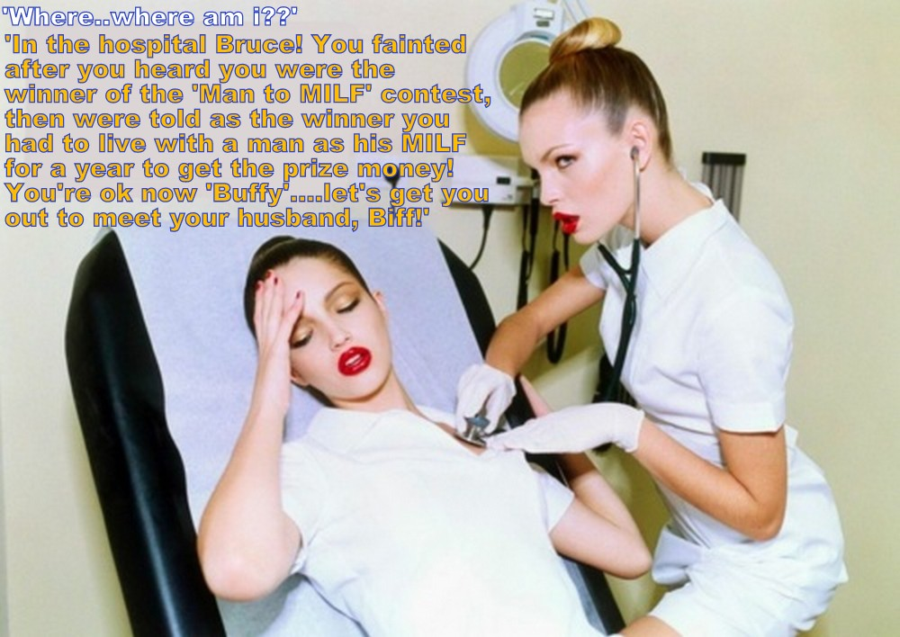

I was an experienced transvestite. I mean that I did more than just dress up at home. I had grown my hair so that I could use falls or wiglets. I had electrolysis on my chin and top lip to keep the five o’clock shadow away when I went out on the town. And that is what I did, going out and pushing things to the edge. But during that day I lived and worked as a man. That was my life.

I suppose a few transvestites wonder what it would be like to live full time as a woman, just for a little while. So when I was made redundant and the competition came up I was keen to try. It meant employment in a well paying administrative position for a year, but as a woman, plus a cash prize, if I was the best looking mature woman on the stage.

The entry forms included contractual commitments. I thought that I read everything before I signed. Where was the term about consenting to surgical procedures? I am sure I would not have signed if I had seen that. The organizers put everything in front of me, right?

All I remember was the applause and the confetti falling and then I must have blacked out. The next thing I remember is that I am in a hospital bed and a beautiful nurse is checking my heartbeat.

“What hospital?” I asked.

“Well actually it is the Beautifex Cosmetic Surgery Clinic.” That figured. She looked like a successful ex-patient. “You are fully recovered from the treatments.”

I could feel a tightness in my face. I reached up and could feel that my browbone was gone and my hairline pulled forward. My nose was smaller and my lips bigger. And then there was my chest. The stethoscope rested on my left breast. A big round creamy white and jiggling breast!

“What the hell is going on!” Even my voice did not sound like me.

“You wouldn’t want to spend a year living as a woman and looking and sounding like a man dressed up, would you?” the nurse scolded me. “The organizers have gone to huge trouble and expense to make things as easy as possible for you. You can thank the sponsor, William Hoggard of Hoggard Technology. He has taken a special interest in you.”

She brought me a mirror and I had the first look at the woman I had become. As I say, I would have been horrified were it not for the fact that I was entranced.

“Ok, so I answer to Buffy now.” I did not seem like the right name at all. With my hair pulled back of my new hairline and in a high bun, at with full makeup even when lying in a bed, I seemed my too sophisticated to go by the name Buffy. “I’m sorry, I missed that - I am living where?”

“With your husband, silly. With Bill … with Bill Hoggard. He is here and on his way up.”

The End

Honey Heart
Inspired by a captioned image by Jenny Valentine
By Maryanne Peters

I guess I thought it was all I knew. Honey Heart was in the whoring business and so was I. When I saw it on the list of probation approved indentures, I saw it as a way out. I did not even know what indenture meant, but anything had to be better than prison. Outside I had been the wise-ass little pimp, but inside I was just not big enough to be anything else but the wide-ass little fuck-buddy. Anything was better than that.

But it turned out that the Honey Heart Institute was a gender adjustment training school, and indenture means another kind of servitude – by contract. There was no way out except the prison way, so that means no way. Back to prison or follow the course they required. “Nothing permanent,” they said. “Nothing irreversible”.

I suppose when I arrived, I thought women were inferior. To me then, bitches were meat for sale. I had fucked plenty of them, but I had never loved a single one. Even my mother meant little to me. She was beautiful but distant – something to admire rather than cuddle. Come to think of it, cuddle was like love, a word I did not really understand. Now I understand the value of cuddling. Sometimes it is all that is needed.

You would think that as a pimp, accepting a term living as a woman would be something I could just not stomach, but that is not the way it went. I got into it. You work in a business and you think that you know all about until you are right there out in front. The coal-face they call it. Where the pick hit’s pay dirt. The room – just him and me. A pimp will never understand.

I never tried to hide who I was. That would be a ticket to trouble. Plenty of guys are interested in a pretty T-girl, and I was pretty. I still am. Some just want to hear your story. Some ask: “Have you ever fucked a girl? Which is better – to fuck or be fucked?”

“Bend over and you can be the judge,” is what I would say, but with a smile.

There were guys who wanted me to be a girl, and to hide what had. Some wished I was bigger, maybe even bigger than them, so they could get off on fucking a man. Those were the guys who want to hear you scream like a guy when they fill the condom. What are they trying to prove.

And then there are the guys who just want to be with you. They want you to hold them, or to have you to hold, and tell them that their touch is all you want.

Of course my ass got a reaming, but I knew how to keep it clean and loose, and free of pain. Blow jobs are the same – use lubricants that keep him clean. Swallow – it is just a tiny protein shake.

But I also learned how to offer other services. These are the services some whores have offered since the very beginning, but not all have the wit to offer. You don’t even have take him in any part of you if you can entertain him. That is what I was invited to teach the others. How to whore without whoring.

“Tell me you story, Honey. How did you end up here?”

I don’t tell the truth. Whores never do. I always used to say: “I have always wanted to be a girl. This is the only way I can get the money I need for the surgery. I just need a little more and then I will have enough. That’s a very generous offer. It means so much to me.”

I used to say that stuff when it was a lie. It isn’t any more.

The End

Feminitis
Inspired by a cap by TG Phun
By Maryanne Peters

Have you ever heard of “Munchausen’s syndrome by proxy”? That is where somebody who loves you makes you sick so they can care for you, and that makes them feel fulfilled. No, that is not my mother’s problem. What she has is just plain old insanity.

A few years ago, she got it into her head that I had caught some disease called feminitis. This is supposed to be an illness which turns a regular guy into a girl. Crazy, huh?

Anyway, nobody would ever believe shit like that, except my Dad. Maybe because he is dumber than a brick (bless him) or maybe because he learned early in his marriage that his wife is always right. For whatever reason he went along with it.

I mean, he said: “This is going to be tough for you, son. God knows no man is going to be happy about turning female, but you just do as your Ma says. She will look after you.” Like I say, not so smart.

Just like that Munchausen thing, Ma made it happen, with drugs and such, that made me go weak and change shape.

She had me grow my hair super long and she was always brushing it and stuff. I only ever had dresses to wear. There were no pants anywhere. There were plenty of panty hose, of course. I just did little things to rebel, like the way I sat with legs apart, or slipped my hand down the front of my tights to scratch my nuts. She was horrified, but then she was deluded too.

But I suppose that if a person keeps being told that they are a duck, maybe they start believing it. In my case, if you look like a duck and you walk like a duck, maybe it is just easier to be one?

Besides, Hank says I look pretty, and he is always buying me stuff. He reminds me a bit of my Dad. So when he asks why I don’t have a pussy for him to pound I have to tell him that I have feminitis and it has just not fully worked through yet.

The End

Self Experimentation
Inspired by a Captioned image by TGFusionist
By Maryanne Peters

As a scientist, let me explain to you something of the advances that have been achieved through self experimentation. Spinal anesthesia had never been tried before August Bier injected cocaine into his own spine and temporarily paralyzed himself. Dr Barry Marshall found a cure for stomach ulcers only after he infected his own stomach and then showed that simple antibiotics would cure it. Sometimes if you want to prove that a drug will work as you say it will, you have to administer it upon yourself.

It is not just the cost - the protocols for human trials are just so difficult. I admit that I was impatient. That may not be a good trait in a researcher. Gus cautioned me against it, but I called him a doubter. He told me that what I was describing was gene modification by hormone treatment – an impossibility.

Just like Bier and Marshall, these are the kinds of statements that spur somebody on – that prompt them to take risks. It is for the advancement of science. We live for that.

So, I did it. I injected myself. I wanted to see the changes, and I keep a log of all that happened to me – all the changes in my body. I had to be scientific.

The thing is that the changes were not just to my body, but my brain. That was not what I expected. I expected female secondary sexual characteristics, quite obviously, but a scientist must assume that the brain function of both men and women is essentially the same. It must be, considering it at a neurological level of course.

I suppose that the first obvious and unexpected change was just how much I liked my new body. It should have felt awkward and uncomfortable, especially the breasts, but I loved them.

Short hair just did not look right on that body, and when I got impatient waiting for it to grow I got the extensions, in blond.

I know I look good. I was always rather ordinary looking as a man – practically invisible. Being a scientist and researcher invisibility can be an asset. Nobody can call me invisible now. I have to say that I prefer not to be. I am guilty of “strutting my stuff” I guess.

Who was I trying to impress? I told myself that it was not about anybody else but me. I was showing off for myself, hence the inordinate time being spent in front of the mirror. I was obsessed with new body – not sexually for some reason, but because I knew that it was beautiful. But I now realize that I was deceiving myself. It was mainly for Gus.

Gus had always been my best friend and collaborator. Neither of us were gay. In fact, neither of us was particularly sexually active. I wasn’t anyway. We worked and after work we might share a drink and a meal. That was it.

My new body changed everything. He watched it all happen. I could see that it was disturbing him. I started to make notes in my log about his reactions. I caught him staring at me longingly, especially after I got the hair extensions and started to wear lower front tops under my lab coat.

But that was not the strange thing. My body now appeared female so who could blame him? No, the thing was that I started to find him sexually attractive. What I knew was that hormones are not supposed to change your sexual orientation, but it was becoming increasingly obvious to me that it was changing. In fact, a libido that I was never really conscious of started to rise up in me. My penis had almost disappeared into the folds of my scrotum, which was now empty with my testicles having shot inside me weeks before. Now the who area seemed to get moist when I looked at Gus in profile.

That is my lab coat in the image. I put my camera on a tripod and posed in it. Then when I was happy I invited Gus around to my place and greeting him at the door wearing nothing but the coat, open to the navel.

He seemed uncertain for a moment, but only a moment. Then he was all over me and I was all over him.

We had sex that night, but it was anal. I would like to have a vagina and given what has been happening science dictates that I should wait to see what develops and maintain my log. But as I have explained, I have a tendency towards impatience, and I did mention the libido – didn’t I?

The End

Wide End
For John inspired by a Cap by Sydney
By Maryanne Peters

You don’t have to be big to be a wide end in high school. You catch the ball and hit the deck. If there is space you run the ball, and if you are small you can weave and duck. You score touchdowns and your name goes up. And Pop always beamed with pride.

But that seemed like the only time I ever saw Pop was at my games. He and Mom broke up years ago and Mom is now with Dale, my stepfather. Dale used to be a friend of my father’s. Now he hates him with a passion.

“I want a receiver,” used to say, “But I am not talking about football.

How wide does a wide end have to be to be a receiver when Dale is running things from quarterback? Pretty wide as it turns out. Dale is big where it counts.

And how pretty does someone playing for Dale need to be? Pretty enough to keep his eyes off Mom, that’s how pretty. Long thick hair colored blonde. Cute makeup and pretty little lips.

I’m playing just for Dale now.

Sorry Pop.

The End

© Maryanne Peters 2020

