Beauty Boy
A Short Story
By Maryanne Peters

Why can’t a guy be a beautician? It is a trade, right?

The truth of it is that I was not smart enough to be an accountant or an engineer. Hell, I was not even smart enough to be an electrician. I tried that. I always assumed that I would find a trade that suited somebody like me. I was not big and strong, and I did not like dirt. I liked to think that I was a bit artistic, but not enough to do design or any of that stuff.

I got a job in a department store working in men’s shoes. I could do that because I could talk a bit, but I was not like, a great salesperson. It is not really a trade. Shop assistant is just a job. Other jobs in the department store looked way more interesting. I wanted to have a skill. That is something that you can keep forever. With the right skill you can get a job anytime you want

Have you ever noticed that when you walk into any department store, the first place you walk into is the beauty section? It is always the first place. Like the most important part of the shop. That’s what Mrs. Hartley who ran that section would say. “People are lured into the shop by beauty. The colors, the smells, the displays, the consultants …”.

That’s what she called her staff – consultants. Doesn’t that sound like they are really important. Like business people – professionals. A consultant. “Just a minute, I will consult my consultant”. Wow. That makes you sound important.

Mrs. Hartley said there was no reason why a boy couldn’t be a beauty consultant. She said the other big department store had a guy working in their beauty section, named Gordon. I went in there to see him, maybe talk about things. That guy was a screaming fag, in his mascara and clipped beard. That was not what I wanted to be.

“You don’t have to be gay,” said Mrs. Hartley. “But you need to show people that you know the product. If you don’t use makeup yourself, you need to work even harder.”

I said I was ready to try, so she gave me a start. She said that she liked my attitude. I mean, I am not afraid of work, provided that it is in a clean environment, I am being a little creative, and that I am doing work that I am proud of.

It seemed to me that beauty work did that for me. Mrs. Hartley said that I had a real talent with color. I could pick up on the colors that my customers liked or presented, and I could create a makeup look to fit. Not everybody in beauty can do that. But when a customer looks at herself and something like: “You have worked a miracle” or “I can’t believe that I could ever look this good” you can feel so proud it is like your heart wants to jump out of your chest.

But on the application side I was lacking. I knew the look, but applying it took way too much time. Mrs. Hartley was right, because I didn’t use makeup myself, it was harder.

I didn’t wear makeup like that guy Gordon, I just practised with it at home. What the hell - why not? There was a model sitting in the mirror, and I needed the practice. Every morning I washed my face and shaved if I needed to, and I went to work without makeup on. I just needed to use a proper skin treatment, because customers expect that from their beautician, man or woman.

There were some study courses available, and I was the only guy. But in some ways that was OK. I must confess that when I first got interested, the idea of being surrounded by beautiful woman was a plus, but when I did the courses, I found myself looking at woman critically rather than with sex in mind. I found myself looking at the makeup job or the overall look and thinking: “That clashes badly. That is just plain awful”.

I studied and I practiced. There is a qualification, and there are examinations to get that. But this was something I could do. There was nothing technical except a few skin conditions and a few ingredients, everything else was just about how it looked. All the rules that other students memorized just seemed natural to me. It was a breeze.

But one thing that annoyed me is that people did not approach me. I got referred by others on the floor – girls. Mrs. Hartley said: “Women are more likely to approach a woman with her beauty concerns.” It was like telling me that I was always going to be second rate.

Anyway, I said that I practised at home, in the apartment I shared with my mother and my older brother. I liked to work on a look after dinner and before I washed up and went to bed. Then one evening there was a fire alarm in our apartment block.

To make matters worse I was wearing my mother’s black robe. When you are using makeup it is never a good idea to wear light colors like my own blue and white striped bathrobe. But in the rush to get to the stairs I completely forgot about how I must have looked.

So we were standing around, because the firefighters would take more than an hour to clear the building. My brother was dressed so he said he was going to a bar with some other guys. My mother was talking to some old ladies. I was just standing alone, in a quiet alcove holding the robe together because it was a bit cold.

A guy walked up to me. I thought I recognized him as being from the penthouse in the building, even though that apartment has a dedicated elevator.

“You look like you are getting ready to go somewhere classy,” he said.

I was about to say something, but I realized from the look on his face rather than the words, that he thought I was a chick. I stepped out in the light a bit so he could see me, like, I was showing him he was wrong. But he smiled. He still thought I was a chick.

“I have just heard from the on site fire chief that there is a small fire in the ducting, so it could be hours before we get back in, he said. “Can I buy you a drink at the Birdcage Bar at the Palace Hotel around the corner?”

The Birdcage Bar at the Palace Hotel? Have you heard of that place? That is what you can call classy.

I should have just shook my head, maybe with a sneer. Or better yet, said in my deepest voice: “Fuck off Charley”. But I didn’t. I just showed him the lapels of my robe, as if to say: “Sorry. Not dressed for a date”.

“The boutique “Atelier” around the corner is still open,” he said. “I am sure we can find you something to wear.”

Atelier? What kind of world did this guy live in? It was open because it was not even a store. Just a brass plaque and a doorbell. Word is you can only come inside if you have a platinum Amex card. I have to say I was curious. But what I did next was downright reckless. I smiled at him, tilted my head slightly and nodded.

I had seen women do that. I knew all the signals. I was a “why not – let’s do it” look. As if I had just said: “Shall we be adventurous and try black lipstick?”

As he escorted me around the corner I suddenly realized my mistake. I did not want to speak but I needed to talk may way out of this.

“I have a bad throat, so I would not be good company,” I whispered, so my voice would not betray me.

“A lady like you does not have to talk,” he said.

“I might give you what I’ve got,” I whispered. But he just smiled. We were standing bedside the brass plaque, and the button was already pushed.

“Thomas Denham,” he introduced himself to the voice above the button. “My escort tonight needs to be dressed for evening cocktails.”

He was ushered into a waiting room and I was directed into an area with racks of clothes. In the light of that display the middle-aged shop attendant could see my hairy legs under the robe, something he had missed while looking at my face. That was understandable, I mean, the makeup job was great. Some of my best work. Eyebrows brushed to a cool shape, smoky eyes, cheekbones highlighted, lips glossy and inviting.

“Mr. Denham does have a taste for the exotic,” she said. “But if it’s a cocktail dress those hairy legs will need to go.”

She gave me a small electric tool. Not a shaver as it turned out. Something that plucked the hairs out. It left my legs sore, but she handed me a pot of soothing cream.

“You will need stockings after all,” she said, without a trace of sympathy for my pain. “Can you wear heels, Dear.”

There was a sneer to her voice. I made me mad enough to say: “Of course”. I wished I hadn’t the moment I had them on.

“I hope you don’t have far to walk,” she said

She had a bag for me as well, and some lipstick, but not in my shade. She asked me about it.

“Evening Crimson”, I told her. “One of our biggest sellers”.

Somehow knowing I was in retail helped break the ice. I it got even friendlier when she understood that I had an eye for color and for style.

Although women’s clothing was not my thing, I knew what looked good on a woman, and so I knew what looked good on me. As it turned out, more than one outfit in Atelier. I suddenly discovered a woman’s joy in shopping. Imagine that!

But I found what I wanted. Thomas just waved his credit card. Everything. The shaped undergarment, the dress, the shoes and the bag, even the mismatched and a hairbrush that I used to attend to my hair with a bit of borrowed spray. I was not into long hair at the time, but anybody in the beauty business knows when volume and height is needed.

I learned later that Thomas had spent well over a thousand dollars in that store that night. But as I learned later, he is a man who is prepared to spend any amount of money to have his woman look just as beautiful as he likes them to.
We went for that drink and I didn’t fall off my heels.  I collected my qualification, so I have a trade.  But I don’t need to work anymore.  I have one client, who insists on me constantly attending to keeping just one person beautiful, and I am happy to serve him.  The End  © Maryanne Peters 2020 | 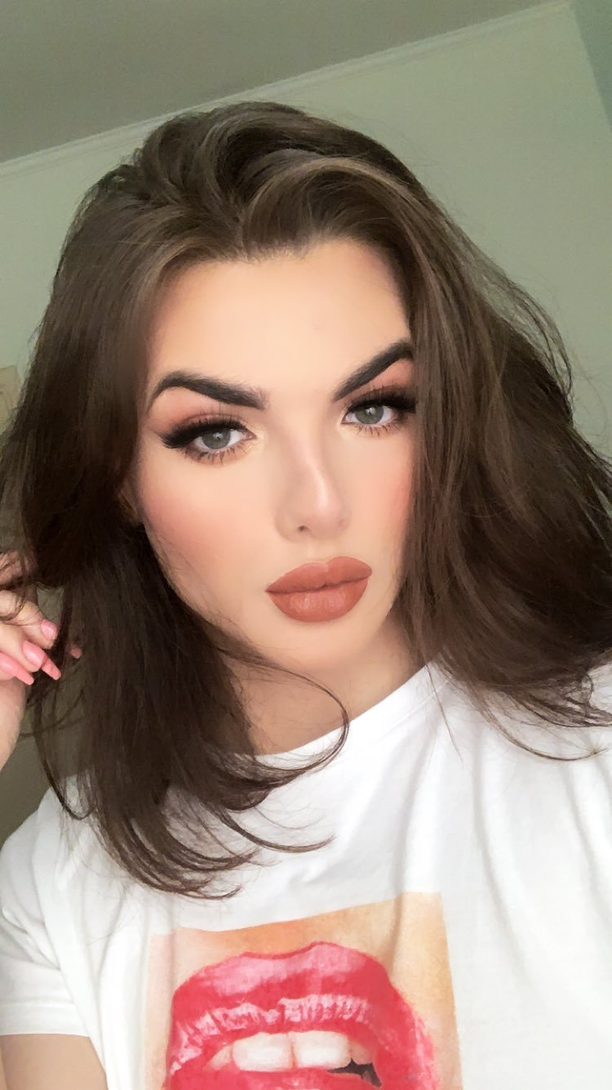

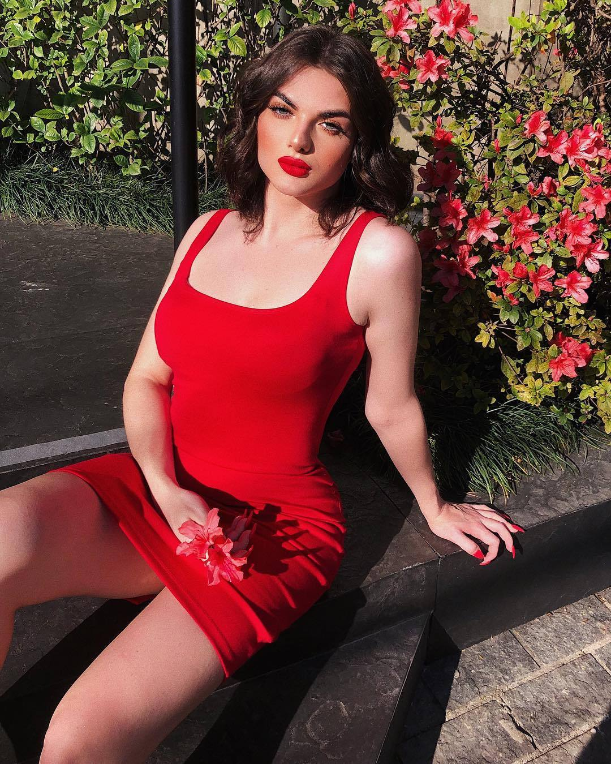

Author’s Note: I owe the inspiration for this story to my patron and fan (and I hope my friend) Brittini Blaire. Thanks Britt! The images are of Romolo Cricca, a Brazilian (male) makeup artist.

