Bonnie Lies Over the Ocean  A Short Story based on Historical Face  By Maryanne Peters  Aye, it is a heavy burden to have the fate of an entire nation born upon your shoulders. More so when that nation has such a fine tradition of bravery and resourcefulness. Surely the Scots are special folk. I only wish that their hero could have been strong enough to live up to the expectation.  They still sing for their hero – “my Bonnie lies over the ocean”. And that is where he lives still. Cry to bring him back, but that will never happen. That Bonnie lives in peace and happiness. Not like me. Not here, in shamed exile. | 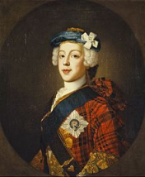

The history will be known to all. The Crown of the United Kingdom was passed to Hanoverian hun in 1714 under “The Act of Settlement” which excluded a catholic monarch. By all rights of succession the crown was there for the Stuart clan, and had been since James I succeeded Elizabeth I.

There were plenty in England, Ireland and Wales who opposed the German king too. James Francis Edward Stuart should have been James II, but instead he will always be “The Old Pretender”.

As for me, I am “The Young Pretender”. I may no longer be young, but I am still pretending. I am pretending to be Charles Edward Stuart – Bonnie Prince Charlie.

The man who would have been Charles III was born in exile – in Rome near the end of the year 1720. He was brought up to believe in the divine right of kings, and the legitimacy of the Jacobite succession over the incursion of William of Orange in the Revolution of 1688. But he was brought up in luxury, and in a mild climate nothing like the Scotland he claimed to love.

His father too, had grown soft living on the continent. James Stuart led the first uprising in 1715 but fell ill and was forced to return to France. His abandoning of the clans caused ill feeling in Scotland, and brought him no credit in France either, which is why he moved to Rome. James knew that his name could never be held high again so he named his son Charles as his regent and the new focal point of revolution.

There were those Scots who believed in Prince Charles Edward Stuart and travelled to Rome to pledge allegiance to him. My true name is of no importance now, but I was born a Stuart and with the features common to our family – the large eyes, long nose and round chin. People would call me “bonnie” too, although that was usually used to speak of a pretty woman.

But Prince Charles was bonnie indeed. Too bonnie to be a king, I think.

Bonnie Prince Charlie landed in Scotland in July 1745 to start “The Rising of ‘45”. As a cousin and a loyal follower I was placed in his “entourage” as the French call it. Charlie’s voice was high and he spoke English with an accent and Gaelic with difficulty, although he had been tutored in both since childhood. But luckily there were others - rough Highland born there to speak for him, while he nodded wisely. He had phrases and small speeches that he could deliver, but it was the sight of him that drew people to him. For sure he was bonnie, and he had the bearing of a prince. At least it appeared that way, because surrounded by the ruffians who backed his claim, he looked royal – even god-like.

But all this history is well known as I have said. An army was raised and he was placed at the head of it. It was an army of highlanders and other clansmen who were strong and brave and a little bloodthirsty. With clan leaders like George Murray (a British army veteran) and John Drummond (leader of a mercenary Scottish regiment in the service of France) Bonnie Prince Charlies needed no soldiering skills. But what was needed was supplies and more soldiers.

The British Army under the Duke of Cumberland was too strong a force, and as the supplies ran out, we were forced to stand and fight too early. The French failed to give the support promised, so we had to do battle with what we had. What we had as courage, that can never be denied. But steel wins battles – steel and lead.

The Battle of Culloden was a disaster for Scotland, although we only knew the half of it at the time. But for Bonnie Prince Charlie it seemed like the end of his life. Here was a man who had been brought up with a single purpose and convinced that it was his destiny. He stood in a blood filled bog with thousands of his followers dead or near to it, and it was clear to him that the goal was lost forever.

He was escorted from the battlefield by his “Lifeguards” cavalry, and the commander of that unit urged him that he should “put yourself at the head of the men that remain with you and live and die with them”, but I suspect with one glance about him, the thought of living with them, let alone dying with them, would have seemed unthinkable.

That was April 1746. The story from there saw Bonnie Prince Charlie escape from Scotland to France in October of that year. In the intervening period “nobody knew where to seek for him” as it is said.

There are many stories. Some have been put to song. But let me tell you what really happened.

First you need to understand that Bonnie Prince Charlie was a broken man, and then you need to understand that in truth he was not much of a man at all. There were those that still believed in the Jacobite cause and that Culloden was a reversal but not the end. I was one of those people. Such men believed that the idea of Bonnie Prince Charlie was more important than the man.

Secondly you need to understand that a reward of 30,000 pounds is a fortune. It is certainly enough to turn many a man from his principles. Bonnie Prince Charlie needed a fool proof disguise and a decoy to put his pursuers off his trail. That was to be me.

I have mentioned that we had a family likeness. It was enough. I was given the role of Bonnie Prince Charlie and it is a role that I have played ever since. It was not our design at the time. The idea was that the Young Pretender would recover given time, and that when we were both on the continent, he could reclaim his place.

But for his own safety, until that day he could travel and live as Betty Burke, and Irish girl and the sister of one of the many Irish soldiers fighting for the Jacobite cause.

Bonnie Prince Charlie had the advantage of being both bonnie and soft, or softer that any grown man in the moors of Scotland. He also wore his hair long under his wig, and he had a plumpness that could be shaped with a girdle made for the purpose. Some might also say that the most complete disguise for a king and a leader of men is to appear to be the opposite – a woman and a servant. But the truth is that Charles was a king and a leader no longer, if he had ever been that. Sadly perhaps, it was as if Betty Burke was his true self. In her he could escape from responsibility and the memory of the horrors of Culloden.

As I said at the start - it is a heavy burden to have the fate of an entire nation born upon your shoulders. Betty had no such burden. I took that burden on, comforted perhaps, by the knowledge that I was not in command. But then neither was Prince Charles in truth. So I have carried that burden, and still do as I lie abed in Italy, waiting for death.

So Betty appeared much earlier than the tales and the songs would tell you. By the time that we were both in the Western Isles Betty and I, after six month on the run from the British, Betty was Betty and I was Bonnie Prince Charlie.

It is true that Flora McDonald knew the truth, and she told her tale and went to prison for it. Flora was from the Isle of Skye but she was married to Allan MacDonald who was the Captain of the Highlanders who had actually fought with the British at Culloden. That certainly helped to secure her release.

The story goes that she helped the Young Pretender escape to board a French frigate by claiming that Betty Burke was her maid on the ferry across to the islands. This is true. The ferry was being watched by the British and all men were being stopped. It seemed a good idea to have the two women proceed while the men found another way across.

What Flora did not say was that the person she was travelling with had left her prior identity well behind her. She was Betty – a bright eyed Irish girl without much of care for anything. How could such a creature go back and assume the burdens of failure and guilt?

It was I who crossed over by small boat in the darkness of a moonless night some days later. It was I that boarded the French frigate and arrived safely in France to announce that the search across Scotland for a half a year had failed. It was I who became the focal point for the Jacobean cause, albeit that as a cause it had faded away to almost nothing.

And what happened to Betty Burke?

Well, on the island while we awaited the French ship she met one of the sons of Norman MacLeod the 22nd Chief of Clan MacLeod of Skye. Norman Macleod was well known as “The Wicked Man” for his role in the Rising of ’45. He had originally backed the Jacobites but then switched to the British, but he and his men never fought at Culloden. He stayed on Skye and then returned with his men and the Campbell clan to help “clear the highlands” in return for a bounty paid by the British Government.

It was the Wicked Man who arranged to send a ship to the Americas filled with Scots plucked from their land to be sold as indentured servants in the new colonies. Betty Burke was on that ship, not as a prisoner but as the wife of Angus Macleod, and mother to his children. What became of the first Mrs. Angus MacLeod is unclear but given the reputation of that family anything is possible. It be sufficient to say that Angus had cause to flee to America and he wanted to take his children and a woman to pass as his wife, and Betty was ready for that.

As it turned out, Elizabeth Macleod was well suited to life in the Americas. There was a refinement about her which was much sought after but the growing sophistication in the new cities being established. She strangely well educated for a woman and encouraged education for other women of standing across the ocean.

She remained a loyal Jacobite and no supporter of the British. I know this because she wrote to me. I have the letter still. It speaks of our time in hiding together, and of her new life, and the role that she and her husband and their children played in American Revolution and the building of a democratic republic. And to close, she thanks me for relieving her of “a weight my feminine body was never designed to bear”. It is signed simply “Betty”.

I often wonder about that feminine body. I wonder how she can still live as a woman after all these years. Is she still as bonnie as she once was? Has she taken steps to rid herself of maleness so that she can remain youthful as I have grown old? Is she a wife to Angus MacLeod in the full sense of that word? How could that be?
She was bonnie, that is for sure, and there was a charm about her that was special.  I feel that the song was not written for me – “The Great Pretender” – that song will never be written. “My Bonnie” was surely written for her not the one I pretend to be. I lie just across a channel, in a bed in nearby Italy. She is the one who is over the ocean from Scotland, not I. “Bring back, bring back my bonnie” they sing. She will never return. She has found happiness and perhaps a new purpose.  The Jacobite cause is finished. It will die with me. Pray God that be soon.  The End? | 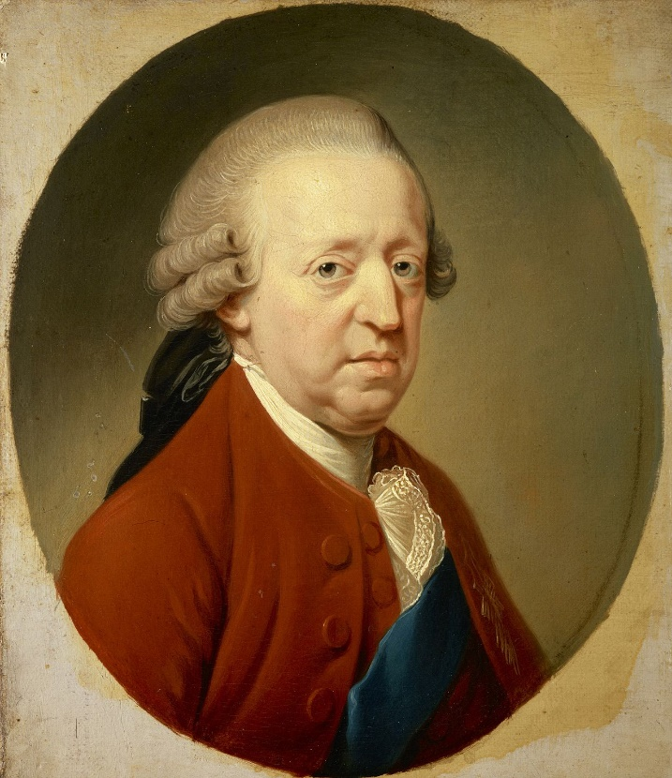

TRANSCRIPT OF A LETTER
Dated the 3rd day of February 1788
3 days after the death of Prince Charles Edward Stuart

Your Royal Highness,

While you have told me in your prior letters that your time no longer has value, I must still for a moment of it to once again give thanks.

I live by your grace and kindness, Sir, and I believe that I am bound by that to make my life a worthy one, in your name, and in the name of Clan Stuart, the rightful heirs to the Crown.

These months since I wrote to you have seen excitement, happiness and a wee sadness.

The wee sadness is that I report the death of my husband, Angus. In honesty he was a brute of man with too much of his father in him. I often thought that our physical love was driven by his need to dominate more than just a woman, but I took joy from it. In recent times with his failing health we found a truer love.

But his greatest gift to me has been our children. My oldest son, David, turned 50 just yesterday. The excitement is that he is involved in the completion of a truly wonderful document. Our new home, the United States of America, has a constitution! It has yet to be circulated and ratified, but it sets out how this new country will be governed, and David had a hand in its creation.

The happiness is that only weeks ago I was present at the birth of my first great grandchild. I have attend the birth of my many grandchildren and each time I have felt the sharp dirk of regret that I could never bear a child, but with the next generation that seems no longer important.

I tell all of my descendants that it is not the blood of the clan that matters so much as the blood of all Scots. Your Royal Highness, I believe that Culloden was not a low point but a high point, when men of Scotland stood in defiance before unbeatable odds. Now I am not a man, but the men that I have raised will learn of the ’45 and never forget it.

I remain, Sir, your humble servant.

Betty

© Maryanne Peters 2021

