Woman of Tomorrow  Inspired by a cap by AnotherTGPage  By Maryanne Peters  It is no longer a man’s world – if it ever was. Deny it if you like, but the future is female. The modern world does not need aggressive gorillas to do the work – we have machines more easily controlled through the dextrous skills of women. A feminine co-operative approach has replaced the rugged individual approach of our male dominated past. And for women child bearing is no longer a necessity.  I was one man who made the decision – “If you can’t bet ‘em, join ‘em”. So I signed up for Becomeanother School – become yet another woman, of course. Be a modern human, not a relic of society based on hunting, killing and manual labor.  I am the kind of person who believes in attacking a task full on. That is the style of the modern woman and that is what I want to be. Be forward and forceful, but feminine too. And when it comes to men, to the extent that they remain relevant in the short-term future, do not be afraid to use sex to get what you want.  I have choices as to how I want to look – I wanted big breasts, a narrow waist, a round butt and solid thighs. It has taken a while to get used to, but now that my hair has grown out, I think the total package is hot. But of course, looks are not everything – you need to know how a body like this is to be used to its full advantage, and that takes practice. | 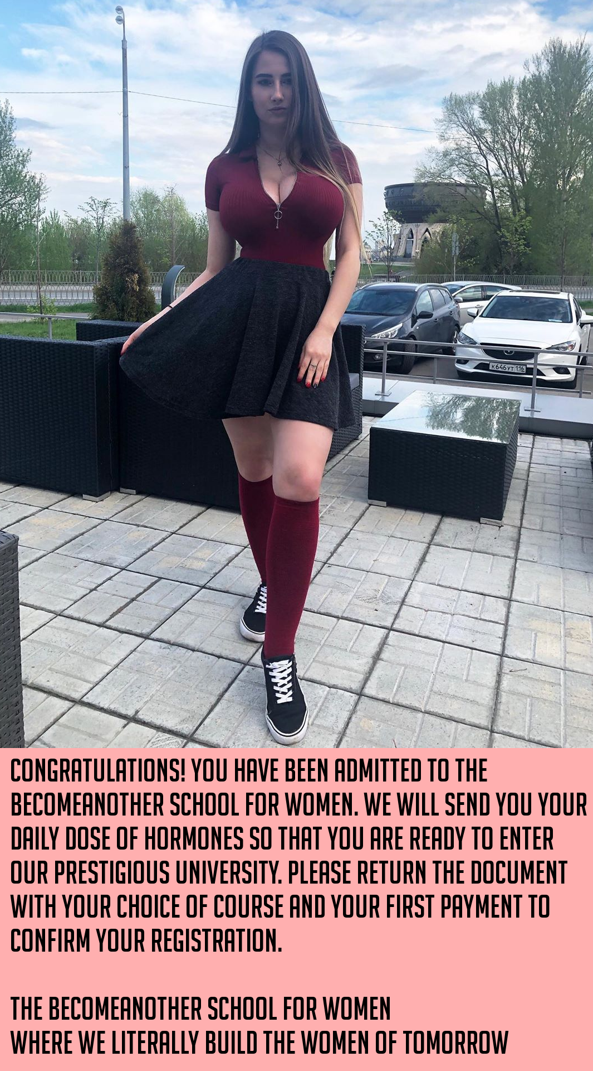

Becomeanother School is all about adding to the female sex and preparing women, whether they are freshly women or not, to be able to contribute to building a beter world, preferably a world undominated by toxic masculinity.

Of course we all exit with a degree in a useful discipline, but for the moment I can’t quite recall what my major was. All I can remember was the fun we had – the sorority parties and the sleepovers, and just relishing being a woman, with a bright feminine future. Because, of course Becomeanother School does not admit men, except ones like me.

But the curious thing about men not like I was, is that I learned that they do have their place, and somehow I don’t think that this is going to change. I got my vagina because that is an essential component for being a woman, but then I had my first man inside my vagina – Toby. He gave me something quite unexpected – my first female orgasm.

I thought that it would be easy to simply thank Toby and send him on his way, but I found myself unable to do that. Instead I found myself clinging to him in my bed and asking him to stay, and wanting to have him see me again; and again after that.

I learned that I am not alone. Becomeanother School prepares the women of tomorrow, but even the women of tomorrow need their pleasures. And sometimes we can give up a little power to me to keep them happy. Where is the harm in that?

The End

Deep Cover  Inspired by a cap by AnotherTGPage  By Maryanne Peters  It seemed like way too much to ask, but I asked anyway. It was agreed that I was entitled to a new identity. It was agreed that my appearance could be modified surgically. Given the size of the group we were busting open, it was even agreed that I could choose a location overseas. The reason was clear – because of negligence within the FBI my identity was totally compromised.  There was also the small fact that I had a huge amount of knowledge about the organization and I would be needed to remain on the staff at an FBI field office, or, in my case and overseas legat.  “You can choose who you want to be for the rest of your life,” the Director said. “We will meet the costs, and you will remain working for the Bureau”.  So there I was, by sheer chance, able to choose my future. For me it presented the chance to live out my fantasy. At last it seemed that I could become Carmelita.  So I asked. I pointed to one of the pictures that I had which showed the shape and style of the woman I had always wanted to be – the woman of my dreams. | 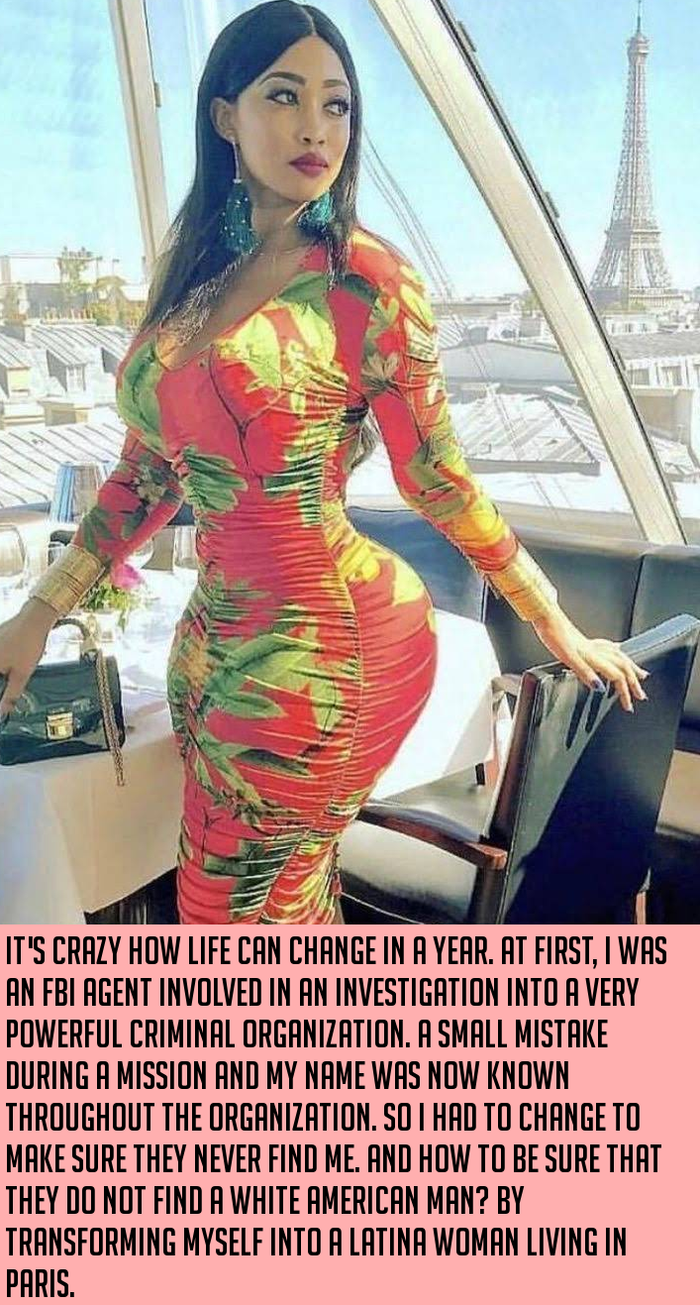

I asked, and while the surprise was clear to see, the Bureau agreed. There could be no denying that this was cover so deep that I would be safe. And in choosing Paris (because my Spanish is not so good) I could enter the FBI Office every working day as civilian staff and connect with the investigation team.

The consulting cosmetic surgeon was flabbergasted. He asked: “You want to look like this? With breasts and a butt that big? And what about between those plumped thighs? Do you want a vagina as well?”

“Yes, please,” I said. Because I have always wanted one of those.

My New Life
Inspired by a captioned image by AnotherTGPage (https://www.deviantart.com/anothertgpage)
By Maryanne Peters

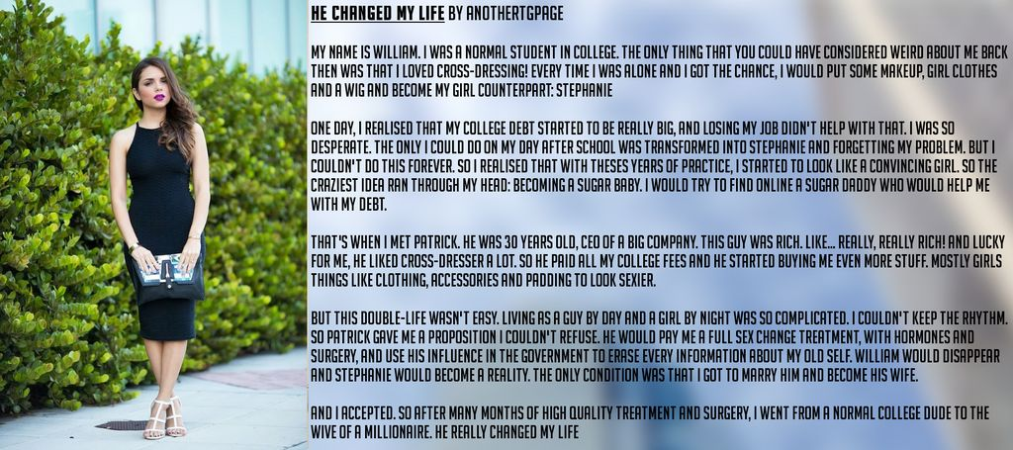

I suppose it is a very feminine thing to do. You are in a pile of shit, debt, no job, no way to stay in college so no future. What do you do? If you are like me you put on your best dress and heels and go window shopping. It seems to work every time. All your cares just seem less important somehow. If you are not a girl, or a girl in your soul, you would probably not understand.

I just saw them in the mall – the pretty young thing and the much older man. At first, I thought that they might be father and daughter, or maybe even grandfather and granddaughter. But when I got closer, listening in while pretending to browse, it was clear he was a sugar daddy, and she was … just lucky I guess. I thought I was prettier than her.

I thought he must be too old for sex. He just likes her company, and her youth, and somebody to shower with gifts and purchases. I know guys like that will also pay cash just to keep a girl like her. Why could I not be a girl like her?

I could. I just needed to advertise. The only question was as to how I could describe myself. Could I call myself “a girl” when that was clearly a lie? I was a cross-dresser meaning that I was just a regular guy who liked dressing as a girl now and again. But that did not sound like something a guy could invest in. So my advert read (deliberately neutral):
“Gender fluid person who presents as a glamorous young woman, seeks mature caring man to pamper and support them”.

I arranged to meet Patrick (the third man who responded to my advert and the only that seemed not be a creep) at a café in the afternoon. I wore my black dress and white heels and carried my fake Masciadri bag, and I applied lipstick color “Gratuitous Voilets”. It was a killer look. It worked.

He said that he had no problem that I was a boy underneath, but he never wanted to see me dressed as a male, ever. In fact I should not even mention it, to him or anybody else. He said that he would give me the name Stephanie. I would have preferred something more playful, but he told me that his grandmother’s name was Stephanie and she was a woman of grace and style, and had meant a lot to him. Somehow that touched me. I never met the woman but I have been trying to live up to her name ever since.

Like I said, he was the CEO of a big company. He was very well paid, and very rich, and he was only 30 years old. Already he had been divorced twice, and he was looking for a less complicated personal life. Because he was a business man he insisted on a deal that could be put in writing – a contract. He would pay my tuition and give me an allowance, and in addition he would buy me gifts that I was to accept with ecstatic enthusiasm. I had to be there when he wanted me, and I was always to look good. He would pay for that too.

It was already a good deal, but when a few weeks later he offered me the spare room in his apartment, I could hardly say no. By that time my room in the place I was supposed to be paying rent for was full of women’s closed and boxes of gifts. It was getting hard to explain.

In fact everything was getting hard to explain. That is why I say it was getting to complicated to be turning into Stephanie and then back again. Stephanie was earning the money and paying the rent, and sort of paying the college fees, so why bother with William. He had no friends who cared about him. In fact, once I was living as Stephanie full time I found myself being totally ashamed of William. It seemed to me that I had a chance for a clean start, with none of his problems.

If I gave the impression that Patrick rushed me into surgery, it was not like that. It was just that by living in his apartment it changed things from the classical sugar daddy or mistress set-up. He was there even when he was not ready for me. I could see his stress and rub his shoulders, I could pour him a drink or sometimes just get together some comfort food or a cup of hot chocolate for him.

That made me something different. Some less expendable, I guess.

Then there was the hormones and the changes they made to me, which were all changes he liked. For that reason I liked them too, even the hot flushes and spells in tears and all that stuff.

Maybe it made for the very relationship that he was trying to avoid – something complicated. I was certainly very keen to avoid that. It seemed that as long as it did not get intimate, It could be just contractual as he wanted. But the nature of attraction does not always rely on reality.

I am not even sure how it happened. We were just in the kitchen bumping into one another despite the fact that it is huge. Then we were in one another’s arms kissing, and then we were in his bed as I was surrendering to him as if it were so completely natural. Because the strange thing is – it was.

Maybe that should have been enough. If it had been I might have been able to put it down to my only experience of gay sex, or rather experiences. But somehow I knew that I preferred being Stephanie.

But if you care about somebody the way I then cared about Patrick, and he starts talking about how we can be together permanently, you have to point out how crazy this all seems. I mean, Patrick was young, rich, good looking enough, and best of all, a kind and loving person. He could have any woman he liked. A real woman. Somebody who could give him children. Somebody who could make him happy.

It makes me cry now just to remember it, so you can imagine that at the time, I was mess. Patrick just held me and said: “When you are in love, none of that matters”. That is Patrick. That is my Patrick.

Like I said, I buried William. I asked for the bits left after the surgery and together with my ID cards I buried them in a hole we dug in the park. Patrick created Stephanie the woman, so with all his contracts replacing my IDs was easy.

It was as if William never existed. I wonder sometimes if he ever really did. I sounds cruel, but I cannot even remember his parents now, except to know that they were not good people. Patrick and I have our own family now – adopted of course.

I said that he changed my life, but that is not really true. He gave me my new life. What greater gift could you ever expect from a sugar daddy now husband?

The End

© Maryanne Peters 2020

Qualifying  Inspired by a cap by AnotherTGPage  By Maryanne Peters  He said it was my idea, and I suppose it was. He told me that he dabbled in cross-dressing. Most girls would have dropped him like a hot brick, but I have to say that I was intrigued. Maybe there was a little bit of a lesbian fantasy in me somewhere.  When he was dressed in his peignoir and we had sex it was the best ever. He always had long hair, but tied back. In bed that first time he had washed it and it was spread across the pillow. I jumped him cowgirl style and he bucked like crazy giggling like a woman. We came together. It was magnificent.  That is where it should have stayed – in the bedroom. It was just that he was so goddam pretty. I felt that I could show him off – as my girlfriend.  I was the one who persuaded him that we should go on the town together as two girls. We could be lesbians and even French kiss in the booth of a bar, but we would still get propositioned by all sorts of guys. He looked that good. | 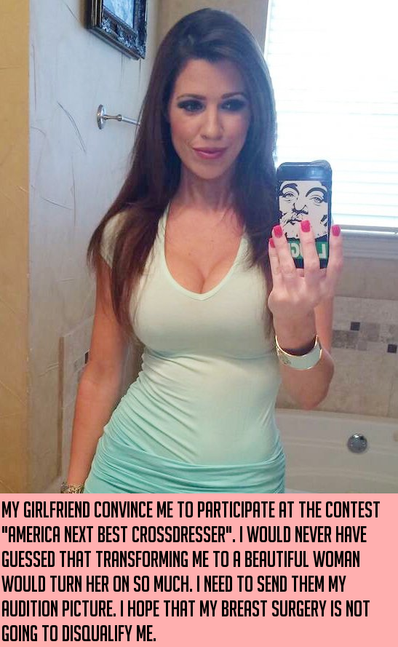

That is where it should have stopped – the occasional night out. Two lesbians having fun. Nobody would have guessed that one of us was not a girl at all.

But I read about “America’s Next Best Cross-dresser” and all the prizes on offer. He was reluctant. I should have listened to him. He said that things were getting weird. He knew that he was starting to behave differently. People at work noticed. It was becoming harder for him to go back to being a man. It was becoming easier for him just to live as a woman – all the time.

And still I was enjoying in helping him to look great as a woman. I think of myself as good-looking, but I am a born girl. To be able to take a man and make him a convincing girl is a real achievement – it made me proud. It made me proud of him and I know he liked that. He put effort into being a convincing female too, but it was becoming easier. I should have noticed that.

That was why he agreed to enter – it was for me. And so that I would not be disappointed he was ready to do whatever it took to win. He got hold of some of the other prospective contestants to discuss what was needed. That was where he got the idea for the breast implants.

And then one day I got home from work and he was there, telling me that he had a surprise for me. Maybe I was stupid to think that it might be an engagement ring, or at least a bunch of flowers, but he pulled down his zipper front and there they were. There were still the surgical dressings on under each of them, and skin had not relaxed over the implants, but there they were. My boyfriend had boobs.

He must have seen my shock, because he said: “It’s totally reversible. But it will just make it so much easier for the contest, with the costumes. And just think about them jiggling when we make love!”

And what about his work? How would he explain this?

“Oh that’s Ok,” he said. “I’m going to work Monday as Sally. It’s all been arranged. The bosses are good with it – maybe even looking forward to seeing me properly dressed.”

But still I had a feeling in my water that a part of my life was about to change, and not for the good. Perhaps I knew it was coming right from the start.

Because somebody as committed as him was bound to win the contest, and he did. There was no disqualification for surgery, but why would he even risk it? There were other considerations in his mind – things that I knew nothing about.

And one of the prizes was a photoshoot, and the glamor shots ending up in him being approached about other work, and before you know it, I was expendable, and then I was expended.

I saw him a couple of days ago. The ring that was supposed to be on my finger was on his, given to him (or should I say “her”) by the man on whose arm she was hanging right there on the street in front of me. Apparently, “she” now qualifies a woman capable of being a bride.

The End

As If Heaven had Heard  Inspired by a cap by AnotherTGPage  By Maryanne Peters  He says it that way, my Henry, to explain it to my little Emily. He calls it an act of God, that brought me into the world; that took a sad and lonely man and moulded him into his wife.  The death of my wife was a crisis for many reasons. She was the only woman in my life, and I lived through her. She was what I always wanted to be.  Perhaps even more I wanted to be like little Emily. A female child with all her life ahead of her. Somebody who could live a girl’s childhood, which is something that a cruel God seemed to have denied me.  As I sat with her, playing with her dolls and trying to explain that she would never see Mommy ever again, I wondered how Frank could ever offer her the upbringing she deserved. I started to wonder if there was any alternative.  She needed a mother. I wanted so much to be her mother. Only Frank stood between us. Sad little Frank, her limp-wristed father.  I began the transformation. Heaven had no part in it. It was pharmacology. Emily and I would advance into womanhood together.  For her it was like I was a full-size version of one of her dolls. She could dress me up and make me look pretty. It was what we both wanted. And then she could push me out the door after the baby-sitter arrived, saying: “Enjoy tonight, Mommy”. | 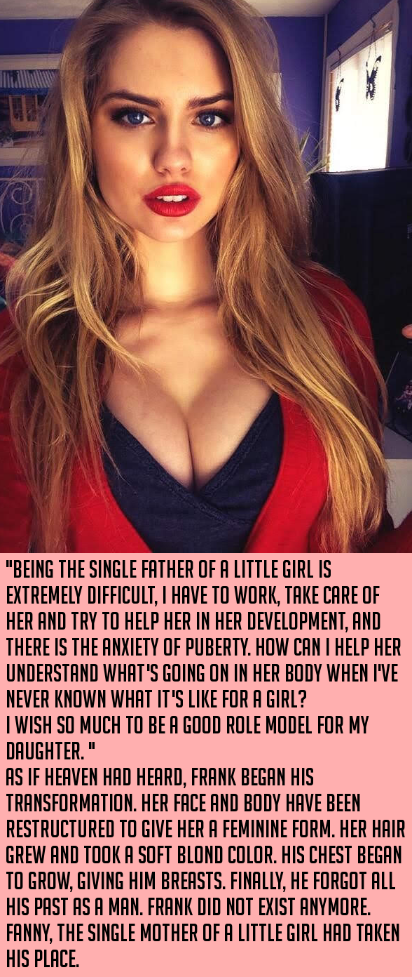

Because dolls don’t dress up for nothing. They go out on dates. And little girls get to here all about those dates in the morning, and imagine the time when they too, will be able to go out with boys, and kiss them in the booths of quiet restaurants, or in the front seats of their cars.

Emily’s choices of clothes for me were sometimes a little overly suggestive. And of course a little girl wants her doll to have long hair that she can play with and braid or style. But I was so happy to be the person she wanted me to be, and to share mother and daughter time.

And then I met Henry. When he asked for a second date, I felt I had to tell him everything: “I am a solo parent with a young daughter at home [would turn off many guys], and by the way, I have a penis.”

He was shocked, but he did not stand up and leave. Instead, after some obvious mind wrestling, he said: “Are you going to have an operation to fix that?”

Heaven had no part it. It was surgery. At last I would be complete.

“But Daddy, Mommy wasn’t always a girl, was she?” Emily asked him.

“Well no. She wanted so much to be your mommy that she prayed, and as if heaven had heard …”.

The End

© Maryanne Peters 2020

